supplemental information

Table S1 Sequence of primers used in the study
Gene | Forward (5’-3’) | Reverse (5’-3’)
IL-22RA1 | CAGCGGATCACCCAGAAGTT | GCGGTTTGATGGTAGTGTGC
IL-17B | GAACCTTGGGGAGATGGTGG | GGGTCGTGGTTGATGCTGTA
IL-17C | ACCATGGAGATATCGCATCGAC | GTCGCCGTAGTACCAGCAG
IL-17D | CTTCTGTAGGGGCGACACC | CGCGAGCATCCAGACCAGT
IL-17E | TCCTTGGAGCTATGAGTTGGAC | TGTGGGAGCCTGTCTGTAGG
IL-17F | GAAGGCTGGGAACTGTCCTC | GGGGTCTCGAGTGATGTTGT

Figure S1. Lung tissues were collected at day 7 post bleomycin administration. qPCR was used to detect mRNA level of IL-22RA1 in lung tissues (n = 6). GAPDH was used as a normalization gene. Data represent fold changes relative to normal control.

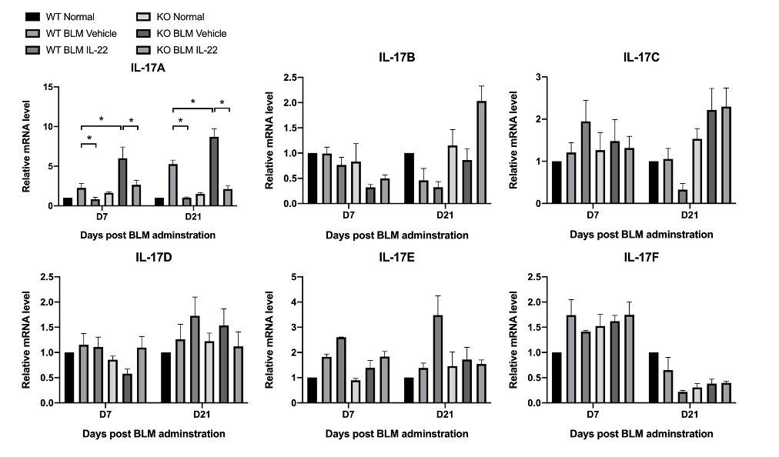
Figure S2. In the bleomycin-induced pulmonary fibrosis model, lung tissues were collected at day 7 and day 21. qPCR was used to detect mRNA (n = 6) levels of IL-17 subtypes. Data are mean ± SEM, compared using one-way ANOVA test. *, P < 0.05.

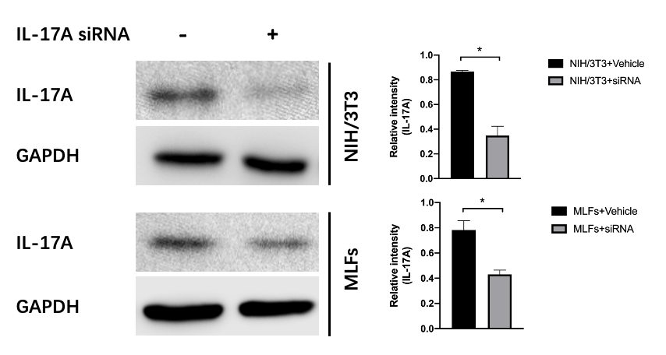
Figure S3. NIH/3T3 cells and MLFs were cultured with or without the IL-17A siRNAs. Western blotting was used to detect protein level of IL-17A (n = 3). Relative intensity of each band was normalized to GAPDH protein. The relevant gels and blots were cropped. Data are mean ± SEM, compared using t-test. *, P < 0.05.

