Association of hemoglobin levels with radiographic progression in patients with rheumatoid arthritis: an analysis from the BRASS Registry
Nancy Shadick^{1*}, Owen Hagino², Amy Praestgaard³, Stefano Fiore³, Michael Weinblatt¹, Gerd Burmester⁴
¹Division of Rheumatology, Inflammation, and Immunity, Brigham and Women’s Hospital, Boston, MA, United States of America
²Sanofi, Research and Development, Bridgewater, NJ, United States of America
³Sanofi, Global Medical Affairs, Biostatistics, Cambridge, MA, United States of America
⁴Department of Rheumatology and Clinical Immunology, Charité – Universitätsmedizin, Berlin, Germany
Corresponding author’s name, address, and email:
Name: Nancy Shadick
Address: Division of Rheumatology, Inflammation, and Immunity, Brigham and Women’s Hospital, 75 Francis Street, Boston, MA, United States of America.
Phone: +1-(617) 732-5266;
Email: nshadick@bwh.harvard.edu.
Supplementary Figure 1: Mean TSS over time by current medication at baseline subgroup
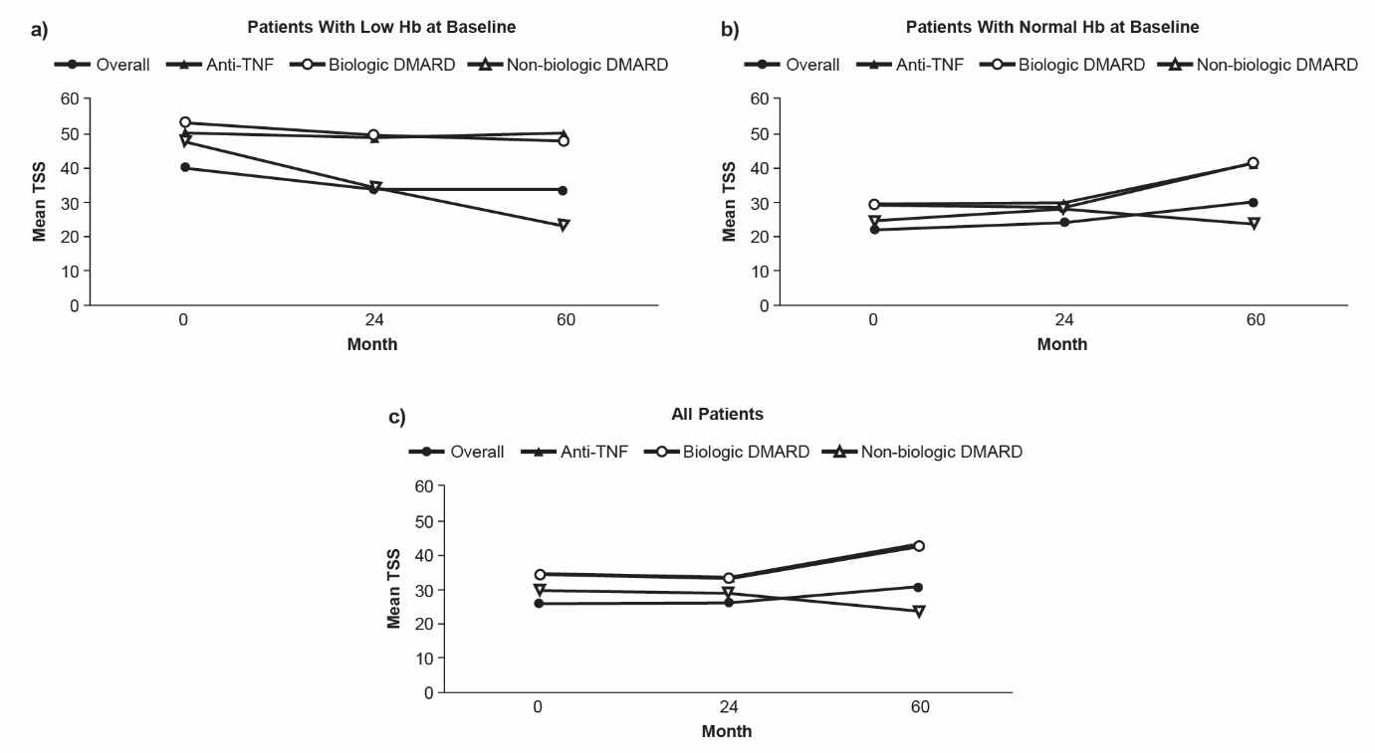DMARD, disease-modifying anti-rheumatic drug; Hb, hemoglobin; TNF, tumor necrosis factor; TSS, total sharp score

Supplementary Figure 2: Mean change in TSS over time by current medication at baseline subgroup
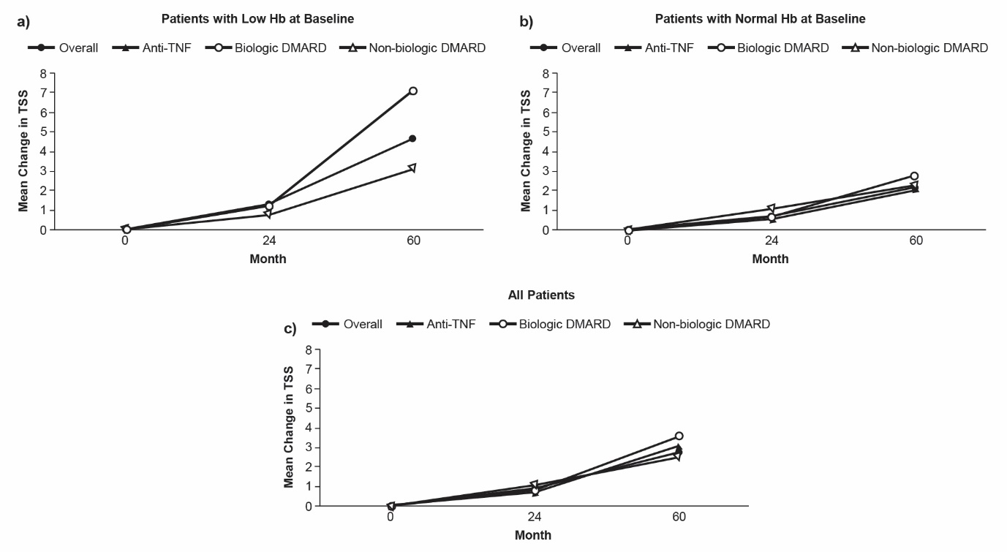DMARD, disease-modifying anti-rheumatic drug; Hb, hemoglobin; TNF, tumor necrosis factor; TSS, total sharp score

