Supplementary material
Supplementary Figure 1. Incidence rates per 100 patient-years of adverse events of special interest in patients receiving ustekinumab
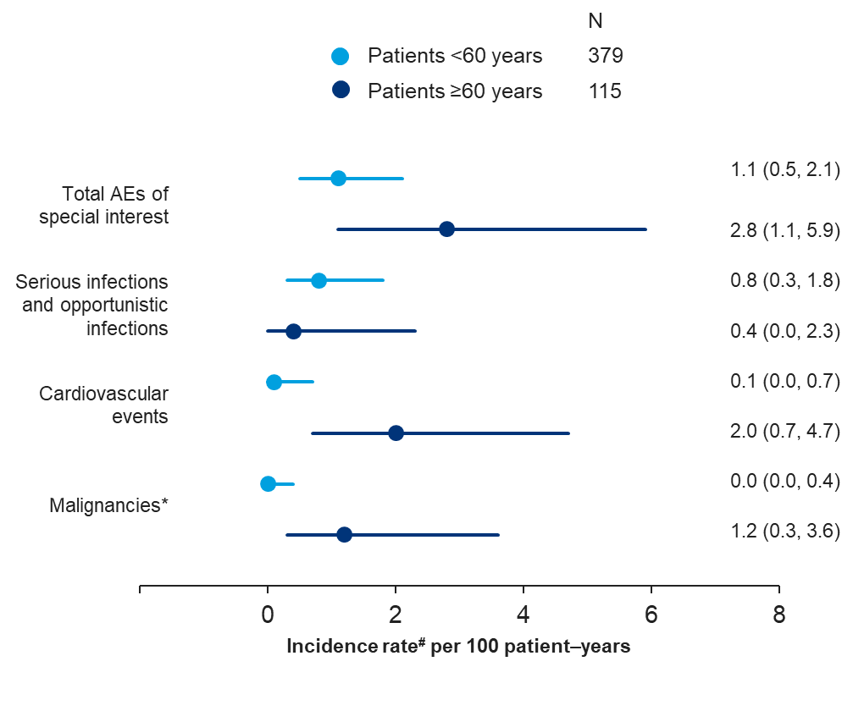
AE, adverse event. AEs do not include neoplasms.
*Malignancies incidence rate was analysed using 12-month lag time; #Exposure-adjusted incidence rate calculated as the number of events divided by the sum of the individual exposure times.

Supplementary Figure 2. Proportion of patients achieving resolution of dactylitis≠, over time and according to age subgroup, % (95% CI)
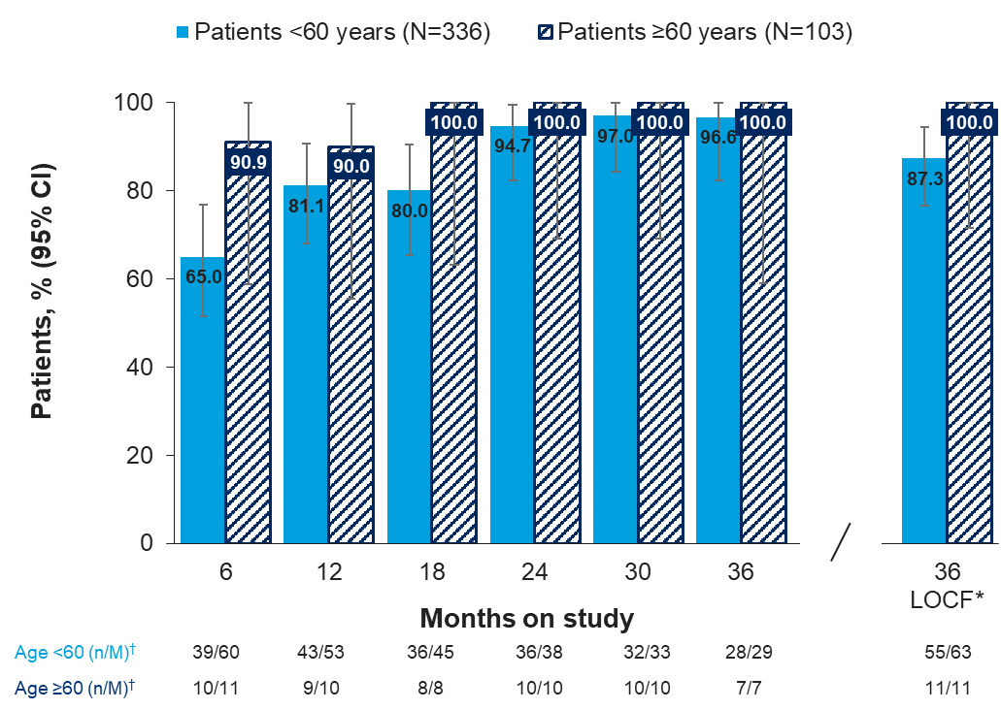
CI, confidence interval; LOCF, last observation carried forward.
≠63/315 (20.0%) patients <60 years and 11/93 (11.8%) patients ≥60 years had dactylitis at baseline.
*last observation carried forward, all other bars show observed case analysis; †n, number of patients achieving resolution of dactylitis; M, number of patients with an assessment at that specific time point.

Supplementary Figure 3. Proportion of patients achieving resolution of nail lesions≠, over time and according to age subgroup, % (95% CI)
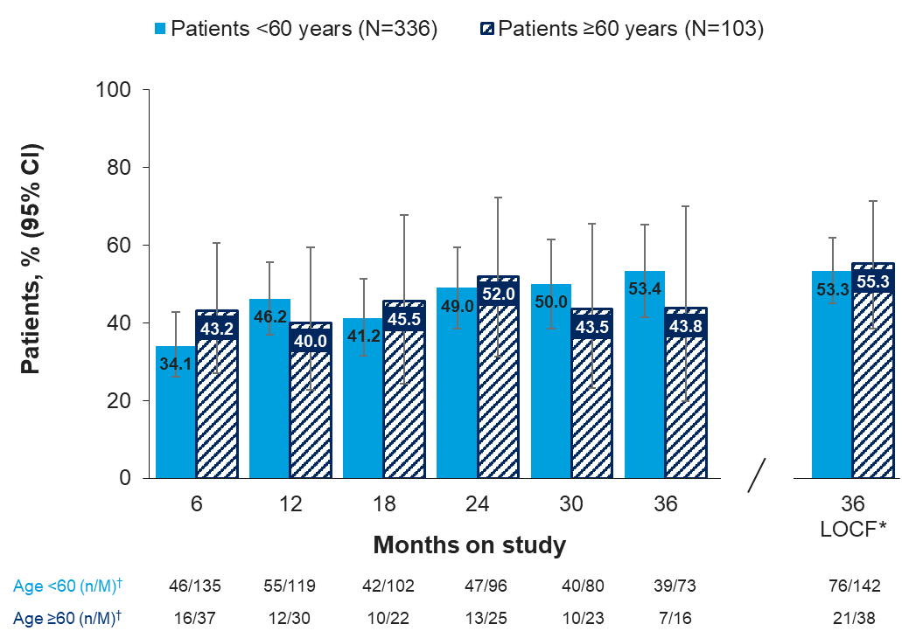
CI, confidence interval; LOCF, last observation carried forward.
≠142/304 (46.7%) patients <60 years and 38/88 (43.2%) patients ≥60 years had nail lesions at baseline.
*last observation carried forward, all other bars show observed case analysis; †n, number of patients achieving resolution of nail lesions; M, number of patients with an assessment at that specific time point.

Supplementary Figure 4. Proportion of patients with skin involvement: body surface area, over time and according to age subgroup, %
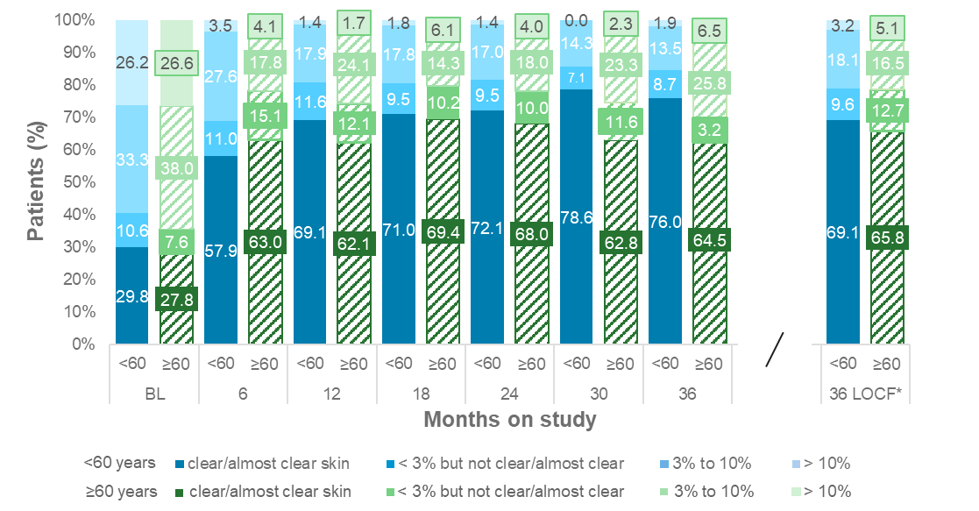
BL, baseline; LOCF, last observation carried forward; <60, patients <60 years; ≥60, patients ≥60 years.
*last observation carried forward; all other bars show observed case analysis.

Supplementary Figure 5A. Change in total tender joint count, 68 joints, over time and according to age subgroup, Mean (95% CI)
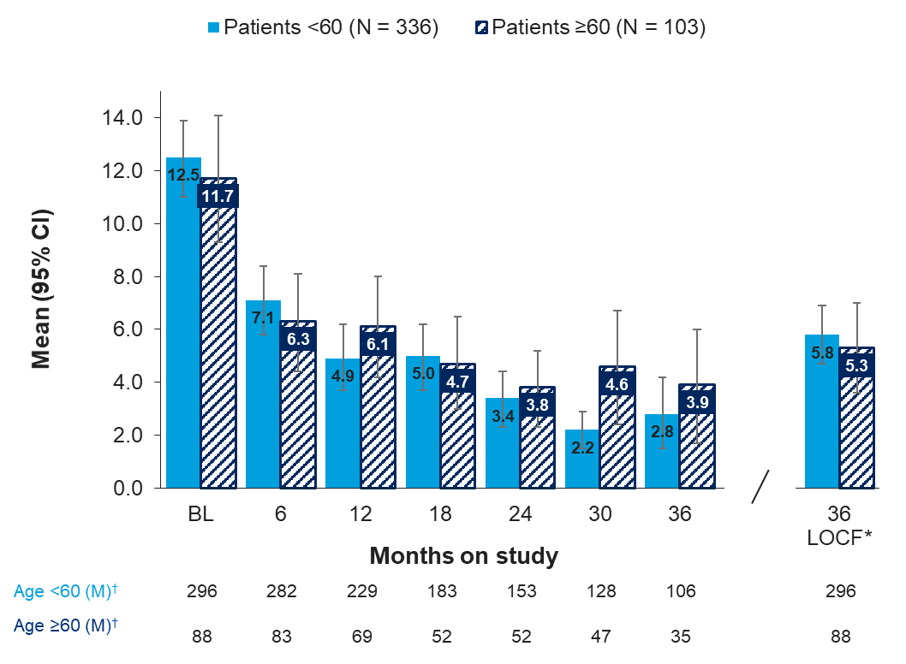
BL, baseline; CI, confidence interval; LOCF, last observation carried forward.
*last observation carried forward, all other bars show observed case analysis; †M, number of patients with an assessment at that specific time point.

Supplementary Figure 5B. Change in total swollen joint count, 66 joints, over time and according to age subgroup, Mean (95% CI)
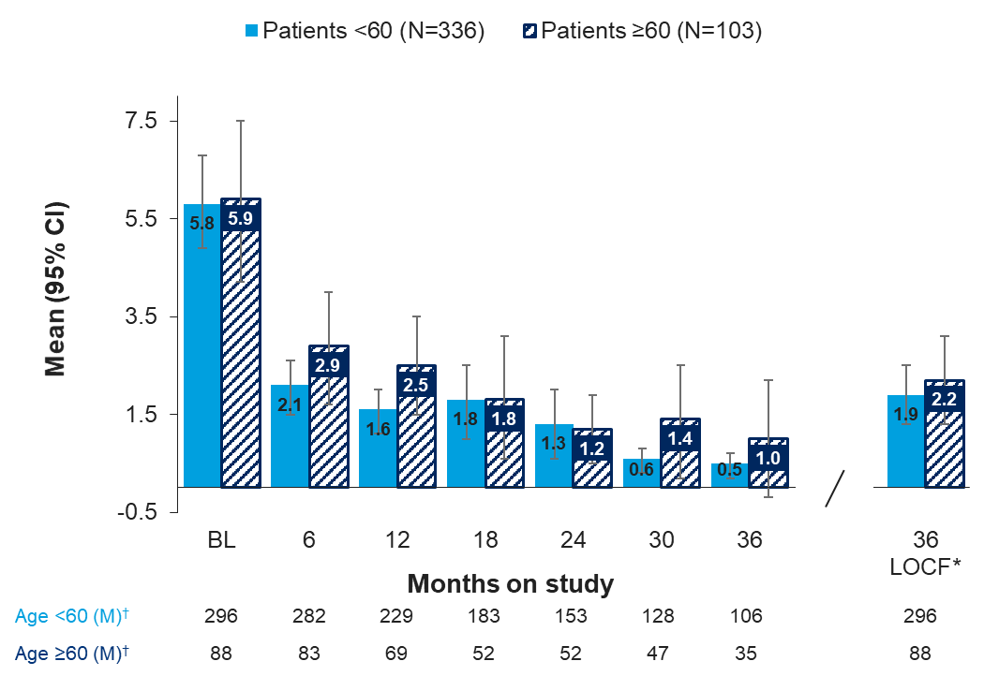
BL, baseline; CI, confidence interval; LOCF, last observation carried forward.
*last observation carried forward, all other bars show observed case analysis; †M, number of patients with an assessment at that specific time point.

Supplementary Figure 5C. Change in health assessment questionnaire – disability index, over time and according to age subgroup, Mean (95% CI)
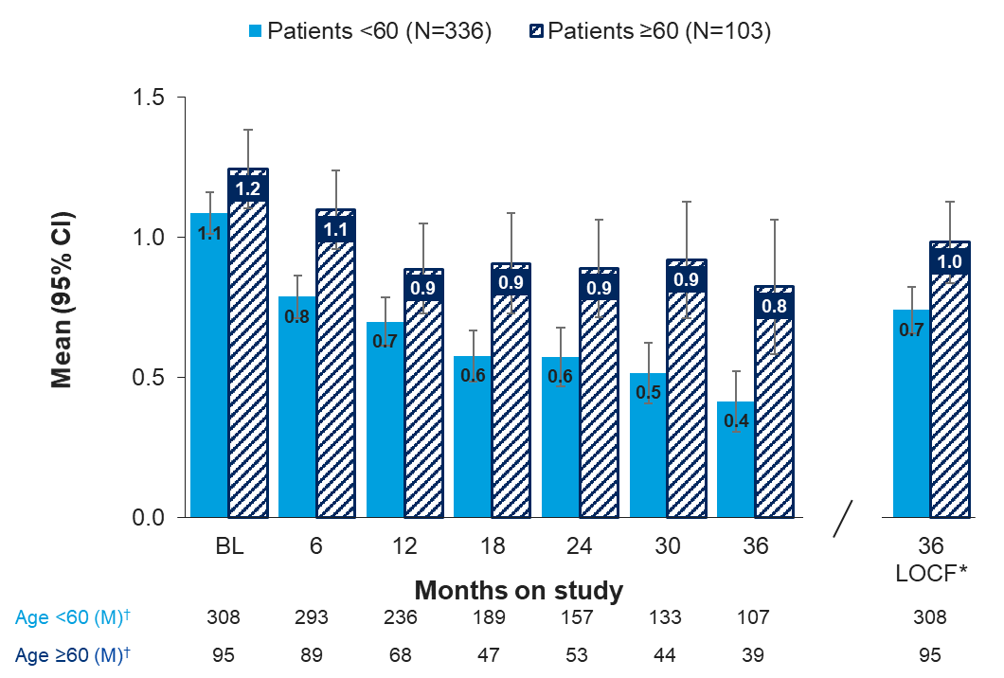
BL, baseline; CI, confidence interval; LOCF, last observation carried forward.
*last observation carried forward, all other bars show observed case analysis; †M, number of patients with an assessment at that specific time point.

Supplementary Figure 5D. Change in C-reactive protein concentration, over time and according to age subgroup, Mean, mg/dL (95% CI)
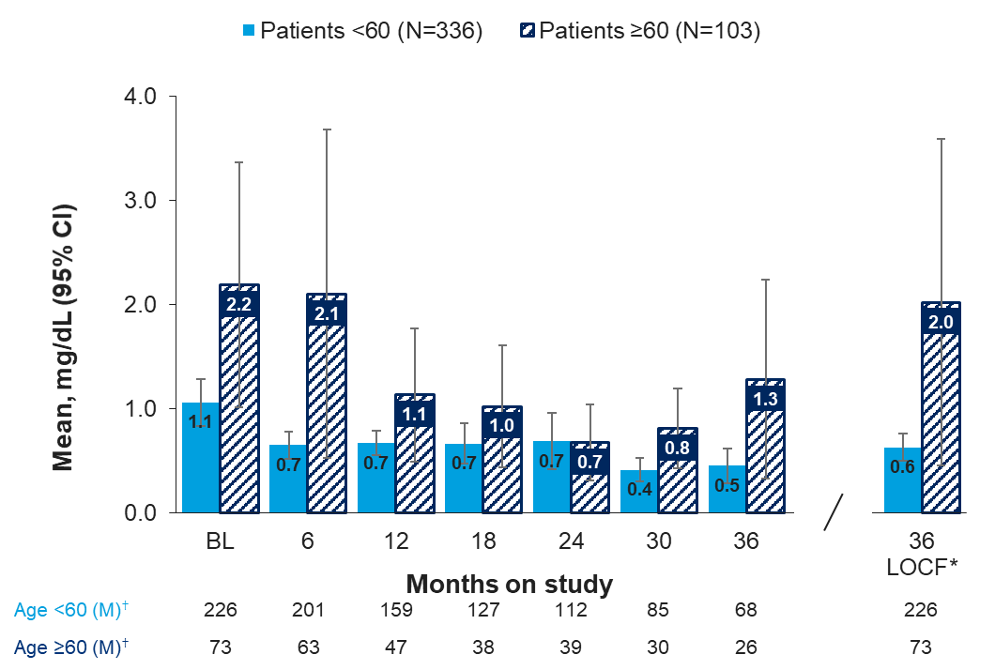
BL, baseline; CI, confidence interval; LOCF, last observation carried forward.
*last observation carried forward, all other bars show observed case analysis; †M, number of patients with an assessment at that specific time point.

Supplementary Figure 5E. Change in physician’s global assessment of disease activity, over time and according to age subgroup, Mean, mm (95% CI)
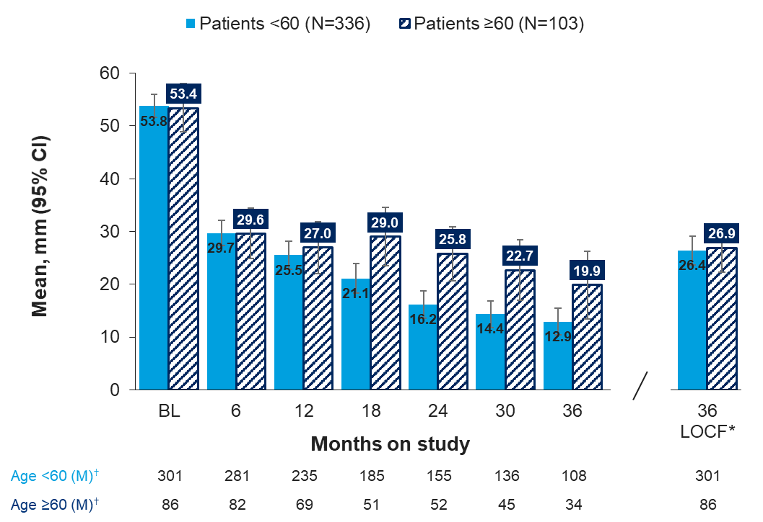
BL, baseline; CI, confidence interval; LOCF, last observation carried forward.
*last observation carried forward, all other bars show observed case analysis; †M, number of patients with an assessment at that specific time point.

Supplementary Figure 5F. Change in patient’s global assessment of disease activity-VAS, over time and according to age subgroup, Mean, mm (95% CI)
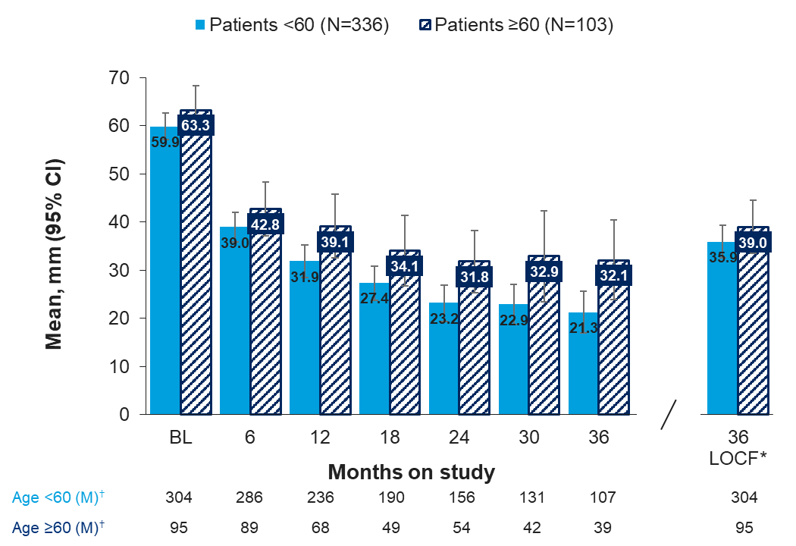
BL, baseline; CI, confidence interval; LOCF, last observation carried forward; VAS, visual analogue scale.
*last observation carried forward, all other bars show observed case analysis; †M, number of patients with an assessment at that specific time point.

Supplementary Figure 5G. Change in patient’s assessment of pain-VAS, over time and according to age subgroup, Mean, mm (95% CI)
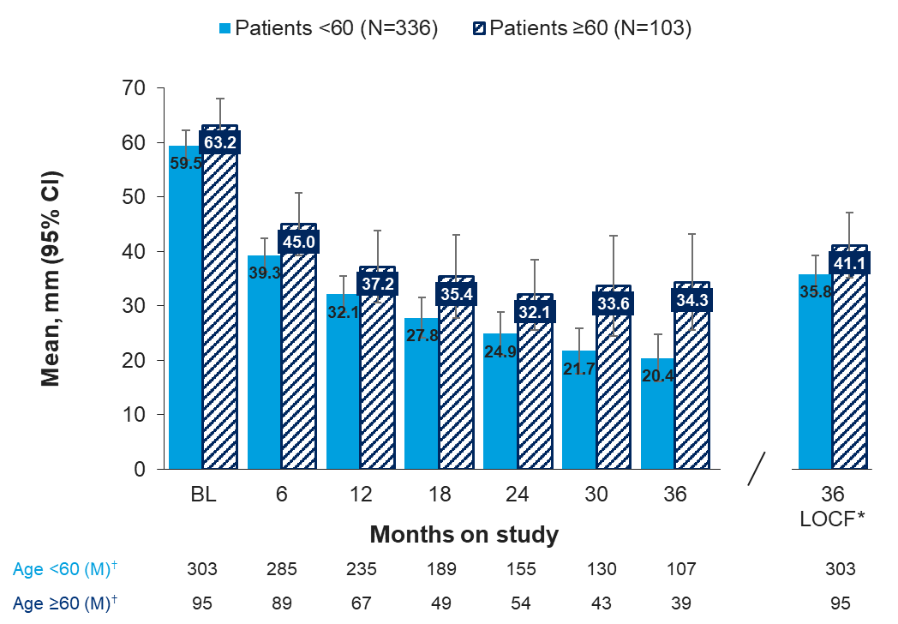
BL, baseline; CI, confidence interval; LOCF, last observation carried forward; VAS, visual analogue scale.
*last observation carried forward, all other bars show observed case analysis; †M, number of patients with an assessment at that specific time point.

