Supplementary appendix
Supplementary Fig. 1 ASAS20 (a), ASAS PR (b), and BASDAI50 (c) responses over time
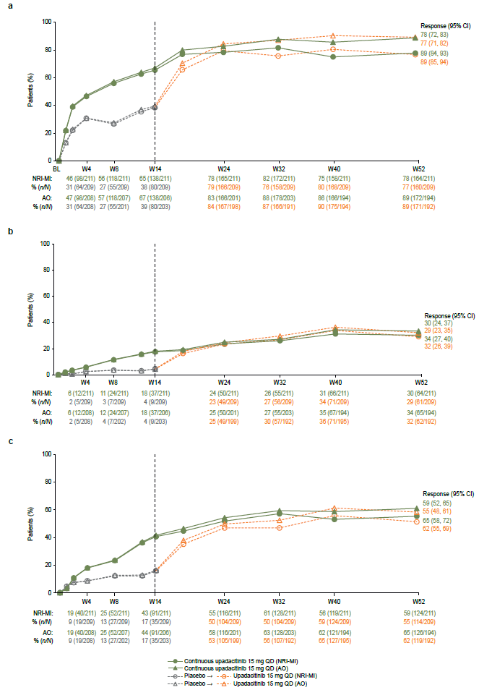
Patients initially randomized to receive placebo received open-label upadacitinib beginning at week 14. NRI-MI (NRI incorporating MI to handle missing data due to COVID-19) and AO analyses were used. AO as observed, ASAS Assessment of SpondyloArthritis international Society, ASAS20 ≥ 20% improvement in Assessment of SpondyloArthritis international Society response, BASDAI50 ≥ 50% improvement in Bath Ankylosing Spondylitis Disease Activity Index, CI confidence interval, MI multiple imputation, NRI non-responder imputation, QD once daily, PR partial remission, W week
Supplementary Fig. 2 Mean change in BASMI (a), MASES (b), ASQoL (c), and ASAS HI (d) over time
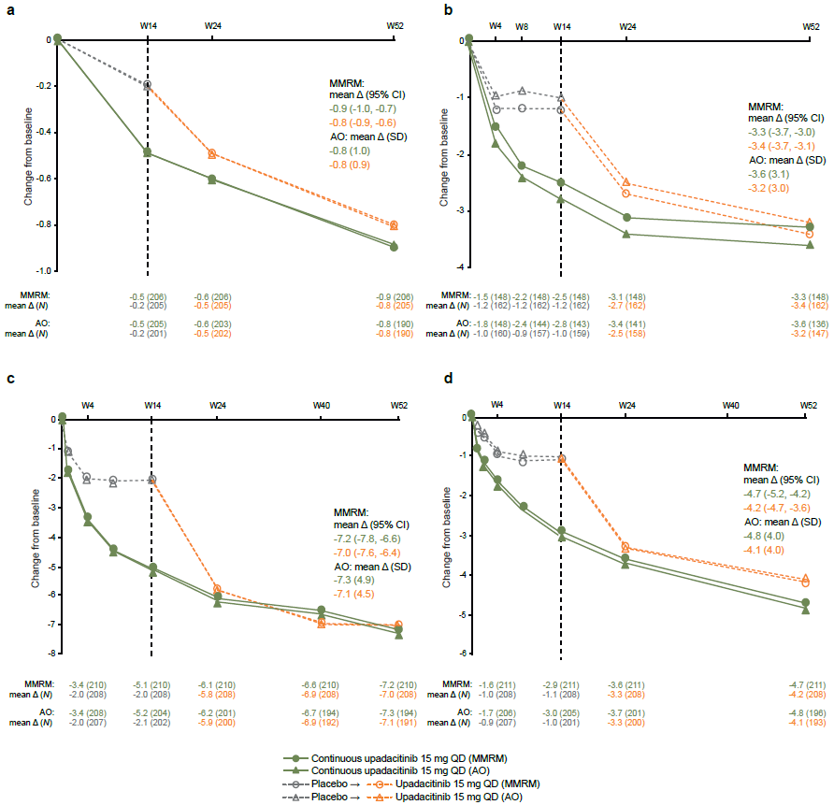
Patients initially randomized to receive placebo received open-label upadacitinib beginning at week 14. MMRM and AO analyses were used. Δ change, AO as observed, ASAS Assessment of SpondyloArthritis international Society, ASQoL Ankylosing Spondylitis Quality of Life, BASMI Bath Ankylosing Spondylitis Metrology Index, CI confidence interval, HI Health Index, MASES Maastricht Ankylosing Spondylitis Enthesitis Score, MMRM mixed-effects model repeated measures, QD once daily, W week
Supplementary Table 1. Number of patients in the post hoc subgroup analysis
Subgroup, n (%) | Placebo → upadacitinib 15 mg QD  (n=209) | Continuous upadacitinib  15 mg QD  (n=211)
bDMARD-IR (lack of efficacy)ª | 159 (76.1) | 166 (78.7)
bDMARD-IR (intolerance)ª | 66 (31.6) | 61 (28.9)
TNFi exposed^{b} | 183 (87.6) | 181 (85.8)
IL-17i exposed^{b} | 36 (17.2) | 38 (18.0)
ªIncludes 33 patients with both lack of efficacy and intolerance to prior bDMARDs. ^{b}Includes 19 patients with both prior TNFi and IL-17i exposure
bDMARD biologic disease-modifying antirheumatic drug, IL-17i interleukin-17 inhibitor, IR inadequate response, QD once daily, TNFi tumor necrosis factor inhibitor

Supplementary Table 2. Additional efficacy results at week 52
 | Placebo → upadacitinib  15 mg QD | Continuous upadacitinib  15 mg QD
Patients, % | NRI-MI / AO  n=209 / 185 | NRI-MI / AO  n=211 / 184
ASDAS major improvement | 44.9 / 49.7 | 45.3 / 52.7
ASDAS CII | 66.9 / 77.3 | 69.0 / 79.9
Mean change from baseline | MMRM / AO (SD)  n=209 / 192 | MMRM / AO (SD)  n=211 / 194
Severity of morning stiffnessª | -4.55 / -4.66 (2.17) | -4.46 / -4.49 (2.54)
Duration of morning stiffnessª | -4.14 / -4.12 (2.51) | -3.97 / -4.10 (3.02)
Patient global assessment of painª | -4.37 / -4.46 (2.06) | -4.61 / -4.67 (2.32)
Patient global assessment of disease activityª | -4.22 / -4.29 (2.20) | -4.54 / -4.62 (2.35)
Fatigue/tirednessª | -3.57 / -3.60 (2.40) | -3.91 / -4.01 (2.45)
FACIT-F | 10.88^{b} / 10.78 (8.95)^{c} | 12.38^{d} / 12.55 (9.20)^{e}
Swollen joint count (of 66 joints) | -1.3^{b} / -1.4 (3.4)^{f} | -1.2^{g} / -1.1 (3.3)^{f}
Tender joint count (of 68 joints) | -3.3^{b} / -3.3 (6.7)^{f} | -3.3^{g} / -3.4 (6.1)^{f}
ªNRS score 0–10. ^{b}n=205. ^{c}n=188. ^{d}n=209. ^{e}n=191. ^{f}n=190. ^{g}n=206
AO as observed, ASDAS Ankylosing Spondylitis Disease Activity Score, CII clinically important improvement, FACIT-F Functional Assessment of Chronic Illness Therapy—Fatigue, MI multiple imputation, MMRM mixed-effects model repeated measures, NRI non-responder imputation, NRS numeric rating scale, QD once daily, SD standard deviation

Supplementary Table 3. Efficacy results at week 52 in bDMARD-IR subgroups
 | Lack of efficacy of bDMARDsª |  | Intolerance to bDMARDsª
 | Placebo → upadacitinib 15 mg QD  n=159 /144 | Continuous upadacitinib 15 mg QD  n=166 / 151 | Placebo → upadacitinib 15 mg QD  n=66 / 61 | Continuous upadacitinib 15 mg QD  n=61 / 58
Patients, % | NRI-MI / AO | NRI-MI / AO | NRI-MI / AO | NRI-MI / AO
ASAS40 response | 64.2 / 74.3 | 65.1 / 74.2 | 60.6 / 70.5 | 68.9 / 72.4
ASAS20 response | 76.1 / 90.3 | 75.3 / 87.4 | 74.2 / 85.2 | 83.6 / 89.7
ASAS PR | 28.3 / 31.3 | 30.1 / 33.8 | 28.8 / 32.8 | 27.9 / 29.3
BASDAI50 | 53.5 / 61.1 | 57.8 / 64.9 | 54.5 / 63.9 | 63.9 / 67.2
ASDAS ID | 23.1 / 25.5^{b} | 24.4 / 29.4^{c} | 30.3 / 34.4 | 28.8 / 32.1^{d}
ASDAS LDA | 55.1 / 63.5^{b} | 56.2 / 66.4^{c} | 51.5 / 57.4 | 55.1 / 60.4^{d}
Mean change from baseline^{e} | MMRM / AO (SD) | MMRM / AO (SD) | MMRM / AO (SD) | MMRM / AO (SD)
ASDAS | -1.92 / -1.92 (1.01)^{b} | -1.97 / -1.97 (1.04)^{c} | -1.92 / -1.96 (0.91) | -1.99 / -2.04 (1.11)^{d}
Total back pain^{f} | -4.41 / -4.45 (2.23) | -4.54 / -4.64 (2.32) | -4.04 / -4.16 (2.10) | -4.34 / -4.33 (2.27)
Nocturnal back pain^{f} | -4.48^{g} / -4.56 (2.23)^{c} | -4.56 / -4.59 (2.53) | -3.93 / -4.15 (2.09) | -4.38 / -4.36 (2.56)
Duration of morning stiffness^{f} | -4.24 / -4.22 (2.61) | -3.89 / -4.02 (3.18) | -3.89 / -3.92 (2.35) | -3.98 / -4.03 (2.82)
Severity of morning stiffness^{f} | -4.59 / -4.72 (2.28) | -4.43 / -4.44 (2.65) | -4.34 / -4.49 (1.83) | -4.39 / -4.43 (2.35)
Fatigue/tiredness^{f} | -3.67 / -3.67 (2.41) | -3.89 / -4.02 (2.53) | -3.34 / -3.43 (2.30) | -3.93 / -3.97 (2.43)
FACIT-F | 10.80^{h} / 10.56 (8.91)^{i} | 12.78^{j} / 13.16 (9.51)^{k} | 11.00^{l} / 11.23 (8.82)^{m} | 11.56 / 11.15 (7.32)^{n}
BASFI  ASQoL | -3.58 / -3.63 (2.12) | -3.59 / -3.65 (2.34) | -3.29 / -3.34 (1.85) | -3.67 / -3.70 (2.32)
BASFI  ASQoL | -6.91^{g} / -6.95 (4.53)^{c} | -7.29º / -7.49 (4.92) | -6.89 / -6.98 (4.18) | -6.98 / -7.07 (4.87)
ASAS HI | -4.15^{g} / -4.13 (4.02) | -4.81 / -4.95 (3.95)^{p} | -3.88 / -3.78 (3.85)^{q} | -4.43 / -4.64 (3.77)
BASMI | -0.72^{r} / -0.73 (0.87)^{c} | -0.84^{s} / -0.82 (1.03)^{t} | -0.85^{l} / -0.84 (0.77)^{m} | -0.78^{u} / -0.82 (1.04)^{v}
MASES | -3.5^{w} / -3.3 (3.1)^{x} | -3.5^{y} / -3.8 (3.2)^{z} | -3.2^{aa} / -3.0 (3.1)^{bb} | -3.1^{cc} / -3.4 (2.7)^{dd}
ªIncludes 33 patients with both lack of efficacy and intolerance to prior bDMARDs. ^{b}n=137. ^{c}n=143. ^{d}n=53. ^{e}Increasing negative values indicate improvement, apart from FACIT-F in which increasing positive values indicate improvement. ^{f}NRS score 0–10. ^{g}n=158. ^{h}n=156. ^{i}n=141. ^{j}n=164. ^{k}n=149. ^{l}n=65. ^{m}n=60. ^{n}n=57. ºn=165. ^{p}n=153. ^{q}n=62. ^{r}n=155. ^{s}n=162. ^{t}n=147. ^{u}n=59. ^{v}n=56. ^{w}n=124. ^{x}n=111. ^{y}n=117. ^{z}n=107. ^{aa}n=50. ^{bb}n=46. ^{cc}n=42. ^{dd}n=39
AO as observed, ASAS Assessment of SpondyloArthritis international Society, ASAS20 ≥ 20% improvement in Assessment of SpondyloArthritis international Society response, ASAS40 ≥ 40% improvement in Assessment of SpondyloArthritis international Society response, ASDAS Ankylosing Spondylitis Disease Activity Score, ASQoL Ankylosing Spondylitis Quality of Life, BASDAI50 ≥ 50% improvement in Bath Ankylosing Spondylitis Disease Activity Index, BASFI Bath Ankylosing Spondylitis Functional Index, BASMI Bath Ankylosing Spondylitis Metrology Index, bDMARD biologic disease-modifying antirheumatic drug, FACIT-F Functional Assessment of Chronic Illness Therapy—Fatigue, HI Health Index, ID inactive disease, IR inadequate response, LDA low disease activity, MASES Maastricht Ankylosing Spondylitis Enthesitis Score, MI multiple imputation, MMRM mixed-effects model repeated measures, NRI non-responder imputation, NRS numeric rating scale, PR partial remission, QD once daily, SD standard deviation

Supplementary Table 4. Efficacy results at week 52 in prior TNFi/IL-17i subgroups
 | TNFi exposedª |  | IL-17i exposedª
 | Placebo → upadacitinib 15 mg QD  n=183 / 168 | Continuous upadacitinib 15 mg QD  n=181 / 165 | Placebo → upadacitinib 15 mg QD  n=36 / 34 | Continuous upadacitinib 15 mg QD  n=38 / 36
Patients, % | NRI-MI / AO | NRI-MI / AO | NRI-MI / AO | NRI-MI / AO
ASAS40 response | 63.9 / 73.2 | 64.1 / 72.7 | 69.4 / 76.5 | 71.1 / 75.0
ASAS20 response | 77.6 / 88.7 | 75.7 / 87.3 | 75.0 / 91.2 | 81.6 / 91.7
ASAS PR | 29.5 / 32.7 | 30.4 / 33.9 | 19.4 / 20.6 | 26.3 / 27.8
BASDAI50 | 54.6 / 62.5 | 56.9 / 63.6 | 55.6 / 58.8 | 63.2 / 66.7
ASDAS ID | 27.0 / 30.1^{b} | 25.8 / 30.6^{c} | 9.3 / 9.4^{d} | 23.9 / 26.5e
ASDAS LDA | 56.2 / 63.2^{b} | 55.2 / 64.3^{c} | 55.0 / 62.5^{d} | 61.1 / 67.6e
Mean change from baseline^{f} | MMRM / AO (SD) | MMRM / AO (SD) | MMRM / AO (SD) | MMRM / AO (SD)
ASDAS | -1.97 / -2.00 (0.98)^{b} | -1.96 / -1.98 (1.06)^{c} | -1.75 / -1.73 (0.83)^{d} | -2.06 / -2.04 (1.04)^{e}
Total back pain^{g} | -4.35 / -4.40 (2.17) | -4.43 / -4.52 (2.32) | -4.13 / -4.16 (2.16) | -4.60 / -4.67 (2.45)
Nocturnal back pain^{g} | -4.39^{h} / -4.47 (2.14)^{i} | -4.44 / -4.48 (2.58) | -4.36 / -4.49 (2.13) | -4.69 / -4.58 (2.67)
Duration of morning stiffness^{g} | -4.26 / -4.26 (2.53) | -3.98 / -4.08 (3.13) | -3.15 / -3.04 (1.93) | -3.37 / -3.69 (3.11)
Severity of morning stiffness^{g} | -4.59 / -4.70 (2.13) | -4.45 / -4.47 (2.62) | -4.05 / -4.19 (2.26) | -4.21 / -4.28 (2.50)
Fatigue/tiredness^{g} | -3.63 / -3.65 (2.40) | -3.80 / -3.89 (2.46) | -3.19 / -3.28 (2.16) | -4.06 / -4.17 (2.89)
FACIT-F | 10.94^{j} / 10.80 (9.00)^{k} | 12.17^{l} / 12.34 (9.34)^{b} | 10.53^{m} / 10.56 (7.78)^{n} | 13.61º / 13.96 (8.40)^{m}
BASFI | -3.46 / -3.51 (2.04) | -3.54 / -3.60 (2.34) | -3.64 / -3.70 (2.05) | -3.69 / -3.82 (2.52)
ASQoL | -7.14^{h} / -7.18 (4.45)^{i} | -7.21^{l} / -7.38 (5.02) | -5.95 / -6.13 (4.52) | -6.78 / -6.86 (4.59)
ASAS HI | -4.28^{h} / -4.22 (3.98) | -4.55 / -4.69 (3.92)^{i} | -3.75 / -3.76 (3.85)^{m} | -5.02 / -5.14 (3.97)
BASMI | -0.78^{j} / -0.79 (0.88)^{p} | -0.85^{q} / -0.83 (1.05)^{r} | -0.48 / -0.44 (0.78) | -0.83 / -0.86 (1.09)^{m}
MASES | -3.4^{s} / -3.2 (3.0)^{t} | -3.3^{u} / -3.6 (3.1)^{v} | -2.8^{w} / -2.8 (3.2)^{x} | -3.3^{y} / -3.5 (2.8)^{y}
ªIncludes 19 patients with both prior TNFi and IL-17i exposure. ^{b}n=163. ^{c}n=157. ^{d}n=32. ^{e}n=34. ^{f}Increasing negative values indicate improvement, apart from FACIT-F in which increasing positive values indicate improvement. ^{g}NRS score 0–10. ^{h}n=182. ^{i}n=167. ^{j}n=179. ^{k}n=164. ^{l}n=180. ^{m}n=35. ^{n}n=33. ºn=37. ^{p}n=166. ^{q}n=176. ^{r}n=162. ^{s}n=140. ^{t}n=128. ^{u}n=132. ^{v}n=120. ^{w}n=31. ^{x}n=28. ^{y}n=21
AO as observed, ASAS Assessment of SpondyloArthritis international Society, ASAS20 ≥ 20% improvement in Assessment of SpondyloArthritis international Society response, ASAS40 ≥ 40% improvement in Assessment of SpondyloArthritis international Society response, ASDAS Ankylosing Spondylitis Disease Activity Score, ASQoL Ankylosing Spondylitis Quality of Life, BASDAI50 ≥ 50% improvement in Bath Ankylosing Spondylitis Disease Activity Index, BASFI Bath Ankylosing Spondylitis Functional Index, BASMI Bath Ankylosing Spondylitis Metrology Index, FACIT-F Functional Assessment of Chronic Illness Therapy—Fatigue, HI Health Index, ID inactive disease, IL-17i interleukin-17 inhibitor, IR inadequate response, LDA low disease activity, MASES Maastricht Ankylosing Spondylitis Enthesitis Score, MI multiple imputation, MMRM mixed-effects model repeated measures, NRI non-responder imputation, NRS numeric rating scale, PR partial remission, QD once daily, SD standard deviation, TNFi tumor necrosis factor inhibitor

Supplementary Table 5. Grade 3 and 4 laboratory parameters in the safety population
Parameter, n (%) | Any upadacitinib 15 mg QD  (n=414)
Hemoglobin
Grade 3 (< 80 g/L) | 1 (0.3)
Lymphocytes
Grade 3 (0.2–< 0.5 × 10⁹/L) | 3 (0.7)
Grade 4 (< 0.2 × 10⁹/L) | 0
Neutrophils
Grade 3 (0.5–< 1.0 × 10⁹/L) | 7 (1.7)
Grade 4 (< 0.5 × 10⁹/L) | 0
ALT
Grade 3 (> 5–20 × ULN) | 3 (0.8)
Grade 4 (> 20 × ULN) | 0
AST
Grade 3 (> 5–20 × ULN) | 5 (1.3)
Grade 4 (> 20 × ULN) | 0
Creatinine
Grade 3 (> 3–6 × ULN or > 3 × baseline) | 1 (0.2)
Grade 4 (> 6 × ULN) | 0
ALT alanine aminotransferase, AST aspartate aminotransferase, QD once daily, ULN upper limit of normal

