Appendix

Shaotai Wang^{1,2}, Huan Jiang^{1,2**}, Huichuan Qi^{1,2}, Danfeng Luo^{1,2}, Tianyuan Qiu^{1,2}, Min Hu^{1,2*}
¹Department of Orthodontics, Hospital of Stomatology, Jilin University, Changchun 130021, China
²Jilin Provincial Key Laboratory of Tooth Development and Bone Remodeling, Changchun 130021, China

Supplementary Table 1 Detailed information on IVs after harmonizing the exposure (PD) and outcome (TMD) data in discovery stage
SNP | EA | OA | PD |  |  |  | TMD
SNP | EA | OA | beta | se | p value |  | beta | se | p value
rs13005050 | T | C | -0.1432 | 0.031 | 3.76E-06 |  | 0.00460575 | 0.032644 | 0.887799
rs138868497 | T | C | 1.6387 | 0.3324 | 8.20E-07 |  | -0.0694323 | 0.0971572 | 0.474832
rs151226594 | T | G | -0.3671 | 0.0768 | 1.75E-06 |  | 0.0650104 | 0.0769802 | 0.398386
rs4956201 | A | C | -0.2406 | 0.0474 | 3.89E-07 |  | -0.0543046 | 0.0577281 | 0.346861
rs6816769 | T | C | -0.1348 | 0.0294 | 4.57E-06 |  | 0.00618585 | 0.0380482 | 0.87085
rs73155039 | A | G | 0.8316 | 0.1757 | 2.22E-06 |  | 0.1297 | 0.145554 | 0.372887

After selecting SNPs by p value and clumping the data, there were eight SNPs left. Rs140388808 was used as a proxy SNP of rs78422482. To eliminate the influence of the confounder, we deleted rs2976950. Then, we removed the rs140388808 for incompatible alleles. There were 6 SNPs left. EA: effect allele; OA: other allele.

Supplementary Table 2 Detailed information on IVs after harmonizing the exposure (PD) and outcome (TMD) data in validation stage
SNP | EA | OA | PD |  |  |  | TMD
SNP | EA | OA | beta | se | p value |  | beta | se | p value
rs13005050 | T | C | -0.1432 | 0.031 | 3.76E-06 |  | -0.0348 | 0.159622 | 0.827433
rs138868497 | T | C | 1.6387 | 0.3324 | 8.20E-07 |  | 0.271451 | 0.607078 | 0.654771
rs151226594 | T | G | -0.3671 | 0.0768 | 1.75E-06 |  | 0.387642 | 0.397102 | 0.328977
rs4956201 | A | C | -0.2406 | 0.0474 | 3.89E-07 |  | -0.04582 | 0.198643 | 0.817573
rs6816769 | T | C | -0.1348 | 0.0294 | 4.57E-06 |  | -0.09062 | 0.165199 | 0.58332
rs73155039 | A | G | 0.8316 | 0.1757 | 2.22E-06 |  | 0.050899 | 0.439734 | 0.907851
rs78422482 | A | G | 0.2425 | 0.051 | 2.02E-06 |  | 0.40967 | 0.269211 | 0.128073

After selecting SNPs by p value and clumping the data, there were eight SNPs left. To eliminate the influence of the confounder, we deleted rs2976950. There were 7 SNPs left. EA: effect allele; OA: other allele.

Supplementary Table 3 Detailed information on IVs after harmonizing the exposure (TMD) and outcome (PD) data
SNP | EA | OA | TMD |  |  |  | PD
SNP | EA | OA | beta | se | p value |  | beta | se | p value
rs10882591 | T | C | -0.197625 | 0.0402223 | 8.95E-07 |  | -0.0615 | 0.033 | 0.06235
rs17017794 | C | T | 0.195693 | 0.0420266 | 3.22E-06 |  | -0.0292 | 0.0493 | 0.5533
rs184920366 | A | G | 0.337796 | 0.0739245 | 4.89E-06 |  | -0.2729 | 0.2018 | 0.1764
rs28497436 | C | T | 0.105372 | 0.0228169 | 3.87E-06 |  | -0.0263 | 0.0189 | 0.1634
rs3024577 | G | A | -0.103926 | 0.0226321 | 4.39E-06 |  | -0.0028 | 0.0176 | 0.8729
rs34459436 | A | G | 0.108601 | 0.0237771 | 4.94E-06 |  | 0.0061 | 0.0462 | 0.8951
rs4739605 | T | C | 0.825826 | 0.177928 | 3.46E-06 |  | 0.1176 | 0.1638 | 0.4727
rs72695283 | G | T | 0.119877 | 0.0259341 | 3.79E-06 |  | 0.0145 | 0.0215 | 0.4987
rs73082331 | A | G | -0.139848 | 0.0306299 | 4.98E-06 |  | 0.0135 | 0.0302 | 0.6545
rs73123505 | A | G | -0.145101 | 0.0293567 | 7.71E-07 |  | 0.0067 | 0.0271 | 0.8048
rs78441633 | T | C | 0.225434 | 0.0492612 | 4.73E-06 |  | -0.0163 | 0.0409 | 0.6899
rs78674086 | G | A | -0.386927 | 0.084655 | 4.86E-06 |  | 0.1364 | 0.0586 | 0.0199

After selecting SNPs by p value and clumping the data, there were 13 SNPs left. Then, we removed the rs73220964 for being palindromic with intermediate allele frequencies. There are 12 SNPs left.

Supplementary Figure 1 Scatter plot of SNPs associated with PD and TMD
- MR estimates for PD on TMD in discovery stage
- MR estimates for PD on TMD in validation stage
- MR estimates for TMD on PD
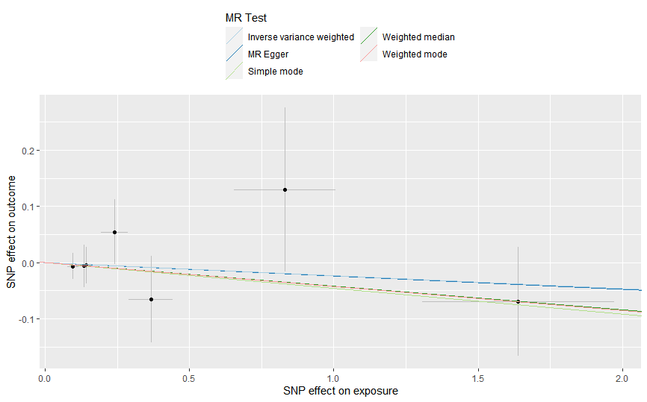
(a)

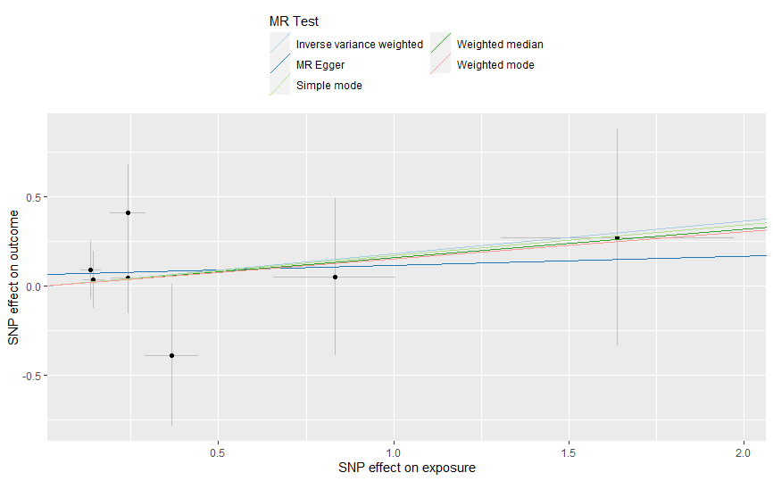
(b)

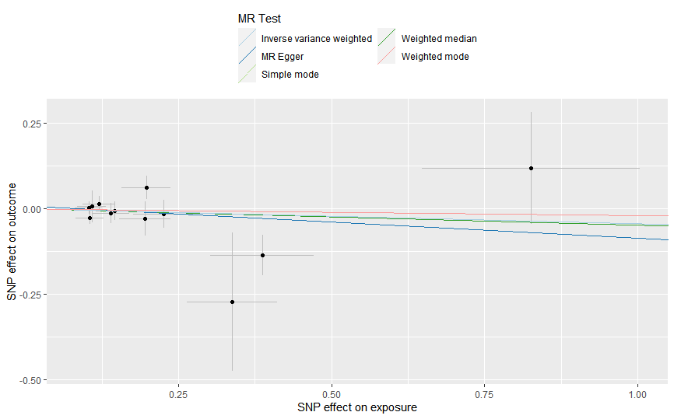
(c)

Supplementary Figure 2 Forest plot of SNPs associated with PD and TMD
- MR estimates for PD on TMD in discovery stage
- MR estimates for PD on TMD in validation stage
- MR estimates for TMD on PD
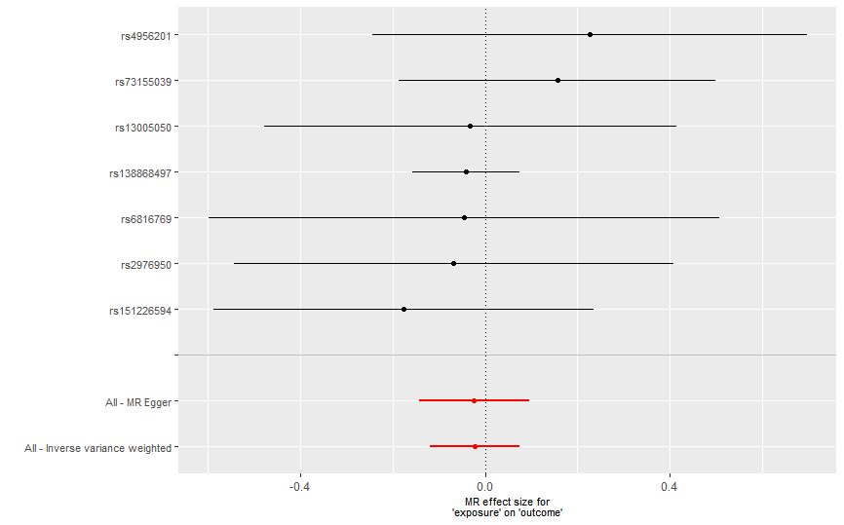
(a)

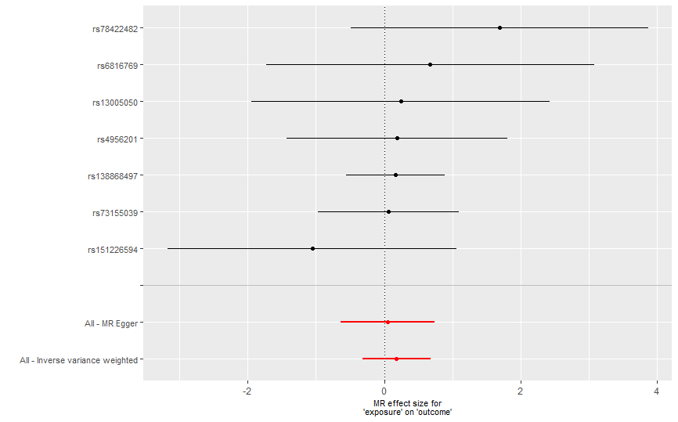
(b)

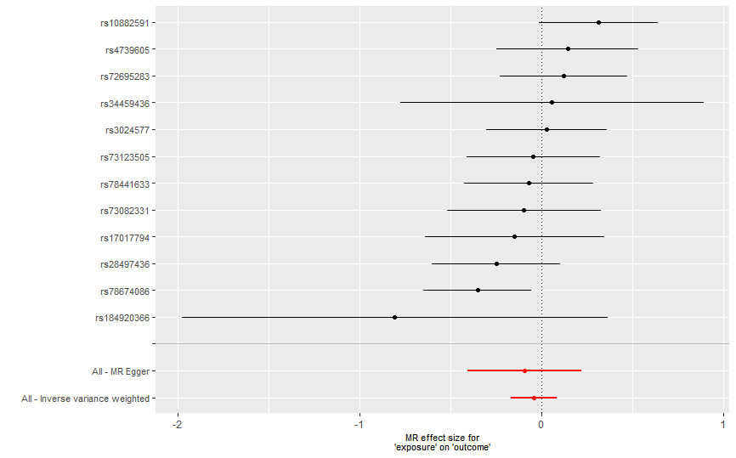
(c)

Supplementary Figure 3 Funnel plot of SNPs associated with PD and TMD
- MR estimates for PD on TMD in discovery stage
- MR estimates for PD on TMD in validation stage
- MR estimates for TMD on PD
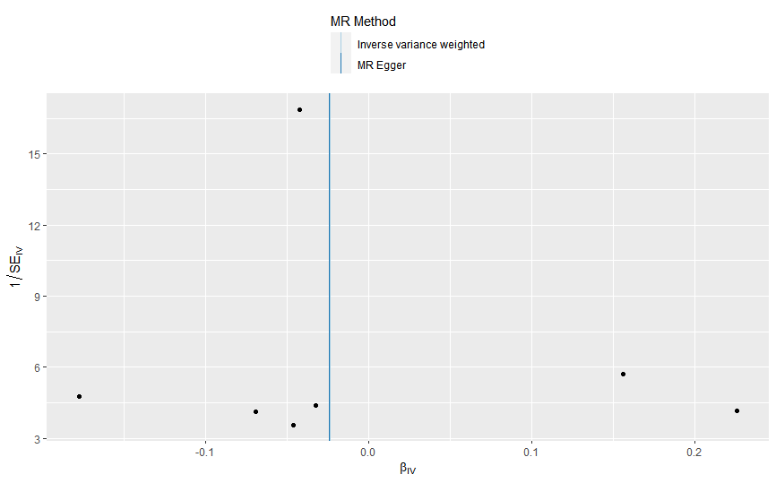
(a)

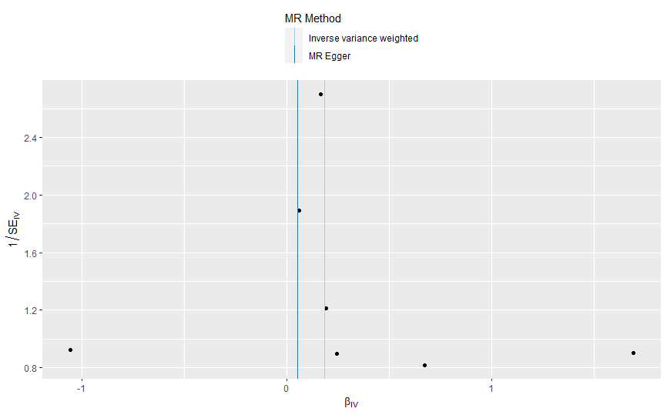
(b)

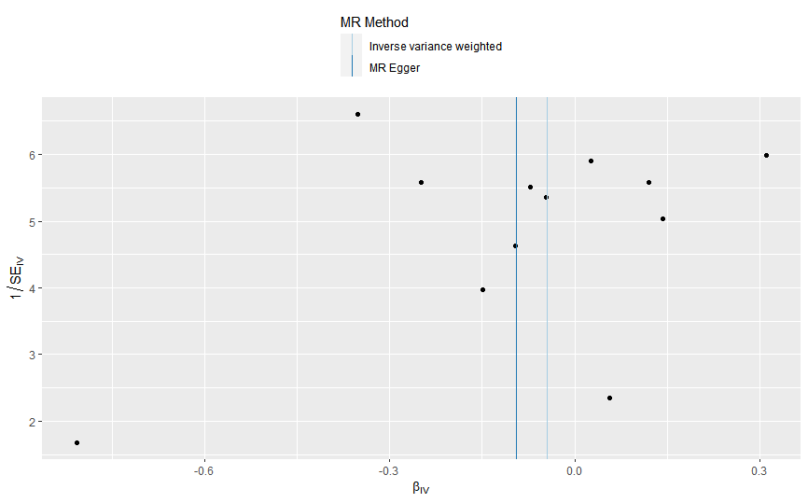
(c)

Supplementary Figure 4 Leave-one-out analysis plot of SNPs associated with PD and TMD
- MR estimates for PD on TMD in discovery stage
- MR estimates for PD on TMD in validation stage
- MR estimates for TMD on PD
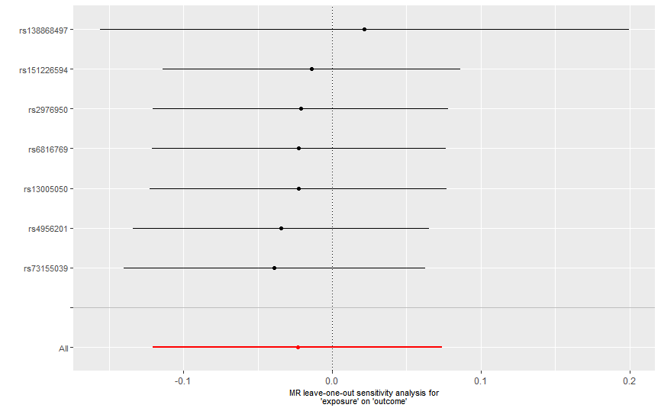
(a)

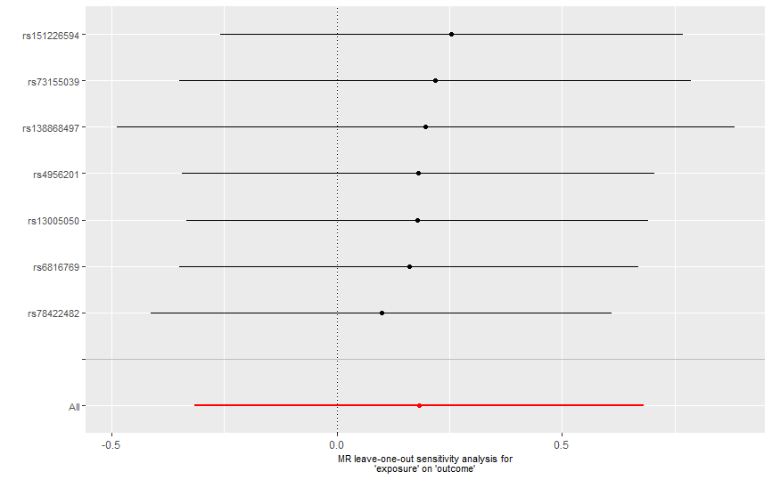
(b)

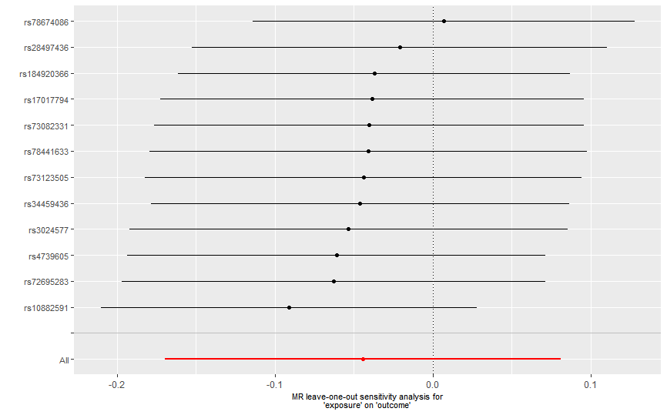
(c)

