SUPPLEMENTARY MATERIALS

Synergistic roles of CBX4 chromo and SIMs domains in regulating senescence of primary human osteoarthritic chondrocytes
Yu-Hsiu Chen^{1,2,5}, Xin Zhang^{1,3}, David Attarian MD³, Virginia Byers Kraus^{1,3,4,5}

¹ Duke Molecular Physiology Institute, Duke University, Durham, NC, USA
² Division of Rheumatology/Immunology/Allergy, Department of Internal Medicine
Tri-Service General Hospital, National Defense Medical Center
³ Department of Orthopaedic Surgery, Duke University, Durham, NC, USA
⁴ Department of Medicine, Duke University School of Medicine, Durham, NC, USA
⁵ Department of Pathology, Duke University Medical Center, Durham, NC, USA

Corresponding Author: Virginia Byers Kraus
Address: 300 N Duke St, Durham, NC 27701
Email: vbk@duke.edu
Key Words CBX4, cellular senescence, DPP4, senomorphic, osteoarthritis
Abstract: 309 words
Main text: 4027 (including table)
Table S1. qPCR custom microarray panel (Qiagen, 330171).
Gene Symbol | Assay Catalog # | Gene Symbol | Assay Catalog # | Gene Symbol | Assay Catalog #
GDC | PPH65835A | PPC | PPX63339A | RTC | PPX63340A
B2M | PPH01094E | YWHAZ | PPH01017A | 18SrRNA | PPH05666E
PVRL4 | PPH09678B | PRODH | PPH00877A | LY6D | PPH19736C
DAO | PPH11264A | EPN3 | PPH13321A | SLC52A1 | PPH11141A
BAX | PPH00078B | BCL2 | PPH00079B | MDM4 | PPH00875E
MDM2 | PPH00193E | FAS | PPH00141B | TP53 | PPH00213F
TP63 | PPH01032F | CDK1 | PPH00116C | CDK4 | PPH00118F
CDKN1A | PPH00211E | CDKN2A | PPH00207C | ATM | PPH00325C
STAT1 | PPH00811C | STAT3 | PPH00708F | NFKB1 | PPH00204F
TNF | PPH00341F | IL6 | PPH00560C | CXCL8 | PPH00568A
HDAC1 | PPH01735F | RB1 | PPH00228F | E2F3 | PPH00917F
E2F1 | PPH00136G | E2F7 | PPH19766A | SUMO1 | PPH00973F
CSNK2A2 | PPH02197F | DNMT1 | PPH01055F | SOX2 | PPH02471A
PARP1 | PPH00686B | MYC | PPH00100B | RING1 | PPH14334B
BMI1 | PPH57778A | CBX4 | PPH19160A | DPP4 | PPH00035B
SIRT1 | PPH02188A | PCNA | PPH00216B | ATR | PPH01318B

Supplementary Figure
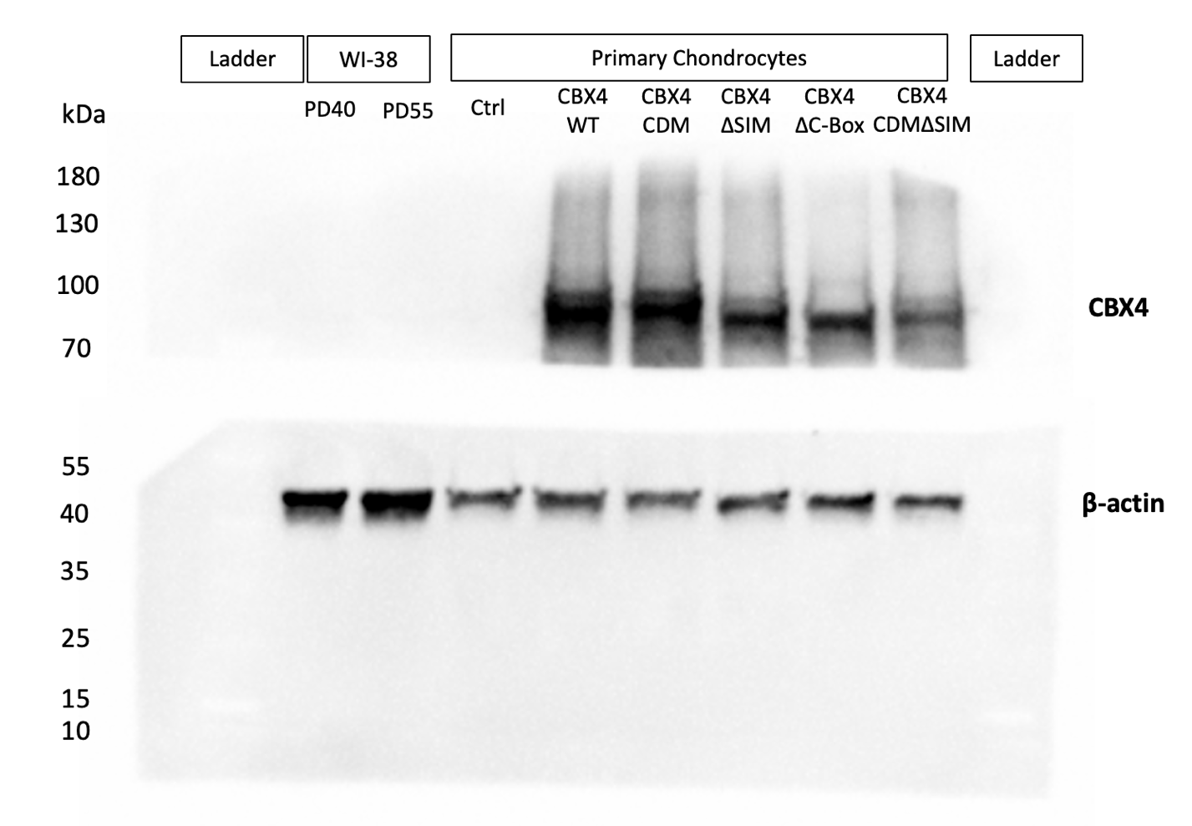
Supplementary Figure 1. "The Western blot underwent a selective exposure with a cutoff at 70 kDa, reflecting substantial variations in protein expression levels between CBX4 and β-actin. In Figure 1A, the blot was further tailored to highlight regions specific to the Control (Ctrl) and CBX4 Wild Type (WT) samples; Figure 2B, focused on CBX4 WT and its mutants within the molecular weight range of 70-100 kDa for CBX4 and 40-55 kDa for β-actin."

