Additional file 2. ROC curves of BVAS to differentiate demised patients in MPA.
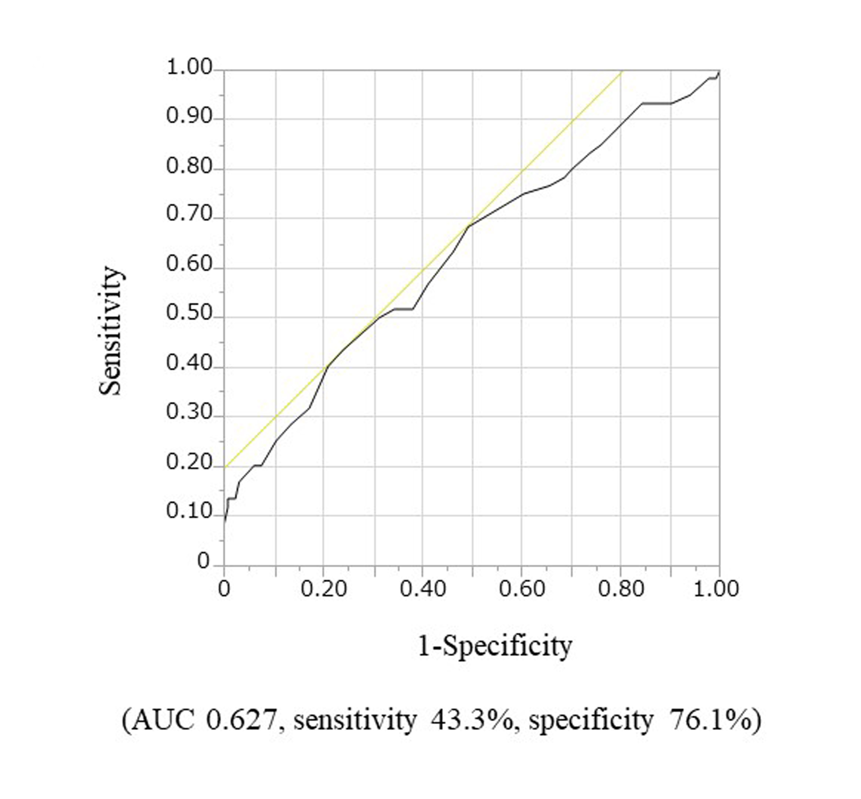
ROC: receiver operating characteristic; BVAS: Birmingham Vasculitis Activity Score; AUC: area under the curve.

