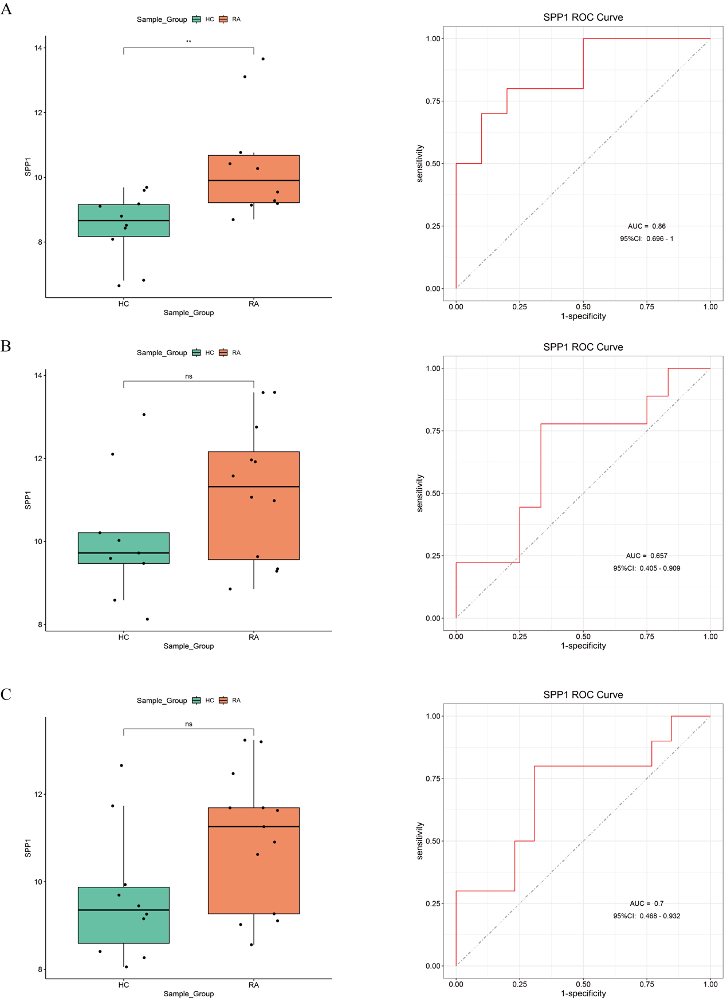

Figure S1 Validation of SPP1 differentially expressed genes in the independent datasets; (A) GSE55235. (B) GSE12021. (C) GSE55457.

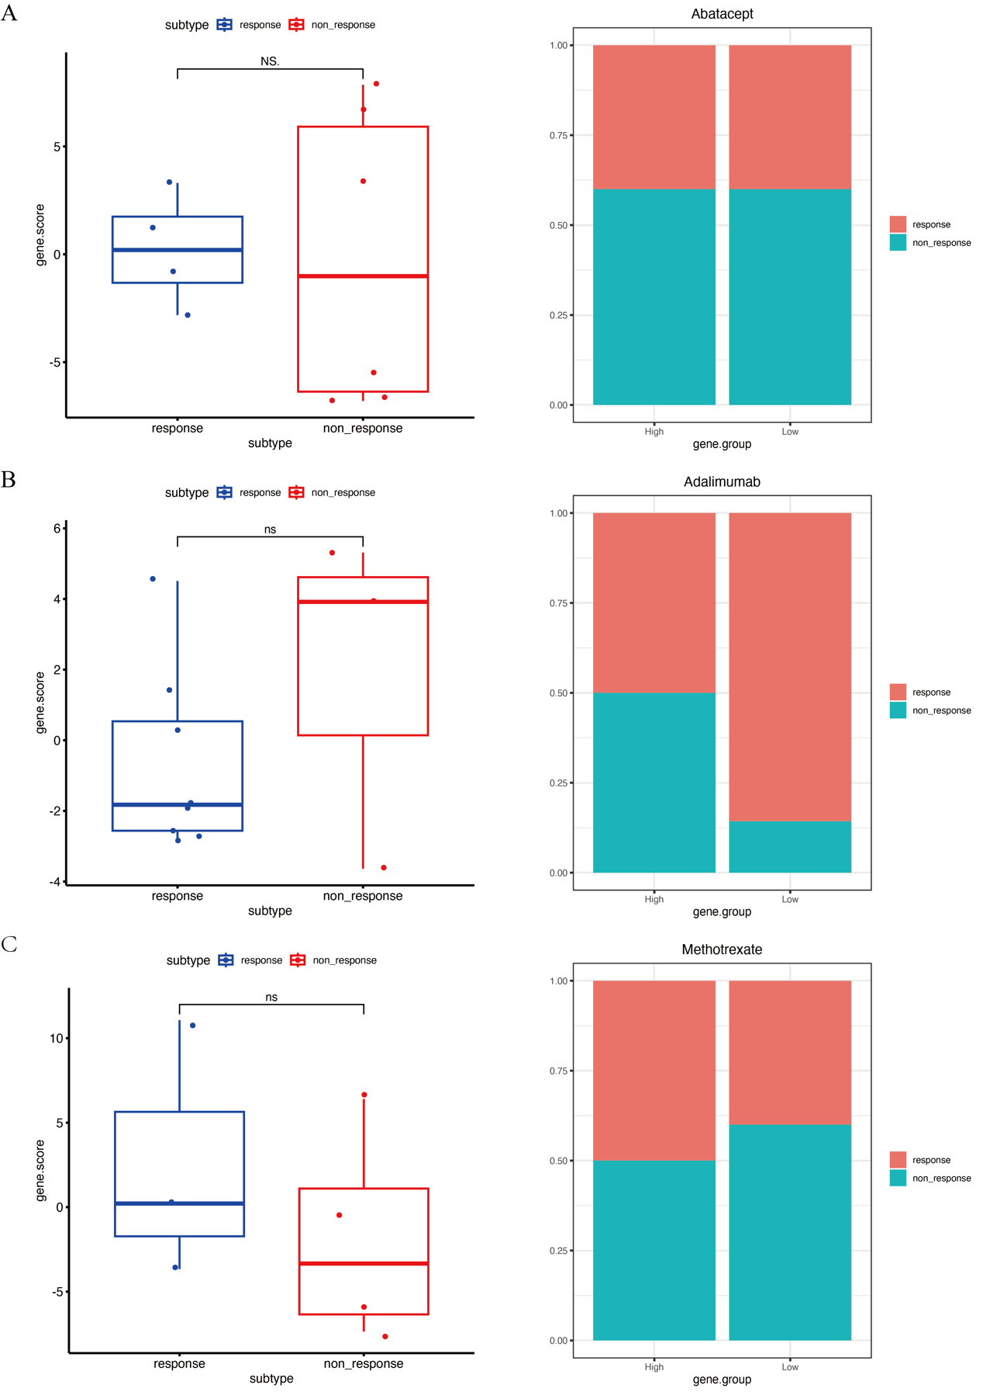
Figure S2 Drug treatments respond to the RA subtypes. (A) GSE172188. (B) GSE15602. (C) GSE45967.

