Supplemental Table 1: Agreement in response status (complete or partial) across visits using non-responder imputation for missing data

 | % Response at both visits | % Non-Response at both visits | % Discordant Response status | Kappa (95% CI) for agreement in response status across visits
Week 12 and Week 26 | 15.0% | 53.3% | 31.7% | 0.28 (0.14, 0.42)
Week 12 and Week 52 | 11.7% | 45.0% | 43.3% | 0.072 (-0.06, 0.20)
Week 26 and Week 52 | 26.1% | 43.3% | 30.6% | 0.37 (0.24, 0.51)

Supplemental Table 2: Predictors of response (complete or partial) at both weeks 26 and 52 versus no response at all visits from logistic regression using non-responder imputation for missing response data and multiple imputation for missing covariate data

Predictor Variable | Odds Ratio Estimate  (95% Confidence interval) | P value
First biopsy | 2.02 (0.72- 5.56) | 0.17
Anti-dsDNA antibody positive | 4.01 (1.33-12.13) | 0.01
No Cyclophosphamide induction | 3.28 (0.75-14) | 0.12
UPCR > 25% decrease from  baseline to week 12 | 8.84 (3.06-25.52) | <0.001

UPCR=urine protein/creatinine ratio

Supplemental Table 3: Predictors of response (complete or partial) at week 52 versus no response from logistic regression analysis using non-responder imputation for missing response data and multiple imputation for missing covariate data

Predictor Variable | Odds Ratio Estimate  (95% Confidence interval) | P value
Anti-dsDNA antibody positive | 1.79 (0.88-3.62) | 0.11
UPCR > 25% decrease from  baseline to week 12 | 2.13 (1.06-4.32) | 0.03
Chronicity index per unit decrease | 1.15 (1.00-1.32) | 0.05
UPCR > 3 at baseline | 1.18 (0.61-2.29) | 0.62

UPCR=urine protein/creatinine ratio

Supplemental Table 4: Predictors of response (complete or partial) at week 52 versus no response from logistic regression analysis for Class V cases only

Predictor Variable | Odds Ratio Estimate  (95% Confidence interval) | P-value
Anti-dsDNA antibody positive | 4.33 (0.57-32.92) | 0.16
UPCR > 25% decrease from baseline to week 12 | 5.86 (0.58-59.38) | 0.13
Chronicity Index per unit decrease | 1.38 (0.92-2.06) | 0.12
UPCR > 3 at baseline | 8.83 (0.72-108.52) | 0.09

UPCR=urine protein/creatinine ratio

Supplemental Table 5: Predictors of week 52 response using multinomial regression with available data

Predictor Variable |  | Odds Ratio Estimate  (95% Confidence Limits) | P Value
Anti-dsDNA antibody positive | CR vs NR | 4.48 (1.01-19.86) | 0.048
Anti-dsDNA antibody positive | PR vs NR | 1.74 (0.55-5.55) | 0.35
UPCR > 25% decrease from baseline to week 12 | CR vs NR | 5.8 (1.66-20.61) | 0.006
UPCR > 25% decrease from baseline to week 12 | PR vs NR | 1.25 (0.43-3.63) | 0.68
Chronicity index per unit decrease | CR vs NR | 1.42 (1.11-1.82) | 0.0049
Chronicity index per unit decrease | PR vs NR | 1.26 (1.01-1.58) | 0.041
UPCR > 3 at baseline | CR vs NR | 2.20 (0.64-7.58) | 0.22
UPCR > 3 at baseline | PR vs NR | 6.11 (1.87-19.95) | 0.003

*CR=complete response, PR=partial response, NR=No Response

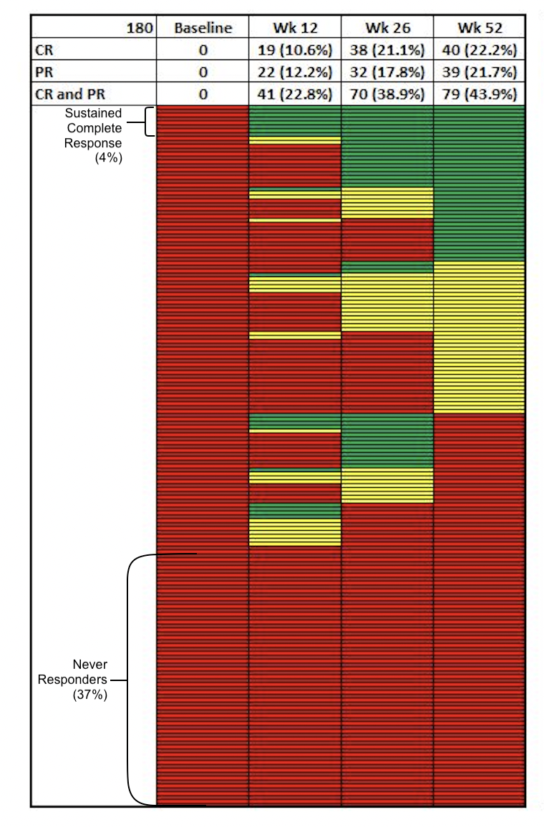
Supplemental Figure 1 legend: Temporal patterns in the response status of patients with systemic lupus erythematosus receiving standard of care therapy employing nonresponder imputation for missing data for 180 patients included. Green indicates complete response, yellow indicates partial response and red indicates no response.

