Supplemental Materials

field | missing_rate_raw_data | exclusion_inclusion_criteria
Allergic | 1.00 | excluded due to high missing rate in raw data
Opp_Inf | 1.00 | excluded due to high missing rate in raw data
currentNSAIDScox | 1.00 | excluded due to high missing rate in raw data
vas_pat | 1.00 | excluded due to high missing rate in raw data
pastNSAIDScox | 1.00 | excluded due to high missing rate in raw data
vas_fatigue | 1.00 | excluded due to high missing rate in raw data
pastNSAIDS | 1.00 | excluded due to high missing rate in raw data
vas_pain | 1.00 | excluded due to high missing rate in raw data
currentNSAIDS | 1.00 | excluded due to high missing rate in raw data
GC_route | 1.00 | excluded due to high missing rate in raw data
ConcDMARD_tot | 1.00 | excluded due to high missing rate in raw data
MTX_delivery | 1.00 | excluded due to high missing rate in raw data
HCQ_dose | 0.99 | excluded due to high missing rate in raw data
SSZ_dose | 0.98 | excluded due to high missing rate in raw data
LEF_dose | 0.97 | excluded due to high missing rate in raw data
tsDMARD_schedule | 0.94 | excluded due to high missing rate in raw data
tsDMARD_dose | 0.94 | excluded due to high missing rate in raw data
GC_dose | 0.84 | excluded due to high missing rate in raw data
MTX_dose | 0.80 | excluded due to high missing rate in raw data
anti_ccp | 0.57 | included to check, if missing rate remains over 0.33 threshold per medication
sjc | 0.38 | included to check, if missing rate remains over 0.33 threshold per medication
haq | 0.38 | included to check, if missing rate remains over 0.33 threshold per medication
rheuma_factor | 0.35 | included to check, if missing rate remains over 0.33 threshold per medication
tjc | 0.33 | included due to high clinical relevance
vas_ph | 0.19 | included due to high clinical relevance
crp | 0.11 | included due to high clinical relevance
vas_pat | 0.11 | included due to high clinical relevance
esr | 0.09 | included due to high clinical relevance
delivery (administration) | 0.07 | included due to high clinical relevance
currentDose_total (mg) | 0.06 | included due to high clinical relevance
bDMARD_currentInterval | 0.06 | included due to high clinical relevance
bDMARD_currentDose (mg/kg | 0.06 | included due to high clinical relevance
previoustsDMARD | 0.00 | excluded expert decision
MTX cotherapy | 0.00 | included due to high clinical relevance
LEF (Leflunomide) | 0.00 | excluded expert decision
SSZ (Sulfasalazine) | 0.00 | excluded expert decision
HCQ (Hydroxychloroquine) | 0.00 | excluded expert decision
GC (Glucocorticoid) cotherapy | 0.00 | included due to high clinical relevance
Other_DMARDs cotherapy | 0.00 | included due to high clinical relevance
Comorb_cardiovascular | 0.00 | excluded expert decision
Comorb_lung | 0.00 | excluded expert decision
Comorb_infections | 0.00 | excluded expert decision
Comorb_malignancy | 0.00 | excluded expert decision
Comorb_metabolic | 0.00 | excluded expert decision
Comorb_neuropsy | 0.00 | excluded expert decision
previouscsDMARD | 0.00 | excluded expert decision
Prev_tsDMARD | 0.00 | excluded expert decision
Prev_csDMARD | 0.00 | excluded expert decision
smoker | 0.00 | included first, but later excluded due to weak  association with ineffectiveness (see table 1)
disease_duration | 0.00 | included due to high clinical relevance
bmi | 0.00 | included due to high clinical relevance
gender | 0.00 | included due to high clinical relevance
age | 0.00 | included due to high clinical relevance
Infection | 0.00 | excluded expert decision
brand_name | 0.00 | excluded expert decision
Prev_bDMARD | 0.00 | excluded expert decision
Prev_btsDMARD | 0.00 | excluded expert decision
previousOtherBio | 0.00 | excluded expert decision
previousABA | 0.00 | excluded expert decision
previous_atnf | 0.00 | included due to high clinical relevance
previousRIT | 0.00 | excluded expert decision
previousTCZ | 0.00 | excluded expert decision

Table S1: Originally available variables from raw dataset potentially affecting treatment outcome, categorized by inclusion/exclusion criteria.

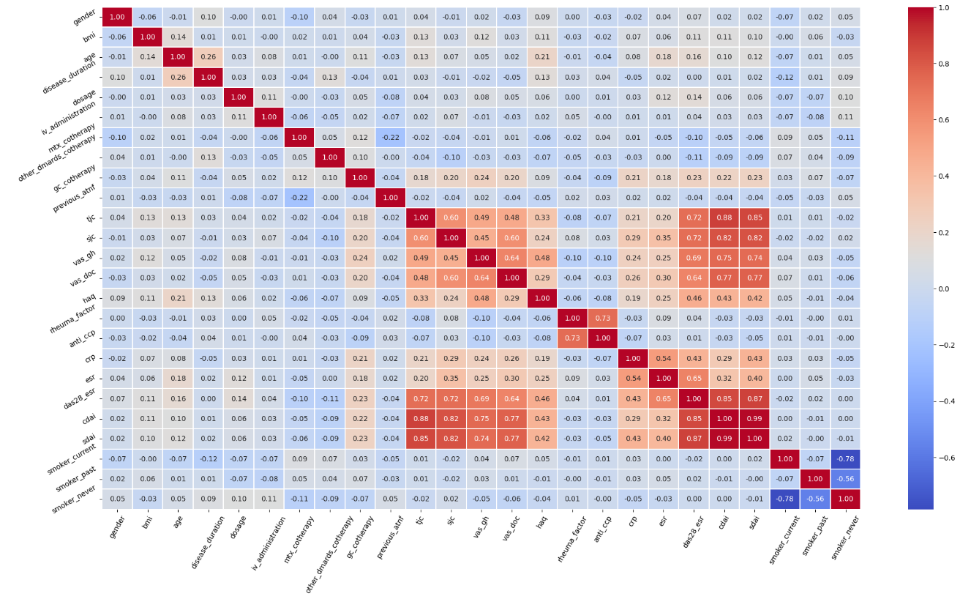
Table S2: Correlation Heatmap for cleaned input dataset. SDAI and CDAI were excluded due to correlation>0.8 with TJC, SJC and DAS28-ESR.

medication | imb_strategy | algo | heldout_test_score | mean_test_score | std_test_score
ETA | rus | LogReg | 0.68 | 0.51 | 0.14
ETA | rus | Bayes | 0.61 | 0.45 | 0.1
ETA | rus | LinSVM | 0.78 | 0.52 | 0.13
ETA | rus | Ridge | 0.69 | 0.51 | 0.13
ETA | rus | LDA | 0.56 | 0.49 | 0.1
ETA | rus | DecTree | 0.19 | 0.55 | 0.18
ETA | rus | k-NN | 0.37 | 0.55 | 0.14
ETA | rus | SVC | 0.73 | 0.57 | 0.13
ETA | rus | ANN | 0.08 | 0.36 | 0.15
ETA | rus | GaussProc | 0.39 | 0.58 | 0.08
ETA | rus | RndForest | 0.56 | 0.57 | 0.14
ETA | rus | ExtraTrees | 0.35 | 0.52 | 0.12
ETA | rus | AdaBoost | 0.28 | 0.48 | 0.18
ETA | rus | xgBoost | 0.1 | 0.55 | 0.12
ETA | rus | Stacking | 0.56 | 0.61 | 0.13
ETA | rus | Voting | 0.66 | 0.52 | 0.1
ETA | rus | SGD | 0.68 | 0.54 | 0.12
ETA | ovs | LogReg | 0.82 | 0.5 | 0.04
ETA | ovs | Bayes | 0.68 | 0.39 | 0.08
ETA | ovs | LinSVM | 0.66 | 0.51 | 0.04
ETA | ovs | Ridge | 0.7 | 0.5 | 0.16
ETA | ovs | LDA | 0.58 | 0.44 | 0.12
ETA | ovs | DecTree | 0.63 | 0.5 | 0.11
ETA | ovs | k-NN | 0.47 | 0.52 | 0.05
ETA | ovs | SVC | 0.35 | 0.51 | 0.19
ETA | ovs | ANN | 0.44 | 0.34 | 0.1
ETA | ovs | GaussProc | 0.49 | 0.66 | 0.12
ETA | ovs | RndForest | 0.63 | 0.68 | 0.07
ETA | ovs | ExtraTrees | 0.53 | 0.46 | 0.13
ETA | ovs | AdaBoost | 0.59 | 0.44 | 0.23
ETA | ovs | xgBoost | 0.29 | 0.49 | 0.25
ETA | ovs | Stacking | 0.4 | 0.44 | 0.09
ETA | ovs | Voting | 0.45 | 0.42 | 0.11
ETA | ovs | SGD | 0.63 | 0.47 | 0.11
ABA | rus | LogReg | 0.89 | 0.61 | 0.05
ABA | rus | Bayes | 0.4 | 0.61 | 0.13
ABA | rus | LinSVM | 0.59 | 0.59 | 0.08
ABA | rus | Ridge | 0.6 | 0.66 | 0.12
ABA | rus | LDA | 0.72 | 0.57 | 0.07
ABA | rus | DecTree | 0.53 | 0.49 | 0.11
ABA | rus | k-NN | 0.44 | 0.58 | 0.16
ABA | rus | SVC | 0.9 | 0.56 | 0.1
ABA | rus | ANN | 0.85 | 0.5 | 0.1
ABA | rus | GaussProc | 0.57 | 0.59 | 0.15
ABA | rus | RndForest | 0.52 | 0.59 | 0.14
ABA | rus | ExtraTrees | 0.57 | 0.59 | 0.11
ABA | rus | AdaBoost | 0.49 | 0.53 | 0.22
ABA | rus | xgBoost | 0.53 | 0.55 | 0.1
ABA | rus | Stacking | 0.68 | 0.64 | 0.05
ABA | rus | Voting | 0.42 | 0.62 | 0.11
ABA | rus | SGD | 0.48 | 0.59 | 0.11
ABA | ovs | LogReg | 0.49 | 0.65 | 0.08
ABA | ovs | Bayes | 0.52 | 0.59 | 0.1
ABA | ovs | LinSVM | 0.36 | 0.53 | 0.17
ABA | ovs | Ridge | 0.64 | 0.62 | 0.12
ABA | ovs | LDA | 0.68 | 0.57 | 0.13
ABA | ovs | DecTree | 0.32 | 0.45 | 0.11
ABA | ovs | k-NN | 0.81 | 0.54 | 0.06
ABA | ovs | SVC | 0.83 | 0.55 | 0.14
ABA | ovs | ANN | 0.55 | 0.49 | 0.06
ABA | ovs | GaussProc | 0.84 | 0.51 | 0.08
ABA | ovs | RndForest | 0.91 | 0.58 | 0.14
ABA | ovs | ExtraTrees | 0.8 | 0.59 | 0.06
ABA | ovs | AdaBoost | 0.59 | 0.61 | 0.15
ABA | ovs | xgBoost | 0.82 | 0.57 | 0.19
ABA | ovs | Stacking | 0.77 | 0.46 | 0.14
ABA | ovs | Voting | 0.84 | 0.58 | 0.11
ABA | ovs | SGD | 0.57 | 0.53 | 0.09
ADA | rus | LogReg | 0.54 | 0.59 | 0.13
ADA | rus | Bayes | 0.46 | 0.63 | 0.12
ADA | rus | LinSVM | 0.54 | 0.55 | 0.11
ADA | rus | Ridge | 0.53 | 0.58 | 0.12
ADA | rus | LDA | 0.46 | 0.64 | 0.12
ADA | rus | DecTree | 0.78 | 0.57 | 0.07
ADA | rus | k-NN | 0.64 | 0.63 | 0.07
ADA | rus | SVC | 0.55 | 0.57 | 0.15
ADA | rus | ANN | 0.6 | 0.5 | 0.07
ADA | rus | GaussProc | 0.42 | 0.54 | 0.14
ADA | rus | RndForest | 0.61 | 0.66 | 0.13
ADA | rus | ExtraTrees | 0.34 | 0.66 | 0.1
ADA | rus | AdaBoost | 0.59 | 0.53 | 0.16
ADA | rus | xgBoost | 0.6 | 0.64 | 0.09
ADA | rus | Stacking | 0.48 | 0.51 | 0.09
ADA | rus | Voting | 0.51 | 0.66 | 0.11
ADA | rus | SGD | 0.57 | 0.67 | 0.05
ADA | ovs | LogReg | 0.52 | 0.66 | 0.1
ADA | ovs | Bayes | 0.4 | 0.67 | 0.1
ADA | ovs | LinSVM | 0.56 | 0.6 | 0.08
ADA | ovs | Ridge | 0.48 | 0.68 | 0.09
ADA | ovs | LDA | 0.47 | 0.68 | 0.12
ADA | ovs | DecTree | 0.65 | 0.58 | 0.05
ADA | ovs | k-NN | 0.51 | 0.59 | 0.1
ADA | ovs | SVC | 0.56 | 0.45 | 0.08
ADA | ovs | ANN | 0.52 | 0.57 | 0.11
ADA | ovs | GaussProc | 0.56 | 0.65 | 0.07
ADA | ovs | xgBoost | 0.73 | 0.7 | 0.07
ADA | ovs | ExtraTrees | 0.48 | 0.71 | 0.1
ADA | ovs | AdaBoost | 0.71 | 0.58 | 0.12
ADA | ovs | xgBoost | 0.65 | 0.68 | 0.11
ADA | ovs | Stacking | 0.53 | 0.67 | 0.05
ADA | ovs | Voting | 0.42 | 0.69 | 0.05
ADA | ovs | SGD | 0.45 | 0.54 | 0.13
CERT | rus | LogReg | 0.75 | 0.68 | 0.16
CERT | rus | Bayes | 0.69 | 0.66 | 0.15
CERT | rus | LinSVM | 0.63 | 0.48 | 0.17
CERT | rus | Ridge | 0.88 | 0.56 | 0.14
CERT | rus | LDA | 0.75 | 0.6 | 0.13
CERT | rus | DecTree | 0.22 | 0.64 | 0.11
CERT | rus | k-NN | 0.88 | 0.59 | 0.21
CERT | rus | SVC | 0.69 | 0.64 | 0.15
CERT | rus | ANN | 0.44 | 0.38 | 0.17
CERT | rus | GaussProc | 0.69 | 0.56 | 0.24
CERT | rus | RndForest | 0.5 | 0.5 | 0,00
CERT | rus | ExtraTrees | 0.5 | 0.5 | 0,00
CERT | rus | AdaBoost | 0.56 | 0.62 | 0.1
CERT | rus | xgBoost | 0.69 | 0.52 | 0.11
CERT | rus | Stacking | 0.81 | 0.68 | 0.09
CERT | rus | Voting | 0.88 | 0.71 | 0.13
CERT | rus | SGD | 0.44 | 0.54 | 0.21
CERT | ovs | LogReg | 0.47 | 0.65 | 0.17
CERT | ovs | Bayes | 1,00 | 0.65 | 0.15
CERT | ovs | LinSVM | 0.44 | 0.66 | 0.16
CERT | ovs | Ridge | 0.19 | 0.62 | 0.22
CERT | ovs | LDA | 0.56 | 0.65 | 0.19
CERT | ovs | DecTree | 0.63 | 0.48 | 0.17
CERT | ovs | k-NN | 0.38 | 0.53 | 0.16
CERT | ovs | SVC | 0.88 | 0.84 | 0.05
CERT | ovs | ANN | 0.19 | 0.39 | 0.26
CERT | ovs | GaussProc | 0.66 | 0.63 | 0.08
CERT | ovs | RndForest | 0.81 | 0.58 | 0.13
CERT | ovs | ExtraTrees | 0.94 | 0.64 | 0.11
CERT | ovs | AdaBoost | 0.81 | 0.62 | 0.14
CERT | ovs | xgBoost | 0.63 | 0.53 | 0.2
CERT | ovs | Stacking | 0.56 | 0.63 | 0.11
CERT | ovs | Voting | 0.78 | 0.57 | 0.1
CERT | ovs | SGD | 0.69 | 0.67 | 0.15
TOC | rus | LogReg | 0.78 | 0.65 | 0.13
TOC | rus | Bayes | 0.49 | 0.66 | 0.08
TOC | rus | LinSVM | 0.73 | 0.64 | 0.14
TOC | rus | Ridge | 0.67 | 0.64 | 0.14
TOC | rus | LDA | 0.61 | 0.62 | 0.12
TOC | rus | DecTree | 0.66 | 0.49 | 0.2
TOC | rus | k-NN | 0.47 | 0.66 | 0.1
TOC | rus | SVC | 0.7 | 0.66 | 0.13
TOC | rus | ANN | 0.53 | 0.64 | 0.07
TOC | rus | GaussProc | 0.56 | 0.73 | 0.08
TOC | rus | RndForest | 0.74 | 0.66 | 0.14
TOC | rus | ExtraTrees | 0.64 | 0.65 | 0.15
TOC | rus | AdaBoost | 0.81 | 0.62 | 0.16
TOC | rus | xgBoost | 0.73 | 0.66 | 0.17
TOC | rus | Stacking | 0.61 | 0.6 | 0.2
TOC | rus | Voting | 0.61 | 0.66 | 0.12
TOC | rus | SGD | 0.7 | 0.68 | 0.1
TOC | ovs | LogReg | 0.77 | 0.54 | 0.06
TOC | ovs | Bayes | 0.69 | 0.57 | 0.14
TOC | ovs | LinSVM | 0.75 | 0.54 | 0.04
TOC | ovs | Ridge | 0.78 | 0.6 | 0.14
TOC | ovs | LDA | 0.76 | 0.6 | 0.15
TOC | ovs | DecTree | 0.67 | 0.6 | 0.15
TOC | ovs | k-NN | 0.49 | 0.68 | 0.07
TOC | ovs | SVC | 0.81 | 0.45 | 0.11
TOC | ovs | ANN | 0.71 | 0.63 | 0.19
TOC | ovs | GaussProc | 0.5 | 0.6 | 0.25
TOC | ovs | RndForest | 0.77 | 0.62 | 0.2
TOC | ovs | ExtraTrees | 0.74 | 0.66 | 0.17
TOC | ovs | AdaBoost | 0.84 | 0.6 | 0.08
TOC | ovs | xgBoost | 0.69 | 0.66 | 0.2
TOC | ovs | Stacking | 0.58 | 0.73 | 0.09
TOC | ovs | Voting | 0.66 | 0.65 | 0.17
TOC | ovs | SGD | 0.75 | 0.54 | 0.08
TOC | no | xgBoost | 0.7 | 0.72 | 0.05

Table S3: Model outcome depending on class imbalancing technique. Highest AUCs with a maximum difference between train mean AUC and held out set of 0.1 were selected for final model evaluation to ensure a robust and stable model.

