  - Supplementary Material
Table S1. PICOS eligibility criteria
Dimension | Criteria
Patient population | Psoriatic arthritis (adults only)
Interventions | Abatacept
Interventions | Adalimumab
Interventions | Apremilast
Interventions | Bimekizumab
Interventions | Brodalumab
Interventions | Certolizumab pegol
Interventions | Etanercept
Interventions | Golimumab
Interventions | Guselkumab
Interventions | Infliximab
Interventions | Ixekizumab
Interventions | Risankizumab
Interventions | Secukinumab
Interventions | Tildrakizumab
Interventions | Tofacitinib
Interventions | Upadacitinib
Interventions | Ustekinumab
Comparators | Standard of care (NSAIDs, DMARDs)
Comparators | Placebo
Outcomes  (specific to WPAI) | Work Productivity and Activity Impairment Questionnaire (WPAI)
Outcomes  (specific to WPAI) | WPAI: General Health (WPAI:GH)
Outcomes  (specific to WPAI) | WPAI: GH v2
Outcomes  (specific to WPAI) | WPAI: Psoriatic Arthritis (WPAI:PsA)
Outcomes  (specific to WPAI) | WPAI: PsA v2
Outcomes  (specific to WPAI) | WPAI: Specific Health Problem (WPAI:SHP)
Outcomes  (specific to WPAI) | WPAI: SHP v2
Study design | Studies with following designs (but not limited to):
Study design | Real-world studies
Study design | Clinical trials
Publication type | Original manuscripts
Publication type | Conference abstracts/posters
Other limits | 2010 – October 21, 2021, for original manuscripts  2018 – October 21, 2021, for conference abstracts/posters
DMARDs, Disease-modifying anti-rheumatic drugs; GH, General Health; NSAIDs, Non-steroidal anti-inflammatory drugs; PICOS, Population, Intervention, Comparator, Outcome and Study Design; PsA, Psoriatic Arthritis; SHP, Specific Health Problem; WPAI, Work Productivity and Activity Impairment Questionnaire.

Figure S1. Meta-analysis of percent mean CFB in absenteeism scores for placebo at 24 weeks
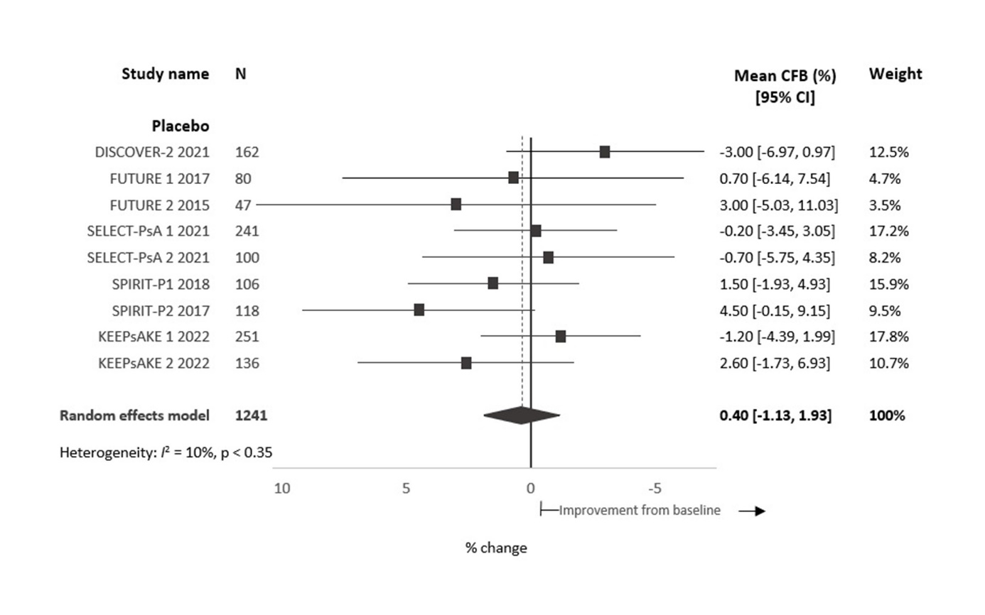CFB, Change from baseline; CI, Confidence interval.

Figure S2. Meta-analysis of percent mean CFB in presenteeism scores for placebo at 24 weeks
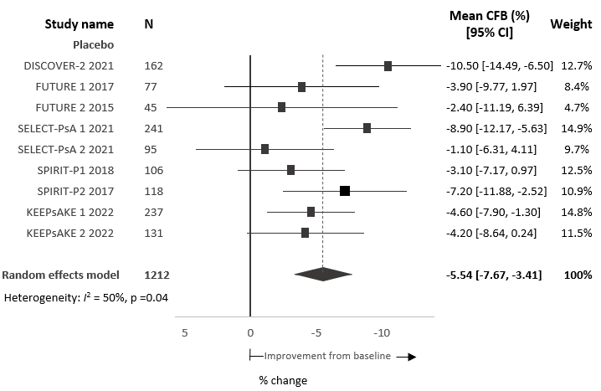
CFB, Change from baseline; CI, Confidence interval.

Figure S3. Meta-analysis of percent mean CFB in total work productivity scores for placebo at 24 weeks
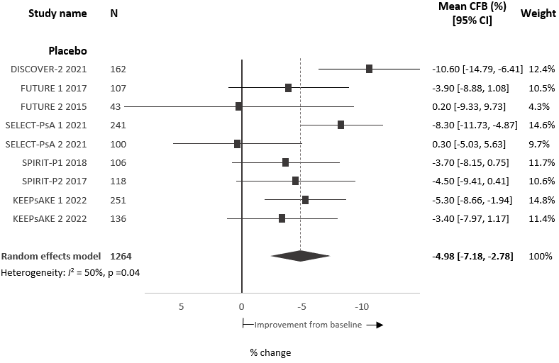
CFB, Change from baseline; CI, Confidence interval.

Figure S4. Meta-analysis of percent mean CFB activity impairment scores for placebo at 24 weeks
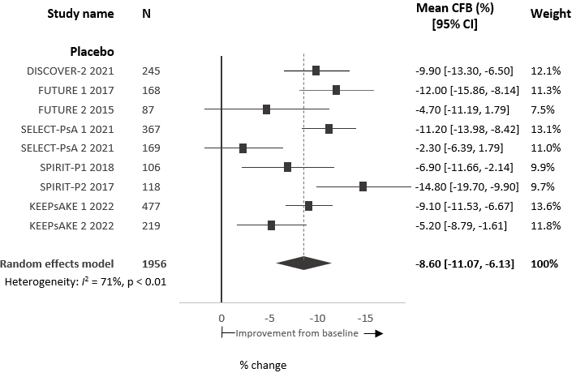
CFB, Change from baseline; CI, Confidence interval.

Table S2. Data sources
Data sources
Electronic databases (via Ovid.com) | - Medical Literature Analysis and Retrieval System Online (MEDLINE®)  - MEDLINE® Epub Ahead of Print, In-Process & Other Non-Indexed Citations  - Excerpta Medica Database (Embase®)  - Cochrane  - Cochrane Central Register of Controlled Trials  - Cochrane Database of Systematic Reviews  - Cochrane Clinical Answers  - Cochrane Methodology Register
Conferences | - All conferences identified via the electronic database search (published in the last five years)  - Hand-search of the proceedings from 2018 onwards of the following conferences (if not yet indexed in Embase at the time of the search):  - American College of Rheumatology (ACR)  - European Alliance of Associations for Rheumatology (EULAR)  - British Society for Rheumatology (BSR)  - Academy of Managed Care Pharmacy (AMCP)  - The Professional Society for Health Economics and Outcomes Research (ISPOR)
Other sources | - Bibliography list of relevant SLRs/meta-analyses identified by the database searches
ACR, American College of Rheumatology; AMCP, Academy of Managed Care Pharmacy; BSR, British Society for Rheumatology; Embase, Excerpta Medica Database; EULAR, European Alliance of Associations for Rheumatology; ISPOR, The Professional Society for Health Economics and Outcomes Research; MEDLINE, Medical Literature Analysis and Retrieval System Online; SLR, Systematic literature review.

Table S3. Search strategy with results
Search |  | Query |  |  | Hits
MEDLINE (1946 to October 21, 2021)
1 |  | Arthritis, Psoriatic/ |  |  | 6975
2 |  | psoriatic arthritis/ |  |  | 6975
3 |  | (psoria$ adj2 (arthrit$ or arthropath$)).ti,ab. |  |  | 11380
4 |  | or/1-3 |  |  | 12520
5 |  | Adalimumab/ or Golimumab/ or Infliximab/ or Etanercept/ or Bimekizumab/ or Secukinumab/ or Certolizumab/ or Ustekinumab/ or Tofacitinib/ or Ixekizumab/ or Tildrakizumab/ or Guselkumab/ or Risankizumab/ or Apremilast/ or Brodalumab/ or Upadacitinib/ or Abatacept/ |  |  | 22250
6 |  | (Humira* or Enbrel* or Remicade* or Cimzia* or Simponi* or adalimumab* or Cosentyx*).mp. |  |  | 10272
7 |  | (certolizumab or CDP870 or cimzia or 428863-50-7).mp. |  |  | 1442
8 |  | (etanercept or enbrel or altebrel or 185243-69-0).mp. |  |  | 9206
9 |  | (Cosentyx* or secukinumab* or AIN?457 or AIN 457).mp. |  |  | 1489
10 |  | (golimumab or CNTO 148 or simponi or 476181-74-5).mp. |  |  | 1421
11 |  | (Remicade* or Inflectra* or Flixabi* or Remsima* or Renflexis* or Ixifi* or infliximab* or TA?650 or TA 650).mp. |  |  | 16190
12 |  | (Enbrel* or Benepali* or Erelzi* or Lifmior* or etanercept* or TNR?001 or "TNR 001" or methotrexate).mp. |  |  | 64506
13 |  | (Stelara* or CNTO 1275 or CNTO-1275 or CNTO1275 or Ustekinumab).mp. |  |  | 2501
14 |  | (Xeljanz* or CP 690550 or CP-690550 or CP690550 or Tofacitinib).mp. |  |  | 2006
15 |  | (Taltz* or Ixekizumab).mp. |  |  | 747
16 |  | (Ilumya* or Ilumetri* or Tildrakizumab-asmn or Tildrakizumab).mp. |  |  | 184
17 |  | (Tremfya* or Guselkumab).mp. |  |  | 363
18 |  | (Skyrizi* or BI 655066 or BI-655066 or BI655066 or "ABBV 066" or ABBV-066 or ABBV066 or Risankizumab).mp. |  |  | 222
19 |  | (Orencia* or Abatacept).mp. |  |  | 4042
20 |  | (Otezla* or Aplex* or CC-10004 or CC10004 or CC 10004 or Apremilast).mp. |  |  | 871
21 |  | (Siliq* or Kyntheum* or KHK4827 or KHK-4827 or KHK 4827 or AMG827 or AMG-827 or AMG 827 or Brodalumab).mp. |  |  | 1961
22 |  | (Rinvoq* or ABT494 or ABT-494 or ABT 494 or Upadacitinib).mp. |  |  | 236
23 |  | or/5-22 |  |  | 89120
24 |  | "quality of life"/ |  |  | 223478
25 |  | (QOL* or HQL* or HQOL* or H QOL* or HRQL* or HRQOL* or HR QOL*).ti,ab. |  |  | 65225
26 |  | (quality adj4 life).ti,ab. |  |  | 324970
27 |  | (quality adj2 well?being).ti,ab. |  |  | 359
28 |  | Quality-Adjusted Life Years/ |  |  | 13892
29 |  | "quality adjusted life year".de. |  |  | 0
30 |  | "disability adjusted life".ti,ab. |  |  | 4033
31 |  | (qal* or qwb* or qald* or qale* or qtime* or daly*).ti,ab. |  |  | 16314
32 |  | health* year* equivalent*.ti,ab. |  |  | 40
33 |  | hye*.ti,ab. |  |  | 1124
34 |  | Patient Reported Outcome Measures/ |  |  | 9743
35 |  | patient-reported outcome/ |  |  | 9743
36 |  | (patient adj2 reported adj2 outcome adj2 measure$).ti,ab. |  |  | 7531
37 |  | (preference* adj4 (patient* or public or valu* or measur*)).ti,ab. |  |  | 26364
38 |  | PRO.ti,ab. |  |  | 215900
39 |  | (utilit* or disutilit*).ti,ab. |  |  | 232652
40 |  | utility measure*.ti,ab. |  |  | 563
41 |  | standard gamble*.ti,ab. |  |  | 881
42 |  | (time trade off* or time tradeoff* or timetradeoff or timetrade off*).ti,ab. |  |  | 1528
43 |  | (willingness adj4 pay).ti,ab. |  |  | 6817
44 |  | (SG or TTO or WTP).ti,ab. |  |  | 14706
45 |  | ((valu* or measur*) adj4 (health or outcome or outcomes or effect or effects or change* or state*)).ti,ab. |  |  | 554148
46 |  | (utilit* adj4 (valu* or measur* or health or life or estimat* or elicit* or disease)).ti,ab. |  |  | 15853
47 |  | (euroqol* or euro qol or euroqual or euro qual or eq?5d or eq 5d).ti,ab. |  |  | 13324
48 |  | (eq?vas or eq vas or visual analogue scale*).ti,ab. |  |  | 31040
49 |  | ("Health Utilities Index" or HUI*).ti,ab. |  |  | 5429
50 |  | (multiattribute* adj1 (health or theor* or analys* or utilit*)).ti,ab. |  |  | 173
51 |  | ((multi adj1 attribute*) and (attribute* adj1 theor*)).ti,ab. |  |  | 1
52 |  | ((multi adj1 attribute*) and (attribute* adj1 analys*)).ti,ab. |  |  | 12
53 |  | ((multi adj1 attribute*) and (attribute* adj1 utilit*)).ti,ab. |  |  | 199
54 |  | (sf?36* or sf 36 or short form 36 or shortform 36 or shortform?36).ti,ab. |  |  | 27780
55 |  | (sf?20* or sf 20 or short form 20 or shortform 20 or shortform?20).ti,ab. |  |  | 474
56 |  | (sf?12* or sf 12 or short form 12 or shortform 12 or shortform?12).ti,ab. |  |  | 6723
57 |  | (sf?8* or sf 8 or short form 8 or shortform 8 or shortform?8).ti,ab. |  |  | 901
58 |  | (sf?6* or sf 6 or short form 6 or shortform 6 or shortform?6).ti,ab. |  |  | 4323
59 |  | productivity/ or absenteeism/ |  |  | 23113
60 |  | (Productivit$ or WPAI or work limitation$).tw. |  |  | 68222
61 |  | (work$ or school$ or employ$).tw. |  |  | 2498787
62 |  | ((work or working) adj1 (absen$ or loss$ or disabilit$ or abilit$ or impairment$ or limitation$ or incapacit$ or capacit$)).tw. |  |  | 14984
63 |  | ((symptom or symptoms) adj5 (score* or scale* or instrument* or measur*)).ti,ab. |  |  | 80453
64 |  | sickness impact profile/ |  |  | 7268
65 |  | sickness impact profile.ti,ab. |  |  | 1072
66 |  | ("Psoriasis Index of Quality of Life" or PSORIQoL or "Psoriasis Life Stress Inventory" or PLSI or "Psoriasis Disability Index" or PDI or "Psoriasis Area and Severity Index" or PASI or "Simplified PASI" or "Simplified Psoriasis Area and Severity Index" or SAPASI or "Psoriasis Symptom Assessment of PSA" or "Patient's Global Psoriasis Assessment" or PGPA).tw. |  |  | 11521
67 |  | ("Physician* Global Assessment" or "Patient* Global Assessment" or PGA).tw. |  |  | 7680
68 |  | ("Questionnaire on Experience with Skin Complaints" or QES or "Dermatology Life Quality Index" or DLQI).tw. |  |  | 2567
69 |  | ("Salford Psoriasis Index" or SPI or "Koo-Menter Psoriasis Instrument" or KMPI).tw. |  |  | 3977
70 |  | ("Psoriatic Arthritis Quality of Life" or PsAQoL).tw. |  |  | 38
71 |  | ("Health Assessment Questionnaire" or HAQ* or "modified HAQ" or "modified Health Assessment Questionnaire" or MHAQ or "Health assessment questionnaire disability index" or HAQ?DI or HAQ DI or "Rheumatoid Arthritis Quality of Life Questionnaire" or RAQoL).tw. |  |  | 5779
72 |  | (Investigator* adj2 Global).mp. |  |  | 1066
73 |  | fatigue.mp. |  |  | 119935
74 |  | pain.mp. |  |  | 781222
75 |  | ("activit$ of daily living" or "Daily Living Activit$" or self-care$ or selfcare$ or "self care$" or self-manage$ or "self manage$" or selfmanage$ or (function$ adj6 (physical or role or emotional or social or cognitive or living or daily or activit$ or patient$ or person$ or mov$ or brain or mental))).tw. |  |  | 727779
76 |  | ("Dermatology Quality of Life Index" or DLQI).mp. |  |  | 1802
77 |  | (PHQ-9 or PHQ?9 or "Patient Health Questionnaire").mp. [mp=title, abstract, original title, name of substance word, subject heading word, floating sub-heading word, keyword heading word, organism supplementary concept word, protocol supplementary concept word, rare disease supplementary concept word, unique identifier, synonyms] |  |  | 8797
78 |  | ("Psoriatic Arthritis Impact of Disease" or PsAID*).mp. |  |  | 45
79 |  | or/24-78 |  |  | 5037082
80 |  | 4 and 23 and 79 |  |  | 1210
81 |  | (letter or editorial or comment or news or newspaper article).pt. |  |  | 2214262
82 |  | (addresses or bibliography or biography or case report or comment or congresses or consensus development conference or duplicate publication or editorial or guideline or in vitro or interview or lectures or letter or monograph or news or "newspaper article" or practice guideline or "review literature" or "review of reported cases" or review, academic or review, multicase or review, tutorial or twin study).pt. |  |  | 2478598
83 |  | animals/ not (humans/ and animals/) |  |  | 4865958
84 |  | or/81-83 |  |  | 7258554
85 |  | 80 not 84 |  |  | 1185
86 |  | limit 85 to human |  |  | 994
87 |  | limit 86 to yr="2010 -Current" |  |  | 727
Embase (1946 to October 21, 2021)
1 |  | Arthritis, Psoriatic/ |  | 13452
2 |  | psoriatic arthritis/ |  | 26090
3 |  | (psoria$ adj2 (arthrit$ or arthropath$)).ti,ab. |  | 22847
4 |  | or/1-3 |  | 29516
5 |  | Adalimumab/ or Golimumab/ or Infliximab/ or Etanercept/ or Bimekizumab/ or Secukinumab/ or Certolizumab/ or Ustekinumab/ or Tofacitinib/ or Ixekizumab/ or Tildrakizumab/ or Guselkumab/ or Risankizumab/ or Apremilast/ or Brodalumab/ or Upadacitinib/ or Abatacept/ |  | 98275
6 |  | (Humira* or Enbrel* or Remicade* or Cimzia* or Simponi* or adalimumab* or Cosentyx*).mp. |  | 43416
7 |  | (certolizumab or CDP870 or cimzia or 428863-50-7).mp. |  | 8335
8 |  | (etanercept or enbrel or altebrel or 185243-69-0).mp. |  | 34941
9 |  | (Cosentyx* or secukinumab* or AIN?457 or AIN 457).mp. |  | 5204
10 |  | (golimumab or CNTO 148 or simponi or 476181-74-5).mp. |  | 8365
11 |  | (Remicade* or Inflectra* or Flixabi* or Remsima* or Renflexis* or Ixifi* or infliximab* or TA?650 or TA 650).mp. |  | 56478
12 |  | (Enbrel* or Benepali* or Erelzi* or Lifmior* or etanercept* or TNR?001 or "TNR 001" or methotrexate).mp. |  | 214199
13 |  | (Stelara* or CNTO 1275 or CNTO-1275 or CNTO1275 or Ustekinumab).mp. |  | 9228
14 |  | (Xeljanz* or CP 690550 or CP-690550 or CP690550 or Tofacitinib).mp. |  | 6505
15 |  | (Taltz* or Ixekizumab).mp. |  | 2511
16 |  | (Ilumya* or Ilumetri* or Tildrakizumab-asmn or Tildrakizumab).mp. |  | 694
17 |  | (Tremfya* or Guselkumab).mp. |  | 1271
18 |  | (Skyrizi* or BI 655066 or BI-655066 or BI655066 or "ABBV 066" or ABBV-066 or ABBV066 or Risankizumab).mp. |  | 718
19 |  | (Orencia* or Abatacept).mp. |  | 10752
20 |  | (Otezla* or Aplex* or CC-10004 or CC10004 or CC 10004 or Apremilast).mp. |  | 2817
21 |  | (Siliq* or Kyntheum* or KHK4827 or KHK-4827 or KHK 4827 or AMG827 or AMG-827 or AMG 827 or Brodalumab).mp. |  | 3048
22 |  | (Rinvoq* or ABT494 or ABT-494 or ABT 494 or Upadacitinib).mp. |  | 954
23 |  | or/5-22 |  | 265748
24 |  | "quality of life"/ |  | 527020
25 |  | (QOL* or HQL* or HQOL* or H QOL* or HRQL* or HRQOL* or HR QOL*).ti,ab. |  | 117647
26 |  | (quality adj4 life).ti,ab. |  | 514374
27 |  | (quality adj2 well?being).ti,ab. |  | 599
28 |  | Quality-Adjusted Life Years/ |  | 30016
29 |  | "quality adjusted life year".de. |  | 30016
30 |  | "disability adjusted life".ti,ab. |  | 4842
31 |  | (qal* or qwb* or qald* or qale* or qtime* or daly*).ti,ab. |  | 28286
32 |  | health* year* equivalent*.ti,ab. |  | 41
33 |  | hye*.ti,ab. |  | 1642
34 |  | Patient Reported Outcome Measures/ |  | 31614
35 |  | patient-reported outcome/ |  | 34252
36 |  | (patient adj2 reported adj2 outcome adj2 measure$).ti,ab. |  | 11164
37 |  | (preference* adj4 (patient* or public or valu* or measur*)).ti,ab. |  | 38923
38 |  | PRO.ti,ab. |  | 327013
39 |  | (utilit* or disutilit*).ti,ab. |  | 323517
40 |  | utility measure*.ti,ab. |  | 874
41 |  | standard gamble*.ti,ab. |  | 1145
42 |  | (time trade off* or time tradeoff* or timetradeoff or timetrade off*).ti,ab. |  | 2155
43 |  | (willingness adj4 pay).ti,ab. |  | 10455
44 |  | (SG or TTO or WTP).ti,ab. |  | 22283
45 |  | ((valu* or measur*) adj4 (health or outcome or outcomes or effect or effects or change* or state*)).ti,ab. |  | 712703
46 |  | (utilit* adj4 (valu* or measur* or health or life or estimat* or elicit* or disease)).ti,ab. |  | 24419
47 |  | (euroqol* or euro qol or euroqual or euro qual or eq?5d or eq 5d).ti,ab. |  | 24475
48 |  | (eq?vas or eq vas or visual analogue scale*).ti,ab. |  | 47034
49 |  | ("Health Utilities Index" or HUI*).ti,ab. |  | 6726
50 |  | (multiattribute* adj1 (health or theor* or analys* or utilit*)).ti,ab. |  | 194
51 |  | ((multi adj1 attribute*) and (attribute* adj1 theor*)).ti,ab. |  | 2
52 |  | ((multi adj1 attribute*) and (attribute* adj1 analys*)).ti,ab. |  | 18
53 |  | ((multi adj1 attribute*) and (attribute* adj1 utilit*)).ti,ab. |  | 289
54 |  | (sf?36* or sf 36 or short form 36 or shortform 36 or shortform?36).ti,ab. |  | 45220
55 |  | (sf?20* or sf 20 or short form 20 or shortform 20 or shortform?20).ti,ab. |  | 538
56 |  | (sf?12* or sf 12 or short form 12 or shortform 12 or shortform?12).ti,ab. |  | 10793
57 |  | (sf?8* or sf 8 or short form 8 or shortform 8 or shortform?8).ti,ab. |  | 1530
58 |  | (sf?6* or sf 6 or short form 6 or shortform 6 or shortform?6).ti,ab. |  | 7305
59 |  | productivity/ or absenteeism/ |  | 58300
60 |  | (Productivit$ or WPAI or work limitation$).tw. |  | 81114
61 |  | (work$ or school$ or employ$).tw. |  | 3123361
62 |  | ((work or working) adj1 (absen$ or loss$ or disabilit$ or abilit$ or impairment$ or limitation$ or incapacit$ or capacit$)).tw. |  | 18534
63 |  | ((symptom or symptoms) adj5 (score* or scale* or instrument* or measur*)).ti,ab. |  | 124926
64 |  | sickness impact profile/ |  | 2360
65 |  | sickness impact profile.ti,ab. |  | 1224
66 |  | ("Psoriasis Index of Quality of Life" or PSORIQoL or "Psoriasis Life Stress Inventory" or PLSI or "Psoriasis Disability Index" or PDI or "Psoriasis Area and Severity Index" or PASI or "Simplified PASI" or "Simplified Psoriasis Area and Severity Index" or SAPASI or "Psoriasis Symptom Assessment of PSA" or "Patient's Global Psoriasis Assessment" or PGPA).tw. |  | 18457
67 |  | ("Physician* Global Assessment" or "Patient* Global Assessment" or PGA).tw. |  | 13450
68 |  | ("Questionnaire on Experience with Skin Complaints" or QES or "Dermatology Life Quality Index" or DLQI).tw. |  | 5254
69 |  | ("Salford Psoriasis Index" or SPI or "Koo-Menter Psoriasis Instrument" or KMPI).tw. |  | 4988
70 |  | ("Psoriatic Arthritis Quality of Life" or PsAQoL).tw. |  | 145
71 |  | ("Health Assessment Questionnaire" or HAQ* or "modified HAQ" or "modified Health Assessment Questionnaire" or MHAQ or "Health assessment questionnaire disability index" or HAQ?DI or HAQ DI or "Rheumatoid Arthritis Quality of Life Questionnaire" or RAQoL).tw. |  | 15177
72 |  | (Investigator* adj2 Global).mp. |  | 2065
73 |  | fatigue.mp. |  | 294236
74 |  | pain.mp. |  | 1386332
75 |  | ("activit$ of daily living" or "Daily Living Activit$" or self-care$ or selfcare$ or "self care$" or self-manage$ or "self manage$" or selfmanage$ or (function$ adj6 (physical or role or emotional or social or cognitive or living or daily or activit$ or patient$ or person$ or mov$ or brain or mental))).tw. |  | 1027097
76 |  | ("Dermatology Quality of Life Index" or DLQI).mp. |  | 4073
77 |  | (PHQ-9 or PHQ?9 or "Patient Health Questionnaire").mp. [mp=title, abstract, heading word, drug trade name, original title, device manufacturer, drug manufacturer, device trade name, keyword heading word, floating subheading word, candidate term word] |  | 17840
78 |  | ("Psoriatic Arthritis Impact of Disease" or PsAID*).mp. |  | 196
79 |  | or/24-78 |  | 6989849
80 |  | 4 and 23 and 79 |  | 5805
81 |  | (letter or editorial or comment or news or newspaper article).pt. |  | 1900726
82 |  | (addresses or bibliography or biography or case report or comment or congresses or consensus development conference or duplicate publication or editorial or guideline or in vitro or interview or lectures or letter or monograph or news or "newspaper article" or practice guideline or "review literature" or "review of reported cases" or review, academic or review, multicase or review, tutorial or twin study).pt. |  | 1900726
83 |  | animals/ not (humans/ and animals/) |  | 990902
84 |  | or/81-83 |  | 2875821
85 |  | 80 not 84 |  | 5678
86 |  | limit 85 to human |  | 5441
87 |  | limit 86 to yr="2010 -Current" |  | 4695
EBM reviews (1946 to October 21, 2021)*
1 | Arthritis, Psoriatic/ |  | 522
2 | psoriatic arthritis/ |  | 522
3 | (psoria$ adj2 (arthrit$ or apacityy$)).ti,ab. |  | 2630
4 | or/1-3 |  | 2687
5 | Adalimumab/ or Golimumab/ or Infliximab/ or Etanercept/ or Bimekizumab/ or Secukinumab/ or Certolizumab/ or Ustekinumab/ or Tofacitinib/ or Ixekizumab/ or Tildrakizumab/ or Guselkumab/ or Risankizumab/ or Apremilast/ or Brodalumab/ or Upadacitinib/ or Abatacept/ |  | 2853
6 | (Humira* or Enbrel* or Remicade* or Cimzia* or Simponi* or adalimumab* or Cosentyx*).mp. |  | 4646
7 | (certolizumab or CDP870 or cimzia or 428863-50-7).mp. |  | 853
8 | (etanercept or apaci or altebrel or 185243-69-0).mp. |  | 2825
9 | (Cosentyx* or secukinumab* or AIN?457 or AIN 457).mp. |  | 1078
10 | (golimumab or CNTO 148 or apacit or 476181-74-5).mp. |  | 899
11 | (Remicade* or Inflectra* or Flixabi* or Remsima* or Renflexis* or Ixifi* or infliximab* or TA?650 or TA 650).mp. |  | 3258
12 | (Enbrel* or Benepali* or Erelzi* or Lifmior* or etanercept* or TNR?001 or “TNR 001” or methotrexate).mp. |  | 15421
13 | (Stelara* or CNTO 1275 or CNTO-1275 or CNTO1275 or Ustekinumab).mp. |  | 1071
14 | (Xeljanz* or CP 690550 or CP-690550 or CP690550 or Tofacitinib).mp. |  | 962
15 | (Taltz* or Ixekizumab).mp. |  | 586
16 | (Ilumya* or Ilumetri* or Tildrakizumab-asmn or Tildrakizumab).mp. |  | 195
17 | (Tremfya* or Guselkumab).mp. |  | 347
18 | (Skyrizi* or BI 655066 or BI-655066 or BI655066 or “ABBV 066” or ABBV-066 or ABBV066 or Risankizumab).mp. |  | 165
19 | (Orencia* or Abatacept).mp. |  | 1043
20 | (Otezla* or Aplex* or CC-10004 or CC10004 or CC 10004 or Apremilast).mp. |  | 526
21 | (Siliq* or Kyntheum* or KHK4827 or KHK-4827 or KHK 4827 or AMG827 or AMG-827 or AMG 827 or Brodalumab).mp. |  | 225
22 | (Rinvoq* or ABT494 or ABT-494 or ABT 494 or Upadacitinib).mp. |  | 426
23 | or/5-22 |  | 23775
24 | “quality of life”/ |  | 27498
25 | (QOL* or HQL* or HQOL* or H QOL* or HRQL* or HRQOL* or HR QOL*).ti,ab. |  | 28329
26 | (quality adj4 life).ti,ab. |  | 120226
27 | (quality adj2 well?being).ti,ab. |  | 239
28 | Quality-Adjusted Life Years/ |  | 4635
29 | “quality adjusted life year”.de. |  | 0
30 | “disability adjusted life”.ti,ab. |  | 275
31 | (qal* or qwb* or qald* or qale* or qtime* or daly*).ti,ab. |  | 4723
32 | health* year* equivalent*.ti,ab. |  | 1
33 | hye*.ti,ab. |  | 49
34 | Patient Reported Outcome Measures/ |  | 809
35 | patient-reported outcome/ |  | 0
36 | (patient adj2 reported adj2 outcome adj2 measure$).ti,ab. |  | 1829
37 | (preference* adj4 (patient* or public or valu* or measur*)).ti,ab. |  | 7270
38 | PRO.ti,ab. |  | 13984
39 | (apacit* or apacityy*).ti,ab. |  | 19079
40 | utility measure*.ti,ab. |  | 250
41 | standard gamble*.ti,ab. |  | 112
42 | (time trade off* or time tradeoff* or timetradeoff or timetrade off*).ti,ab. |  | 241
43 | (willingness adj4 pay).ti,ab. |  | 1669
44 | (SG or TTO or WTP).ti,ab. |  | 2031
45 | ((valu* or measur*) adj4 (health or outcome or outcomes or effect or effects or change* or state*)).ti,ab. |  | 178037
46 | (apacit* adj4 (valu* or measur* or health or life or apacity* or elicit* or disease)).ti,ab. |  | 3820
47 | (euroqol* or euro qol or euroqual or euro qual or eq?5d or eq 5d).ti,ab. |  | 10731
48 | (eq?vas or eq vas or visual analogue scale*).ti,ab. |  | 26342
49 | (“Health Utilities Index” or HUI*).ti,ab. |  | 565
50 | (multiattribute* adj1 (health or theor* or analys* or apacit*)).ti,ab. |  | 15
51 | ((multi adj1 attribute*) and (attribute* adj1 theor*)).ti,ab. |  | 0
52 | ((multi adj1 attribute*) and (attribute* adj1 analys*)).ti,ab. |  | 1
53 | ((multi adj1 attribute*) and (attribute* adj1 utilit*)).ti,ab. |  | 24
54 | (sf?36* or sf 36 or short form 36 or shortform 36 or shortform?36).ti,ab. |  | 14061
55 | (sf?20* or sf 20 or short form 20 or shortform 20 or shortform?20).ti,ab. |  | 88
56 | (sf?12* or sf 12 or short form 12 or shortform 12 or shortform?12).ti,ab. |  | 2950
57 | (sf?8* or sf 8 or short form 8 or shortform 8 or shortform?8).ti,ab. |  | 314
58 | (sf?6* or sf 6 or short form 6 or shortform 6 or shortform?6).ti,ab. |  | 1619
59 | productivity/ or absenteeism/ |  | 912
60 | (Productivit$ or WPAI or work limitation$).tw. |  | 5728
61 | (work$ or school$ or employ$).tw. |  | 155784
62 | ((work or working) adj1 (absen$ or loss$ or apacityy$ or apacit$ or impairment$ or limitation$ or apacityy$ or apacity$)).tw. |  | 4087
63 | ((symptom or symptoms) adj5 (score* or scale* or instrument* or measur*)).ti,ab. |  | 43828
64 | sickness impact profile/ |  | 571
65 | sickness impact profile.ti,ab. |  | 298
66 | (“Psoriasis Index of Quality of Life” or PSORIQoL or “Psoriasis Life Stress Inventory” or PLSI or “Psoriasis Disability Index” or PDI or “Psoriasis Area and Severity Index” or PASI or “Simplified PASI” or “Simplified Psoriasis Area and Severity Index” or SAPASI or “Psoriasis Symptom Assessment of PSA” or “Patient’s Global Psoriasis Assessment” or PGPA).tw. |  | 3728
67 | (“Physician* Global Assessment” or “Patient* Global Assessment” or PGA).tw. |  | 4433
68 | (“Questionnaire on Experience with Skin Complaints” or QES or “Dermatology Life Quality Index” or DLQI).tw. |  | 1937
69 | (“Salford Psoriasis Index” or SPI or “Koo-Menter Psoriasis Instrument” or KMPI).tw. |  | 371
70 | (“Psoriatic Arthritis Quality of Life” or PsAQoL).tw. |  | 40
71 | (“Health Assessment Questionnaire” or HAQ* or “modified HAQ” or “modified Health Assessment Questionnaire” or MHAQ or “Health assessment questionnaire disability index” or HAQ?DI or HAQ DI or “Rheumatoid Arthritis Quality of Life Questionnaire” or RAQoL).tw. |  | 4218
72 | (Investigator* adj2 Global).mp. |  | 1978
73 | fatigue.mp. |  | 40859
74 | pain.mp. |  | 213568
75 | (“activit$ of daily living” or “Daily Living Activit$” or self-care$ or selfcare$ or “self care$” or self-manage$ or “self manage$” or selfmanage$ or (function$ adj6 (physical or role or emotional or social or cognitive or living or daily or activit$ or patient$ or person$ or mov$ or brain or mental))).tw. |  | 141846
76 | (“Dermatology Quality of Life Index” or DLQI).mp. |  | 1535
77 | (PHQ-9 or PHQ?9 or “Patient Health Questionnaire”).mp. [mp=ti, ab, tx, kw, ct, ot, sh, hw] |  | 3710
78 | (“Psoriatic Arthritis Impact of Disease” or PsAID*).mp. |  | 29
79 | or/24-78 |  | 686937
80 | 4 and 23 and 79 |  | 1358
81 | (letter or editorial or comment or news or newspaper article).pt. |  | 9152
82 | (addresses or bibliography or biography or case report or comment or congresses or consensus development conference or duplicate publication or editorial or guideline or in vitro or interview or lectures or letter or monograph or news or “newspaper article” or practice guideline or “review literature” or “review of reported cases” or review, academic or review, multicase or review, tutorial or twin study).pt. |  | 9355
83 | animals/ not (humans/ and animals/) |  | 21
84 | or/81-83 |  | 9376
85 | 80 not 84 |  | 1358
86 | limit 85 to human [Limit not valid in CDSR,ACP Journal Club,DARE,CCA,CCTR,CLCMR; records were retained] |  | 1357
87 | limit 86 to yr=”2010 -Current” [Limit not valid in DARE; records were retained] |  | 1265
EconLit (1946 to October 21, 2021)**
1 | [Arthritis, Psoriatic/] |  |  |  |  | 0
2 | [psoriatic arthritis/] |  |  |  |  | 0
3 | (psoria$ adj2 (arthrit$ or arthropath$)).ti,ab. |  |  |  |  | 5
4 | or/1-3 |  |  |  |  | 5
5 | [Adalimumab/ or Golimumab/ or Infliximab/ or Etanercept/ or Bimekizumab/ or Secukinumab/ or Certolizumab/ or Ustekinumab/ or Tofacitinib/ or Ixekizumab/ or Tildrakizumab/ or Guselkumab/ or Risankizumab/ or Apremilast/ or Brodalumab/ or Upadacitinib/ or Abatacept/] |  |  |  |  | 0
6 | (Humira* or Enbrel* or Remicade* or Cimzia* or Simponi* or adalimumab* or Cosentyx*).mp. |  |  |  |  | 8
7 | (certolizumab or CDP870 or cimzia or 428863-50-7).mp. |  |  |  |  | 1
8 | (etanercept or enbrel or altebrel or 185243-69-0).mp. |  |  |  |  | 10
9 | (Cosentyx* or secukinumab* or AIN?457 or AIN 457).mp. |  |  |  |  | 1
10 | (golimumab or CNTO 148 or simponi or 476181-74-5).mp. |  |  |  |  | 3
11 | (Remicade* or Inflectra* or Flixabi* or Remsima* or Renflexis* or Ixifi* or infliximab* or TA?650 or TA 650).mp. |  |  |  |  | 16
12 | (Enbrel* or Benepali* or Erelzi* or Lifmior* or etanercept* or TNR?001 or "TNR 001" or methotrexate).mp. |  |  |  |  | 14
13 | (Stelara* or CNTO 1275 or CNTO-1275 or CNTO1275 or Ustekinumab).mp. |  |  |  |  | 1
14 | (Xeljanz* or CP 690550 or CP-690550 or CP690550 or Tofacitinib).mp. |  |  |  |  | 0
15 | (Taltz* or Ixekizumab).mp. |  |  |  |  | 0
16 | (Ilumya* or Ilumetri* or Tildrakizumab-asmn or Tildrakizumab).mp. |  |  |  |  | 0
17 | (Tremfya* or Guselkumab).mp. |  |  |  |  | 0
18 | (Skyrizi* or BI 655066 or BI-655066 or BI655066 or "ABBV 066" or ABBV-066 or ABBV066 or Risankizumab).mp. |  |  |  |  | 0
19 | (Orencia* or Abatacept).mp. |  |  |  |  | 0
20 | (Otezla* or Aplex* or CC-10004 or CC10004 or CC 10004 or Apremilast).mp. |  |  |  |  | 1
21 | (Siliq* or Kyntheum* or KHK4827 or KHK-4827 or KHK 4827 or AMG827 or AMG-827 or AMG 827 or Brodalumab).mp. |  |  |  |  | 0
22 | (Rinvoq* or ABT494 or ABT-494 or ABT 494 or Upadacitinib).mp. |  |  |  |  | 0
23 | or/5-22 |  |  |  |  | 25
24 | ["quality of life"/] |  |  |  |  | 0
25 | (QOL* or HQL* or HQOL* or H QOL* or HRQL* or HRQOL* or HR QOL*).ti,ab. |  |  |  |  | 278
26 | (quality adj4 life).ti,ab. |  |  |  |  | 4166
27 | (quality adj2 well?being).ti,ab. |  |  |  |  | 13
28 | [Quality-Adjusted Life Years/] |  |  |  |  | 0
29 | ["quality adjusted life year".de.] |  |  |  |  | 0
30 | "disability adjusted life".ti,ab. |  |  |  |  | 97
31 | (qal* or qwb* or qald* or qale* or qtime* or daly*).ti,ab. |  |  |  |  | 741
32 | health* year* equivalent*.ti,ab. |  |  |  |  | 16
33 | hye*.ti,ab. |  |  |  |  | 47
34 | [Patient Reported Outcome Measures/] |  |  |  |  | 0
35 | [patient-reported outcome/] |  |  |  |  | 0
36 | (patient adj2 reported adj2 outcome adj2 measure$).ti,ab. |  |  |  |  | 12
37 | (preference* adj4 (patient* or public or valu* or measur*)).ti,ab. |  |  |  |  | 2875
38 | PRO.ti,ab. |  |  |  |  | 6668
39 | (utilit* or disutilit*).ti,ab. |  |  |  |  | 32542
40 | utility measure*.ti,ab. |  |  |  |  | 89
41 | standard gamble*.ti,ab. |  |  |  |  | 87
42 | (time trade off* or time tradeoff* or timetradeoff or timetrade off*).ti,ab. |  |  |  |  | 144
43 | (willingness adj4 pay).ti,ab. |  |  |  |  | 6352
44 | (SG or TTO or WTP).ti,ab. |  |  |  |  | 2254
45 | ((valu* or measur*) adj4 (health or outcome or outcomes or effect or effects or change* or state*)).ti,ab. |  |  |  |  | 21751
46 | (utilit* adj4 (valu* or measur* or health or life or estimat* or elicit* or disease)).ti,ab. |  |  |  |  | 2438
47 | (euroqol* or euro qol or euroqual or euro qual or eq?5d or eq 5d).ti,ab. |  |  |  |  | 209
48 | (eq?vas or eq vas or visual analogue scale*).ti,ab. |  |  |  |  | 58
49 | ("Health Utilities Index" or HUI*).ti,ab. |  |  |  |  | 260
50 | (multiattribute* adj1 (health or theor* or analys* or utilit*)).ti,ab. |  |  |  |  | 60
51 | ((multi adj1 attribute*) and (attribute* adj1 theor*)).ti,ab. |  |  |  |  | 1
52 | ((multi adj1 attribute*) and (attribute* adj1 analys*)).ti,ab. |  |  |  |  | 7
53 | ((multi adj1 attribute*) and (attribute* adj1 utilit*)).ti,ab. |  |  |  |  | 74
54 | (sf?36* or sf 36 or short form 36 or shortform 36 or shortform?36).ti,ab. |  |  |  |  | 43
55 | (sf?20* or sf 20 or short form 20 or shortform 20 or shortform?20).ti,ab. |  |  |  |  | 1
56 | (sf?12* or sf 12 or short form 12 or shortform 12 or shortform?12).ti,ab. |  |  |  |  | 25
57 | (sf?8* or sf 8 or short form 8 or shortform 8 or shortform?8).ti,ab. |  |  |  |  | 2
58 | (sf?6* or sf 6 or short form 6 or shortform 6 or shortform?6).ti,ab. |  |  |  |  | 17
59 | [productivity/ or absenteeism/] |  |  |  |  | 0
60 | (Productivit$ or WPAI or work limitation$).tw. |  |  |  |  | 51301
61 | (work$ or school$ or employ$).tw. |  |  |  |  | 273088
62 | ((work or working) adj1 (absen$ or loss$ or disabilit$ or abilit$ or impairment$ or limitation$ or incapacit$ or capacit$)).tw. |  |  |  |  | 383
63 | ((symptom or symptoms) adj5 (score* or scale* or instrument* or measur*)).ti,ab. |  |  |  |  | 53
64 | [sickness impact profile/] |  |  |  |  | 0
65 | sickness impact profile.ti,ab. |  |  |  |  | 1
66 | ("Psoriasis Index of Quality of Life" or PSORIQoL or "Psoriasis Life Stress Inventory" or PLSI or "Psoriasis Disability Index" or PDI or "Psoriasis Area and Severity Index" or PASI or "Simplified PASI" or "Simplified Psoriasis Area and Severity Index" or SAPASI or "Psoriasis Symptom Assessment of PSA" or "Patient's Global Psoriasis Assessment" or PGPA).tw. |  |  |  |  | 36
67 | ("Physician* Global Assessment" or "Patient* Global Assessment" or PGA).tw. |  |  |  |  | 60
68 | ("Questionnaire on Experience with Skin Complaints" or QES or "Dermatology Life Quality Index" or DLQI).tw. |  |  |  |  | 13
69 | ("Salford Psoriasis Index" or SPI or "Koo-Menter Psoriasis Instrument" or KMPI).tw. |  |  |  |  | 83
70 | ("Psoriatic Arthritis Quality of Life" or PsAQoL).tw. |  |  |  |  | 0
71 | ("Health Assessment Questionnaire" or HAQ* or "modified HAQ" or "modified Health Assessment Questionnaire" or MHAQ or "Health assessment questionnaire disability index" or HAQ?DI or HAQ DI or "Rheumatoid Arthritis Quality of Life Questionnaire" or RAQoL).tw. |  |  |  |  | 68
72 | (Investigator* adj2 Global).mp. |  |  |  |  | 1
73 | fatigue.mp. |  |  |  |  | 337
74 | pain.mp. |  |  |  |  | 748
75 | ("activit$ of daily living" or "Daily Living Activit$" or self-care$ or selfcare$ or "self care$" or self-manage$ or "self manage$" or selfmanage$ or (function$ adj6 (physical or role or emotional or social or cognitive or living or daily or activit$ or patient$ or person$ or mov$ or brain or mental))).tw. |  |  |  |  | 6116
76 | ("Dermatology Quality of Life Index" or DLQI).mp. |  |  |  |  | 1
77 | (PHQ-9 or PHQ?9 or "Patient Health Questionnaire").mp. [mp=heading words, abstract, title, country as subject] |  |  |  |  | 4
78 | ("Psoriatic Arthritis Impact of Disease" or PsAID*).mp. |  |  |  |  | 0
79 | or/24-78 |  |  |  |  | 367193
80 | 4 and 23 and 79 |  |  |  |  | 2
81 | (letter or editorial or comment or news or newspaper article).pt. |  |  |  |  | 0
82 | (addresses or bibliography or biography or case report or comment or congresses or consensus development conference or duplicate publication or editorial or guideline or in vitro or interview or lectures or letter or monograph or news or "newspaper article" or practice guideline or "review literature" or "review of reported cases" or review, academic or review, multicase or review, tutorial or twin study).pt. |  |  |  |  | 0
83 | [animals/ not (humans/ and animals/)] |  |  |  |  | 0
84 | or/81-83 |  |  |  |  | 0
85 | 80 not 84 |  |  |  |  | 2
86 | limit 85 to human [Limit not valid; records were retained] |  |  |  |  | 2
87 | limit 86 to yr="2010 -Current" |  |  |  |  | 2
Note: The search strategies provided was designed to assess HRQoL in addition to the work impact of PsA. This manuscript encompasses only those results captured by key terms and synonyms related to work outcomes, as described in Search strategy and selection criteria.
*Cochrane Database of Systematic Reviews 2005 to October 20, 2021, Database Field Guide EBM Reviews - ACP Journal Club 1991 to September 2021, Database Field Guide EBM Reviews - Database of Abstracts of Reviews of Effects 1st Quarter 2016, Database Field Guide EBM Reviews - Cochrane Clinical Answers September 2021, Database Field Guide EBM Reviews - Cochrane Central Register of Controlled Trials September 2021, Database Field Guide EBM Reviews - Cochrane Methodology Register 3rd Quarter 2012, Database Field Guide EBM Reviews - Health Technology Assessment 4th Quarter 2016, Database Field Guide EBM Reviews - NHS Economic Evaluation Database 1st Quarter 2016; **Search executed on 22 October, 2021 via the Ovid platform.

Table S4. Risk of bias assessment
Randomized controlled trials
NICE Checklistª
Study name, year and NCT |  |  |  | Selection bias |  |  |  | Performance bias |  |  | Attrition bias |  |  |  |  | Detection bias
KEEPsAKE 1 2022 (NCT03675308)⁴⁰ |  |  |  | Low risk of bias |  |  |  | Low risk of bias |  |  | Low risk of bias |  |  |  |  | Low risk of bias
KEEPsAKE 2 2022 (NCT03671148)⁴¹ |  |  |  | Low risk of bias |  |  |  | Low risk of bias |  |  | Low risk of bias |  |  |  |  | Low risk of bias
BE OPTIMAL 2022  (NCT03895203)³⁹ (data on file) |  |  |  | Low risk of bias |  |  |  | Low risk of bias |  |  | Low risk of bias |  |  |  |  | Low risk of bias
SELECT-PsA 1 2021 (NCT03104400)²² |  |  |  | Low risk of bias |  |  |  | Low risk of bias |  |  | Unclear |  |  |  |  | Low risk of bias
DISCOVER-2 2021 (NCT03158285)⁴² |  |  |  | Low risk of bias |  |  |  | Unclear |  |  | Low risk of bias |  |  |  |  | Unclear
SELECT-PsA 2 2021 (NCT03104374)⁴³ |  |  |  | Low risk of bias |  |  |  | Low risk of bias |  |  | Unclear |  |  |  |  | Unclear
FUTURE 1 2017 (NCT01392326)⁴⁴ |  |  |  | Low risk of bias |  |  |  | Low risk of bias |  |  | Low risk of bias |  |  |  |  | Low risk of bias
SPIRIT-P2 2017 (NCT02349295)^{45,46} |  |  |  | Low risk of bias |  |  |  | Low risk of bias |  |  | Low risk of bias |  |  |  |  | Low risk of bias
SPIRIT-P1 2018 (NCT01695239)^{45,47} |  |  |  | Low risk of bias |  |  |  | Low risk of bias |  |  | Low risk of bias |  |  |  |  | Low risk of bias
FUTURE 2 2015 (NCT01752634)⁴⁸ |  |  |  | Low risk of bias |  |  |  | Low risk of bias |  |  | Low risk of bias |  |  |  |  | Low risk of bias
Non-randomized studies
Newcastle-Ottawa Scale Cohort Studies^{b}
Study name, year and NCT |  |  |  | Selection |  |  |  |  |  | Comparability |  | Outcome |  |  |  |  | Total  (9*)
 |  |  |  | Representativeness of exposed cohort (*) | Selection of non-exposed cohort (*) |  | Ascertainment of exposure (*) |  | Outcome not present at start of study (*) | (**) |  | Assessment of outcome (*) | Length of follow up (*) |  | Adequacy of follow up (*) |  | Total  (9*)
Nakagawa 2019 (NCT02414633)³⁸ |  |  |  | * | – |  | – |  | * | – |  | – | * |  | * |  | * * * * (4)
Corrona 2020 (NCT02530268)²¹ |  |  |  | * | – |  | * |  | * | – |  | – | * |  | * |  | * * * * * (5)
ª National Institute for Health and Care Excellence. The guidelines manual: appendices B-I (Appendix C: Methodology checklist: randomised controlled trials).
^{b} Wells GA, Shea B, O’Connell D, et al. The Newcastle-Ottawa Scale (NOS) for assessing the quality of nonrandomised studies in meta-analyses.

