Supplementary Figures

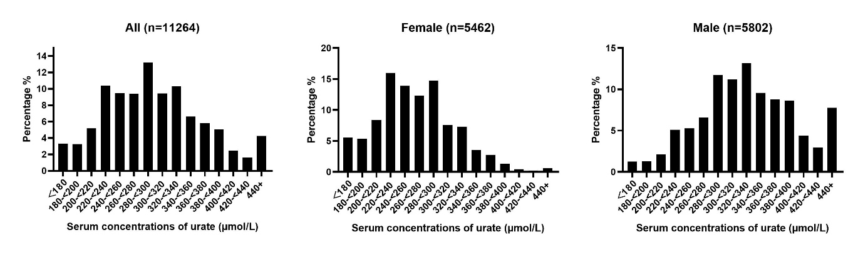
e Fig.1 Distribution of Serum Concentrations of Urate Among US Adolescents.

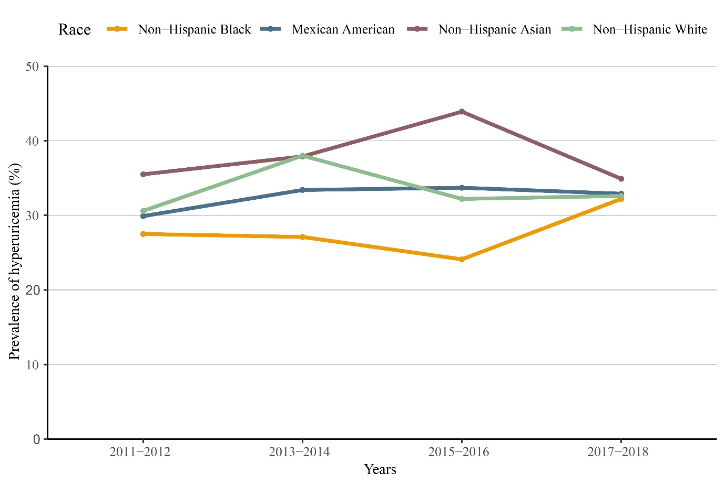
e Fig.2 Trends in Hyperuricemia Prevalence by Race/Ethnicity Among US Adolescents.

