Supplementary Materials for
A Non-Invasive Model for Diagnosis of Primary Sjogren’s Disease Based on Salivary Biomarkers, Serum Autoantibodies, and Schirmer's Test
Xinwei Zhang, Zhangdi Liao, Yangchun Chen, Huiqin Lu, Aodi Wang, Yingying Shi, Qi Zhang, Ying Wang, Yan Li, Jingying Lan, Chubing Chen, Chaoqiong Deng, Wuwei Zhuang, Lingyu Liu, Hongyan Qian, Shiju Chen, Zhibin Li, Guixiu Shi and Yuan Liu
Correspondence to: Yuan Liu (liuyuan@xmu.edu.cn) or Guixiu Shi (gshi@xmu.edu.cn)
This PDF file includes:
Supplementary Table 1 to 6
Figure S1 to S2

Supplementary Tables
Supplementary Table 1 Demographics and clinical characteristics of patient cohort for proteome profiling.
Characteristics | pSS (n=6)* | non-pSS (n=6)* | P value†
Age, years | 67.0 (54.8-71.0) | 34.5 (31.0-43.0) | 0.0022
Sex (females), % | 83.3 (5/6) | 100.0 (6/6) | 0.999
uSFR, ml/15min | 1.80 (0.95-3.15) | 5.10 (3.08-9.93) | 0.015
sSFR, ml/min | 0.38 (0.21-0.58)S | 1.03 (0.59-1.21) | 0.0087
Schirmer’s test (left), mm/5min | 5.0 (1.0-23.5) | 12.5 (3.5-27.0) | 0.632
Schirmer’s test (right), mm/5min | 1.0 (0.0-16.0) | 15.5 (2.0-28.5) | 0.136
RF, IU/ml | 9.00 (9.00-9.50) | 9.00 (9.00-10.00) | 0.999
CRP, mg/L | 1.37 (0.86-3.56) | 0.79 (0.77-1.64) | 0.128
ESR, mm/h | 34.00 (24.50-69.50) | 9.50 (6.50-11.25) | 0.0043
WBC count, 10^9/L | 5.23 (4.17-5.59) | 4.75 (3.97-5.48) | 0.699
serum C3, g/L | 1.26 (1.00-1.35) | 0.91 (0.82-1.16) | 0.126
serum C4, g/L | 0.24 (0.20-0.28) | 0.20 (0.16-0.26) | 0.353
IgG, mg/Dl | 15.40 (13.60-18.10) | 12.60 (11.32-14.05) | 0.178
anti-SSA (+), % | 83.30 (5/6) | 50.00 (3/6) | 0.546
anti-Ro52 (+), % | 83.30 (5/6) | 33.33 (2/6) | 0.242
ant-SSB (+), % | 50.00 (3/6) | 0.00 (0/6) | 0.182
ANA (+), % | 66.67 (4/6) | 33.33 (2/6) | 0.567
Focus (+), % | 100.00 (6/6) | 0.00 (0/6) | <0.001
Focus score | 1.50 (1.00-2.00) | 0.00 (0.00-0.00 | 0.002
*Median (IQR).
†Mann-Whitney U test (continuous variables) or Chi-square test (categorical variables).
pSS, primary Sjögren’s syndrome; C3, Complement C3; CFB, Complement factor B; CLU, Clusterin; NE, Neutrophil elastase; CALR, Calreticulin; uSFR, unstimulated salivary flow rate; sSFR, stimulated salivary flow rate; RF, rheumatoid factors; CRP, C-reactive protein; WBC, white blood cell; ANA, antinuclear antibody.

Supplementary Table 2 The diagnostic efficiency of C3, CFB, CLU, CALR, and NE.
 | AUC (95%CI) | Cut-off value | Sensitivity (%) | Specificity (%) | P value
C3, ng/ml | 0.678 (0.606-0.745) | 2623.00 | 62.0 | 66.2 | <0.001
CFB, ng/ml | 0.631 (0.558-0.701) | 173.50 | 84.3 | 44.6 | 0.003
CLU, ng/ml | 0.832 (0.770-0.883) | 221.40 | 86.8 | 69.2 | <0.001
CALR, ng/ml | 0.608 (0.534-0.679) | 3.78 | 49.6 | 73.9 | 0.009
NE, ng/ml | 0.706(0.635-0.770) | 0.00 | 67.8 | 75.4 | <0.001
AUC, the area under the curve; CI, confidence interval.

Supplementary Table 3 Univariate and multivariate logistic analysis of salivary biomarkers and clinical parameters for predicting pSjD.
 | Univariate analysis |  | Multivariate analysis
 | OR (95%CI) | P value | OR (95%CI) | P value
C3* | 3.187 (1.695-5.992) | ＜0.001 | .. | ..
CFB* | 4.325 (2.165-8.640) | ＜0.001 | 3.932 (1.283-12.043) | 0.017
CLU* | 14.766 (7.014-31.084) | ＜0.001 | 11.489 (3.816-34.585) | ＜0.001
NE* | 6.439 (3.259-12.724) | ＜0.001 | 3.444 (1.213-9.781) | 0.020
CALR* | 2.777 (1.438-5.363) | 0.002 | .. | ..
uSFR† | 7.404 (2.166-25.310) | 0.004 | .. | ..
Schirmers test† | 4.094 (2.078-8.065) | 0.023 | 3.301(1.164-9.363) | 0.025
anti-SSA/Ro60‡ | 2.205 (1.665-2.921) | 0.001 | 2.032 (1.287-3.209) | 0.002
anti-SSA/Ro52‡ | 1.622 (1.275-2.063) | ＜0.001 | 1.617 (1.070-2.445) | 0.023
anti-SSB‡ | 4.402 (1.443-13.432) | 0.001 | .. | ..
ANA titer | 1.004 (1.002-1.006) | ＜0.001 | .. | ..
WBC count, 10⁹/L | 0.914 (0.803-1.040) | 0.173 | .. | ..
RF, IU/ml | 1.006 (0.996-1.016) | 0.278 | .. | ..
CRP, mg/L | 1.005 (0.976-1.036) | 0.720 | .. | ..
ESR, mm/h | 1.052 (1.024-1.080) | 0.001 | .. | ..
serum C3, g/L | 0.970 (0.257-3.666) | 0.964 | .. | ..
sesum C4, g/L | 0.266 (0.009-7.865) | 0.444 | .. | ..
IgG, mg/dL | 1.217 (1.106-1.339) | ＜0.001 | .. | ..
Sex | 0.921 (0.372-2.283) | 0.859 | .. | ..
Age, years | 1.017 (0.995-1.041) | 0.131 | .. | ..
*Converted to categorical variables coded 1 or 0 according to the cut-off level.
†Converted to categorical variables coded 1 or 0 according to the 2016 ACR/EULAR classification criteria.
‡Coded 0, 1, 2, and 3 according to the number of “+”.
OR, odds ratio.

Supplementary Table 4 Regression coefficients and odds ratios of the final non-invasive model to predict pSjD.
Predictors | β coefficent | SE | OR
CFB | 1.369 | 0.571 | 3.932
CLU | 2.441 | 0.562 | 11.489
NE  Schirmer’s test | 1.237  1.194 | 0.533  0.532 | 3.444  3.301
anti-SSA/Ro60 | 0.709 | 0.233 | 2.032
anti-SSA/Ro52 | 0.481 | 0.211 | 1.617
constant | -4.511 | 0.833
SE, standard errors.

Supplementary Table 5 Pairwise comparison of ROC curves between the combined 6-marker model and each of the 6 variables retained in the model and the model containing anti-SSA/Ro60, anti-SSA/Ro52, and Schirmer’s test only.
 | Difference between areas | SE | 95%CI | P value
The combined model vs. CFB | 0.265 | 0.039 | 0.188-0.341 | <0.001
The combined model vs. CLU | 0.141 | 0.030 | 0.082-0.201 | <0.001
The combined model vs. NE | 0.208 | 0.040 | 0.130-0.287 | <0.001
The combined model vs. Schirmer’s test | 0.262 | 0.039 | 0.185-0.338 | <0.001
The combined model vs. anti-SSA/Ro60 | 0.191 | 0.037 | 0.118-0.263 | <0.001
The combined model vs. anti-SSA/Ro52 | 0.237 | 0.042 | 0.155-0.320 | <0.001
The combined model vs. anti-SSA/Ro60, anti-SSA/Ro52 and Schirmer’s test | 0.102 | 0.027 | 0.048-0.156 | <0.001

Supplementary Table 6 Pairwise comparison of ROC curves between the combined 6-marker model and MSGB and the model containing MSGB and Schirmer’s test in pooled cohort.
 | Difference between areas | SE | 95%CI | P value
The combined model vs. MSGB | 0.109 | 0.030 | 0.050-0.169 | <0.001
The combined model vs. MSGB and Schirmer’s test | 0.033 | 0.028 | -0.023-0.089 | 0.2522

Supplementary Figure
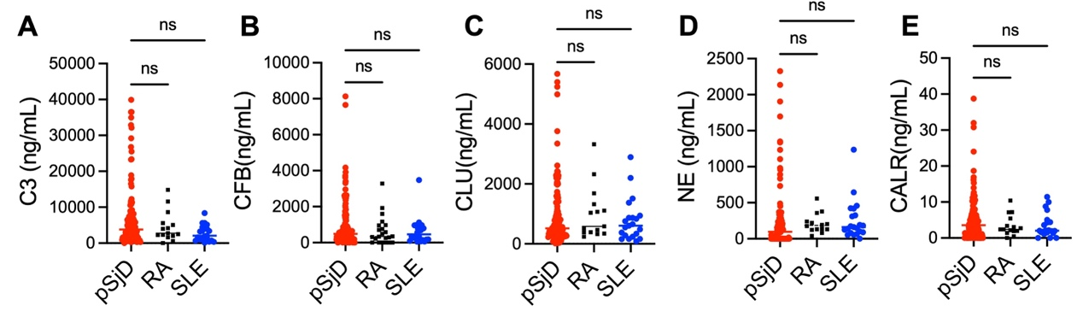
Fig. S1. The levels of C3, CFB, CLU, CALR, and NE between pSjD, RA, and SLE groups. The concentration of C3 (A), CFB (B), CLU (C), NE (D), and CALR (E) in saliva samples from pSjD (n=121), RA (n=15), and SLE (n=21) groups. One-way ANOVA was used to analyze data for differences. ns, no statistical significance; pSjD, primary Sjögren’s disease; RA, rheumatoid arthritis; SLE, systemic lupus erythematosus; C3, Complement C3; CFB, Complement factor B; CLU, Clusterin; CALR, Calreticulin; NE, Neutrophil elastase.

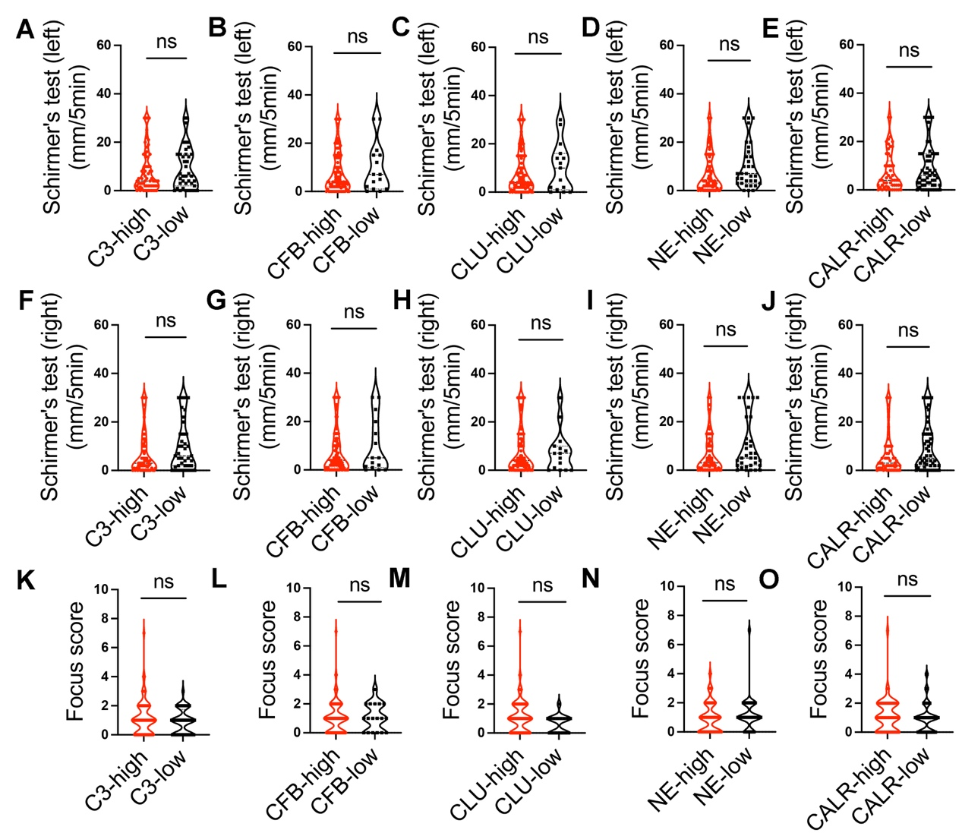
Fig. S2. Comparisons of Schirmer's test value and focus score between high- and low-level salivary biomarker groups. The 121 pSjD patients were divided into high-level and low-level groups based on the cut-off value. Schirmer's test value of left (A-E) and right eye (F-J) was compared between high- and low-level salivary biomarker groups. Focus score of labial glands was compared between high- and low-level salivary biomarker groups (K-O). Mann-Whitney U test was used to analyze data for differences. Data are representative of 3 independent experiments. ns, no statistical significance. C3, Complement C3; CFB, Complement factor B; CLU, Clusterin; NE, Neutrophil elastase; CALR, Calreticulin.

