SUPPLEMENTARY MATERIALS

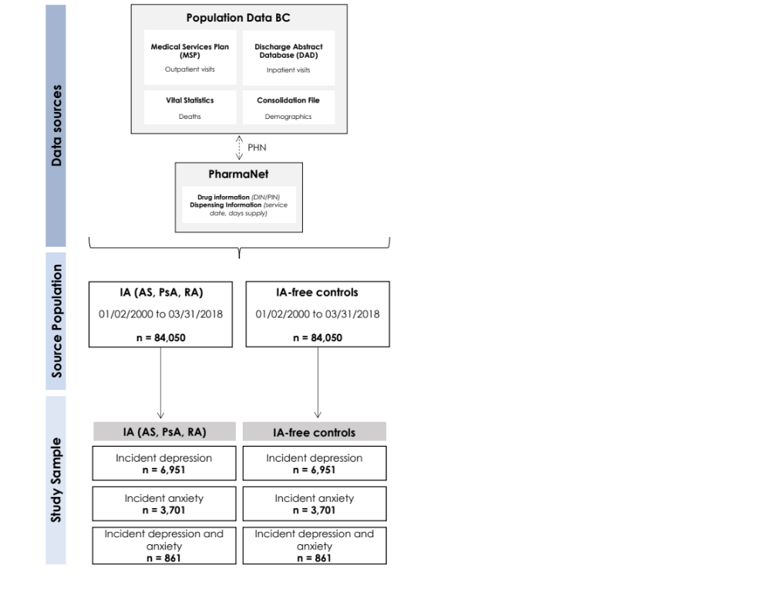

Supplementary Figure 1. Overview of data sources, source population, and study sample for individuals with inflammatory arthritis (IA) and IA-free controls with incident depression and/or anxiety (dashed arrow shows linkages between databases using provincial health numbers which are then de-identified/scrambled).
Abbreviations: DIN/PIN – drug identification number/product identification number; PHN – provincial health number.
Supplementary Table 1. Medication codes for antidepressants and anxiolytic according to the Anatomical Therapeutic Chemical (ATC) classification system.
ATC Classification | Chemical Class
N06A | Antidepressants
N06AA | Non-selective monoamine reuptake inhibitors
N06AB | Selective serotonin reuptake inhibitors
N06AF | Monoamine oxidase inhibitors, non-selective
N06AG | Monoamine oxidase A inhibitors
N06AX | Other antidepressants
NO5B | Anxiolytics
N05BA | Benzodiazepine derivatives
N05BB | Diphenylmethane derivatives
N05BC | Carbamates
N05BD | Dibenzo-bicyclo-octadiene derivatives
N05BE | Azaspirodecanedione derivatives
N05BX | Other anxiolytics

Supplementary Table 2. Procedural codes for psychological treatments (counselling, psychotherapy, telehealth, psychiatry, and general practitioner)
Fee item code(s) | Definition
Counselling
12120, 00120, 15320, 16120, 17120, 18120 | Individual counselling – in office
12220, 13220, 15220, 16220, 17220, 18220 | Individual counselling – out of office
00121, 00122, 00513, 00515 | Group counselling
00514 | Prolonged visit for counselling
00276, 00277 | Prolonged visit/or counselling complex case
Psychotherapy
00630, 00631, 00632 | Individual psychotherapy (office or hospital out-patient)
00650, 00651, 00652 | Individual psychotherapy (hospital or institution in-patient or home)
00633, 00635, 00636, 00638, 00639 | Family/Conjoint Psychotherapy
00663, 00664, 00665, 00666, 00667, 00668, 00669, 00670, 00671, 00672, 00673, 00674, 00675, 00676, 00677, 00678, 00679, 00680, 00681 | Group Psychotherapy
Telehealth
13018 | Telehealth GP in-office individual counselling
13021, 13022 | Telehealth GP out-of-office group counselling
13038 | Telehealth GP in-office individual counselling for prolonged visit
60607 | Telehealth subsequent office visit – psychiatric treatment
60608 | Telehealth hospital in-patient visit – psychiatric treatment
60610 | Full telehealth consultation – psychiatry
60613 | Telehealth geriatric consult – psychiatry
60625 | Telehealth repeat or limited consult – psychiatry
60630, 60631, 60632 | Individual telehealth psychiatric treatment
Psychiatrist visits
00605 | Emergency visit – psychiatry
00607 | Office visit – psychiatry
00608 | Hospital visit – psychiatry
00609 | Home visit – psychiatry
00610 | Individual consultation – psychiatry
00625 | Individual repeat consultation – psychiatry
00699 | Miscellaneous – psychiatry
GP mental health planning
14044, 14045, 14046, 14047, 14048 | GP Mental health management

Supplementary Table 3. Sex-stratified odds of receiving minimally adequate pharmacotherapy, psychological treatment, and pharmacotherapy or psychological treatment for depression and anxiety in individuals with inflammatory arthritis (IA) compared to IA-free controls.
 | Depression  OR (95% CI) |  | Anxiety  OR (95% CI)
 | Males | Females | Males | Females
1: Minimally adequate pharmacotherapy
Unadjusted model
 | 1.07 (0.95, 1.21) | 1.12 (1.03, 1.22) | 1.14 (0.93, 1.38) | 1.11 (1.00, 1.25)
Adjusted model^{A}
 | 1.06 (0.94, 1.20) | 1.11 (1.02, 1.21) | 1.14 (0.93, 1.38) | 1.10 (0.98, 1.23)
2: Minimally adequate psychological treatment
Unadjusted model
 | 1.01 (0.87, 1.17) | 0.98 (0.88, 1.09) | 1.10 (0.87, 1.39) | 1.07 (0.93, 1.23)
Adjusted model^{A}
 | 1.02 (0.88, 1.18) | 0.97 (0.87, 1.09) | 1.10 (0.87, 1.39) | 1.06 (0.92, 1.22)
3: Minimally adequate pharmacotherapy or psychological treatment
Unadjusted model
 | 1.07 (0.95, 1.21) | 1.13 (1.03, 1.23) | 1.06 (0.88, 1.28) | 1.10 (0.99, 1.23)
Adjusted model^{A}
 | 1.06 (0.94, 1.20) | 1.11 (1.02, 1.21) | 1.05 (0.87, 1.28) | 1.09 (0.97, 1.22)
^{A}Adjusted for age, Charlson-Romano comorbidity index, neighbourhood income quintile, and residence.
Abbreviations: 95% CI – 95% confidence interval; OR – odds ratio

Supplementary Table 4. Inflammatory arthritis (IA)-stratified odds of receiving minimally adequate pharmacotherapy, psychological treatment, and pharmacotherapy or psychological treatment for depression and anxiety in individuals with IA compared to IA-free controls.
 | Depression  OR (95% CI) |  |  | Anxiety  OR (95% CI)
 | Ankylosing Spondylitis | Psoriatic Arthritis | Rheumatoid Arthritis | Ankylosing Spondylitis | Psoriatic Arthritis | Rheumatoid Arthritis
1: Minimally adequate pharmacotherapy
Unadjusted model
 | 1.20 (0.97, 1.47) | 1.18 (0.91, 1.52) | 1.09 (1.01, 1.18) | 1.24 (0.94, 1.63) | 1.34 (0.96, 1.87) | 1.08 (0.97, 1.20)
Adjusted model^{A}
 | 1.20 (0.98, 1.48) | 1.13 (0.87, 1.47) | 1.07 (0.99, 1.16) | 1.25 (0.94, 1.65) | 1.33 (0.95, 1.86) | 1.06 (0.95, 1.18)
2: Minimally adequate psychological treatment
Unadjusted model
 | 1.22 (0.95, 1.57) | 0.94 (0.69, 1.28) | 0.97 (0.87, 1.07) | 1.22 (0.87, 1.70) | 1.58 (1.06, 2.37) | 1.01 (0.88, 1.16)
Adjusted model^{A}
 | 1.22 (0.94, 1.58) | 0.91 (0.67, 1.25) | 0.96 (0.87, 1.07) | 1.22 (0.87, 1.71) | 1.62 (1.08, 2.43) | 0.99 (0.86, 1.14)
3: Minimally adequate pharmacotherapy or psychological treatment
Unadjusted model
 | 1.23 (1.00, 1.52) | 1.15 (0.88, 1.50) | 1.09 (1.00, 1.18) | 1.23 (0.93, 1.63) | 1.27 (0.91, 1.76) | 1.05 (0.95, 1.17)
Adjusted model^{A}
 | 1.23 (0.99, 1.51) | 1.09 (0.84, 1.43) | 1.07 (0.99, 1.16) | 1.23 (0.93, 1.63) | 1.27 (0.91, 1.77) | 1.03 (0.92, 1.15)
^{A}Adjusted for age, sex, Charlson-Romano comorbidity index, neighbourhood income quintile, and residence.
Abbreviations: 95% CI – 95% confidence interval; OR – odds ratio

Supplementary Table 5. Characteristics of individuals with inflammatory arthritis (IA) and IA-free controls with incident depression and anxiety.
 | Depression & Anxiety
Characteristic | IA  (n=861) | IA-free  Controls  (n=861)
Age, mean (SD) | 52.0 (18.8) | 51.9 (18.8)
Female, n (%) | 608 (70.6) | 608 (70.6)
Type of inflammatory arthritis, n (%)
Ankylosing spondylitis | 96 (11.2) | ---
Psoriatic arthritis | 70 (8.1) | ---
Rheumatoid arthritis | 695 (80.7) | ---
Charlson-Romano comorbidity index, mean (SD) | 0.92 (1.04) | 0.32 (0.89)
Neighbourhood income quintile, n (%)
Quintile 1 | 199 (23.1) | 170 (19.7)
Quintile 2 | 200 (23.2) | 167 (19.4)
Quintile 3 | 141 (16.4) | 194 (22.5)
Quintile 4 | 180 (20.9) | 161 (18.7)
Quintile 5 | 141 (16.4) | 169 (19.6)
Residence, n (%)
Urban | 144 (16.7) | 743 (86.3)
Rural | 717 (83.3) | 118 (13.7)
Descriptive statistics were determined for the year prior to IA index date.
Abbreviations: IA – inflammatory arthritis; SD – standard deviation

Supplementary Table 6. Mean number of antidepressant/anxiolytic prescriptions dispensed, and mental health services accessed by individuals with inflammatory arthritis (IA) and IA-free controls in the first year after diagnosis of incident depression and anxiety.
 | Depression & Anxiety
 | IA  mean (SD) | IA-free controls  mean (SD) | p-value
Pharmacotherapy
Antidepressants
Total antidepressant prescriptions | 7.42 (19.64) | 5.92 (9.42) | 0.987
Days’ supply^{A} | 234.5 (126.3) | 247.5 (121.8) | 0.076
Proportion of days covered | 0.64 (0.35) | 0.68 (0.33) | 0.076
Anxiolytics
Total anxiolytic prescriptions | 3.03 (7.49) | 2.65 (6.76) | 0.576
Days’ supply (benzodiazepines)^{A, B} | 114.8 (125.2) | 110.4 (121.8) | 0.797
Proportion of days covered (benzodiazepines)^{B} | 0.31 (0.34) | 0.30 (0.33) | 0.797
Psychological Treatment
Outpatient visits
All mental health services | 3.55 (7.68) | 4.34 (11.20) | 0.242
By service type
Psychiatrist | 0.47 (1.86) | 0.61 (2.81) | 0.446
Publicly funded counselling | 1.03 (1.43) | 1.00 (1.38) | 0.536
Publicly funded psychotherapy | 2.00 (6.47) | 2.74 (9.60) | 0.087
Telehealth | 0.01 (0.11) | 0.00 (0.04) | 0.315
Mental health planning | 0.07 (0.46) | 0.05 (0.35) | 0.285
Inpatient visits
All-cause hospitalization | 0.99 (2.48) | 0.74 (1.50) | 0.019
Hospitalization for depression | 0.29 (1.98) | 0.21 (0.96) | 0.039
Hospitalization for anxiety | 0.24 (0.58) | 0.20 (0.46) | 0.262
Hospitalization for depression and anxiety | 0.15 (0.48) | 0.11 (0.36) | 0.025
^{A}Days’ supply refers to the mean days of supply of antidepressant/anxiolytic prescriptions dispensed over 365 days for IA and IA-free controls with at least one antidepressant/anxiolytic dispensed.
^{B}Analyses restricted to benzodiazepines only as these were the most frequently prescribed anxiolytics.
Abbreviations: IA – inflammatory arthritis; SD – standard deviation

Supplementary Table 7. Proportion of individuals with inflammatory arthritis (IA) and IA-free controls with ≥1 antidepressant/anxiolytic prescription dispensed and ≥1 mental health service accessed in the first year after diagnosis of incident depression and anxiety.
 | Depression & Anxiety
 | IA  n (%) | IA-free controls  n (%) | p-value
Pharmacotherapy
Antidepressants
All antidepressants | 507 (68.0) | 514 (68.7) | 0.754
By class
Selective serotonin reuptake inhibitors | 281 (37.7) | 349 (46.7) | <0.001
Tricyclic antidepressants | 82 (11.0) | 60 (8.0) | 0.050
Other^{A} | 290 (38.9) | 233 (31.1) | 0.002
By prescriber
Family physician-prescribed | 466 (62.5) | 469 (62.7) | 0.926
Psychiatrist-prescribed | 101 (13.5) | 100 (13.4) | 0.923
Rheumatologist-prescribed | <5^{B} | <5^{B} | 0.374
Anxiolytics
All anxiolytics | 344 (46.1) | 342 (45.7) | 0.880
By class
Benzodiazepines | 330 (44.2) | 331 (44.3) | 0.995
Hydroxyzine | 14 (1.9) | 12 (1.6) | 0.687
Buspirone | 17 (2.3) | 10 (1.3) | 0.172
By prescriber
Family physician-prescribed | 320 (42.9) | 311 (41.6) | 0.606
Psychiatrist-prescribed | 44 (5.9) | 50 (6.7) | 0.531
Rheumatologist-prescribed | <5 | 0 (0.0) | 0.062
Psychological Treatment
Outpatient visits
All mental health services | 492 (66.0) | 456 (61.0) | 0.045
By service type
Psychiatrist | 143 (19.2) | 130 (17.4) | 0.371
Publicly funded counselling | 368 (49.3) | 344 (46.0) | 0.196
Publicly funded psychotherapy | 207 (27.7) | 168 (22.5) | 0.018
Telehealth | <5 | <5 | 0.374
Mental health planning | 26 (3.5) | 19 (2.5) | 0.285
Inpatient visits
All-cause hospitalization | 319 (42.8) | 278 (37.2) | 0.027
Hospitalization for depression | 125 (16.8) | 96 (12.8) | 0.033
Hospitalization for anxiety | 145 (19.4) | 129 (17.2) | 0.274
Hospitalization for depression and anxiety | 95 (12.7) | 68 (9.1) | 0.024
^{A}Other antidepressants included selective serotonin-norepinephrine reuptake inhibitors, trazodone, and mirtazapine.
^{B}Cell sizes <5 not reported according to agreements of the data access request.
Abbreviations: IA – inflammatory arthritis

