SUPPLEMENTARY MATERIAL

The EULAR criteria for definition of good and moderate response.

Current disease activity state (DAS28) | DAS 28 improvement from baseline
Current disease activity state (DAS28) | >1.2 | >0.6 to ≤1.2 | ≤0.6
Low (≤3.2) | Good | Moderate | None
Moderate (>3.2 and ≤5.1) | Moderate | Moderate | None
High (>5.1) | Moderate | None | None
In light grey, the definition of the “EULAR response”, that incudes the moderate and good response.. EULAR, European League Against Rheumatisms. DAS28: disease activity score on 28 joints.

Association between the number of AAbs positive (continuous variable) and achievement of six-.months EULAR response

 |  |  | Logistic regression
 |  |  | OR (95%CI) | adjOR (95%CI) | p
 | Absolute number of AAbs positive (all 5 AAbs) |  | 1.2 (0.9 to 1.8) |  | 0.114
 | Absolute number of AAbs positive (excluding aRA33) |  | 1.4 (0.9 to 1.9) |  | 0.077

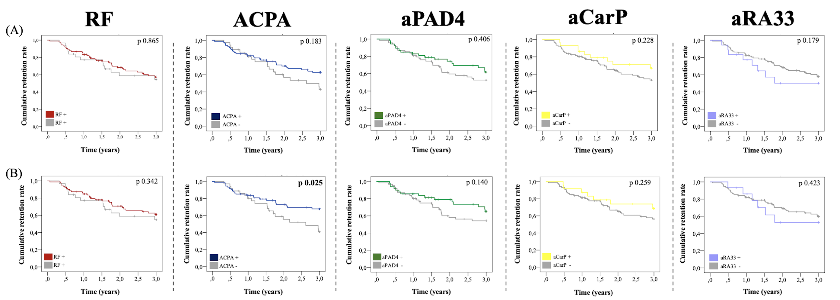
Kaplan-Meier curves comparing the abatacept retention rate in patients stratified according to the positivity of different autoantibodies, as individually assessed. In the panels (A) withdrawals for any reason were accounted; in panels (B) only those for inefficacy. P values refer to the results of the impact of the antibody positivity on the drug survival, after adjustment for different confounders. RF, rheumatoid factor. ACPA, anti-citrullinated protein antibodies. aPAD4, anti-peptidyl-arginine deiminase 4. aCarP, anti-carbamylated proteins. aRA33 anti-RA33

