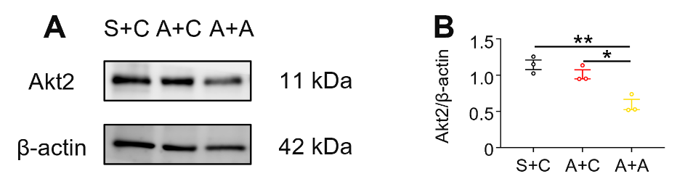
Supplementary Figure 1. The knockout efficacy of shAkt2 assessed via Western blot.
(A) Representative Western blot bands showing the expression of Akt2 and β-actin in subchondral bone of the condyles in the shCtrl- or shAkt2-treated groups. n = 3 per group.
(B) Quantitative analysis of the relative intensity of Akt2. All levels were normalized to β-actin. The data were presented as mean and SEM. Statistical analysis was determined by one-way ANOVA with Bonferroni’s multiple comparison test. * P < 0.05. ** P < 0.01. n = 3 per group.

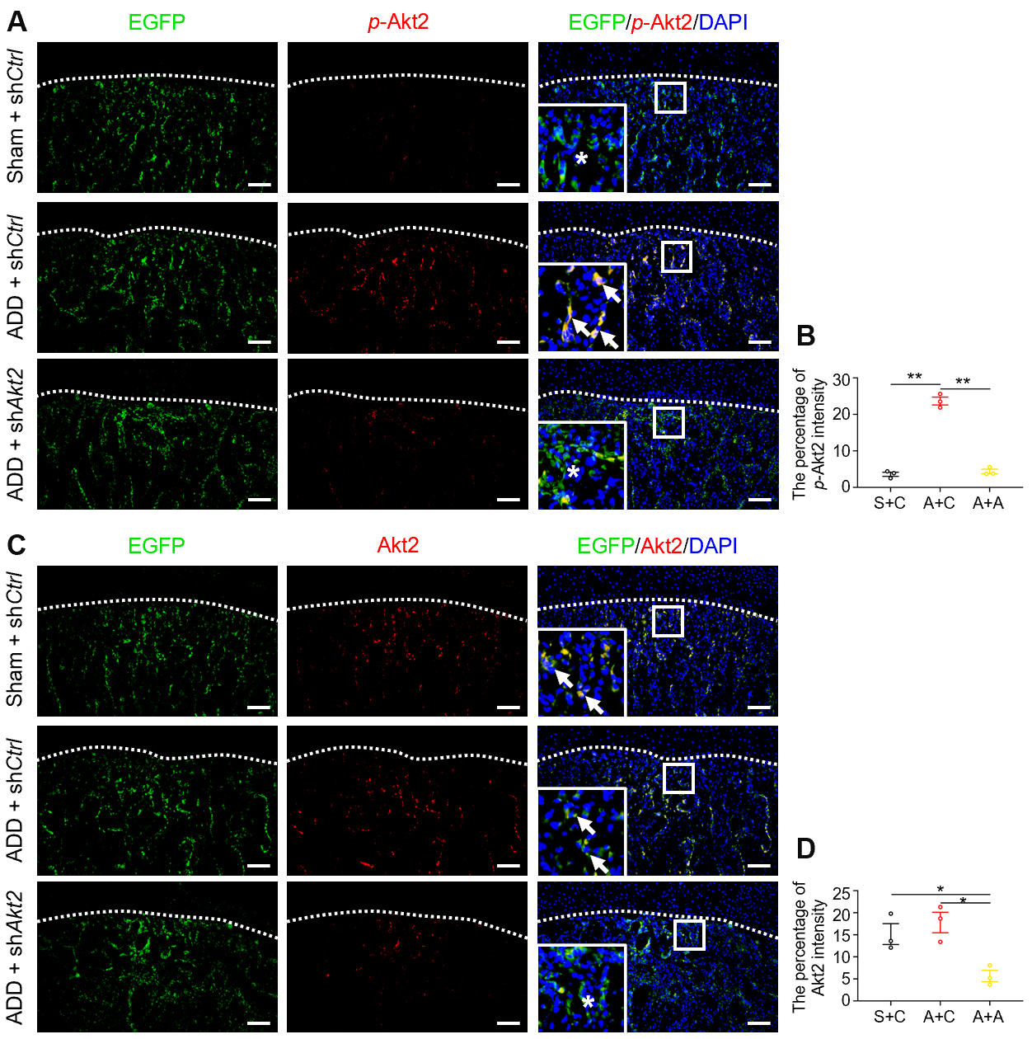
Supplementary Figure 2. The transfection efficacy of shAkt2 assessed via immunofluorescence staining.
(A) Representative images of immunofluorescence staining of EGFP and p-Akt2 in condyles in shCtrl- or shAkt2-treated rats. The white dotted line shows the demarcation between the articular cartilage and underlying subchondral bone. The white arrowheads indicate p-Akt2⁺ cells, and asterisks indicate negative signals. Scale bar: 100 μm.
(B) Quantitative analysis of the mean fluorescence intensity of p-Akt2⁺ cells of condyles. The data were presented as mean and SEM. Statistical analysis was determined by one-way ANOVA with Bonferroni’s multiple comparison test. * P < 0.05. n = 3 per group.
(C) Representative images of immunofluorescence staining of EGFP and Akt2 in condyles in shCtrl- or shAkt2-treated rats. The white dotted line shows the demarcation between the articular cartilage and underlying subchondral bone. The white arrowheads indicate Akt2⁺ cells, and asterisks indicate negative signals. Scale bar: 100 μm.
(D) Quantitative analysis of the mean fluorescence intensity of Akt2⁺ cells of condyles. The data were presented as mean and SEM. Statistical analysis was determined by one-way ANOVA with Bonferroni’s multiple comparison test. ** P < 0.01. n = 3 per group.
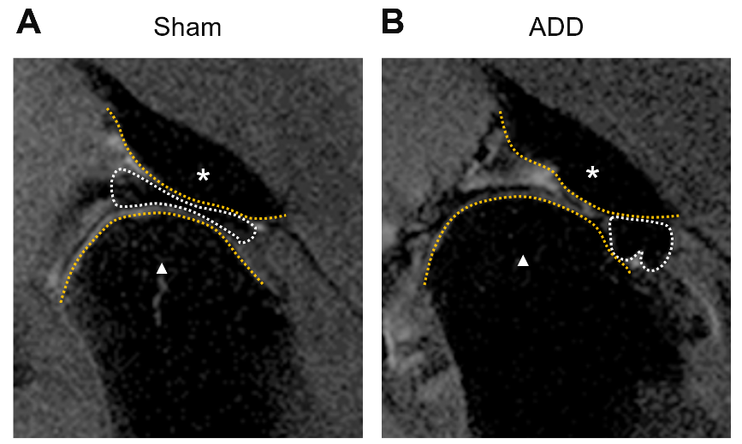
Supplementary Figure 3. MR images of TMJs in the rat model.
(A) Representative T2 weighted image of TMJ after sham operation in sagittal section. The white dotted line shows the TMJ disc. The white star shows articular tubercle. The white triangle shows condyle. The disc is located between the articular tubercle and the condyle.
(B) Representative T2 weighted image of TMJ after ADD operation in sagittal section. The white dotted line shows the TMJ disc. The white star shows articular tubercle. The white triangle shows condyle. The disc is located anterior to the condyle.

