Supplement to:
Burden and Determinants of Muti-b/tsDMARD Failure in Psoriatic Arthritis

Rebecca H. Haberman, Kyra Chen, Catherine Howe, Seungha Um, Adamary Felipe, Brianna Fu, Stephanie Eichman, Margaret Coyle, Eileen Lydon, Andrea L. Neimann, Soumya M. Reddy, Samrachana Adhikari, Jose U. Scher

Table of Contents:

Tables
Table S1. Baseline characteristics of total patient population | 2
Table S2. Survival estimates by b/tsDMARD exposure | 4
Table S3. Hazard ratio for first b/tsDMARD persistence | 4
Table S4. Regression models for multi-failure vs 1 b/tsDMARD exposure | 5
Table S5. Baseline characteristics of patients requiring 1 b/tsDMARD (with at least 5 years of disease) compared to multi-failure patients | 6
Table S6. Regression models for multi-b/tsDMARD failure vs 1 b/tsDMARD exposure with ≥5 years of disease duration | 8
Table S7. Baseline characteristics of patients requiring 1 b/tsDMARD compared to those requiring 3+ b/tsDMARDS | 9
Table S8. Regression models for patients requiring 3+ b/tsDMARDs compared to those requiring 1 b/tsDMARD | 11
Table S9. Baseline characteristics of patients by mechanism of action | 12
Table S10. Disease activity of patients requiring 1 b/ts DMARD compared to multi-b/tsDMARD failure patients (in those currently on b/tsDMARD at time of visit) | 14

Figures
Figure S1. Figure S1. Reason for discontinuing b/tsDMARD by exposure (including type of primary failure) | 15
Figure S2. Kaplan-Meier estimates of first b/tsDMARD persistence by sex | 16
Figure S3. Risk estimates of multi-b/tsDMARD failure psoriatic arthritis compared to those with 1 b/tsDMARD exposure and at least 5 years of disease | 17
Figure S4. Risk estimates of requiring 3+ b/tsDMARDs compared to 1 b/tsDMARD. | 17

Table S1. Baseline characteristics of total patient population
Characteristics | All  (n=960) | No b/tsDMARD exposure (n=235) | + b/tsDMARD exposure (n=725) | p-value
Demographics
Age- median (IQR) | 49 (37-61) | 49 (37-60) | 48.5 (37-61) | 0.701
Female- n (%) | 466 (48.54) | 114 (48.51) | 352 (48.55) | 0.213
Race/Ethnicity- n (%)* |  |  |  | 0.927
Asian | 80 (8.33) | 20 (8.51) | 60 (8.28)
Black | 17 (1.77) | 5 (2.13) | 12 (1.66)
White | 795 (82.81) | 193 (82.13) | 602 (83.03)
Other | 68 (7.08) | 17 (7.23) | 51 (7.03)
Hispanic | 74 (7.71) | 14 (5.96) | 60 (8.28) | 0.456
Psoriatic Disease and Treatment Timeline – median (IQR)
Age PsO Onset^ | 25 (17-38) | 29 (19-41.75) | 25 (16-35) | 0.001
Age PsA Onset | 38 (29-49) | 42 (32-52) | 37 (28-48) | <0.001
PsO to PsA Transition (years) | 8 (2-17) | 8 (2-14.75) | 8 (2-17) | 0.816
PsA Diagnosis Delay (years) | 1 (0-2) | 1 (0-3) | 1 (0-2) | 0139
Disease Duration (years) | 7 (3-13) | 3 (0-8) | 8 (4-14) | <0.001
Time to First Biologic (years) | --- | --- | 1 (0-3) | ---
Number of b/tsDMARDs | --- | --- | 2 (1-3) | ---
Number of MOAs | --- | --- | 1 (1-2) | ---
Psoriatic Disease Phenotype- n (%)
Imaging Erosions | 222 (23.13) | 42 (17.87) | 180 (24.83) | 0.028
Peripheral Deformities | 76 (7.92) | 16 (6.81) | 60 (8.28) | 0.578
Enthesitis | 345 (35.94) | 90 (38.30) | 255 (35.17) | 0.296
Dactylitis | 273 (28.44) | 73 (31.06) | 200 (27.59) | 0.318
Axial Disease | 172 (17.92) | 30 (12.77) | 142 (19.59) | 0.019
Scalp Psoriasis | 592 (61.67) | 141 (60.00) | 426 (58.76) | 0.939
Inverse Psoriasis | 162 (16.88) | 48 (20.43) | 114 (15.72) | 0.109
Nail Involvement | 482 (50.21) | 113 (48.09) | 369 (50.90) | 0.499
Comorbidities- n(%)
Uveitis | 29 (3.02) | 5 (2.13) | 24 (3.31) | 0.510
Inflammatory Bowel Disease | 21 (2.19) | 3 (1.28) | 18 (2.48) | 0.440
Depression | 162 (16.88) | 32 (13.62) | 130 (17.93) | 0.134
Anxiety | 180 (18.75) | 37 (15.74) | 143 (19.72) | 0.211
ADHD | 35 (3.65) | 6 (2.55) | 29 (4.00) | 0.423
Obesity | 275 (28.65) | 57 (24.25) | 218 (30.07) | 0.170
Hypertension | 214 (22.29) | 52 (22.13) | 162 (22.34) | >0.999
Hyperlipidemia | 206 (21.46) | 53 (22.55) | 153 (21.10) | 0.648
Diabetes Mellitus | 79 (8.23) | 18 (7.66) | 61 (8.41) | 0.768
Fibromyalgia | 13 (1.35) | 2 (0.85) | 11 (1.52) | 0.745
Current/Former Smoker | 297 (30.94) | 76 (32.34) | 221 (30.48) | .0626
Disease Activity – mean (SD)/median (IQR)
Tender Joint Count | 2.18 (4.05)/  1 (0-2) | 2.47 (3.82)/  1 (0-3) | 2.08 (4.12)/  0 (0-2) | 0.231/  0.001
Swollen Joint Count | 1.21 (2.84)/  0 (0-1) | 1.61 (3.28)/  0 (0-2) | 1.09 (2.67)/  0 (0-1) | 0.021/  <0.001
% Psoriasis BSA | 1.72 (6.57)/  0.5 (0-1) | 2.12 (6.75)/  1 (0.5-2) | 1.59 (6.52)/  0.5 (0-1) | 0.308/  <0.001
Moderate to Severe PsO#--n (%) | 110 (11.46) | 41(17.44) | 69 (9.52) | 0.002
Body Mass Index—mean (SD) | 28.59 (12.55) | 27.55 (5.11) | 28.91 (14.07) | 0.176
Physician Global | 2.36 (1.67)/  2 (1-3) | 2.69 (1.68)/  2.5 (1.5-4) | 2.25 (1.66)/  2 (1-3) | 0.001/  <0.001
RAPID 3—mean (SD) | 9.78 (6.11) | 8.8 (4.99) | 10.18 (6.47) | 0.060
Characteristics | All  (n=960) | No b/tsDMARD exposure (n=235) | + b/tsDMARD exposure (n=725) | p-value
Erythrocyte Sedimentation Rate | 20.73 (20.25)/ 14 (6-29) | 17.9 (18.20)/  11 (4-26.5) | 21.5 (20.73)/  15 (7-30) | 0.120/  0.060
C-Reactive Protein | 4.63 (7.30)/  14 (6-29) | 5.22 (7.71)/  2.5 (0.8-6) | 4.47 (7.19)/  1.9 (0.7-5.1) | 0.363/  0.430
Current Use of csDMARD^{X} - n(%) | 312 (32.50) | 110 (46.81) | 202 (27.86) | <.001
* Patients may identify as more than one race/ethnicity.
^ PsO skin psoriasis, PsA psoriatic arthritis, ADHD attention deficit hyperactivity disorder, BSA body surface area.
# Moderate to severe PsO is BSA ≥3%.
^{X} csDMARD also includes PDE4 inhibitors

Table S2. Survival estimates by b/tsDMARD exposure
 | First b/tsDMARD  (n=529) | Second b/tsDMARD  (n=192) | Third b/tsDMARD  (n=98) | Fourth + b/tsDMARD  (n=103)
Year 1 | 72.4% | 51.0% | 46.9% | 32.0%
Year 2 | 57.5% | 30.7% | 17.3% | 9.7%
Year 3 | 45.2% | 18.7% | 18.7% | 4.9%
Month Estimate | 22.9 (21.7-24.0) | 14.9 (13.1-16.6) | 12.6 (10.5-14.8) | 10.1 (8.3-11.8)
Month estimates shown as mean estimate with 95% confidence interval.
Fourth+ b/tsDMARD includes fourth, fifth, and sixth line medications.

Table S3. Hazard ratios for first b/tsDMARD persistence
 | Year 1 |  |  | Year 3
 | HR | 95%CI | p-value | HR | 95%CI | p-value
Unadjusted
Female Sex | 1.74 | 1.25-2.42 | 0.001 | 1.64 | 1.30-2.07 | <0.001
Age | 1.01 | 0.99-1.01 | 0.728 | 1.00 | 0.99-1.01 | 0.511
Depression | 1.35 | 0.91-1.98 | 0.135 | 1.26 | 0.95-1.68 | 0.105
Obesity | 1.04 | 0.73-1.50 | 0.814 | 1.16 | 0.90-1.50 | 0.265
Smoker⁺ | 1.12 | 0.85-1.69 | 0.315 | 1.21 | 0.95-1.55 | 0.124
Axial Involvement | 1.06 | 0.72-1.55 | 0.782 | 1.10 | 0.83-1.44 | 0.505
Dactylitis | 0.95 | 0.66-1.36 | 0.774 | 1.00 | 0.78-1.29 | 0.975
Peripheral Erosions | 0.96 | 0.66-1.39 | 0.839 | 0.99 | 0.76-1.28 | 0.942
Adjusted*
Female Sex | 1.49 | 1.05-2.11 | 0.025 | 1.48 | 1.16-1.89 | 0.002
Age | 1.00 | 0.99-1.01 | 0.808 | 1.00 | 0.99-1.01 | 0.417
Depression | 1.26 | 0.84-1.89 | 0.273 | 1.19 | 0.89-1.60 | 0.245
Obesity | 0.99 | 0.68-1.42 | 0.966 | 1.09 | 0.85-1.41 | 0.502
Smoker⁺ | 1.22 | 0.85-1.75 | 0.285 | 1.25 | 0.77-1.62 | 0.089
Axial Involvement | 1.04 | 0.70-1.55 | 0.840 | 1.04 | 0.78-1.38 | 0.793
Dactylitis | 0.87 | 0.59-1.29 | 0.485 | 0.96 | 0.73-1.26 | 0.775
Peripheral Erosions | 0.93 | 0.63-1.38 | 0.722 | 0.96 | 0.73-1.27 | 0.778
⁺ Smoker includes current and former smokers.
* Adjusted for sex, depression, obesity, and smoking status.

Table S4. Regression models for multi-b/tsDMARD failure vs 1 b/tsDMARD exposure
Factor | Odds Ratios | 95%CI | p-value | Model
Unadjusted
Age | 1.03 | 1.01-1.04 | <0.001 | -1.836+0.27(age)
Female Sex | 1.93 | 1.30-2.85 | 0.001 | -.253 +.766(sex)
Disease Duration | 1.06 | 1.04-1.09 | <0.001 | -1.108+ .60(disease duration)
Axial Involvement | 1.89 | 1.16-3.00 | 0.011 | -.311+ .622(axial)
Depression | 2.15 | 1.31-3.53 | 0.003 | -.253+ .766(depression)
Anxiety | 1.36 | 0.84-2.21 | 0.215 | -.399+ .308(anxiety)
Hypertension | 2.12 | 1.35-3.35 | 0.001 | -.295+ .753(hypertension)
Hyperlipidemia | 1.35 | 0.84-2.18 | 0.215 | -.405+.301 (hyperlipidemia)
Diabetes | 2.92 | 1.18-4.46 | 0.015 | -.157+ .839(diabetes)
Smoking* | 1.23 | 0.81-1.87 | 0.326 | -.454+.209(smoker)
Obesity | 1.63 | 1.07-2.49 | 0.023 | -3.94+ .488(obesity)
Moderate to Severe Skin Severity | 1.74 | 0.91-3.33 | 0.095 | .228+ .553(moderate-severe skin activity)
Adjusted Analysis⁺
Age | 1.02 | 0.99-1.03 | 0.107 | -1.157+ .060(disease duration)+ .015(age)+ .849(sex)+ .701(depression)+ .040 (smoker)+ .528 (obesity)+ .764 (moderate to severe skin severity)
Female Sex | 2.34 | 1.44-3.81 | <0.001 | -1.157+ .060(disease duration)+ .015(age)+ .849(sex)+ .701(depression)+ .040 (smoker)+ .528 (obesity)+ .764 (moderate to severe skin severity)
Disease Duration | 1.06 | 1.03-1.09 | <0.001 | -1.157+ .060(disease duration)+ .015(age)+ .849(sex)+ .701(depression)+ .040 (smoker)+ .528 (obesity)+ .764 (moderate to severe skin severity)
Axial Involvement | 2.06 | 1.17-3.61 | 0.012 | -1.038+ .059(disease duration)+ .016(age)+ .847(sex)+ .669(depression)+ .047(smoker)+ .567 (obesity)+ .661(moderate to severe skin severity)+ .722(axial)
Depression | 2.02 | 1.10-3.71 | 0.024 | -1.157+ .060(disease duration)+ .015(age)+ .849(sex)+. 701(depression)+ .040 (smoker)+ .528 (obesity)+ .764 (moderate to severe skin severity)
Anxiety | 0.93 | 0.48-1.80 | 0.83 | -1.150+ .060(disease duration)+ .015(age)+ .853(sex)+.732 (depression)+ .050(smoker)+ .528(obesity)+ .768(moderate to severe skin severity) - .72(anxiety)
Hypertension | 1.45 | 0.79-2.66 | 0.237 | -.887+ .059(disease duration)+ 0.11(age)+ .851(sex)+ .661(depression)+ .041(smoker)+ .494(obesity)+ .757(moderate to severe skin severity) + .369(hypertension)
Hyperlipidemia | 0.84 | 0.42-1.56 | 0.536 | -1.325+ .060(disease duration)+ .017(age)+ .850(sex)+ .706(depression)+ .052(smoker)+ .518(obesity)+ .755(moderate to severe skin severity) - .206(hyperlipidemia)
Diabetes | 1.28 | 0.58-2.92 | 0.565 | -1.023+ .059(disease duration)+ .014(age)+ .839(sex)+ .717(depression)+ .028 (smoker)+ .508(obesity)+ .741 (moderate to severe skin severity) + .244(diabetes)
Smoking* | 1.04 | 0.61-1.77 | 0.881 | -1.157+ .060(disease duration)+ .015(age)+ .849(sex)+. 701(depression)+ .040 (smoker)+ .528 (obesity)+ .764 (moderate to severe skin severity)
Obesity | 1.7 | 1.02-2.82 | 0.042 | -1.157+ .060(disease duration)+ .015(age)+ .849(sex)+. 701(depression)+ .040 (smoker)+ .528 (obesity)+ .764 (moderate to severe skin severity)
Moderate to Severe Skin Severity | 2.15 | 0.96-4.78 | 0.061 | -1.157+ .060(disease duration)+ .015(age)+ .849(sex)+. 701(depression)+ .040 (smoker)+ .528 (obesity)+ .764 (moderate to severe skin severity)
*Smoking includes current and former smokers.
⁺ Multivariate analysis adjusts for age, sex, disease duration, depression, smoking, obesity, and skin severity.

Table S5. Baseline characteristics of patients requiring 1 b/tsDMARD compared to multi-b/tsDMARD failure patients (≥ 5 years of disease duration)
Characteristics | All  (n=299) | 1 b/tsDMARD^{O}  (n=146) | 4+ b/tsDMARD^{O}  (n=153) | p-value
Demographics
Age- median (IQR) | 51 (40-62) | 47.5 (39-59) | 55 (40-63.5) | 0.040
Female- n (%) | 153 (47.22) | 62 (42.47) | 91 (59.48) | 0.004
Race/Ethnicity- n (%)*
Asian | 24 (7.41) | 15 (10.27) | 9 (5.88)
Black | 4 (1.23) | 2 (1.37) | 2 (1.31)
White | 256 (79.01) | 123 (84.25) | 133 (86.93)
Other | 15 (4.63) | 6 (4.11) | 9 (5.88)
Hispanic | 19 (5.86) | 7 (4.79) | 12 (7.84) | 0.340
Psoriatic Disease and Treatment Timeline – median (IQR))
Age PsO Onset^ | 23 (15-35) | 25 (18-35) | 22 (14-35) | 0.236
Age PsA Onset | 36 (27-48) | 35 (26-45) | 38 (28-48.5) | 0.163
PsO to PsA Transition (years) | 9 (1-17.75) | 7 (1-14) | 9 (2-21) | 0.070
PsA Diagnosis Delay (years) | 0 (0-2) | 0 (0-2) | 0 (0-2) | 0.845
Disease Duration (years) | 11 (7-17) | 10 (7-16) | 11 (6-19) | 0.994
Time to First Biologic (years) | 1 (0-5) | 2 (0-6) | 0.5 (0-2) | <.001
Number of b/tsDMARDs | 4 (1-5) | 1 (1-1) | 5 (4-6)
Number of MOAs | 1 (1-3) | 1 (1-1) | 3 (2-3)
csDMARD^{X} use ever—n(%) | 212 (70.90) | 91 (62.33) | 121 (79.08) | 0.002
Psoriatic Disease Phenotype- n (%)
Imaging Erosions | 83 (25.62) | 35 (23.97) | 48 (31.37) | 0.158
Peripheral Deformities | 31 (9.57) | 19 (13.01) | 12 (7.84) | 0.184
Enthesitis | 92 (28.40) | 32 (21.92) | 60 (39.22) | 0.001
Dactylitis | 84 (28.09) | 37 (25.34) | 47 (30.72) | 0.307
Axial Disease | 63 (19.44) | 23 (15.75) | 40 (26.14) | 0.033
Scalp Psoriasis | 176 (54.32) | 88 (60.27) | 88 (57.52) | 0.640
Inverse Psoriasis | 52 (16.05) | 26 (17.81) | 26 (16.99) | 0.880
Nail Involvement | 144 (44.44) | 65 (44.52) | 79 (51.63) | 0.247
Comorbidities- n(%)
Uveitis | 10 (3.09) | 5 (3.42) | 5 (3.27) | >0.999
Inflammatory Bowel Disease | 8 (2.47) | 1 (0.68) | 7 (4.58) | 0.067
Depression | 57 (17.59) | 20 (13.70) | 37 (24.18) | 0.027
Anxiety | 58 (17.90) | 23 (15.75) | 35 (22.88) | 0.144
ADHD | 11 (3.40) | 4 (2.74) | 7 (4.58) | 0.542
Obesity | 80 (26.76) | 24 (16.44) | 56 (36.60) | <0.001
Hypertension | 68 (20.99) | 23 (15.75) | 45 (29.41) | 0.006
Hyperlipidemia | 62 (19.14) | 30 (20.55) | 32 (20.92) | >0.999
Diabetes Mellitus | 28 (8.64) | 8 (5.48) | 20 (13.07) | 0.029
Fibromyalgia | 4 (1.23) | 1 (0.68) | 3 (1.96) | 0.623
Current/Former Smoker | 92 (30.77) | 44 (30.14) | 48 (31.37) | 0.900
Disease Activity – mean (SD)/ median (IQR)
Tender Joint Count | 1.91 (3.85)/  0 (0-2) | 1.18 (3.33)/  0 (0-1) | 2.63 (4.18)/  1 (0-3) | 0.001/ <0.001
Swollen Joint Count | 1.04 (2.53)/  0 (0-1) | 0.62 (1.80)/  0 (0-0) | 1.47 (3.04)/  0 (0-1.5) | 0.003/ <0.001
% Psoriasis BSA | 1.13 (3.20)/  0.5 (0-1) | 0.73 (1.53)/  0.5 (0-1) | 1.51 (4.17)/  0.5 (0-1) | 0.021/ 0.158
Moderate to Severe PsO# | 26 (8.70) | 7 (4.79) | 9 (5.88) | 0.024
Body Mass Index—mean (SD) | 28.04 (6.68) | 26.66 (6.11) | 29.3 (6.94) | <0.001
Physician Global | 2.19 (1.64)/  2 (1-3) | 1.56 (1.44)/  1 (0.63-2) | 2.73 (1.62)/  2.5 (1.5-3.5) | <0.001/ <0.001
Characteristics | All  (n=299) | 1 b/tsDMARD^{O}  (n=146) | 4+ b/tsDMARD  (n=153) | p-value
RAPID 3—mean(SD) | 10.45 (6.26) | 7.1 (4.72) | 12.81 (6.16) | <0.001
Erythrocyte Sedimentation Rate | 22.78 (21.48)/  18 (7.25-33) | 14.1 (13.52)/  8 (5-20.5) | 29.68 (24.06)/  23 (13.75-36.25) | <0.001/ <0.001
C-Reactive Protein | 4.78 (6.99)/  1.8 (0.63-5.08) | 3.16 (4.58)/  1.3 (0.5-3.15) | 6.15 (8.30)/  2.4 (1-6.94) | 0.005/ 0.007
Current Use of csDMARD- n(%) | 87 (26.85) | 27 (18.49) | 60 (39.22) | 0.013
^{O} All patients in this table have had psoriatic arthritis for at least 5 years.
* Patients may identify as more than one race/ethnicity.
^ PsO skin psoriasis, PsA psoriatic arthritis, MOA mechanism of action, ADHD attention deficit hyperactivity disorder, BSA body surface area.
^{X} csDMARD also includes PDE4 inhibitors.
# Moderate to severe PsO is BSA ≥3%.

Table S6. Regression models for multi-b/tsDMARD failure vs. 1 b/tsDMARD exposure (with ≥5 years of disease duration)
Factor | Odds Ratios | 95%CI | p-value | Model
Unadjusted Analysis
Age | 1.02 | 1.00-1.03 | 0.048 | -.786+ .016(age)
Female Sex | 1.99 | 1.26-3.15 | 0.003 | .040+ .687(sex)
Disease Duration | 1.01 | 0.99-1.04 | 0.332 | -.114+ 0.12(disease duration)
Axial Involvement | 1.83 | 1.07-3.36 | 0.029 | .234+ .638(axial)
Depression | 2.01 | 1.10-3.66 | 0.023 | .266+ .698(depression)
Anxiety | 1.59 | 0.89-2.84 | 0.121 | .189+ .461(anxiety)
Hypertension | 2.23 | 1.27-3.92 | 0.005 | .271+.801(hypertension)
Hyperlipidemia | 1.02 | 0.58-1.79 | 0.938 | .053+ .022(hyperlipidemia)
Diabetes | 2.59 | 1.11-6.00 | 0.029 | .440+ .953(diabetes)
Smoking* | 1.06 | 0.65- 1.73 | 0.817 | .058+0.58(smoker)
Obesity | 2.83 | 1.62-4.92 | <0.001 | .327+ 1.041(obesity)
Moderate to Severe Skin Severity | 2.78 | 1.13-6.85 | 0.026 | .487+ 1.023(moderate to severe skin activity)
Adjusted Analysis⁺
Age | 1.017 | 0.99-1.04 | 0.104 | .069+ .017(age)+ .562(sex)+ .007(disease duration)+ .733 (depression)+ .039(smoker)+ .833(obesity)+ 1.239(skin severity)
Female Sex | 1.754 | 1.02-3.01 | 0.041 | .069+ .017(age)+ .562(sex)+ .007(disease duration)+ .733 (depression)+ .039(smoker)+ .833(obesity)+ 1.239(skin severity)
Disease Duration | 1.007 | 0.98-1.04 | 0.64 | .069+ .017(age)+ .562(sex)+ .007(disease duration)+ .733 (depression)+ .039(smoker)+ .833(obesity)+ 1.239(skin severity)
Axial Involvement | 2.176 | 1.14-4.14 | 0.018 | .192+ .018(age)+ .587(sex)+ .008(disease duration)+ .677(depression)+ .057(smoker)+ .885(obesity)+ 1.142(skin severity)+ .92(axial)
Depression | 2.081 | 1.06-4.08 | 0.033 | .069+ .017(age)+ .562(sex)+ .007(disease duration)+ .733 (depression)+ .039(smoker)+ .833(obesity)+ 1.239(skin severity)
Anxiety | 1.076 | 0.51-2.26 | 0.846 | .059+ .017(age)+ .558(sex)+ .007(disease duration)+ .704(depression)+ .026(smoker)+ .833(obesity)+ 1.235(obesity)+ 1.235(moderate to severe skin severity)+ .074(anxiety)
Hypertension | 1.66 | 0.84-3.27 | 0.017 | -.235 + .021(age)+ .562(sex)+ .008(disease duration)+ .747(depression)+ .061(smoker)+ .825(obesity)+ 1.222(obesity)+ 1.222(moderate to severe skin severity)- .357(hyperlipidemia)
Hyperlipidemia | 0.699 | 0.35-1.41 | 0.315 | .059+ .017(age)+ .558(sex)+ .007(disease duration)+ .704(depression)+ .026(smoker)+ .833(obesity)+ 1.235(obesity)+ 1.235(moderate to severe skin severity)+ .074(anxiety)
Diabetes | 1.664 | 0.61-4.53 | 0.319 | .386+ .015(age)+ .526(sex)+ .006(disease duration)+ .772(depression)+ .007(smoker)+ .793(obesity)+ .793(obesity)+ 1.249(moderate to severe skin severity)+ .509(diabetes)
Smoking* | 1.039 | 0.58-1.85 | 0.894 | .069+ .017(age)+ .562(sex)+ .007(disease duration)+ .733 (depression)+ .039(smoker)+ .833(obesity)+ 1.239(skin severity)
Obesity | 2.3 | 1.27-4.18 | 0.006 | .069+ .017(age)+ .562(sex)+ .007(disease duration)+ .733 (depression)+ .039(smoker)+ .833(obesity)+ 1.239(skin severity)
Moderate to Severe Skin Severity | 3.453 | 1.27-9.42 | 0.016 | .069+ .017(age)+ .562(sex)+ .007(disease duration)+ .733 (depression)+ .039(smoker)+ .833(obesity)+ 1.239(skin severity)
*Smoking includes current and former smokers.
⁺ Adjusted for age, sex, disease duration, depression, smoking, obesity, and skin severity.

Table S7. Baseline characteristics of patients requiring 1 b/tsDMARD compared to those requiring 3+ b/tsDMARDs
Characteristics | All  (n=560) | 1 b/tsDMARD  (n=272) | 3+ b/tsDMARD (n=288) | p-value
Demographics
Age- mean (SD) | 48 (37-60) | 45 (35-59) | 51 (38.25-61.75) | 0.005
Female- n (%) | 272 (48.57) | 118 (43.38) | 154 (53.47) | 0.022
Race/Ethnicity- n (%)* |  |  |  | 0.072
Asian | 46 (8.21) | 30 (11.03) | 16 (5.56)
Black | 9 (1.61) | 5 (1.84) | 4 (1.39)
White | 469 (83.75) | 220 (80.88) | 248 (86.11)
Other | 36 (6.43) | 16 (5.88) | 20 (6.94)
Hispanic | 42 (7.50) | 19 (6.99) | 23 (7.99) | 0.216
Psoriatic Disease and Treatment Timeline – median (IQR)
Age PsO Onset^ | 24 (16-35) | 25.5 (18-35.75) | 22 (14-35) | 0.031
Age PsA Onset | 36 (27.75-48) | 36 (27-47) | 37 (28-48) | 0.905
PsO to PsA Transition (years) | 8 (2-17) | 8 (2-15) | 9 (2-20.5) | 0.189
PsA Diagnosis Delay (years) | 1 (0-2) | 1 (0-2) | 0 (0-2) | 0.080
Disease Duration (years) | 8 (4-14) | 6 (3-12) | 9 (5-17) | <0.001
Time to First Biologic (years) | 1 (0-3) | 1 (0-3) | 0 (0-2) | 0.155
Year of First Biologic | 2016  (2011-2019) | 2016  (2013.75-2020) | 2014  (2009-2018) | <0.001
Number of b/tsDMARDs | 3 (1-4) | 1.00 (0.00) | 4 (3-5)
Number of MOAs | 1 (1-2) | 1.00 (0.00) | 2 (2-3)
csDMARD^{X} use ever—n(%) | 343 (61.25) | 141 (51.84) | 202 (70.14) | <0.001
Psoriatic Disease Phenotype- n (%)
Imaging Erosions | 134 (23.93) | 60 (22.06) | 6 (2.08) | 0.427
Peripheral Deformities | 44 (7.86) | 29 (10.66) | 15 (5.21) | 0.018
Enthesitis | 201 (35.89) | 85 (31.25) | 116 (40.28) | 0.048
Dactylitis | 159 (28.39) | 73 (26.84) | 86 (29.86) | 0.454
Axial Disease | 108 (19.29) | 42 (15.44) | 65 (22.57) | 0.041
Scalp Psoriasis | 331 (59.11) | 160 (58.82) | 170 (59.03) | >0.999
Inverse Psoriasis | 87 (15.54) | 42 (15.44) | 45 (15.63) | >0.999
Nail Involvement | 201 (35.89) | 85 (31.25) | 272 (94.44) | 0.048
Comorbidities- n(%)
Uveitis | 19 (3.39) | 7 (2.57) | 12 (4.17) | 0.355
Inflammatory Bowel Disease | 12 (2.14) | 4 (1.47) | 8 (2.78) | 0.385
Depression | 106 (18.93) | 35 (12.87) | 70 (24.31) | <0.001
Anxiety | 112 (20.00) | 46 (16.91) | 66 (22.92) | 0.091
ADHD | 20 (3.57) | 7 (2.57) | 13 (4.51) | 0.259
Obesity | 172 (30.71) | 71 (26.10) | 101 (35.07) | 0.024
Hypertension | 124 (22.14) | 47 (17.28) | 77 (26.74) | 0.008
Hyperlipidemia | 115 (20.54) | 48 (17.65) | 66 (22.92) | 0.142
Diabetes Mellitus | 46 (8.21) | 17 (6.25) | 29 (10.07) | 0.124
Fibromyalgia | 11 (1.96) | 5 (1.84) | 6 (2.08) | >0.999
Current/Former Smoker | 166 (29.64) | 78 (28.68) | 88 (30.56) | 0.644
Disease Activity – mean (SD)/ median (IQR)
Tender Joint Count | 2.01 (3.89)/  0 (0-2) | 1.52 (3.44)/  1 (1-1) | 2.49 (4.22)/  1 (0-3) | 0.006/ <0.001
Swollen Joint Count | 1.07 (2.60)/  0 (0-1) | 0.78 (1.95)/  0 (0-0) | 1.35 (3.08)/  0 (0-1) | 0.015/ 0.009
Characteristics | All  (n=560) | 1 b/tsDMARD  (n=272) | 3+ b/tsDMARD (n=288) | p-value
% Psoriasis BSA | 1.39 (4.43)/  0.5 (0-1) | 1.02 (2.02)/  .5 (0-1) | 1.73 (5.80)/  0.5 (0-1) | 0.075/ 0.357
Moderate to Severe PsO# | 55 (8.92) | 20 (7.35) | 35 (12.15) | 0.086
Body Mass Index—mean (SD) | 29.18 (15.55) | 29.16 (21.24) | 29.21 (6.73) | 0.973
Physician Global | 2.25 (1.64)/  2 (1-3) | 1.81 (1.46)/  1.5 (1-2.38) | 2.64 (1.68)/  2.5 (1.5-3.5) | <0.001/ <0.001
RAPID 3—mean (SD) | 10.57 (6.48) | 8.36 (5.74) | 12.35 (6.52) | <0.001
Erythrocyte Sedimentation Rate | 21.64 (20.62)/ 16 (7-31) | 17.46 (17.87)/  10 (5-24) | 25.46 (22.23)/  19 (9-33) | 0.001/ <0.001
C-Reactive Protein | 4.66 (7.80)/  2.1 (0.7-5.1) | 4.05 (8.51)/  1.5 (0.6-4.55) | 5.23 (7.03)/  2.5 (0.85-6.15) | 0.202/ 0.027
Current Use of csDMARD- n(%) | 156 (27.86) | 63 (23.16) | 93 (32.29) | 0.018
Current Use of b/tsDMARD- n(%) | 444 (79.29) | 222 (81.62) | 222 (77.08) | 0.174
* Patients may identify as more than one race/ethnicity.
^ PsO skin psoriasis, PsA psoriatic arthritis, ADHD attention deficit hyperactivity disorder, BSA body surface area, MOA mechanism of action.
^{X} csDMARD also includes PDE4 inhibitors.
# Moderate to severe PsO is BSA ≥3%.

Table S8. Regression models for of patients requiring 3+ b/tsDMARDs compared to those requiring 1 b/tsDMARDs
Factor | Odds Ratios | 95%CI | p-value | Model
Unadjusted Analysis
Age | 1.01 | 1.01-1.03 | 0.006 | -.736 + .016(age)
Female Sex | 1.5 | 1.08-2.10 | 0.017 | .064+ .405(sex)
Disease Duration | 1.05 | 1.05-1.07 | <0.001 | -.391+ .048(disease duration)
Axial Involvement | 1.55 | 1.01-3.38 | 0.044 | .193+ .440(axial)
Depression | 2.11 | 1.35-3.28 | <0.001 | .293+ .744(depression)
Anxiety | 1.46 | 0.96-2.22 | 0.077 | .172+ .379(anxiety)
Hypertension | 1.75 | 1.61-2.63 | 0.007 | .215+ .558(hypertension)
Hyperlipidemia | 1.35 | 0.90-2.05 | 0.152 | .147+ .302(hyperlipidemia)
Diabetes | 1.68 | 0.90-3.13 | 0.103 | .275+ .519(diabetes)
Smoking* | 1.09 | 0.76-1.57 | 0.627 | .076+. 090(smoker)
Obesity | 1.55 | 1.07-2.25 | 0.020 | .132+ .441(obesity)
Moderate to Severe Skin Severity | 1.69 | 0.95-3.02 | 0.077 | .298+ .532(skin severity)
Adjusted Analysis⁺
Age | 1.009 | 0.99-1.02 | 0.256 | -.135+ .009(age)+ .468(sex) +.047(disease duration)+ .758(depression) +.000(smoker)+ .515(obesity)+ .713(skin severity)
Female Sex | 1.598 | 1.07-2.39 | 0.022 | -.135+ .009(age)+ .468(sex) +.047(disease duration)+ .758(depression) +.000(smoker)+ .515(obesity)+ .713(skin severity)
Disease Duration | 1.048 | 1.02-1.07 | <0.001 | -.135+ .009(age)+ .468(sex) +.047(disease duration)+ .758(depression) +.000(smoker)+ .515(obesity)+ .713(skin severity)
Axial Involvement | 1.56 | 0.95-2.55 | 0.078 | -.008+ .008(age)+ .459(sex) +.046(disease duration)+ .752(depression) - .006(smoker)+ .516(obesity)+ .674(skin severity)+ .443 (axial)
Depression | 2.134 | 1.27-3.60 | 0.004 | -.135+ .009(age)+ .468(sex) +.047(disease duration)+ .758(depression) +.000(smoker)+ .515(obesity)+ .713(skin severity)
Anxiety | 1.08 | 0.62-1.86 | 0.793 | -.143+ .009(age)+ .464(sex) +.047(disease duration)+ .725(depression) - .008(smoker)+ .514(obesity)+ .708(skin severity)+ .073 (anxiety)
Hypertension | 1.29 | 0.75-2.23 | 0.361 | .056+ .006(age)+ .475(sex) +.047(disease duration)+ .738(depression) + .002(smoker)+ .691(obesity)+ .691(skin severity)+ .255 (hypertension)
Hyperlipidemia | 0.936 | 0.54-1.62 | 0.814 | -.189+ .009(age)+ .469(sex) +.047(disease duration)+ .759(depression) + .002(smoker)+ .511(obesity)+ .713(skin severity)- .066 (hyperlipidemia)
Diabetes | 0.95 | 0.44-2.12 | 0.885 | -.164+ .009(age)+ .469(sex) +.047(disease duration)+ .759(depression) + .002(smoker)+ .511(obesity)+ .713(skin severity)- .066 (hyperlipidemia)
Smoking* | 1 | 0.64-1.57 | 0.999 | -.135+ .009(age)+ .471(sex) +.047(disease duration)+ .755(depression) +.002(smoker)+ .520(obesity)+ .719(skin severity)- .056(diabetes)
Obesity | 1.674 | 1.09-2.57 | 0.018 | -.135+ .009(age)+ .468(sex) +.047(disease duration)+ .758(depression) +.000(smoker)+ .515(obesity)+ .713(skin severity)
Moderate to Severe Skin Severity | 2.04 | 1.03-4.04 | 0.041 | -.135+ .009(age)+ .468(sex) +.047(disease duration)+ .758(depression) +.000(smoker)+ .515(obesity)+ .713(skin severity)
*Smoking includes current and former smokers.
⁺ Adjusted for age, sex, disease duration, depression, smoking, obesity, and skin severity.

Table S9. Baseline characteristics of patients by mechanism of action
Characteristics | All  (n=517) | 1 MOA  (n=382) | 3+ MOAs  (n=145) | p-value
Demographics
Age- median (IQR) | 48 (37-60) | 46 (36-60) | 53 (39-62) | 0.047
Female- n (%) | 257 (49.71) | 180 (47.12) | 58 (42.96) | 0.057
Race/Ethnicity- n (%)* | (0.00) |  |  | 0.468
Asian | 47 (9.09) | 38 (9.95) | 9 (6.67)
Black | 9 (1.74) | 7 (1.83) | 2 (1.48)
White | 428 (82.79) | 314 (82.20) | 114 (84.44)
Other | 33 (6.38) | 23 (6.02) | 10 (7.41)
Hispanic | 363 (70.21) | 351 (91.88) | 12 (8.89) | 0.231
Psoriatic Disease and Treatment Timeline—median (IQR)
Age PsO Onset^ | 25 (17-35) | 25 (18-35) | 22 (14-36.5) | 0.136
Age PsA Onset | 36 (28-48) | 36 (27.75-47) | 38 (28-50) | 0.622
PsO to PsA Transition (years) | 8 (2-15.75) | 7 (2-15) | 10 (1-20.75) | 0.157
PsA Diagnosis Delay (years) | 1 (0-2) | 1 (0-2.75) | 0 (0-2) | 0.032
Disease Duration (years) | 7 (4-14) | 7 (3-13) | 9 (4-17.75) | 0.006
Time to First Biologic (years) | 1 (0-3) | 1 (0-4) | 0 (0-2) | 0.247
Year of First Biologic | 2016  (2011-2019) | 2016  (2011-2019) | 2015  (2010-2019) | 0.270
Number of b/tsDMARDs | 1 (1-3) | 1 (1-2) | 5 (4-6)
Number of MOAs | 1 (1-3) | 1 (1-1) | 3 (3-4)
csDMARD^{X} use ever—n(%) | 326 (63.05) | 228 (59.69) | 98 (67.59) | 0.009
Psoriatic Disease Phenotype- n (%)
Imaging Erosions | 124 (23.98) | 87 (22.77) | 37 (27.41) | 0.292
Peripheral Deformities | 52 (10.06) | 41 (10.73) | 11 (8.15) | 0.505
Enthesitis | 171 (33.08) | 118 (30.89) | 53 (39.26) | 0.082
Dactylitis | 138 (26.69) | 99 (25.92) | 39 (26.90) | 0.499
Axial Disease | 89 (17.21) | 59 (15.45) | 30 (22.22) | 0.085
Scalp Psoriasis | 307 (59.38) | 229 (59.95) | 78 (57.78) | 0.684
Inverse Psoriasis | 79 (15.28) | 58 (15.18) | 21 (15.56) | 0.890
Nail Involvement | 244 (47.20) | 183 (47.91) | 61 (45.19) | 0.617
Comorbidities- n(%)
Uveitis | 22 (4.26) | 15 (3.93) | 7 (5.19) | 0.620
Inflammatory Bowel Disease | 14 (2.71) | 10 (2.62) | 4 (2.96) | 0.765
Depression | 89 (17.21) | 61 (15.97) | 28 (20.74) | 0.233
Anxiety | 105 (20.31) | 73 (19.11) | 32 (23.70) | 0.264
ADHD | 21 (4.06) | 13 (3.40) | 8 (5.93) | 0.210
Obesity | 153 (29.59) | 107 (28.01) | 46 (31.72) | 0.180
Hypertension | 110 (21.28) | 78 (20.42) | 32 (23.70) | 0.463
Hyperlipidemia | 102 (19.73) | 78 (20.42) | 24 (17.78) | 0.532
Diabetes Mellitus | 41 (7.93) | 26 (6.81) | 15 (11.11) | 0.137
Fibromyalgia | 9 (1.74) | 6 (1.57) | 3 (2.22) | 0.703
Current/Former Smoker | 154 (29.79) | 113 (29.58) | 41 (28.27) | 0.913
Disease Activity – mean (SD)/ median (IQR)
Tender Joint Count | 2.08 (4.21)/  0 (0-2) | 1.82 (4.38)/  0 (0-2) | 2.77 (3.95)/  1 (0-4) | 0.034/ <0.001
Swollen Joint Count | 1.11 (2.65)/  0 (0-1) | 0.99 (2.59)/  0 (0-1) | 1.44 (2.80)/  0 (0-2) | 0.115/ 0.030
% Psoriasis BSA | 1.9 (7.66)/  0.5 (0-1) | 1.68 (7.47)/  0.5 (0-1) | 2.53 (8.16)/  0.5 (0-1.5) | 0.296/ 0.347
Moderate to Severe PsO# --n(%) | 57 (11.03) | 35 (9.16) | 22 (15.17) | 0.036
Body Mass Index—mean (SD) | 29.11 (16.21) | 29.05 (18.40) | 29.28 (6.95) | 0.894
Characteristics | All  (n=517) | 1 MOA  (n=382) | 3+ MOAs  (n=145) | p-value
Physician Global | 2.23 (1.70)/  2 (1-3) | 2.03 (1.66)/  1.5 (1-3) | 2.74 (1.69)/  2.5 (1.5-4) | <0.001/ <0.001
RAPID 3—mean (SD) | 10.38 (6.67) | 9.32 (6.62) | 13.43 (5.91) | <0.001
Erythrocyte Sedimentation Rate | 21.67 (21.26)/  15 (6-31.5) | 19.62 (19.60)/  13 (5-28) | 26.64 (24.26)/  20 (9-33.75) | 0.017/  0.013
C-Reactive Protein | 4.68 (7.97)/  1.9 (0.7-5.18) | 4.27 (8.00)/  1.75 (0.6-5) | 5.71 (7.83)/  2.35 (1-6.275) | 0.193/ 0.066
Current Use of csDMARD- n(%) | 147 (28.43) | 103 (26.96) | 44 (32.59) | 0.223
Current Use of b/tsDMARD- n(%) | 403 (77.95) | 305 (79.84) | 98 (72.59) | 0.091
* Patients may identify as more than one race/ethnicity.
^ PsO skin psoriasis, PsA psoriatic arthritis, ADHD attention deficit hyperactivity disorder, BSA body surface area, MOA mechanism of action.
^{X} csDMARD also includes PDE4 inhibitors.
# Moderate to severe PsO is BSA ≥3%.

Table S10. Disease activity of patients requiring 1 b/tsDMARD compared to muti-b/tsDMARD failure patients (in those currently on b/tsDMARD at time of visit)
Disease Activity Measure | All  (n=350) |  | 1 b/tsDMARD  (n=222) |  | Multi-Failure PsA  (n=128) |  | p-value
Tender Joint Count | 1.62 | (3.58) | 1.28 | (3.36) | 2.23 | (3.88) | 0.026
Swollen Joint Count | 0.84 | (2.21) | 0.58 | (1.64) | 1.33 | (2.93) | 0.005
% Psoriasis BSA | 1.32 | (4.94) | 0.94 | (1.92) | 1.97 | (7.67) | 0.075
Body Mass Index | 29.62 | (18.98) | 29.47 | (23.30) | 29.87 | (7.30) | 0.852
Physician Global | 2.05 | (1.56) | 1.67 | (1.32) | 2.68 | (1.73) | <0.001
RAPID 3 | 10.07 | (6.21) | 8.21 | (5.51) | 12.84 | (6.22) | <0.001
Erythrocyte Sedimentation Rate | 20.85 | (20.01) | 17.24 | (17.48) | 26.93 | (22.53) | <0.001
C-Reactive Protein | 4.14 | (6.18) | 3.47 | (4.92) | 5.33 | (7.84) | 0.024
Current Use of cDMARD- n(%) | 98 | (28.00) | 45 | (20.27) | 53 | (41.41) | <0.001

Figure S1. Reason for discontinuing b/tsDMARD by exposure (including type of primary failure). (A) First exposure (n= 499), (B) Second exposure (n=325), (C) Third exposure (n=171), (D) Fourth exposure (n=111), and (E) Fifth exposure (n=55).

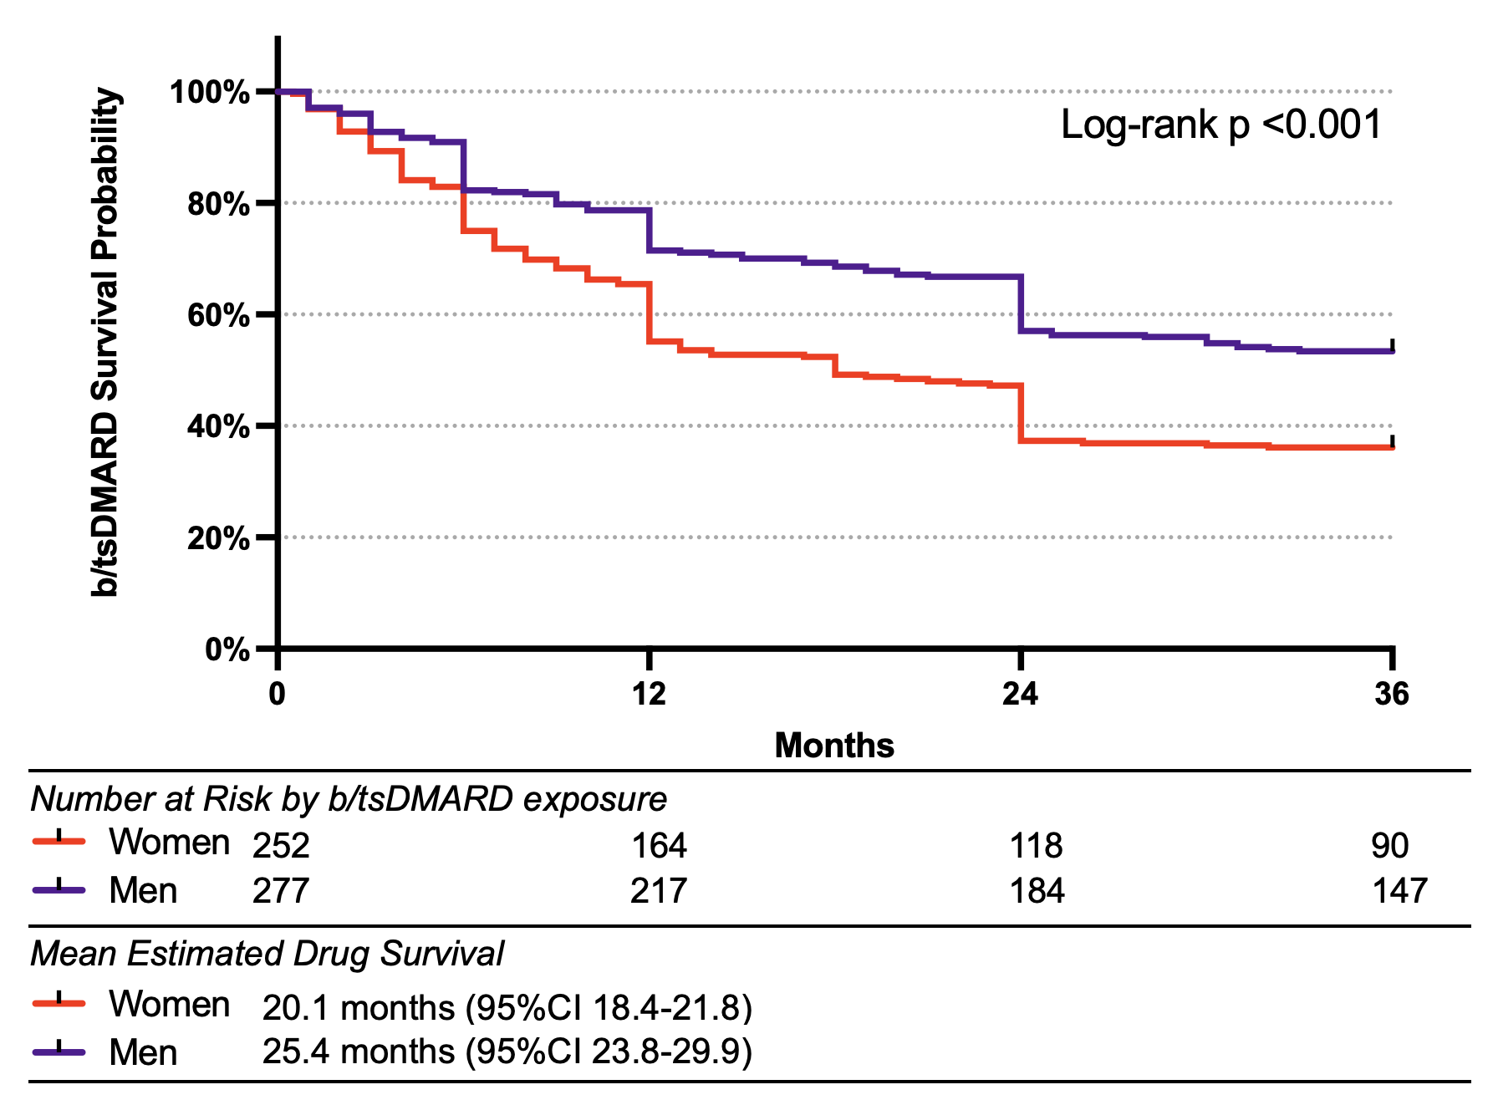
Figure S2. Kaplan-Meier estimates of first b/tsDMARD persistence by sex. Persistence was defined as the time from therapy initiation to discontinuation.

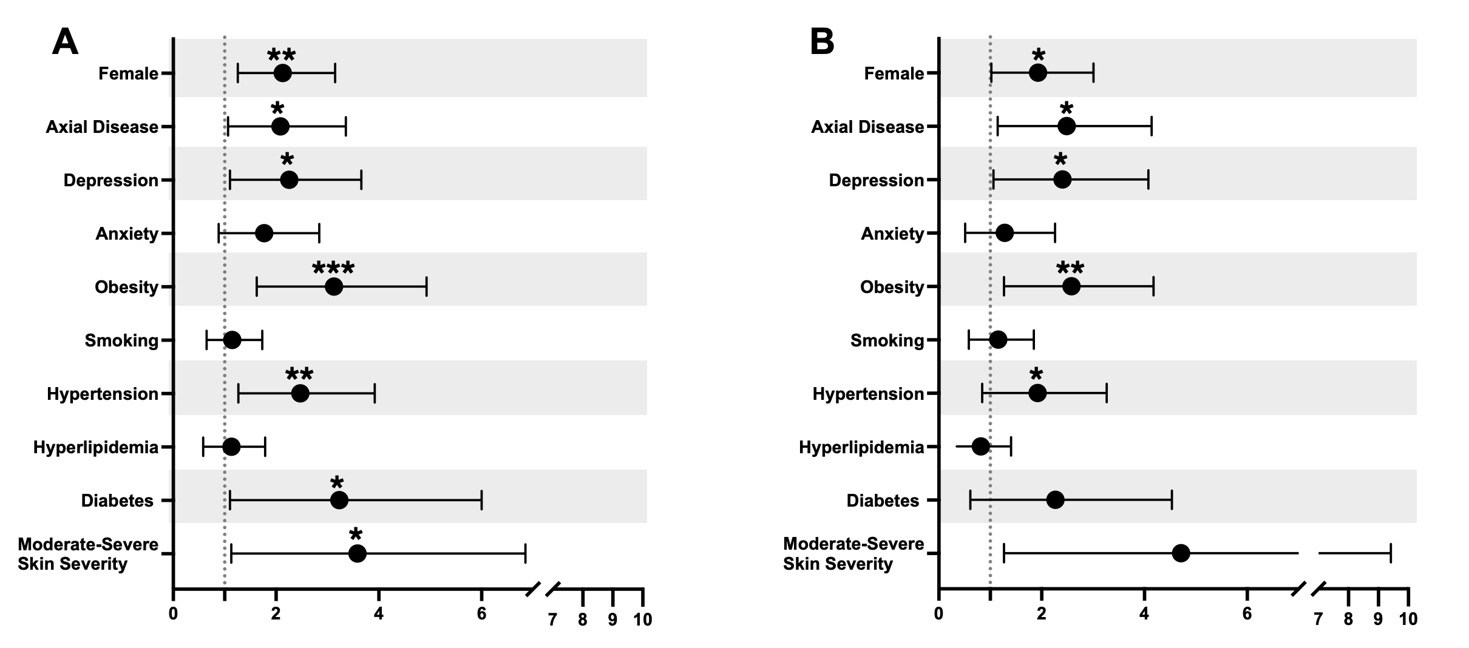
Figure S3. Risk estimates of multi-b/tsDMARD failure psoriatic arthritis compared to those with 1 b/tsDMARD exposure and at least 5 years of disease. Odds ratios are unadjusted (A) and adjusted (B) or disease duration, age, sex, depression, smoking status, obesity, and skin severity.

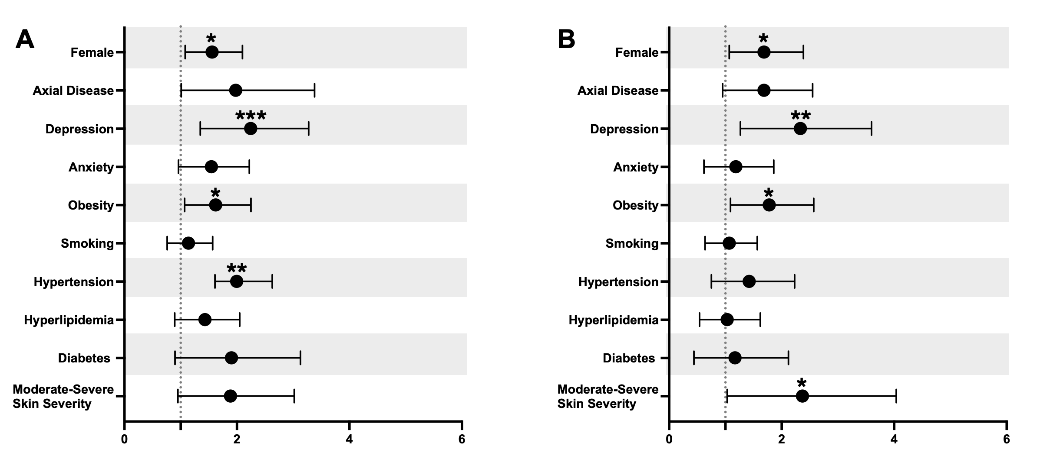
Figure S4. Risk estimates of requiring 3+ b/tsDMARDs compared to 1 b/tsDMARD. Odds ratios are unadjusted (A) and adjusted (B) for disease duration, age, sex, depression, smoking status, obesity, and skin severity.

