Supplementary Table 1. Multivariate Linear Regression Models of plasma CAM levels in DM and Controls (n=111)
 | ICAM-1 |  | VCAM-1
 | $β$ [95%CI] | P value | $β$ [95%CI] | P value
DM (vs control) | 105.15[8.31,202.01] | 0.03 | 0.33 [0.07, 0.58] | 0.01
ESR per 10mm/hr | 10.92[-4.02,25.85] | 0.15 | -0.003[-0.04, 0.04] | 0.87
Triglyceride per 100 | 24.18[5.20,43.16] | 0.01 | 0.06[0.01, 0.11] | 0.03
Diabetes | 63.83[-97.76,225.43] | 0.43 | 0.20[-0.23,0.62] | 0.35
$β$ [95%CI] Regression coefficient and 95% confidence interval
ICAM-1 and VCAM-1 levels were log transformed to fit linearity. hsCRP was colinear with ESR

Supplementary Table 2. MSA subgroups in DM and controls (n=111)
 | ICAM-1 |  |  |  |  |  |  | VCAM-1
 | $β$ | P value | $β$ | P value | $β$ | P value | $β$ |  | P value | $β$ | P value | $β$ | P value
Anti-Jo1 DM | 0.15 | 0.08 | - |  | - | - | 0.18 |  | 0.15 | - |  | - | -
Anti-MDA5 DM | - | - | 0.18 | 0.04 | - | - | - |  | - | 0.29 | 0.02 | - | -
Anti-TIF1$γ$ DM | - | - | - | - | -0.11 | 0.17 | - |  | - | - |  | -0.13 | 0.25
ESR per 100mm/hr | 0.03 | 0.03 | 0.24 | 0.07 | 0.31 | 0.02 | 0.12 |  | 0.53 | 0.03 | 0.87 | 0.01 | 0.46
Triglyceride per 100 | 0.03 | 0.06 | 0.04 | 0.02 | 0.04 | 0.03 | 0.05 |  | 0.04 | 0.06 | 0.01 | 0.05 | 0.02
Diabetes | 0.12 | 0.41 | 0.11 | 0.47 | 0.11 | 0.46 | 0.19 |  | 0.38 | 0.16 | 0.02 | 0.18 | 0.42
$β$ [95%CI] Regression coefficient and 95% confidence interval
Anti-Jo1 n=24, anti-MDA5 n=29, anti-TIF1r $γ$ n=30
ICAM-1 and VCAM-1 levels were log transformed to fit linearity. hsCRP was colinear with ESR

Supplementary Table 3. Comparison in ILD vs no ILD DM (n=83)
 | ILD  (n=42) | No ILD  (n=41) | P value
Age | 52 $±$15* | 43$±$115 | 0.01
Sex, female | 28 (67)* | 37 (90) | 0.01
Ethnicity, Hispanic | 7(17) | 5(12) | 0.56
Race, White | 25(60) | 33(80) | 0.10
Black | 3(7) | 2(5)
Asian | 14(33) | 6(15)
ICAM-1, ng/mL | 576[491-764]* | 394[336-509] | <0.001
VCAM-1, ng/mL | 3350[2730-4939]* | 2557[1923-3687] | 0.01
Paraoxonase, U/ml | 381[233-739]* | 696[324-1063] | 0.04
Arylesterase, U/ml | 199[152-264] | 206[160-294] | 0.43
Lactonase, U/ml | 14[10-21] | 18[11-22] | 0.37
hsCRP, mg/L | 2.6[0.9-9.4]* | 0.9[0.4-4] | 0.01
ESR, mm/hr | 30[14-52] | 23[9-42] | 0.22
Total cholesterol, mg/dl | 213[178-251] | 204[175-241] | 0.31
LDL-C, mg/dl | 117[93-169] | 118[89-150] | 0.82
HDL-C, mg/dl | 54[41-73] | 62[53-80] | 0.06
Triglyceride, mg/dl | 181[119-302]* | 125[83-172] | 0.004
CVD risk factors
History of MI | 1(2) | 0 | 0.24
History of stroke | 2(5) | 2(5) | 0.98
Hypertension | 8(19) | 8(19) | 0.96
Hyperlipidemia | 4(10) | 6(14) | 0.47
Diabetes | 8(19)* | 0 | 0.001
FHx of premature MI | 4(12) | 2(7) | 0.54
Ever smoker | 7(19) | 5(17) | 0.82
BMI, kg/m2 | 26[23-30] | 27[23-30] | 0.80
Statin | 5(12) | 4(10) | 0.75
IIM characteristics
Disease duration from symptom onset, months | 14[8-37] | 27[8-82] | 0.15
MSA group, Jo-1 | 21(50) | 3(7) | <0.01
MDA5 | 21(50) | 8(20) | <0.01
TIF1r | 0 | 30(73) | <0.01
Cancer | 6(14) | 9(22) | 0.36
MD activity VAS | 50[36-66] | 45[28-60] | 0.15
MD activity likert | 2[2-3] | 2[1-2 | 0.08
MD damage VAS | 45[32-54]* | 13[6-30] | <0.01
MD damage likert | 2[1-2]* | 1[1-1] | <0.01
MMT8 | 148[142-150] | 150[145-150] | 0.12
CPK, U/ml | 68[45-182] | 79[61-124] | 0.56
Aldolase, U/ml | 6.6[5.3-9.3]* | 5.6[3.9-7.4] | 0.03
Medications, at visit
Intravenous or subcutaneous immunoglobulin | 21(50) | 16(39) | 0.31
Mycophenolate Mofetil | 24[57]* | 12[29] | 0.01
Rituximab | 14(33)* | 4(10) | 0.01
Cyclophosphamide | 6(14)* | 0 | <0.01
Azathioprine | 3(7) | 1(3) | 0.32
Methotrexate | 1(2)* | 13(32) | <0.01
Hydroxychloroquine | 5(12) | 11(27) | 0.08
Prednisone | 36(86)* | 26(63) | 0.02
Values are in mean $±$SD for non-skewed data, median[IQR] for skewed data
*p<0.05 by student’s t test for non-skewed data and Wilcoxon test for skewed data, chi square test for categorical data
Supplementary Table 4. Association between CAM levels and ILD severity using Multivariate linear regression in DM only cohort
 | FVC |  |  |  | DLCO
 | $β$ | P value | $β$ | P value | $β$ | P value | $β$ | P value
ICAM-1 | -17.49 | 0.04 | - | - | -18.3 | 0.01 | - | -
VCAM-1 | - | - | 1.04 | 0.88 | - | - | -0.56 | 0.93
Age | -0.24 | 0.26 | -0.22 | 0.32 | -0.33 | 0.07 | -0.31 | 0.11
Sex, Female | 7.53 | 0.32 | 8.66 | 0.29 | -4.46 | 0.50 | -3.09 | 0.67
Diabetes | -6.56 | 0.58 | -10.21 | 0.42 | 4.22 | 0.71 | -0.97 | 0.93
Triglyceride per 100 | -0.26 | 0.84 | -0.95 | 0.48 | -0.19 | 0.87 | -0.80 | 0.49
MMF | 2.90 | 0.65 | 3.41 | 0.62 | -6.36 | 0.27 | -5.00 | 0.42
$β$ Regression coefficient, ICAM-1 and VCAM-1 were log transformed
Includes patients with PFT values available, 35 patients with ILD and 24 without ILD
Model including MMF reported. Models including other medications show similar significance for CAM

Supplementary Table 5. Association between Lactonase and CAM levels using Multivariate linear regression in DM only (n=83)
 | Log ICAM |  | Log VCAM
 | $β$ [95%CI] | P value | $β$ [95%CI] | P value
Lactonase, 10U/L | -0.15[-0.28,-0.03] | 0.02 | -0.01[-0.17,0.15] | 0.91
Disease duration, year | -0.004[-0.02,0.02] | 0.69 | - | -
Aldolase, 10U/L | 0.04[0.01,0.07] | 0.02 | - | -
MD damage VAS,10mm | 0.01[-0.05,0.07] | 0.68 | - | -
FVC,10%predicted | -0.03[-0.08,0.03] | 0.31 | - | -
Methotrexate | -0.46[-0.79,-0.13] | 0.01 | -0.29[-0.64,0.07] | 0.11
Prednisone dose | - | - | 0.004[-0.003,0.01] | 0.27
Dyspnea | - | - | 0.11[-0.21,0.42] | 0.45
Fever | - | - | 0.01[-0.38,0.39] | 0.97
Multivariate models adjusted for variables significantly associated with CAM (Table 3). When variables were colinear, one representative variable was selected. Continuous variables were preferentially selected (ex, FVC over ILD yes/no)

Supplementary Figure 1. Schema for causal mediation analysis.
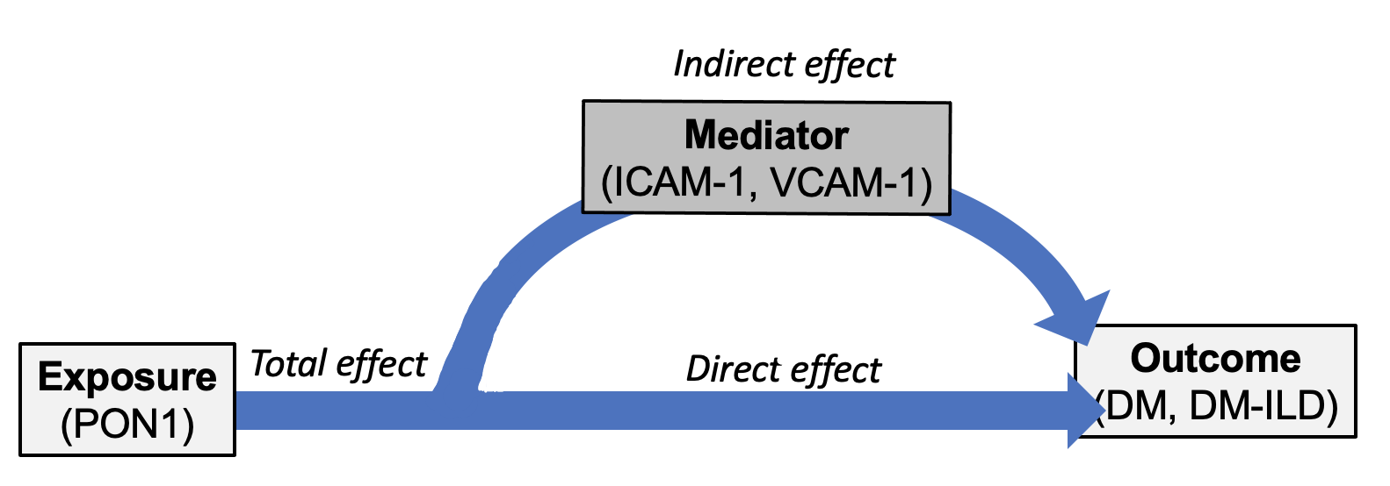

Supplementary Figure 2. Correlation between PON1 activity by lactonase and CAM levels in DM patients and controls (n=111)
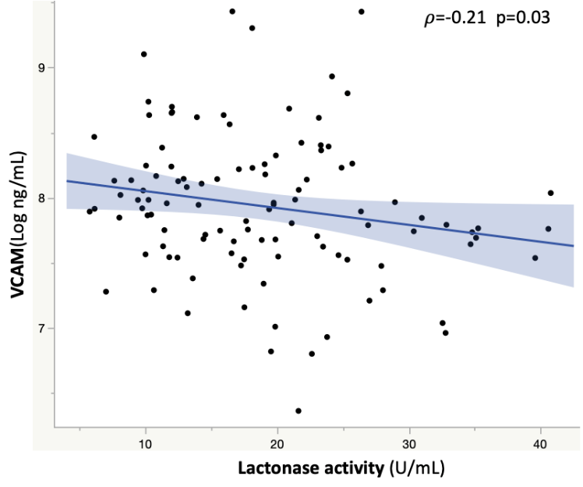 | 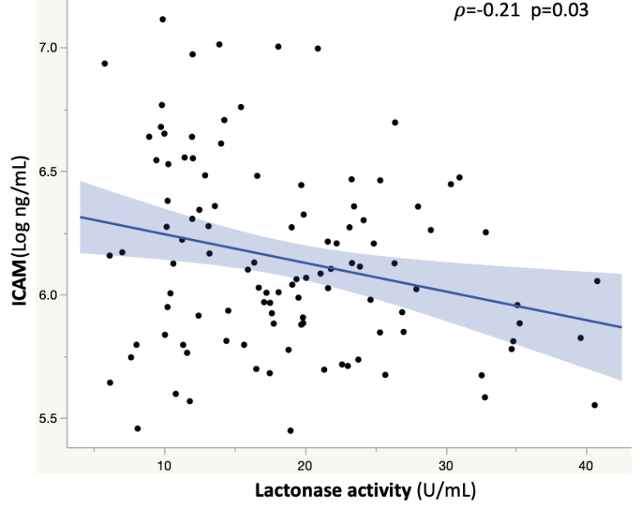
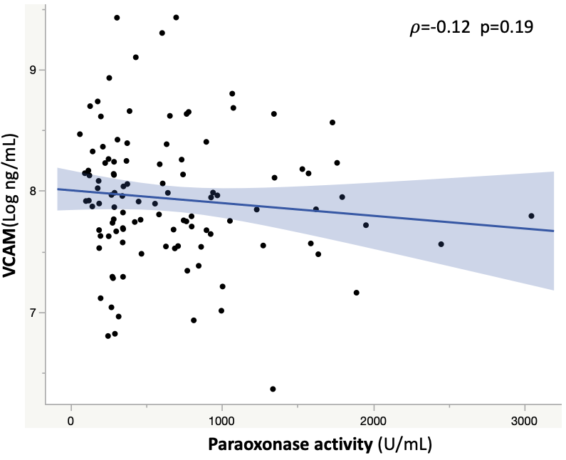 | 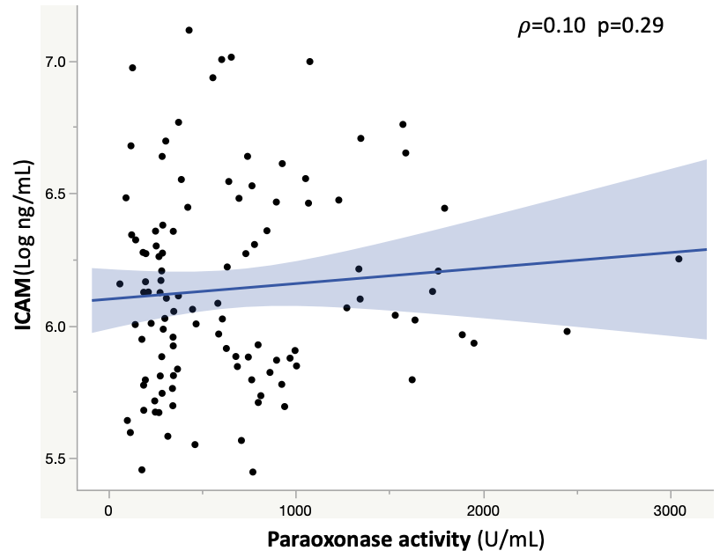
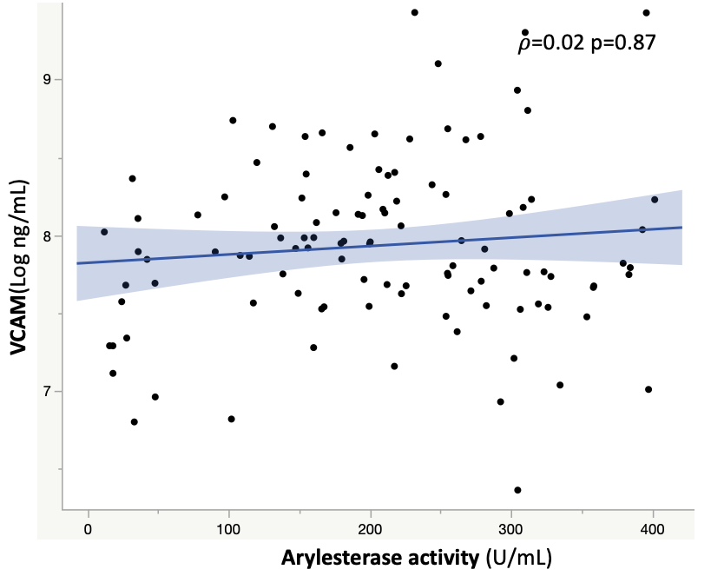 | 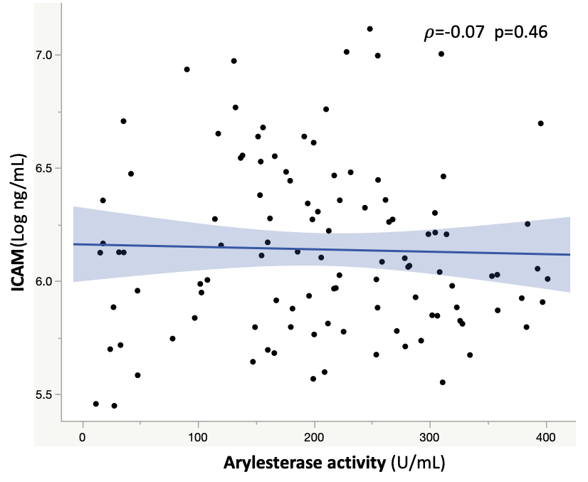
Spearman correlation coefficient ($ρ$) between PON1 by lactonase with log transformed CAM levels

