Achievement of treatment targets and maintenance of response with upadacitinib in patients with moderate-to-severe rheumatoid arthritis in real-world practice: 1-year outcomes from the UPHOLD observational study
Andrew Östör^{1,2}*, Eugen Feist^{3,4}, Prodromos Sidiropoulos⁵, Jérôme Avouac⁶, Martin Rebella^{7,8}, Rajaie Namas⁹, Erin McDearmon-Blondell¹⁰, Tianming Gao¹⁰, Ivan Lagunes-Galindo¹⁰, Sander Strengholt¹¹, Devy Zisman^{12,13}, and Suzan Attar¹⁴
Author details
¹Monash University & Emeritus Research, Melbourne, Victoria, Australia. ²Australian National University, Canberra, Australia. ³Experimental Rheumatology, Otto-von-Guericke University Magdeburg, Magdeburg, Germany. ⁴Department of Rheumatology and Clinical Immunology, Helios Fachklinik, Vogelsang-Gommern, Germany. ⁵Faculty of Medicine, University of Crete, Heraklion, Greece. ⁶Service de Rhumatologie, Hôpital Cochin, AP-HP.Centre – Université Paris Cité, Paris, France. ⁷Departamento de Medicina, Facultad de Medicina, Universidad de la República, Montevideo, Uruguay. ⁸Unidad de Enfermedades Autoinmunes Sistémicas, MUCAM, Montevideo, Uruguay. ⁹Medical Subspecialties Institute, Division of Rheumatology, Cleveland Clinic Abu Dhabi, Abu Dhabi, UAE. ¹⁰AbbVie Inc., North Chicago, Illinois, USA. ¹¹AbbVie B.V., Mijdrecht, Utrecht, The Netherlands. ¹²Rheumatology Unit, Carmel Medical Center, Haifa, Israel. ¹³Ruth and Bruce Rappaport Faculty of Medicine, Technion, Haifa, Israel. ¹⁴King Abdulaziz University, Jeddah, Saudi Arabia.

*Correspondence:
Andrew Östör
andrewostor@gmail.com
Suite 43, Cabrini Medical Centre, 183 Wattletree Rd, Malvern, VIC 3144, Australia

Target journal: Arthritis Research & Therapy
Trial registration: NCT04497597

Supplementary information
Supplementary Table 1. Proportions of patients by number of prior RA therapies
Type of RA therapy, n (%)ª | All participants  (FAS) | ts/bDMARD-experienced^{b} | TNFi-experienced only^{c} | tsDMARD-experienced^{d} | ts/bDMARD-naïve^{e}
n^{f} | 1523 | 1028 | 333 | 276 | 495
csDMARDs
1 | 562 (36.9) | 327 (31.8) | 108 (32.4) | 87 (31.5) | 235 (47.5)
2 | 393 (25.8) | 242 (23.5) | 85 (25.5) | 69 (25.0) | 151 (30.5)
≥ 3 | 248 (16.3) | 188 (18.3) | 43 (12.9) | 55 (19.9) | 60 (12.1)
bDMARDs
1 | 385 (25.3) | 385 (37.5) | 223 (67.0) | 66 (23.9) | 0 (0.0)
2 | 287 (18.8) | 287 (27.9) | 83 (24.9) | 59 (21.4) | 0 (0.0)
≥ 3 | 307 (20.2) | 307 (29.9) | 27 (8.1) | 102 (37.0) | 0 (0.0)
tsDMARDs
1 | 256 (16.8) | 256 (24.9) | 0 (0.0) | 256 (92.8) | 0 (0.0)
2 | 17 (1.1) | 17 (1.7) | 0 (0.0) | 17 (6.2) | 0 (0.0)
≥ 3 | 3 (0.2) | 3 (0.3) | 0 (0.0) | 3 (1.1) | 0 (0.0)
ªPatients may be counted multiple times between types of therapies. ^{b}Prior use of any tsDMARD or bDMARD; N = 1031. ^{c}Prior use of only a TNFi; N = 333. ^{d}Prior use of a tsDMARD; N = 279. ^{e}No prior use of any TNFi, bDMARD, or tsDMARD at baseline; N = 670. ^{f}Number of patients who answered “yes” for any prior RA therapy.
bDMARD biologic DMARD, csDMARD conventional synthetic DMARD, DMARD disease-modifying antirheumatic drug, FAS full analysis set, RA rheumatoid arthritis, TNFi tumor necrosis factor inhibitor, tsDMARD targeted synthetic DMARD.

Supplementary Table 2. Patients with RA achieving DAS28(CRP) remission (< 2.6) and LDA (≤ 3.2) by therapy strategy
Visit | Patients achieving DAS28(CRP) remissionª  n/non-missing (%) [95% CI] |  |  |  | Patients achieving DAS28(CRP) LDAª  n/non-missing (%) [95% CI]
Visit | In monotherapy |  | In combination therapy |  | In monotherapy |  | In combination therapy
Visit | mNRI^{b} | AO^{c} | mNRI^{b} | AO^{c} | mNRI^{b} | AO^{c} | mNRI^{b} | AO^{c}
3 months | N = 690  250/510 (49.0)  [44.7, 53.4] | N = 689  250/509 (49.1)  [44.8, 53.5] | N = 723  248/540 (45.9)  [41.7, 50.1] | N = 722  248/539 (46.0)  [41.8, 50.2] | N = 690  335/510 (65.7)  [61.6, 69.8] | N = 689  335/509 (65.8)  [61.7, 69.9] | N = 723  339/540 (62.8)  [58.7, 66.9] | N = 722  339/539 (62.9)  [58.8, 67.0]
6 months | N = 661  245/494 (49.6)  [45.2, 54.0] | N = 572  245/405 (60.5)  [55.7, 65.3] | N = 657  221/504 (43.8)  [39.5, 48.2] | N = 581  221/427 (51.8)  [47.0, 56.5] | N = 661  305/494 (61.7)  [57.5, 66.0] | N = 572  305/405 (75.3)  [71.1, 79.5] | N = 657  292/504 (57.9)  [53.6, 62.2] | N = 581  292/427 (68.4)  [64.0, 72.8]
9 months | N = 647  229/516 (44.4)  [40.1, 48.7] | N = 495  229/364 (62.9)  [57.9, 67.9] | N = 635  211/502 (42.0)  [37.7, 46.3] | N = 501  211/368 (57.3)  [52.3, 62.4] | N = 647  296/516 (57.4)  [53.1, 61.6] | N = 495  296/364 (81.3)  [77.3, 85.3] | N = 635  272/502 (54.2)  [49.8, 58.5] | N = 501  272/368 (73.9)  [69.4, 78.4]
12 months | N = 636  214/519 (41.2)  [37.0, 45.5] | N = 445  214/326 (65.6)  [60.5, 70.8] | N = 627  188/501 (37.5)  [33.3, 41.8] | N = 458  188/331 (56.8)  [51.5, 62.1] | N = 636  268/519 (51.6)  [47.3, 55.9] | N = 445  268/326 (82.2)  [78.1, 86.4] | N = 627  246/501 (49.1)  [44.7, 53.5] | N = 458  246/331 (74.3)  [69.6, 79.0]
ªThe proportion of patients who achieved remission/LDA was calculated using the number of patients with non-missing data for the disease activity score as the denominator. ^{b}Patients who continued to receive UPA at 3 months or discontinued the study prematurely. ^{c}Patients who continued to receive UPA at 3 months.
AO as observed, CI confidence interval, DAS28(CRP) disease activity score in 28 joints using C-reactive protein, LDA low disease activity, mNRI modified non-responder imputation, RA rheumatoid arthritis, UPA upadacitinib.
Supplementary Table 3. Malignancy events through 12 months (FAS)
Type of malignancy | Number of events  (N = 29)
Breast cancer | 3
Colon/rectal cancerª | 3
Renal cancer | 3
Hematological malignancies^{b} | 3
Ovarian cancer | 2
Oropharyngeal cancer | 1
Pancreatic carcinoma (metastatic) | 1
Prostate cancer | 1
Thyroid cancer | 1
Bone neoplasm | 1
Malignant melanoma | 1
Non-melanoma skin cancer^{c} | 9
ªIncludes events listed as: colorectal adenocarcinoma (n = 1); adenocarcinoma of colon (n = 1); one event listed as “adenocarcinoma” (organ not specified). ^{b}Includes events listed as: “acute myeloid leukemia” (n = 1); “Hodgkin's disease” (n = 1); “non-Hodgkin's lymphoma” (n = 1). ^{c}Includes events listed as: “basal cell carcinoma” (n = 4); “neoplasm skin” (n = 1); “skin cancer” (n = 1); “squamous cell carcinoma of skin” (n = 2); two events listed as “squamous cell carcinoma” (organ not specified).
FAS full analysis set.

Supplementary Table 4. Risk factors in the medical history of patients with MACE and VTE
Type of event | Patient age, years | Sex | BMI, kg/m² | Smoking status | HTN |  | DM | HDL < 40 mg/dL | LDL > 130 mg/dL
MACE
Acute MI – CV death | 74 | F | 19.8 | Current | N | N |  | Y | N
Sudden CV death | 35 | F | 22.2 | Current | N | N |  | ND | ND
Cerebrovascular accident | 60 | F | 27.8 | Former | Y | N |  | ND | ND
MI – CV death | 82 | F | 19.9 | Never | Y | N |  | Y | Y
Ischemic cerebral infarction | 70 | F | 28.8 | Never | Y | Y |  | ND | ND
Intracranial hemorrhage | 80 | M | 21.5 | Never | Y | N |  | ND | ND
VTE
PE | 84 | M | 22.7 | Current | N | N |  | ND | ND
PE | 62 | M | 19.3 | Current | Y | N |  | N | N
PE | 66 | F | 27.3 | Current | N | N |  | ND | ND
PE | 83 | F | 25.3 | Never | Y | N |  | ND | ND
PE | 80 | F | 25.6 | Never | Y | N |  | N | Y
PEª | 74 | F | 27.1 | Never | N | N |  | ND | ND
PE | 62 | M | 25.1 | Current | N | N |  | ND | ND
PE and DVT | 66 | F | 30.5 | Former | Y | Y |  | ND | ND
DVT | 50 | F | 37.9 | Never | N | N |  | N | N
DVT | 65 | F | 23.4 | Current | N | N |  | ND | ND
DVT^{b} | 46 | M | 29.4 | Never | N | N |  | N | Y
ªPatient also suffered from portal vein thrombosis. ^{b}Patient had hyperhomocysteinemia.
BMI body mass index, CV cardiovascular, DM diabetes mellitus, DVT deep vein thrombosis, F female, HDL high-density lipoprotein, HTN hypertension, LDL low-density lipoprotein, M male, MACE major adverse cardiovascular events, MI myocardial infarction, N no, ND not determined, PE pulmonary embolism, VTE venous thromboembolic events, Y yes.
Supplementary Table 5. Proportion of patients with investigator-reported clinically significantly abnormalª laboratory test results by analysis visit (FAS)
Parameter, n/N (%) | Baseline | 6 months | 12 months
Hematology
Hemoglobin | 33/1445 (2.3) | 10/1058 (0.9) | 4/899 (0.4)
Erythrocyte sedimentation rate | 256/1295 (19.8) | 53/944 (5.6) | 37/770 (4.8)
Absolute lymphocyte count | 5/1214 (0.4) | 3/891 (0.3) | 5/761 (0.7)
Absolute neutrophil count | 3/1190 (0.3) | 7/874 (0.8) | 2/746 (0.3)
Chemistry
Serum creatinine | 6/1359 (0.4) | 5/975 (0.5) | 9/822 (1.1)
Creatine phosphokinase | 5/307 (1.6) | 4/302 (1.3) | 4/275 (1.5)
Alanine aminotransferase | 7/1375 (0.5) | 8/1018 (0.8) | 2/868 (0.2)
Aspartate aminotransferase | 3/1197 (0.3) | 4/905 (0.4) | 1/779 (0.1)
Blood lipid levels
Total cholesterol | 28/650 (4.3) | 30/569 (5.3) | 19/470 (4.0)
Low-density lipoprotein | 24/492 (4.9) | 22/431 (5.1) | 21/362 (5.8)
High-density lipoprotein | 7/507 (1.4) | 7/459 (1.5) | 0
Triglycerides | 14/573 (2.4) | 7/512 (1.4) | 12/427 (2.8)
C-reactive protein | 356/1485 (24.0) | 60/1093 (5.5) | 39/906 (4.3)
ªClinical significance was determined by the investigator and defined as a newly observed unfavorable and unintended laboratory abnormality.
FAS full analysis set.
Supplementary Fig. 1 Study design
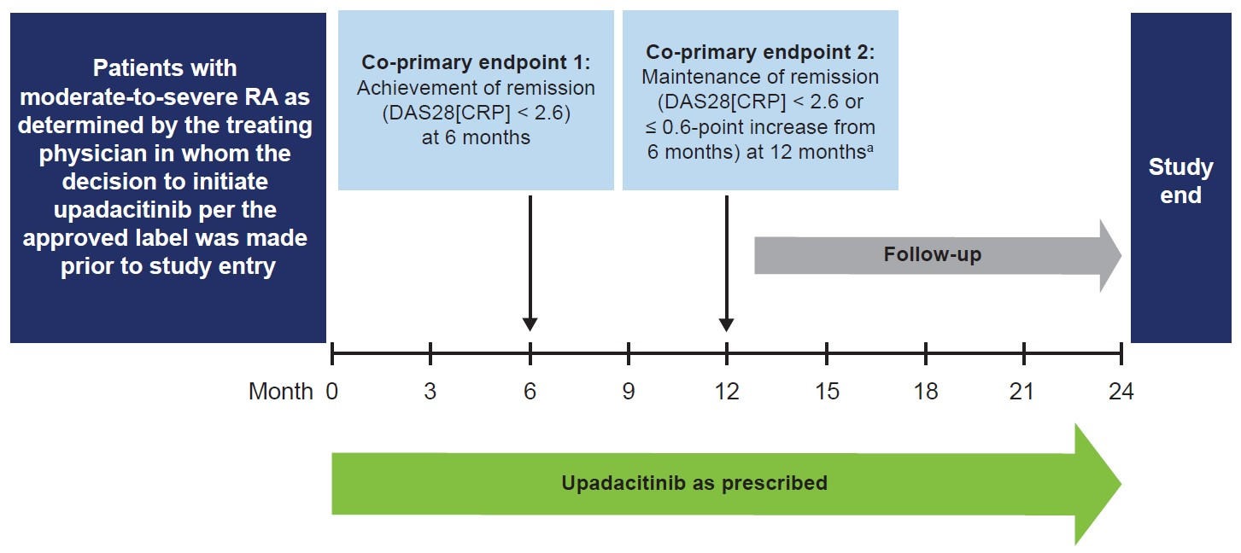
ªIn patients who achieved DAS28(CRP) remission at 6 months.
DAS28(CRP) disease activity score in 28 joints using C-reactive protein, RA rheumatoid arthritis.

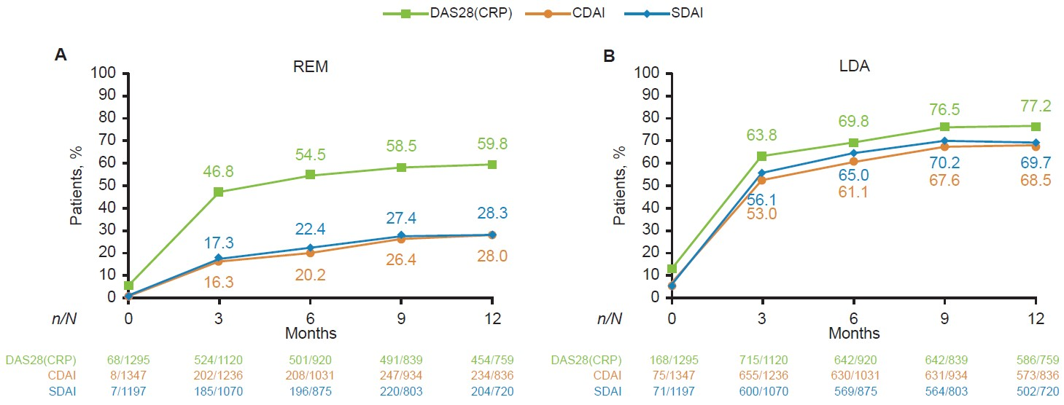
Supplementary Fig. 2 Proportions of patients with RA achieving (A) remission and (B) LDA by analysis visit (AO)

The proportion of patients who achieved each level of disease activity was calculated using the number of patients with non-missing data for the disease activity score as the denominator.
DAS28(CRP) remission: < 2.6; DAS28(CRP) LDA: ≤ 3.2. CDAI remission: ≤ 2.8; CDAI LDA: ≤ 10.0. SDAI remission: ≤ 3.3; SDAI LDA: ≤ 11.0.
AO as observed, CDAI clinical disease activity index, DAS28(CRP) disease activity score in 28 joints using C-reactive protein, LDA low disease activity, RA rheumatoid arthritis, REM remission, SDAI simplified disease activity index.
Supplementary Fig. 3 Subgroup analysis of achievement (A,B) and maintenance (C,D) of DAS28(CRP) remission (<2.6) and LDA (≤3.2)
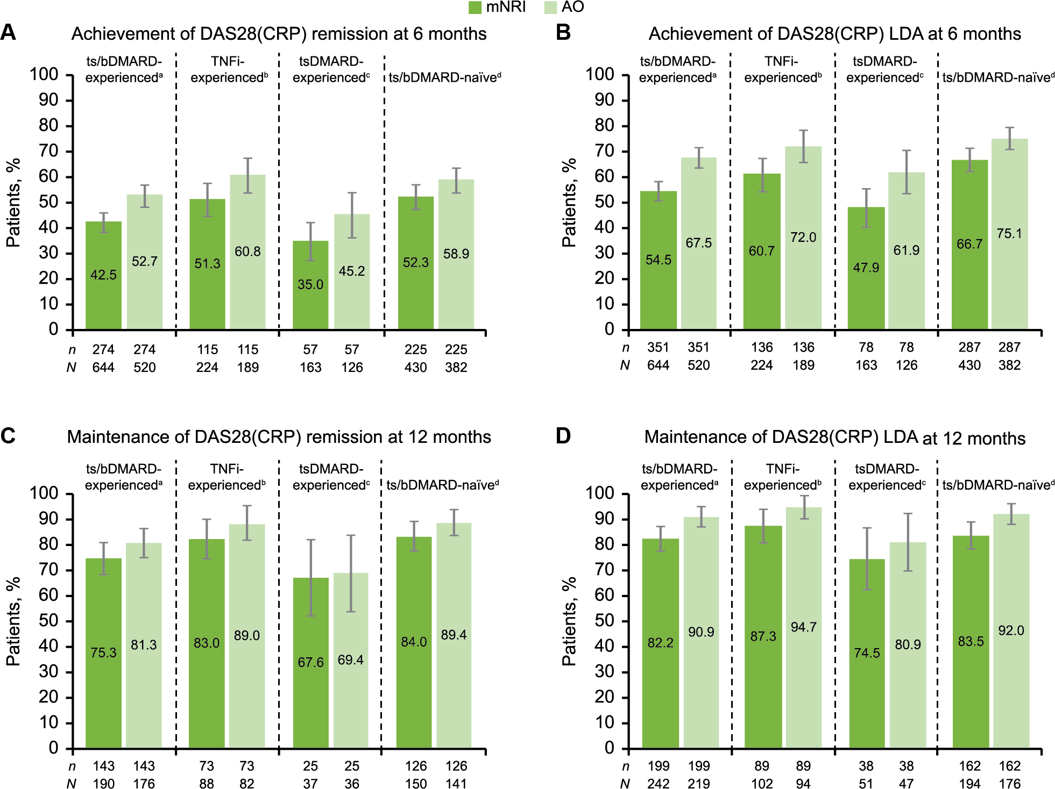

Error bars represent 95% confidence intervals.
ªPrior use of any tsDMARD or bDMARD; N = 1031. ^{b}Prior use of only a TNFi; N = 333. ^{c}Prior use of a tsDMARD; N = 279. ^{d}No prior use of any TNFi, bDMARD, or tsDMARD at baseline; N = 670.
AO as observed, bDMARD biologic DMARD, DAS28(CRP) disease activity score in 28 joints using C-reactive protein, DMARD disease-modifying antirheumatic drug, LDA low disease activity, mNRI modified non-responder imputation, RA rheumatoid arthritis, TNFi tumor necrosis factor inhibitor, tsDMARD targeted synthetic DMARD.

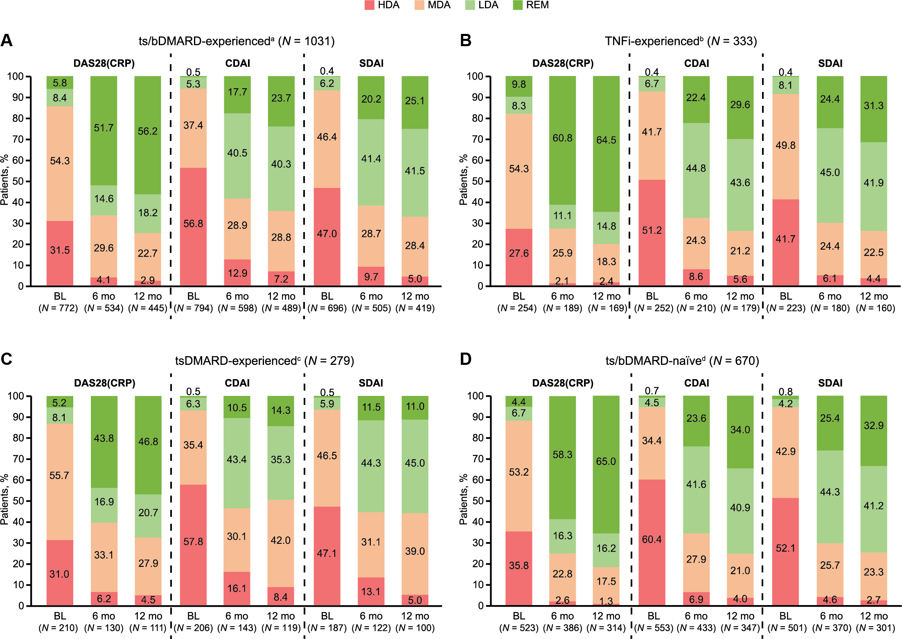
Supplementary Fig. 4 Subgroup analysis of disease activity in (A) ts/bDMARD-experienced, (B) TNFi-experienced, (C) tsDMARD-experienced, (D) ts/bDMARD-naïve patients

DAS28(CRP) remission: < 2.6; LDA: 2.6 ≤ DAS28(CRP) ≤ 3.2; MDA: 3.2 < DAS28(CRP) ≤ 5.1; HDA: > 5.1. CDAI remission: ≤ 2.8; LDA: 2.8 < CDAI ≤ 10.0; MDA: 10.0 < CDAI ≤ 22.0; HDA: > 22.0. SDAI remission: ≤ 3.3; LDA: 3.3 < SDAI ≤ 11.0; MDA: 11.0 < SDAI ≤ 26.0; HDA: > 26.0.
Data are presented using the AO approach. The proportion of patients who achieved each level of disease activity was calculated using the number of patients with non-missing data for the disease activity score as the denominator. The sum of the proportions may not total 100.0% due to rounding.
ªPrior use of any tsDMARD or bDMARD. ^{b}Prior use of only a TNFi. ^{c}Prior use of a tsDMARD. ^{d}No prior use of any TNFi, bDMARD, or tsDMARD at baseline.
AO as observed, bDMARD biologic DMARD, BL baseline, CDAI clinical disease activity index, DAS28(CRP) disease activity score in 28 joints using C-reactive protein, DMARD disease-modifying antirheumatic drug, HDA high disease activity, LDA low disease activity, MDA moderate disease activity, mo month, REM remission, SDAI simplified disease activity index, TNFi tumor necrosis factor inhibitor, tsDMARD targeted synthetic DMARD.

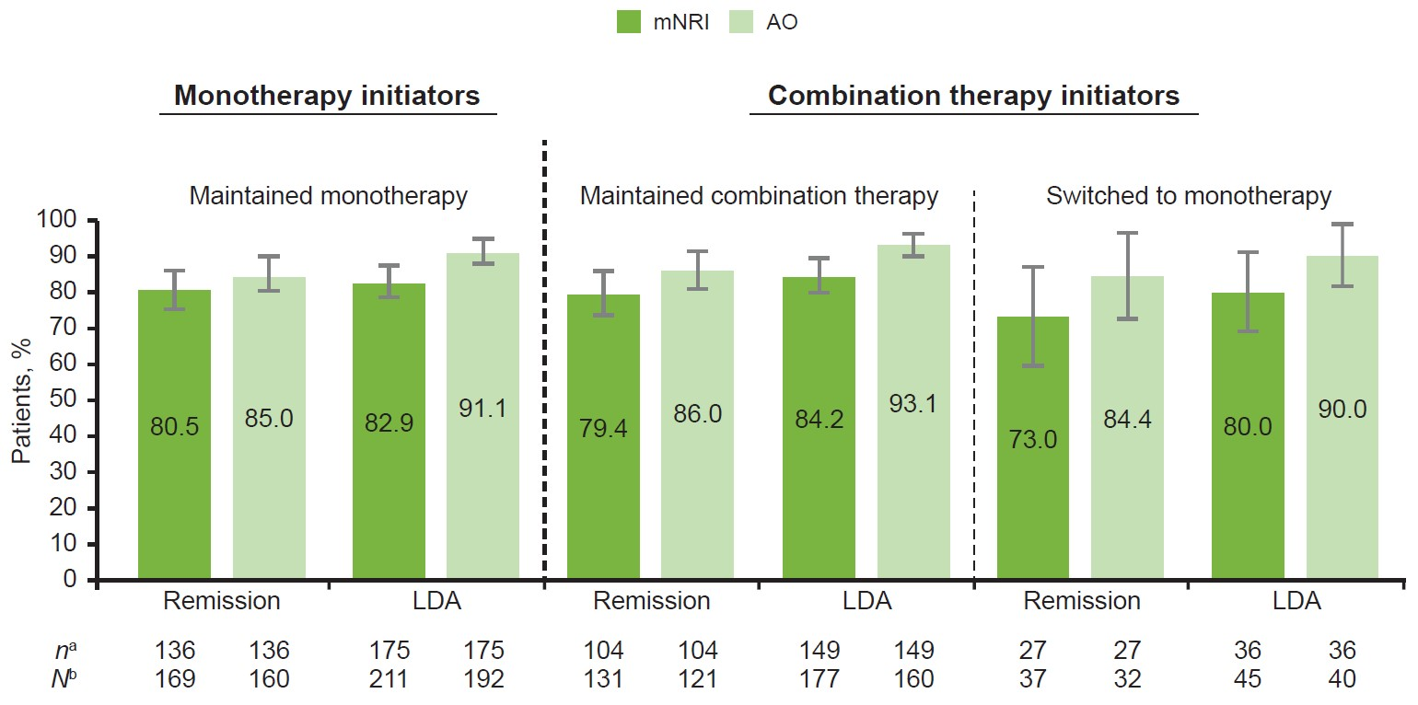
Supplementary Fig. 5 Maintenance of DAS28(CRP) remission (<2.6) and LDA (≤3.2) at 12 months by baseline treatment strategy
Of patients who initiated UPA as monotherapy and switched to combination therapy, two out of four maintained remission, and three out of six maintained LDA at 12 months (numbers not shown).
Error bars represent 95% confidence intervals.
ªNumber of patients who maintained remission/LDA or had no more than a 0.6-point increase in their DAS28(CRP) at 12 months. ^{b}Number of patients initiating UPA at baseline as monotherapy (± glucocorticoids) or combination therapy (conventional synthetic DMARDs ± glucocorticoids), who achieved DAS28(CRP) remission at 6 months, had DAS28(CRP) data available at 6 and 12 months, and continued receiving UPA at 12 months (or discontinued between 6 and 12 months), who maintained or did not maintain their initial therapy strategy at 12 months.
AO as observed, DAS28(CRP) disease activity score in 28 joints using C-reactive protein, DMARD disease-modifying antirheumatic drug, LDA low disease activity, mNRI modified non-responder imputation, UPA upadacitinib.

Supplementary Fig. 6 EAIRs of TEAEs in patients with moderate-to-severe RA treated with UPA 15 mg
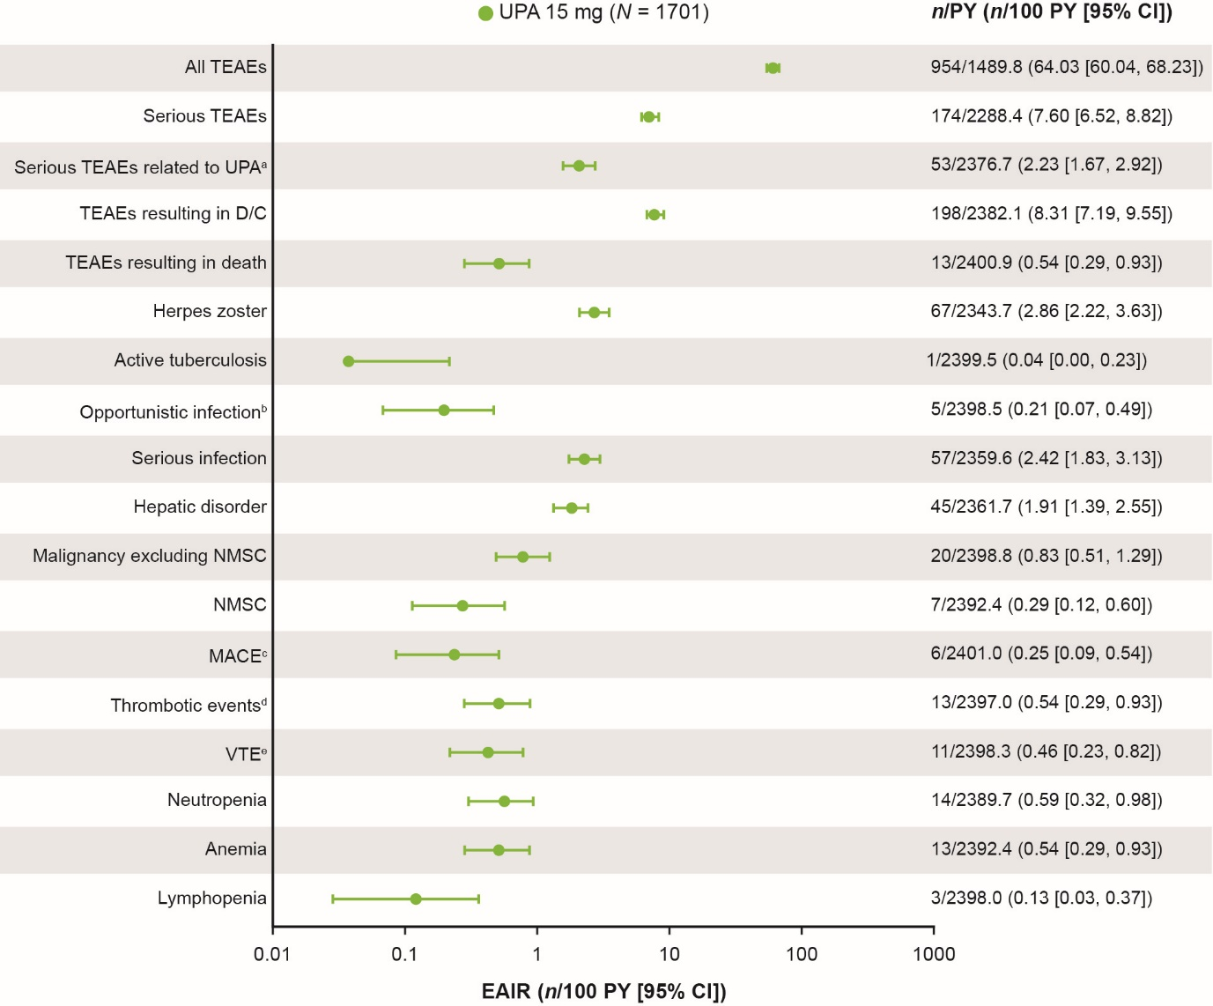
Safety was evaluated by assessing all TEAEs (AEs occurring after the first dose of study drug and up to 30 days after the last dose of study drug) recorded in the FAS up to the data cutoff date of August 10, 2023. There were no reported events of gastrointestinal perforation.
ªReasonable possibility. ^{b}Excluding herpes zoster and active tuberculosis. ^{c}Includes cardiovascular death, non-fatal myocardial infarction, and non-fatal stroke. ^{d}Includes VTE, other venous thrombosis, and arterial thromboembolic events. ^{e}Includes DVT and PE.
AE adverse event, CI confidence interval, D/C discontinuation, DVT deep vein thrombosis, E event, EAIR exposure-adjusted incidence rate, FAS full analysis set, MACE major adverse cardiovascular events, NMSC non-melanoma skin cancer, PE pulmonary embolism, PY patient-years, RA rheumatoid arthritis, TEAE treatment-emergent adverse event, UPA upadacitinib, VTE venous thromboembolic events.

