Table S1. LASSO logistic regression analysis of RA and RA-OP in the training set
Variables | B score | Wald score | P | OR | OR（95% CI）
 |  |  |  |  | Lower | Upper
Female | 0.948 | 8.184 | 0.004 | 2.579 | 1.348 | 4.937
Age | 0.052 | 16.803 | <.001 | 1.054 | 1.028 | 1.08
β-CTX | 0.004 | 12.794 | <.001 | 1.004 | 1.002 | 1.006
ACPA | 0.001 | 18.847 | <.001 | 1.001 | 1.001 | 1.002
TG | 0.584 | 14.599 | <.001 | 1.794 | 1.329 | 2.421
PINP | -0.004 | 0.375 | 0.54 | 0.996 | 0.982 | 1.01
OC | -0.015 | 0.403 | 0.526 | 0.986 | 0.942 | 1.031
HDL-C | 0.157 | 0.167 | 0.683 | 1.169 | 0.552 | 2.479
Constant | -8.732 | 50.921 | <.001 | / | / | /
ACPA: anti-cyclic citrullinated peptide antibody; HDL-C: high-density lipoprotein cholesterol; OC: osteocalcin; PINP: N-terminal propeptide of type I procollagen; TG: triglycerides; β-CTX: beta C-terminal cross-linked peptide.
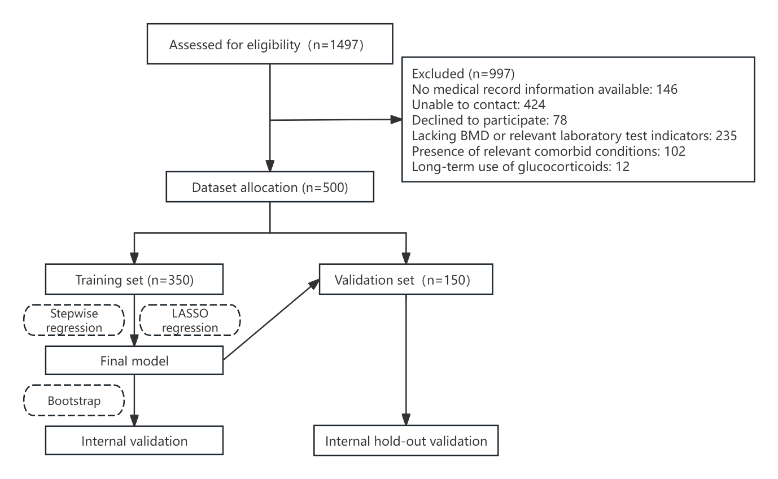
Figure S1. Study Flowchart.
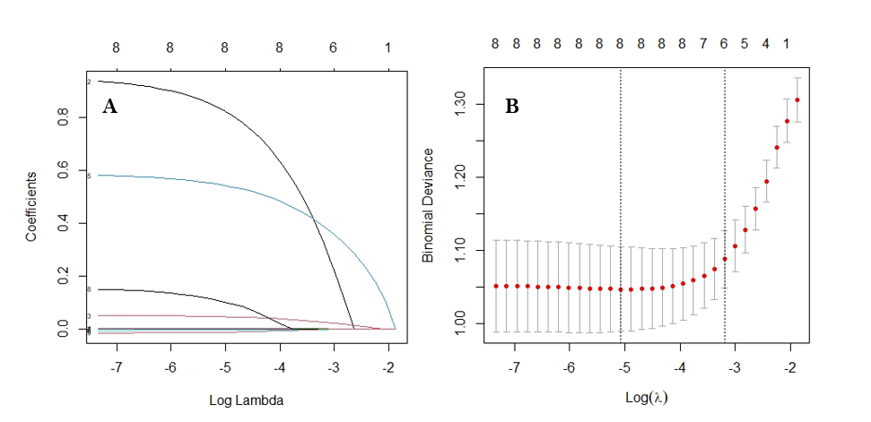
Figure S2. A: LASSO coefficient profiles of the 8 risk factors. B: Number of variables corresponding to different λ values. The left dashed line corresponds to the number of variables that minimizes the binomial deviance.
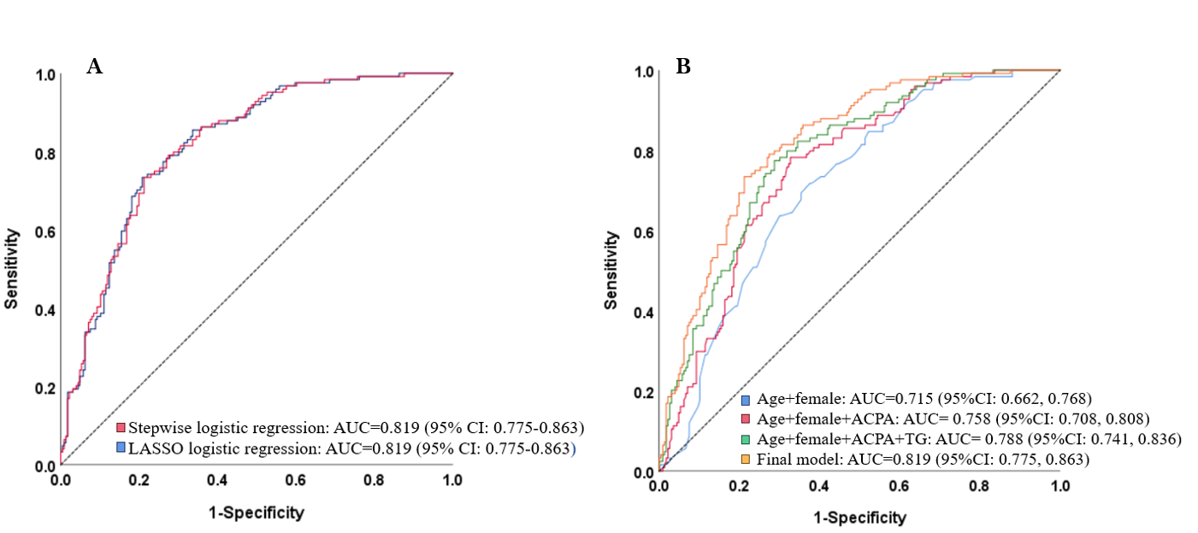
Figure S3. A: Comparison of ROC curves for the stepwise logistic regression and LASSO logistic regression models. Red line: Stepwise logistic regression includes female sex, age, β-CTX, PINP, ACPA, and TG, with an AUC of 0.819 (95% CI: 0.775-0.863); Blue line: LASSO regression includes female sex, age, β-CTX, PINP, ACPA, TG, HDL-C, and OC, also with an AUC of 0.819 (95% CI: 0.775-0.863). B: Comparison of the ROC curves between the final model and simpler models. The orange curve represents the final model with an AUC of 0.819 (95% CI: 0.775, 0.863). The blue model is the simplest model, including only age and gender, with an AUC of 0.715 (95% CI: 0.662, 0.768). The red model adds ACPA to the blue model, resulting in an AUC of 0.758 (95% CI: 0.708, 0.808). The green model further incorporates both ACPA and TG, yielding an AUC of 0.788 (95% CI: 0.741, 0.836).
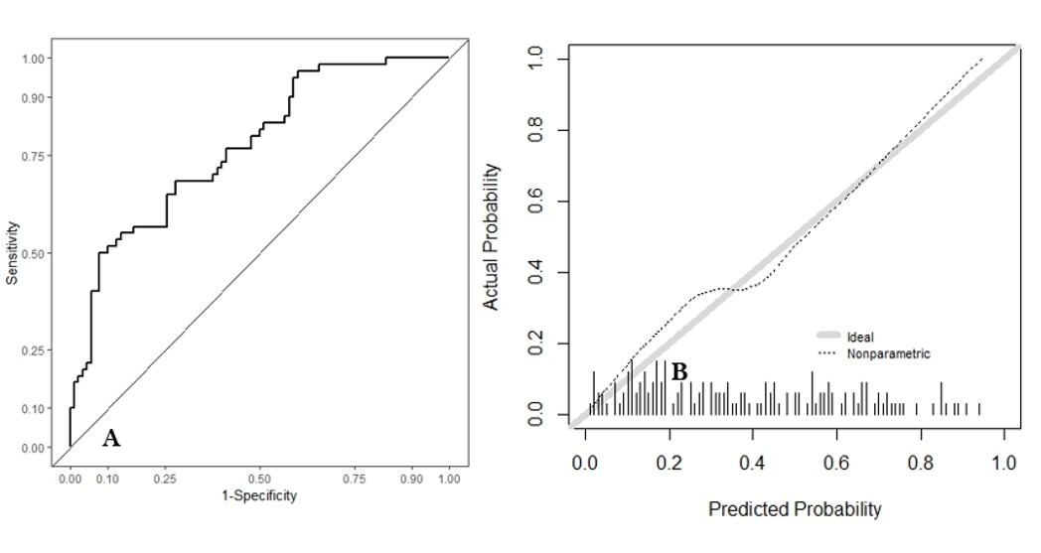
Figure S4. ROC curve (A) and calibration curve (B) of the model in Internal hold-out validation
(A) The ROC curve of the model during internal hold-out validation shows an AUC of 0.772 (95% CI: 0.697-0.847), indicating that the model exhibits good discriminative ability. (B) The calibration curve of the model during internal hold-out validation features the diagonal line representing the reference line, which indicates the actual occurrence of OP in RA patients, and the black dashed line representing the model's actual predictions. The calibration curve is closely aligned with the reference line, suggesting that the model's predictive accuracy is acceptable.
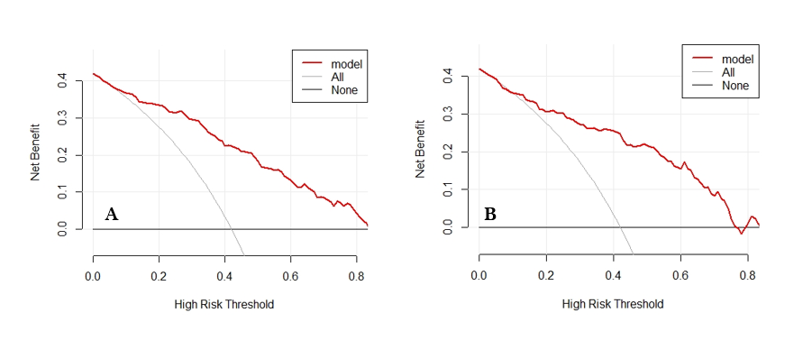
Figure S5. Clinical decision curves of the model in the training set (A) and validation set (B).
(A) The DCA curve of the model in the training set. (B) The DCA curve of the model in the validation set. In the curves, the x-axis represents the threshold probability, while the y-axis indicates the net benefit. In addition to the model curve, there are two extreme lines: the black horizontal line signifies a scenario where all samples are classified as negative, indicating that the probability of RA patients developing OP is below the threshold probability; therefore, no bone mineral density assessments are conducted, resulting in an overall net benefit of zero. The gray curve represents a scenario where all patients undergo bone mineral density assessments, yielding a net benefit represented by a negatively sloped line. The red thick line denotes the predictive model. The model curves in both the training and validation sets demonstrate superior performance compared to the two extreme lines, suggesting a favorable overall benefit for the population.

