Supporting Information
Title: Nocturnal administration of baricitinib leads to rapid drug responses in rheumatoid arthritis: A multicenter non-randomized controlled study.

Autors: Teppei Hashimoto¹, Kazuyuki Tsuboi², Takeo Abe¹, Takahiro Yoshikawa^{1,3}, Kazuteru Noguchi¹, Tetsuya Furukawa¹, Koji Tateishi⁴, Yasuhiro Terashima⁴, Nao Sibanuma⁵, Naoto Azuma¹, Takashi Yamane⁶, Kiyoshi Matsui^{1,3}, Akira Hashiramoto⁷
Departments and institutions
¹ Department of Diabetes, Endocrinology and Clinical Immunology, School of Medicine, Hyogo Medical University, Nishinomiya, Japan
² Department of rheumatology, Kobe City Medical Center West Hospital, Kobe, Japan
³ Department of rheumatology, Amagasaki Central Hospital, Amagasaki, Japan
⁴ Department of Orthopedics, Konan Kakogawa Hospital, Kakogawa Japan
⁵ Department of Orthopedics, Kobe Kaisei Hospital, Kobe, Japan
⁶ Department of rheumatology, Kakogawa Central City Hospital, Kakogawa Japan
⁷ Department of Biophysics, Kobe University Graduate School of Health Sciences, Kobe, Japan

Supplemental figure S1

A
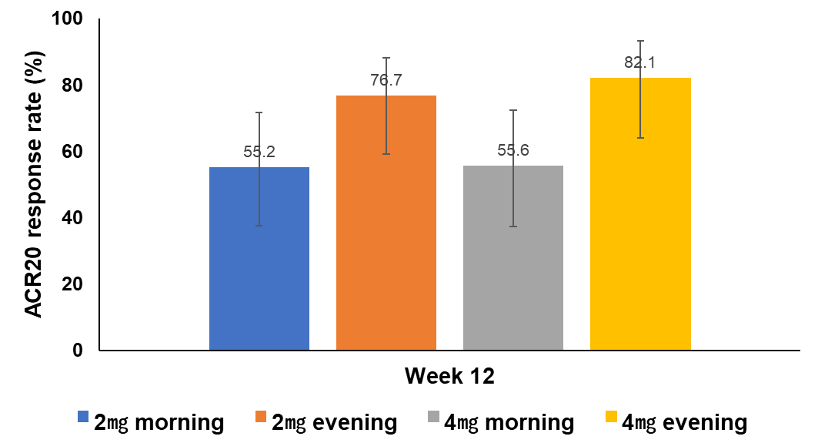
B

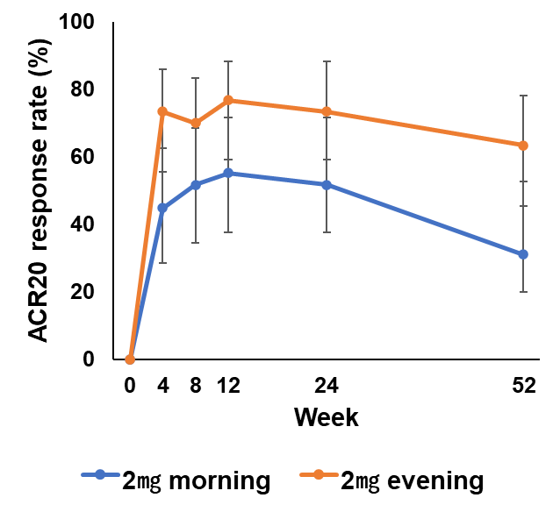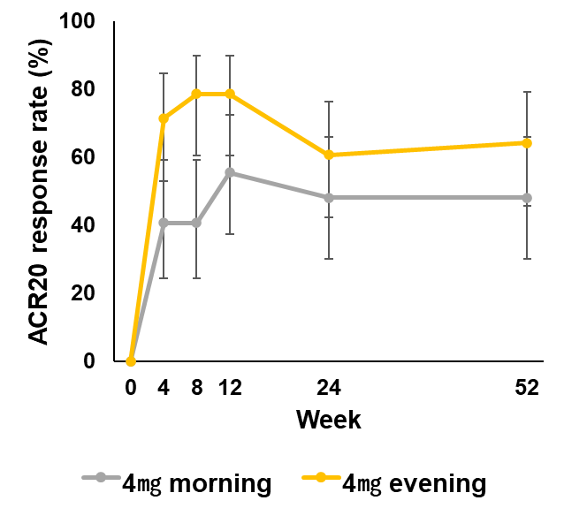
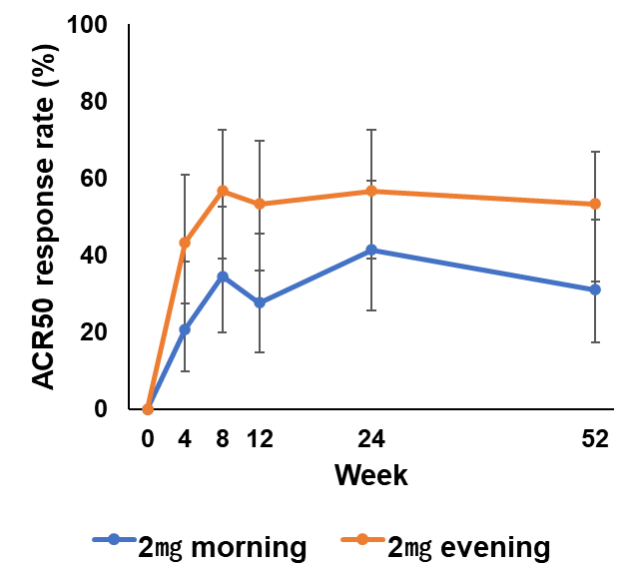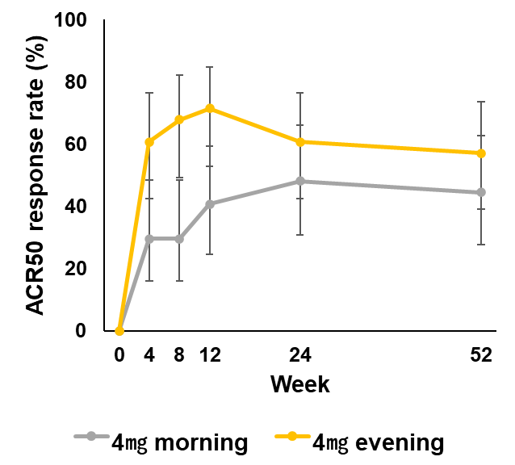
C
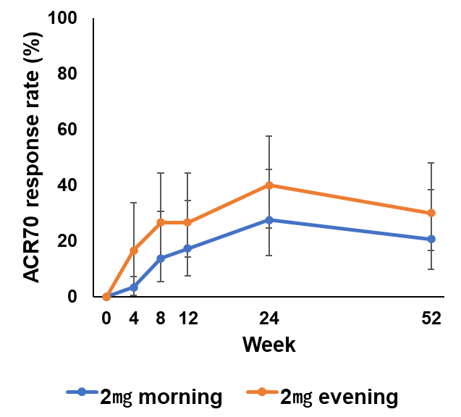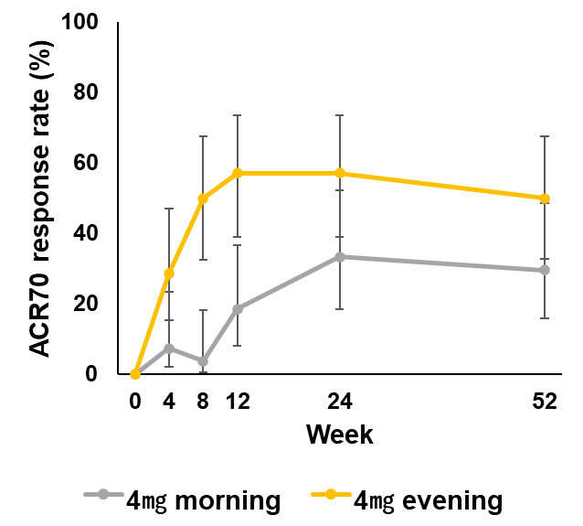
D
Improvement rate in the American College of Rheumatology (ACR) criteria before inverse probability of treatment weighted: (A) proportion of patients who achieved ACR20 at week 12; (B) proportion of patients who achieved ACR20 at 52 weeks; (C) proportion of patients who achieved ACR50 at 52 weeks; and (D) proportion of patients who achieved ACR70 at 52 weeks. Error bars represented 95% confidence interval; n = 29, 30, 27, and 28 for 2 mg baricitinib in the morning, 2 mg baricitinib in the evening, 4 mg baricitinib in the morning, and 4 mg baricitinib in the evening, respectively. ACR20/50/70, 20, 50, and 70% improvement in the American College of Rheumatology criteria.

Supplemental figure S2
A
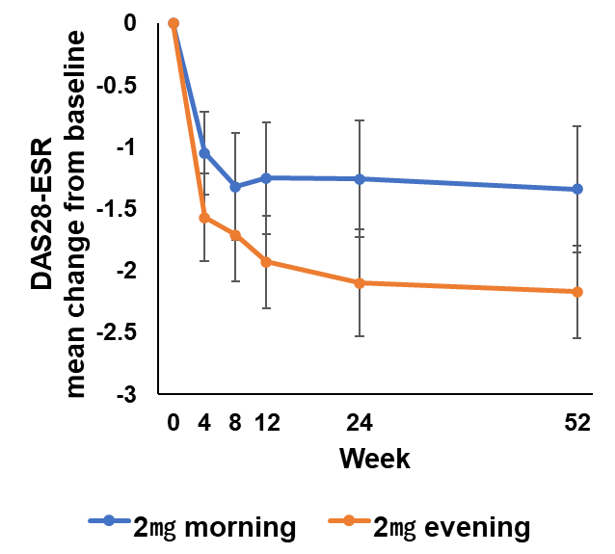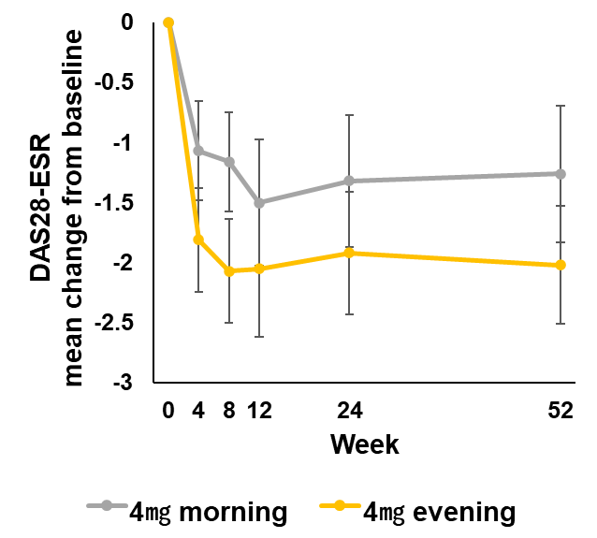
B
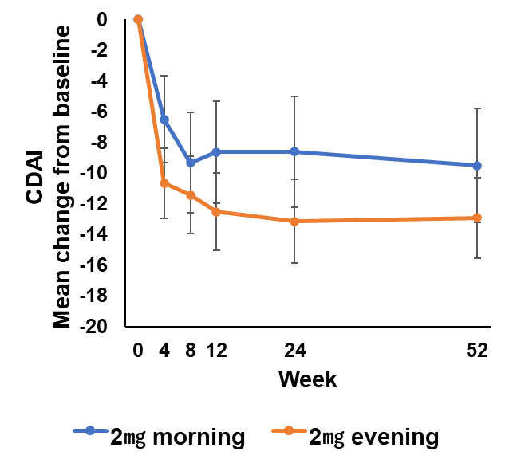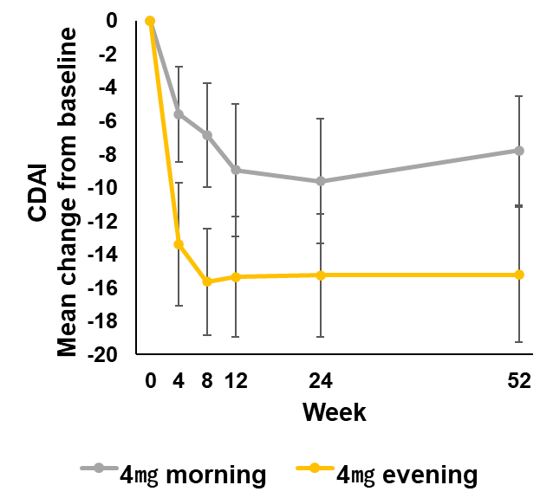

Changes in (A) DAS28-ESR and (B) CDAI from baseline to weeks 4, 8, 12, 24, and 52 before the inverse probability of treatment weighted. Results are expressed as the mean ± 95% confidence interval. n = 29, 30, 27, and 28 for 2 mg baricitinib in the morning, 2 mg baricitinib in the evening, 4 mg baricitinib in the morning, and 4 mg baricitinib in the evening, respectively.

