Source data of Fig. 1B
The first source data of Western blot.
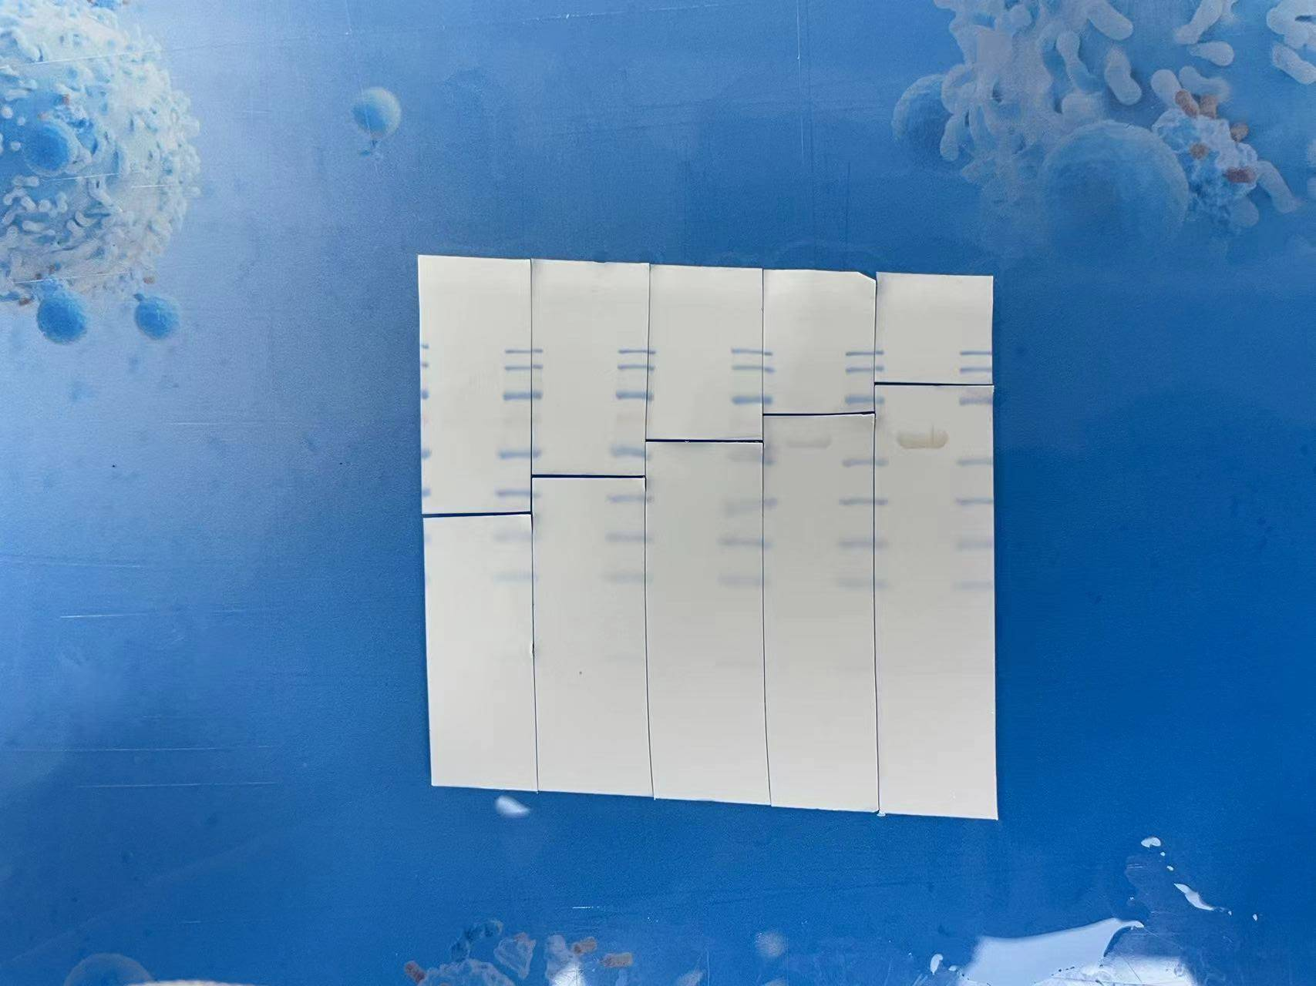
15
25
35
55
Samples 7 5 4 3 2
40
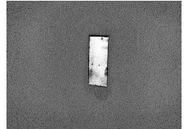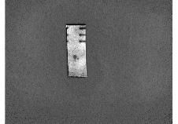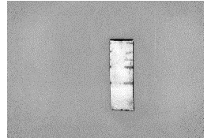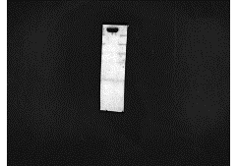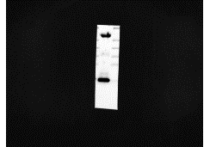
IFN-α（19.2kDa）
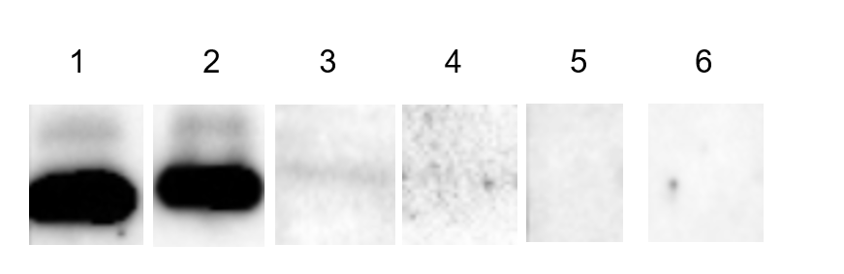
Note: To distinguish each sample, the original strips were cut at the different location before imaging. Additionally, sample 2, 3 and 4 were shown in the result of Fig. 1B, while sample 5 and 7 were excluded since the imperfect band results. All samples were exposed to the same time.

The second source data of Western blot.
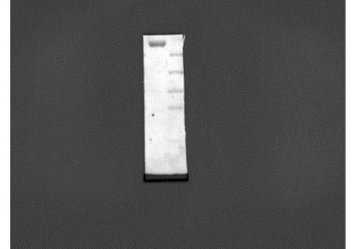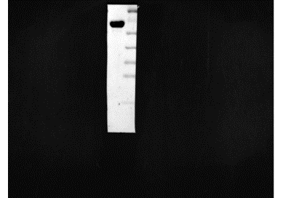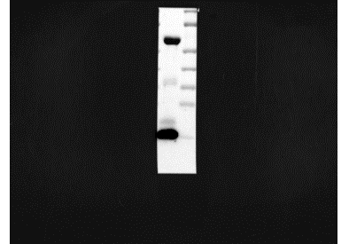
IFN-α（19.2kDa）
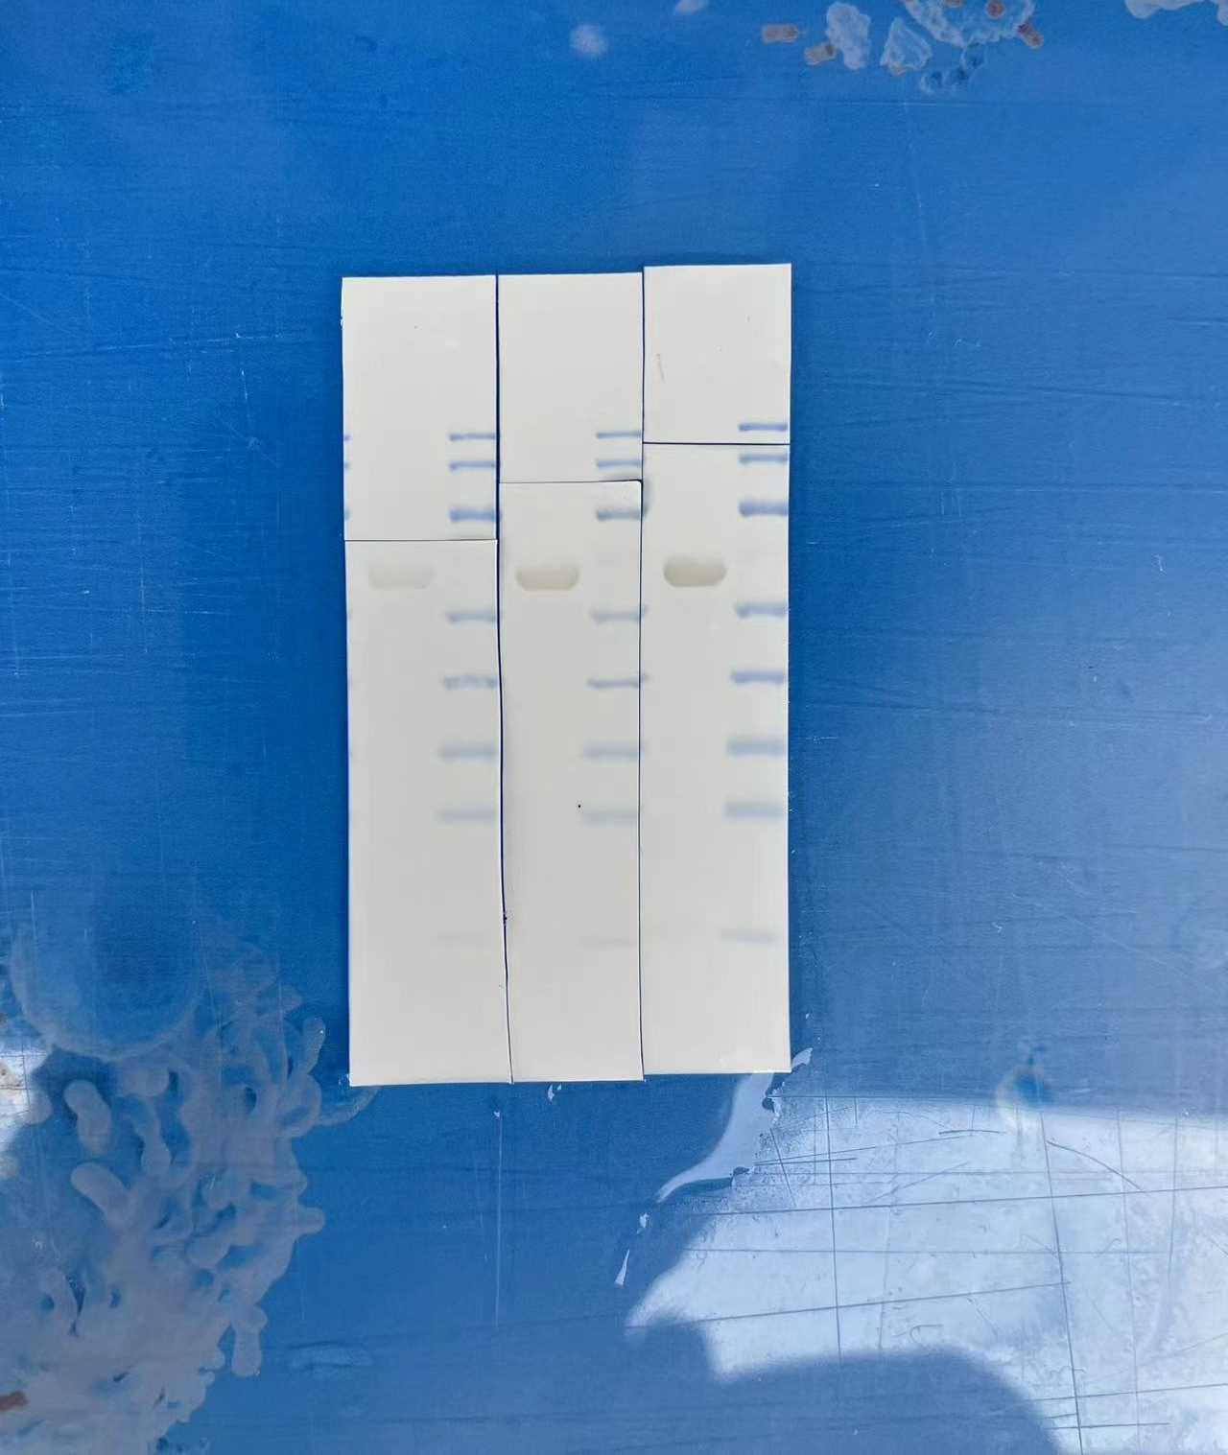
15
25
35
40
55
Samples 6 5 1
Note: To distinguish each sample, the original strips were cut at the different location before imaging. Sample 5 was the same with that in the first source data. All samples were exposed to the same time with that in the first source data.

