Additional file 1: Supplementary Figures

Supplementary Figure S1

Title: Representative image examples of entheseal Doppler grade 0 to 3
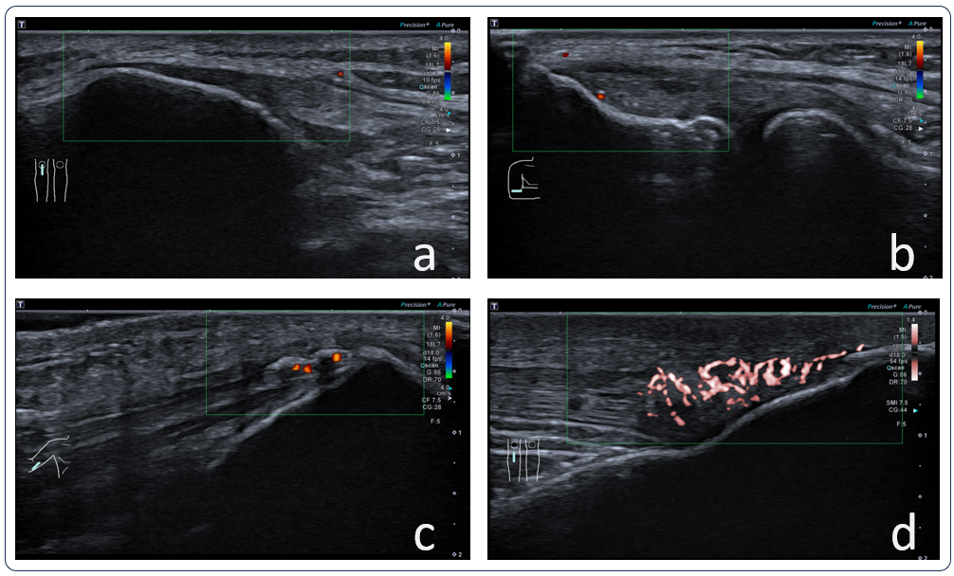
Doppler signals were scored semi-quantitatively from 0 to 3. In picture a, the enthesis of the proximal patellar ligament is seen without Doppler signals, graded as a 0. In b, the common extensor enthesis at the lateral humeral epicondyle is shown with < 2 punctiform Doppler signals with no confluent Doppler signal and thus graded as 1. In c, the distal triceps enthesis is graded as 2, which means 2-4 punctiform Doppler signals or 1 confluent Doppler signal. In picture d, the distal insertion of the patellar ligament is displayed with > 4 punctiform Doppler signals or > 1 confluent Doppler signals and therefore graded as 3. In images a-c, color Doppler ultrasound (CDU) is shown, while d illustrates the smooth microvascular imaging (SMI) application.

Supplementary Figure S2

Title: Definition of the enthesis as seen on ultrasound
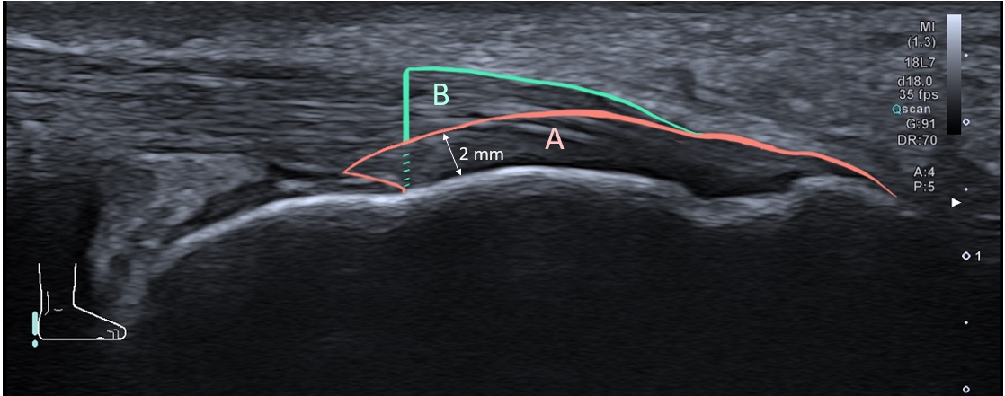

Doppler scores were graded within a 2 mm margin from cortical bone, defined as the enthesis (A), and proximal to this margin (B), defined as outside the enthesis.

