Supplementary Table S1.
Patients’ characteristics
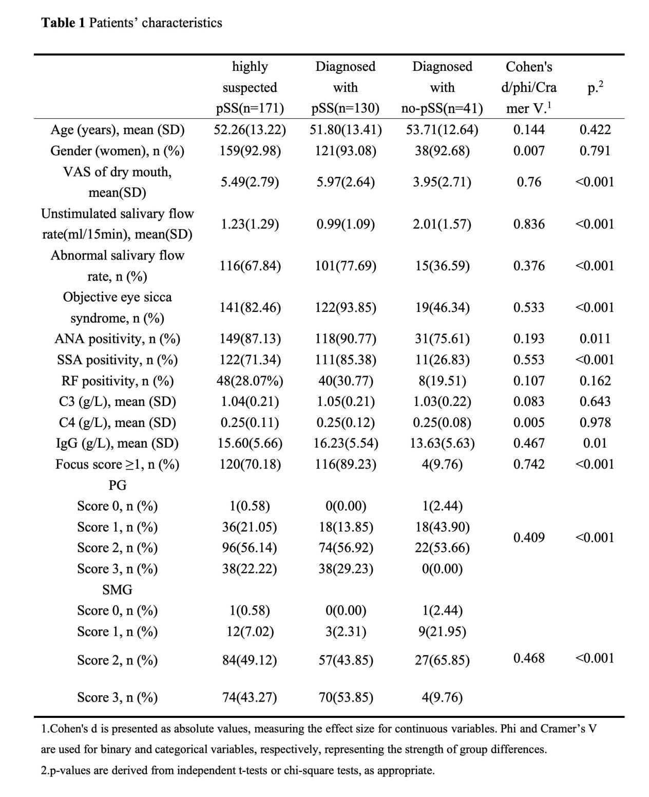

Supplementary Table S2.
Efficiency of disease diagnosis
 | Cut-off value | Sensitivity | Specificity | PPV | NPV | Accuracy
parotid gland | Grade 1 | 1 | 0.02 | 0.76 | 1 | 0.77
parotid gland | Grade 2 | 0.85 | 0.46 | 0.83 | 0.49 | 0.75
parotid gland | Grade 3 | 0.27 | 1 | 1 | 0.30 | 0.44
parotid gland + SSA | Grade 1 | 1 | 0 | 0.76 | NA | 0.76
parotid gland + SSA | Grade 2 | 0.96 | 0.27 | 0.81 | 0.69 | 0.80
parotid gland + SSA | Grade 3 | 0.86 | 0.73 | 0.91 | 0.63 | 0.83
submandibular gland | Grade 1 | 1 | 0.02 | 0.76 | 1 | 0.77
submandibular gland | Grade 2 | 0.95 | 0.24 | 0.80 | 0.59 | 0.78
submandibular gland | Grade 3 | 0.52 | 0.90 | 0.94 | 0.37 | 0.61
submandibular gland + SSA | Grade 1 | 1 | 0 | 0.76 | NA | 0.76
submandibular gland + SSA | Grade 2 | 0.99 | 0.17 | 0.80 | 0.78 | 0.85
submandibular gland + SSA | Grade 3 | 0.89 | 0.66 | 0.89 | 0.66 | 0.84
SSA |  | 0.85 | 0.73 | 0.91 | 0.61 | 0.82

Supplementary Table S3.
Correlation between the length and area of anechoic region and diagnosis, biopsy results, and focus score
 |  | diagnosis |  | biopsy results |  | focus score
 |  | coefficient | P | coefficient | P | coefficient | P
PG | length | 0.25 | 0.001 | 0.27 | <0.001 | 0.25 | 0.001
 | area | 0.22 | 0.004 | 0.26 | 0.001 | 0.25 | 0.001
SMG | length | 0.31 | <0.001 | 0.25 | 0.001 | 0.24 | 0.001
 | area | 0.32 | <0.001 | 0.22 | 0.003 | 0.21 | 0.006
MAX | length | 0.26 | 0.001 | 0.23 | 0.002 | 0.21 | 0.005
 | area | 0.25 | 0.001 | 0.20 | 0.009 | 0.18 | 0.018
* P-value < 0.05

Supplementary Table S4.
Correlation between the length and area of anechoic region and USFR and Dryness VAS
 |  | USFR |  | VAS
 |  | coef | P | coef | P
PG | length | -0.22 | 0.004* | 0.17 | 0.028*
 | area | -0.18 | 0.020* | 0.13 | 0.088
SMG | length | -0.35 | <0.001* | 0.20 | 0.010*
 | area | -0.35 | <0.001* | 0.19 | 0.012*
MAX | length | -0.28 | <0.001* | 0.15 | 0.049*
 | area | -0.29 | <0.001* | 0.13 | 0.087
* P-value < 0.05

