The inhibition of miR-125b-5P prevented Treg differentiation through activating STAT3/HIF-1α Pathway in PBMCs of Ankylosing Spondylitis

Supplementary Figures:
Suppl. Figure 1 Uncropped images of Figure 1F
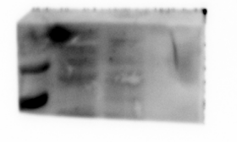
FOXP3
HC
AS
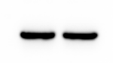
GAPDH
HC
AS

Suppl. Figure 2 Uncropped images of Figure 1H

FOXP3 CD4 DAPI Merge
HC
AS

Suppl. Figure 3 Uncropped images of Figure 2E

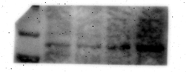
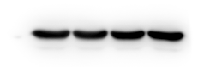
HIF-1α
FOXP3
GAPDH
OE-NC
OE-STAT3
sh-NC
sh-STAT3

Suppl. Figure 4 Uncropped images of Figure 2J
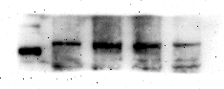
HIF-1α

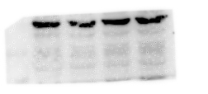
FOXP3

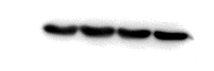
GAPDH
OE-NC
OE-STAT3
sh-NC
sh-STAT3

Suppl. Figure 5 Uncropped images of Figure 4D

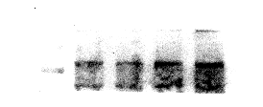
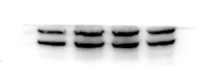
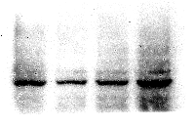
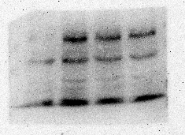
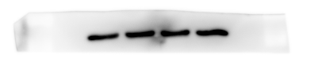
FOXP3
HIF-1α
GAPDH
STAT3
P-STAT3
minic-NC
minic
inhibitor-NC
inhibitor

Suppl. Figure 6 Uncropped images of Figure 4H

P-STAT3

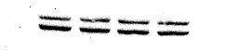
STAT3

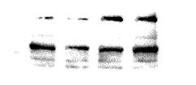
HIF-1α

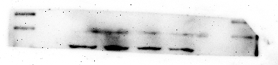
FOXP3

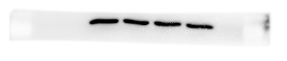
GAPDH
minic-NC
minic
inhibitor-NC
inhibitor

Suppl. Figure 7 Uncropped images of Figure 4I

WB detection results of STAT3 sampled stimulated with IL-6 (200 ng/mL) for various durations (Ctrl, 5, 10, 15, 30, and 60 minutes)
WB detection results of p-STAT3 sampled stimulated with IL-6 (200 ng/mL) for various durations (Ctrl, 5, 10, 15, 30, and 60 minutes)

WB detection results of GAPDH sampled stimulated with IL-6 (200 ng/mL) for various durations (Ctrl, 5, 10, 15, 30, and 60 minutes)

Suppl. Figure 8 Uncropped images of Figure 4J

WB detection results of STAT3 after adding minic or inhibitor at 15 min of IL-6 treatment.
WB detection results of P-STAT3 after adding minic or inhibitor at 15 min of IL-6 treatment.

WB detection results of GAPDH after adding minic or inhibitor at 15 min of IL-6 treatment.
Suppl. Figure 9 Uncropped images of Figure 5H
IP
input
IP
input
HC
AS
NOX2

Suppl. Figure 10 Uncropped images of Figure 5I

IP
input
IP
input
HC
AS
STAT3

Suppl. Figure 11 Uncropped images of Figure 5J

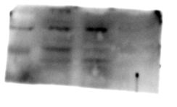
GAPDH
NOX2
HC
AS

Suppl. Figure 12 Uncropped images of Figure 5K
NOX2
STAT3
DAPI
Merge
Suppl. Figure 13 Uncropped images of Figure 6I
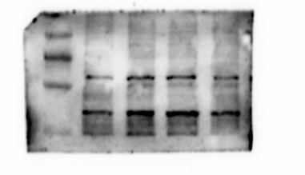
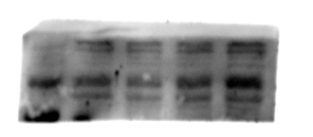
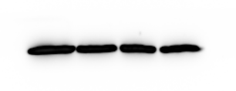
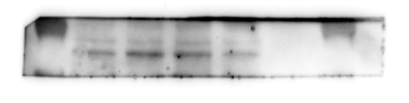
HIF-1α
FOXP3
GAPDH
OE-NC
OE-NOX2
sh-NC
sh-NOX2
NOX2

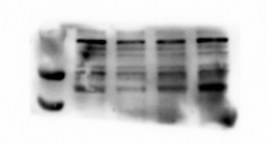
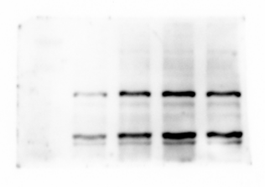
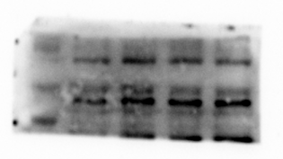
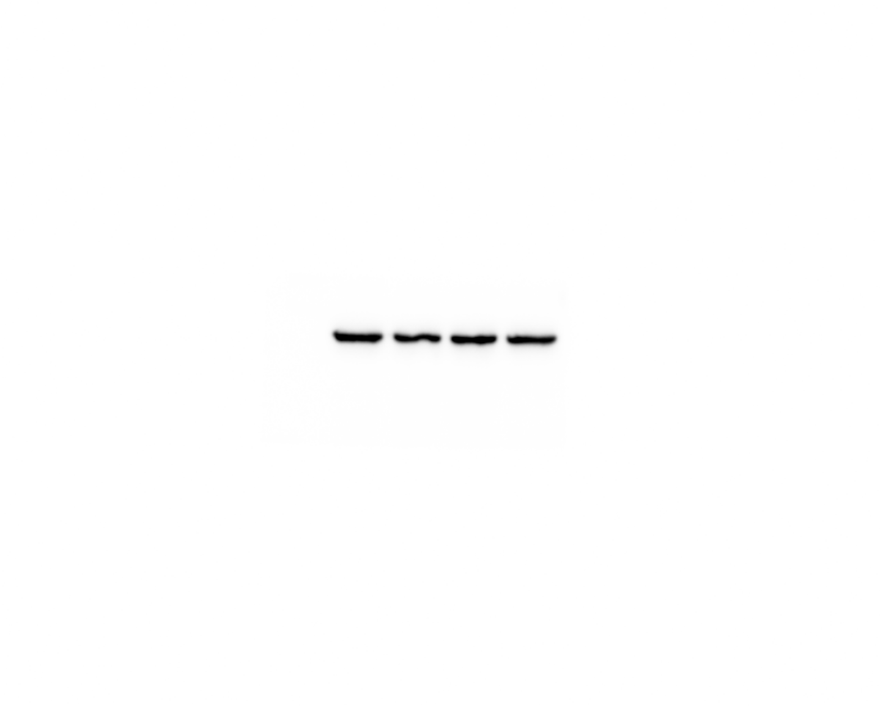
Suppl. Figure 14 Uncropped images of Figure 6J
FOXP3
HIF-1α
NOX2
GAPDH
OE-NC
OE-NOX2
sh-NC
sh-NOX2

