Supplementary information
Identification of candidate biomarkers for diagnosis, disease activity, and relapse prediction in IgG4-related disease
Qiyuan Hao¹, Difei Lian¹, Mingzhu Zhou¹, Hang Zhou¹, Xia Zhang¹, Tianqi Wang¹, Huilan Liu¹, Lan Gao¹, Mingxin Bai¹, Yuetong Xu¹, Fan Yang¹, Guang Yang², Zhitao Ying³, Yini Wang⁴, Xiaolin Sun⁵, Yanying Liu^{1*}

Affiliations:
- Department of Rheumatology and Immunology, Beijing Friendship Hospital, Capital Medical University, Beijing, China
- Beijing Institute of Tropical Medicine, Beijing Friendship Hospital, Capital Medical University, Beijing, China
- Department of Hematology, Cancer Hospital Chinese Academy of Medical Sciences
- Department of Hematology, Beijing Anzhen Hospital, Capital Medical University, Beijing, China
- Department of Rheumatology and Immunology, Peking University People's Hospital & Beijing Key Laboratory for Rheumatism Mechanism and Immune Diagnosis, Beijing China.

*Corresponding author:
Yanying Liu
Department of Rheumatology and Immunology, Beijing Friendship Hospital, Capital Medical University, No.95, Yong'an Road, Xicheng District, Beijing, 100050, China
E-mail: Liuyanying6850@126.com
Telephone: +86-13581746850
List of Supplementary Figures:
Figure S1. Correlation map between DEPs of IgG4-RD versus HCs with clinical and laboratory parameters. 3
Figure S2. Diagnostic performance of biomarkers in seronegative IgG4-RD and HCs. 4

List of Supplementary Tables:
Table S1. Differential biomarkers between IgG4-RD and HC by Olink proteomic. 5
Table S2. Association of serum PD1, OX40, CCL19 and MMP12 levels with organ involvement in IgG4-RD patients 10
Table S3. Clinical characteristics of IgG4-RD patients in validation cohort. 12
Table S4. Baseline characteristics of IgG4-RD patients with or without clinical relapse 13

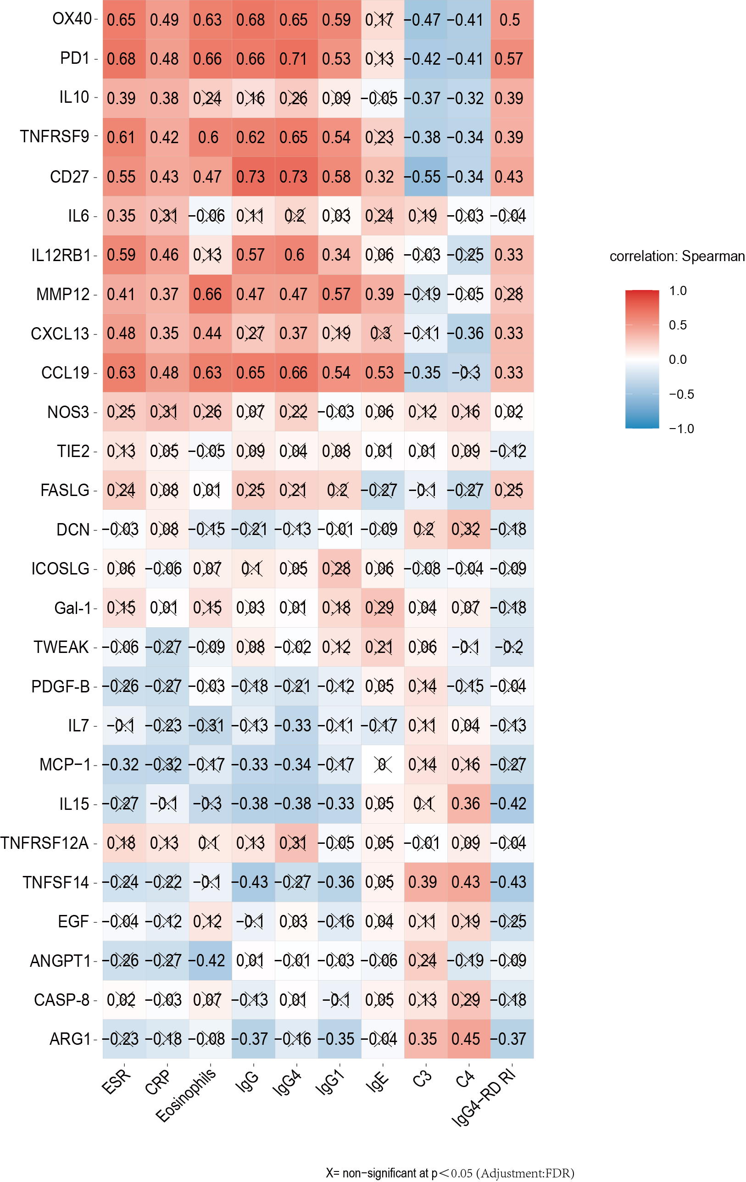
Figure S1. Correlation map between 27 DEPs of IgG4-RD versus HCs with clinical and laboratory parameters. The color intensity corresponded to the correlation coefficients which were indicated in the matrix. X = non-significant at P < 0.05 (Adjusted for FDR). HC, healthy control; IgG4-RD, IgG4-related disease; FDR, false discovery rate.

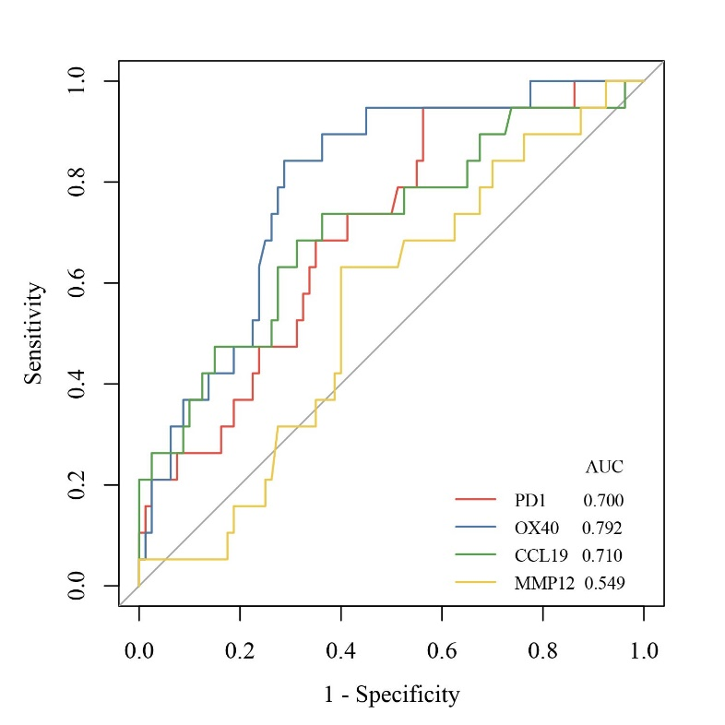
Figure S2 Diagnostic performance of biomarkers in seronegative IgG4-RD and HCs. HC, healthy control; IgG4-RD, Immunoglobulin G4-related disease; ROC, receiver operating characteristic.

 |  | Table S1. The Olink proteomic biomarkers showing P values and adjusted P value (FDR) between IgG4-RD and HC
 |  | Markers | Names | IgG4-RD  Mean |  | HC Mean |  | Different  NPX |  | P value |  | Adjusted P value (FDR)
 |  | ADA | Adenosine deaminase | 3.609 | 3.671 |  | -0.062 |  | 0.816 |  |  | 0.939
 |  | ADGRG1 | G-protein coupled receptor G1 | 0.490 | 0.244 |  | 0.245 |  | 0.647 |  |  | 0.879
 |  | ANGPT1 | Angiopoietin-1 | 9.193 | 9.604 |  | -0.411 |  | 0.027* |  |  | 0.131
 |  | TIE2 | Angiopoietin-1 receptor | 5.998 | 6.464 |  | -0.466 |  | 0.008** |  |  | 0.094
 |  | ANGPT2 | Angiopoietin-2 | 3.832 | 3.830 |  | 0.002 |  | 0.994 |  |  | 0.994
 |  | ARG1 | Arginase-1 | 1.976 | 2.860 |  | -0.884 |  | 0.048* |  |  | 0.158
 |  | CAIX | Carbonic anhydrase 9 | 3.510 | 3.583 |  | -0.074 |  | 0.775 |  |  | 0.939
 |  | CASP-8 | Caspase-8 | 3.315 | 5.732 |  | -2.418 |  | ＜0.001*** |  |  | 0.001
 |  | MCP-1 | Monocyte Chemoattractant Protein-1 | 10.314 | 10.859 |  | -0.545 |  | 0.043* |  |  | 0.147
 |  | CCL3 | C-C motif chemokine 3 | 6.497 | 6.487 |  | 0.011 |  | 0.981 |  |  | 0.994
 |  | CCL4 | C-C motif chemokine 4 | 7.356 | 7.581 |  | -0.224 |  | 0.650 |  |  | 0.879
 |  | MCP-3 | Monocyte Chemoattractant Protein-3 | 1.955 | 1.289 |  | 0.666 |  | 0.146 |  |  | 0.304
 |  | MCP-2 | Monocyte Chemoattractant Protein-2 | 7.870 | 8.338 |  | -0.468 |  | 0.157 |  |  | 0.320
 |  | MCP-4 | Monocyte Chemoattractant Protein-4 | 10.104 | 10.137 |  | -0.033 |  | 0.933 |  |  | 0.994
 |  | CCL17 | C-C motif chemokine 17 | 9.063 | 9.357 |  | -0.293 |  | 0.306 |  |  | 0.529
 |  | CCL19 | C-C motif chemokine 19 | 11.044 | 9.410 |  | 1.634 |  | ＜0.001*** |  |  | 0.000
 |  | CCL20 | C-C motif chemokine 20 | 5.947 | 6.386 |  | -0.439 |  | 0.370 |  |  | 0.608
 |  | CCL23 | C-C motif chemokine 23 | 9.661 | 9.649 |  | 0.012 |  | 0.975 |  |  | 0.994
 |  | CD27 | CD27 antigen | 8.518 | 7.874 |  | 0.644 |  | 0.026* |  |  | 0.131
 |  | CD40L | CD40 ligand | 6.311 | 6.498 |  | -0.188 |  | 0.752 |  |  | 0.935
 |  | CD40 | CD40L receptor | 9.592 | 9.671 |  | -0.080 |  | 0.793 |  |  | 0.939
 |  | CD70 | CD70 antigen | 3.390 | 3.088 |  | 0.302 |  | 0.294 |  |  | 0.529
Markers |  |  | Names | IgG4-RD  Mean |  | HC Mean |  | Different  NPX |  | P value | Adjusted P value (FDR)
 |  | CD83 | CD83 antigen | 1.890 | 1.927 |  | -0.037 |  | 0.846 |  | 0.939
 |  | CXCL1 | C-X-C motif chemokine 1 | 7.985 | 8.000 |  | -0.015 |  | 0.969 |  | 0.994
 |  | CXCL5 | C-X-C motif chemokine 5 | 10.313 | 10.759 |  | -0.447 |  | 0.307 |  | 0.529
 |  | CXCL9 | C-X-C motif chemokine 9 | 6.042 | 5.923 |  | 0.119 |  | 0.660 |  | 0.879
 |  | CXCL10 | C-X-C motif chemokine 10 | 6.869 | 7.329 |  | -0.460 |  | 0.135 |  | 0.289
 |  | CXCL11 | C-X-C motif chemokine 11 | 6.549 | 6.862 |  | -0.314 |  | 0.298 |  | 0.529
 |  | CXCL13 | C-X-C motif chemokine 13 | 8.649 | 6.912 |  | 1.736 |  | 0.001** |  | 0.022
 |  | CRTAM | Cytotoxic and regulatory T-cell molecule | 4.597 | 4.439 |  | 0.159 |  | 0.581 |  | 0.836
 |  | DCN | Decorin | 1.377 | 1.699 |  | -0.322 |  | 0.020* |  | 0.131
 |  | FGF2 | Fibroblast growth factor 2 | -0.539 | -0.533 |  | -0.006 |  | 0.984 |  | 0.994
 |  | CX3CL1 | Fractalkine | 2.510 | 2.975 |  | -0.465 |  | 0.063 |  | 0.180
 |  | Gal-1 | Galectin-1 | 5.495 | 5.913 |  | -0.418 |  | 0.010* |  | 0.103
 |  | Gal-9 | Galectin-9 | 7.819 | 7.732 |  | 0.087 |  | 0.614 |  | 0.869
 |  | GZMA | Granzyme A | 4.980 | 5.110 |  | -0.130 |  | 0.574 |  | 0.836
 |  | GZMB | Granzyme B | 1.435 | 1.507 |  | -0.072 |  | 0.839 |  | 0.939
 |  | GZMH | Granzyme H | 3.224 | 3.079 |  | 0.146 |  | 0.581 |  | 0.836
 |  | HO-1 | Heme oxygenase 1 | 11.371 | 11.586 |  | -0.215 |  | 0.529 |  | 0.811
 |  | HGF | Hepatocyte growth factor | 7.884 | 8.307 |  | -0.423 |  | 0.074 |  | 0.189
 |  | ICOSLG | ICOS ligand | 4.460 | 4.875 |  | -0.415 |  | 0.008** |  | 0.094
 |  | IFN-γ | Interferon gamma | 6.856 | 6.788 |  | 0.068 |  | 0.871 |  | 0.954
 |  | IL-1α | Interleukin-1 alpha | N/A | N/A
 |  | IL2 | Interleukin-2 | -1.594 | -1.694 |  | 0.099 |  | 0.708 |  | 0.905
 |  | IL4 | Interleukin-4 | N/A | N/A
 |  | IL5 | Interleukin-5 | N/A | N/A
Markers |  |  | Names | IgG4-RD  Mean |  | HC Mean |  | Different  NPX |  | P value | Adjusted P value (FDR)
 |  | IL6 | Interleukin-6 | 2.202 | 1.489 |  | 0.713 |  | 0.024* |  | 0.131
 |  | IL7 | Interleukin-7 | 3.851 | 4.617 |  | -0.766 |  | 0.033* |  | 0.134
 |  | IL8 | Interleukin-8 | 6.533 | 7.491 |  | -0.958 |  | 0.198 |  | 0.387
 |  | IL10 | Interleukin-10 | 2.317 | 1.311 |  | 1.007 |  | 0.029* |  | 0.134
 |  | IL12 | Interleukin-12 | 5.323 | 4.770 |  | 0.553 |  | 0.091 |  | 0.209
 |  | IL12RB1 | Interleukin-12 receptor subunit beta-1 | 1.701 | 1.138 |  | 0.563 |  | 0.024* |  | 0.131
 |  | IL13 | Interleukin-13 | N/A | N/A
 |  | IL15 | Interleukin-15 | 3.043 | 3.559 |  | -0.517 |  | 0.024* |  | 0.131
 |  | IL18 | Interleukin-18 | 7.713 | 7.810 |  | -0.097 |  | 0.808 |  | 0.939
 |  | IL33 | Interleukin-33 | N/A | N/A
 |  | KIR3DL1 | Killer cell immunoglobulin-like receptor 3DL1 | -0.296 | -0.476 |  | 0.180 |  | 0.679 |  | 0.879
 |  | LAP TGF-β1 | Latency-associated peptide transforming growth factor beta-1 | 7.992 | 8.526 |  | -0.534 |  | 0.050 |  | 0.160
 |  | LAG3 | Lymphocyte activation gene 3 protein | 3.932 | 3.429 |  | 0.503 |  | 0.100 |  | 0.223
 |  | LAMP3 | Lysosome-associated membrane glycoprotein 3 | 3.694 | 4.233 |  | -0.539 |  | 0.062 |  | 0.180
 |  | CSF-1 | Macrophage colony-stimulating factor 1 | 8.456 | 8.745 |  | -0.289 |  | 0.091 |  | 0.209
 |  | MMP7 | Macrophage metalloproteinase-7 | 11.702 | 11.642 |  | 0.060 |  | 0.673 |  | 0.879
 |  | MMP12 | Macrophage metalloproteinase-12 | 6.859 | 5.951 |  | 0.908 |  | 0.006** |  | 0.093
 |  | MIC-A/B | MHC class I polypeptide-related sequence A/B | 4.674 | 3.015 |  | 1.659 |  | 0.067 |  | 0.180
 |  | MUC-16 | Mucin-16 | 0.672 | 0.613 |  | 0.059 |  | 0.847 |  | 0.939
 |  | NCR1 | Natural cytotoxicity triggering receptor | 2.709 | 2.735 |  | -0.026 |  | 0.911 |  | 0.986
 |  | CD244 | Natural killer cell receptor 2B4 | 4.527 | 4.934 |  | -0.408 |  | 0.103 |  | 0.225
 |  | KLRD1 | Natural killer cells antigen CD94 | 5.093 | 5.260 |  | -0.167 |  | 0.513 |  | 0.799
 |  | NOS3 | Nitric oxide synthase, endothelial | 0.453 | -0.278 |  | 0.731 |  | 0.036* |  | 0.134
Markers |  |  | Names | IgG4-RD  Mean |  | HC Mean |  | Different  NPX |  | P value |  | Adjusted P value (FDR)
 |  | PGF | Placenta growth factor | 7.510 | 7.568 |  | -0.059 |  | 0.731 |  |  | 0.921
 |  | PDGF-B | Platelet-derived growth factor subunit B | 10.122 | 10.449 |  | -0.326 |  | 0.020* |  |  | 0.131
 |  | PTN | Pleiotrophin | N/A | N/A
 |  | EGF | Pro-epidermal growth factor | 8.646 | 10.000 |  | -1.354 |  | 0.041* |  |  | 0.144
 |  | PD-L1 | Programmed cell death 1 ligand 1 | 5.127 | 5.196 |  | -0.068 |  | 0.802 |  |  | 0.939
 |  | PD-L2 | Programmed cell death 1 ligand 2 | 0.651 | 0.743 |  | -0.092 |  | 0.562 |  |  | 0.836
 |  | PD1 | Programmed cell death protein 1 | 8.544 | 6.716 |  | 1.828 |  | ＜0.001*** |  |  | 0.002
 |  | CXCL12 | Stromal cell-derived factor 1 | N/A | N/A
 |  | CD4 | T-cell surface glycoprotein CD4 | 2.478 | 2.138 |  | 0.340 |  | 0.065 |  |  | 0.180
 |  | CD5 | T-cell surface glycoprotein CD5 | 5.276 | 4.892 |  | 0.385 |  | 0.079 |  |  | 0.192
 |  | CD8A | T-cell surface glycoprotein CD8 alpha chain | 8.686 | 8.662 |  | 0.025 |  | 0.945 |  |  | 0.994
 |  | CD28 | T-cell-specific surface glycoprotein CD28 | N/A | N/A
 |  | TRAIL | TNF-related apoptosis-inducing ligand | 7.565 | 7.884 |  | -0.319 |  | 0.160 |  |  | 0.321
 |  | TNF | Tumor necrosis factor | 3.219 | 2.722 |  | 0.497 |  | 0.074 |  |  | 0.189
 |  | FASLG | Tumor necrosis factor ligand superfamily member 6 | 5.882 | 6.544 |  | -0.662 |  | 0.020* |  |  | 0.131
 |  | TWEAK | Tumor necrosis factor ligand superfamily member 12 | 8.072 | 8.586 |  | -0.513 |  | 0.035* |  |  | 0.134
 |  | TNFSF14 | Tumor necrosis factor ligand superfamily member 14 | 4.572 | 5.439 |  | -0.867 |  | 0.036* |  |  | 0.134
 | OX40 |  | Tumor necrosis factor receptor superfamily member 4 | 6.049 | 4.991 |  | 1.058 |  | 0.004** |  |  | 0.065
 |  | TNFRSF9 | Tumor necrosis factor receptor superfamily member 9 | 5.536 | 4.865 |  | 0.671 |  | 0.017* |  | 0.131
 |  | TNFRSF12A | Tumor necrosis factor receptor superfamily member 12A | 4.823 | 5.502 |  | -0.679 |  | 0.036* |  | 0.134
 |  | TNFRSF21 | Tumor necrosis factor receptor superfamily member 21 | 7.838 | 8.177 |  | -0.340 |  | 0.057 |  | 0.174
 |  | VEGFA | Vascular endothelial growth factor A | 9.128 | 9.274 |  | -0.147 |  | 0.640 |  | 0.879
 |  | VEGFR-2 | Vascular endothelial growth factor receptor 2 | 6.637 | 7.035 |  | -0.398 |  | 0.076 |  | 0.189
N/A：Proteins with a missing data frequency＞75% were excluded. HC, healthy control; IgG4-RD, IgG4-related disease. *P＜0.05, **P＜0.01,*** P＜0.001

Table S2. Association of serum PD1, OX40, CCL19 and MMP12 levels with organ involvement in IgG4-RD patients
 | OR (95%CI) | FDR-adjusted P value
Lacrimal gland  PD1, pg/ml  OX40, pg/ml  CCL19, pg/ml  MMP12, ng/ml | 0.995 (0.989-1.001)  0.999 (0.997-1.000)  0.998 (0.996-1.001)  0.852 (0.496-1.498) | 0.400  0.400  0.400  0.698
Salivary gland
PD1, pg/ml | 0.995 (0.988-1.003) | 0.400
OX40, pg/ml | 0.998 (0.997-1.000) | 0.400
CCL19, pg/ml | 0.998(0.995-1.002) | 0.505
MMP12, ng/ml | 0.856 (0.472-1.792) | 0.726
Paranasal sinus
PD1, pg/ml | 0.996(0.990-1.001) | 0.400
OX40, pg/ml | 1.000(0.999-1.002) | 0.889
CCL19, pg/ml | 0.999 (0.997-1.002) | 0.647
MMP12, ng/ml | 0.805 (0.406-1.394) | 0.647
Lung
PD1, pg/ml | 1.006 (1.000-1.012) | 0.400
OX40, pg/ml | 1.001 (1.000-1.003) | 0.400
CCL19, pg/ml | 1.003 (1.001-1.006) | 0.400
MMP12, ng/ml | 1.479 (0.861-2.684) | 0.400
Pancreas
PD1, pg/ml | 1.000 (0.995-1.005) | 0.981
OX40, pg/ml | 0.999 (0.998-1.001) | 0.647
CCL19, pg/ml | 0.999 (0.996-1.001) | 0.400
MMP12, ng/ml | 0.994 (0.577-1.680) | 0.981
Bile duct
PD1, pg/ml | 0.998 (0.992-1.003) | 0.647
OX40, pg/ml | 0.999 (0.996-1.001) | 0.505
CCL19, pg/ml | 0.998 (0.996-1.001) | 0.400
MMP12, ng/ml | 0.978 (0.478-1.689) | 0.981
Kidney
PD1, pg/ml | 1.008 (1.002-1.015) | 0.400
OX40, pg/ml | 1.001 (1.000-1.003) | 0.400
CCL19, pg/ml | 1.002 (0.999-1.004) | 0.400
MMP12, ng/ml | 1.338 (0.768-2.411) | 0.505
RPF/aorta
PD1, pg/ml | 1.001 (0.995-1.007) | 0.788
OX40, pg/ml  CCL19, pg/ml  MMP12, ng/ml | 1.000 (0.997-1.002)  1.002 (1.000-1.005)  1.287 (0.597-2.315) | 0.981  0.400  0.647
CI, confidence interval; FDR, false discovery rate; IgG4-RD, IgG4-related disease; OR, odds ratio; RPF, retroperitoneum. All analyses were performed using logistic regression models adjusted for IgG4-RD RI. P-values for all biomarkers were corrected using the Benjamini-Hochberg procedure.

Table S3. Clinical characteristics of IgG4-RD patients in validation cohort.
 | IgG4-RD  (N= 140) | HC  (N=80)
Male | 80 (57.1%) | 2.33/1
Age, year | 60.5 (54.0-67.0) | 65.0(54.0-68.0)
Onset age, year | 57.0 (50.0-65.0) | -
History of allergy, n (%) | 66 (47.1%) | -
IgG, g/L | 15.35 (12.18-19.15) | -
IgM,g/L | 0.681 (0.465-0.977) | -
IgG1, g/L | 8.22 (6.86-9.80) | -
IgG4, g/L | 4.00 (2.02-10.55) | -
IgE, IU/ml | 200.51 (75.75-506.52) | -
ESR, mm/H | 14.0 (8.0-27.0) | -
CRP, mg/L | 1.27 (0.59-2.54) | -
C3, g/L | 0.981 (0.864-0.110) | -
C4, g/L | 0.228±0.098 | -
IgG4-RD RI | 6.50 (2.00-10.00) | -
Number of involved organs | 5.0 (4.0-6.0) | -
Organ involvement, n (%) |  | -
Salivary gland | 118 (84.3%)
Lacrimal gland | 99 (70.7%)
Paranasal sinus | 68 (48.6%)
Lung | 32 (22.9%)
Pancreas | 66 (47.1%)
Bile duct | 36 (25.7%)
Kidney | 41 (29.3%)
RPF/ aorta | 16 (11.4%)
HC, healthy control; IgG4-RD, IgG4-related disease; IgG4-RD RI, IgG4-related disease responder index; OR, odds ratio; RPF, retroperitoneum.

Table S4. Baseline characteristics of IgG4-RD patients with or without clinical relapse.
 | Non-relapse  (N= 46) | Relapse  (N=20) | P value
Male/Female | 0.92/1 | 2.33/1 | 0.096
Age, year | 59.0 (51.8-66.3) | 65.0(54.0-68.0) | 0.184
Onset age, year | 57.5 (49.8-65.0) | 63.5 (52.5-68.0) | 0.060
History of allergy, n (%) | 20 (43.5%) | 12 (60.0%) | 0.217
IgG, g/L | 17.20 (13.85-21.03) | 17.15 (15.05-24.43) | 0.490
IgM, g/L | 0.783 (0.478-1.025) | 0.645(0.446-1.060) | 0.681
IgG1, g/L | 9.01(7.27-10.45) | 9.00(7.86-11.85) | 0.391
IgG4, g/L | 7.17 (3.76-13.10) | 7.52 (5.82-21.90) | 0.350
IgE, IU/ml | 287.49(160.51-655.57) | 381.69(236.03-896.91) | 0.208
EO, 10⁹/L | 0.16 (0.08-0.25) | 0.28 (0.12-0.59) | 0.082
ESR, mm/H | 18.0(11.8-33.0) | 23.0(14.0-57.8) | 0.182
CRP, mg/L | 1.36 (0.46-2.49) | 1.63 (0.98-4.14) | 0.151
C3, g/L | 0.957 (0.854-1.050) | 0.870 (0.638-1.033) | 0.091
C4, g/L | 0.218±0.879 | 0.172±0.096 | 0.067
IgG4-RD RI | 10.0(6.8-12.0) | 8.0(6.0-10.8) | 0.474
Number of involved organs | 5.0 (4.0-6.0) | 5.0 (4.0-5.8) | 0.471
Organ involvement, n (%)
Salivary gland | 40 (87.0%) | 17 (85.0%) | 1.000
Lacrimal gland | 35 (76.1%) | 12 (60.0%) | 0.185
Paranasal sinus | 30 (65.2%) | 11 (55.0%) | 0.432
Lung | 9 (19.6%) | 2 (10.0%) | 0.549
Pancreas | 26 (56.5%) | 8 (40.0%) | 0.217
Bile duct | 14 (30.4%) | 6 (30.0%) | 0.972
Kidney | 14 (30.4%) | 5 (25.0%) | 0.654
RPF/ aorta | 6 (13.0%) | 4 (20.0%) | 0.726
Treatment |  |  | 0.013*
GC  GC combined with IM  Biologics | 13 (28.3%)  23 (50.0%)  10 (21.7%) | 13 (65.0%)  6 (30.0%)  1 (5.0%)
EO, eosinophils; ESR, erythrocyte sedimentation rate; CRP, C-reactive protein; GC, glucocorticoid; IgG4-RD, IgG4-related disease; IgG4-RD RI, IgG4-related disease responder index; IM, immunosuppressant; RPF, retroperitoneum. * P＜0.05.

