SUPPLEMENTARY MATERIAL
Supplementary table 1. B-mode ultrasound settings for the acquisition of images of the muscles included in SpUMAR
Frequency | 6–15 MHz
Gain | ~ 50–70 dB (adjust to clearly visualize muscle fibres and fibroadipose septa)
Dynamic range | ~ 50–70 dB
Depth | Just beyond the muscle of interest

Supplementary figure 1. Examples of images of four different patients with grades 0-3 of the RF muscle obtained with correct and incorrect ultrasound settings.
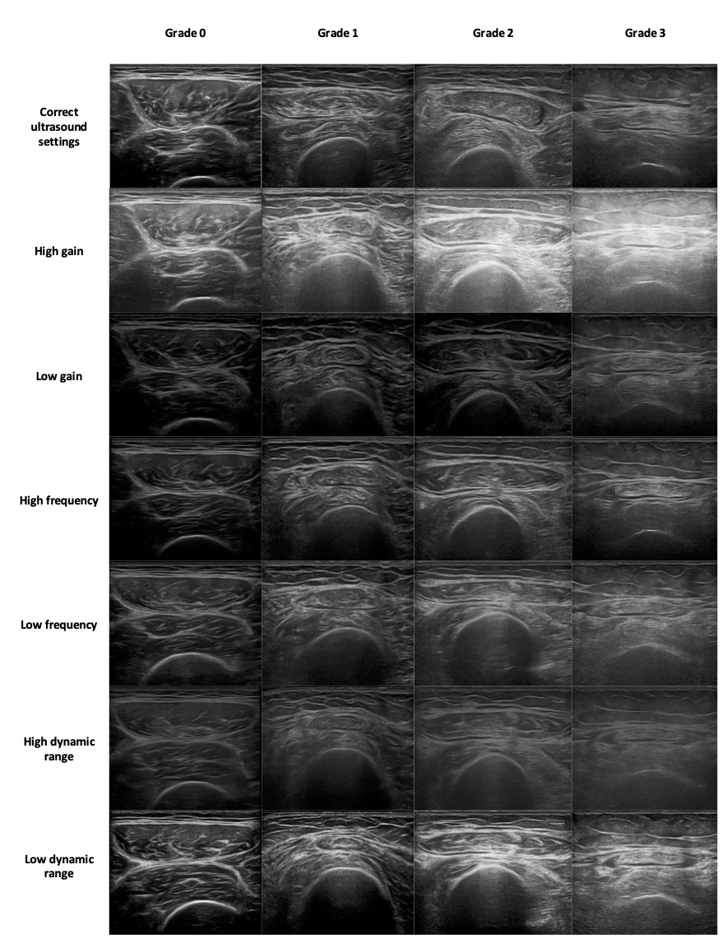

Supplementary table 2. Ultrasound machine model and probe frequency range used by each investigator for image acquisition to construct the image dataset for the reliability exercise.
Investigator | Ultrasound machine | Probe frequency range
Investigator 1 | GE LOGIQ P9 (GE Healthcare, Chicago, IL, USA) | 6–15 MHz
Investigator 2 | GE LOGIQ 9 (GE Healthcare, Chicago, IL, USA) | 6–15 MHz
Investigator 3 | GE LOGIQ S8 (GE Healthcare, Chicago, IL, USA) | 6–15 MHz
Investigator 4 | Esaote MyLab™ 9 (Esaote, Genoa, Italy) | 4–15 MHz
Investigator 5 | Esaote MyLab™ 9 (Esaote, Genoa, Italy) | 4–15 MHz
Investigator 6 | Esaote MyLab™ X8 (Esaote, Genoa, Italy) | 4–15 MHz
Investigator 7 | Canon Aplio i700 Prism Edition (Canon Medical Systems, Tustin, CA, USA) | 5–18 MHz
Investigator 8 | Canon Aplio i700 Prism Edition (Canon Medical Systems, Tustin, CA, USA) | 5–18 MHz
Investigator 9 | GE LOGIQ E10 (GE Healthcare, Chicago, IL, USA) | 10–20 MHz
Investigator 10 | GE LOGIQ S8 XD CLEAR (GE Healthcare, Chicago, IL, USA) | 6–15 MHz
Investigator 11 | GE LOGIQ S8 XD CLEAR (GE Healthcare, Chicago, IL, USA) | 6–15 MHz
Investigator 12 | Esaote MyLab™ Eight (Esaote, Genoa, Italy) | 10–18 MHz
Investigator 13 | GE LOGIQ E10 (GE Healthcare, Chicago, IL, USA) | 10–20 MHz

Supplementary table 3. Demographic and RA characteristics of the patients included for muscle ultrasound evaluation for the image dataset used in the reliability exercise
Variables | n = 57
Age (years), mean (SD) | 59.9 (14.7)
Sex (female), n (%) | 43 (75.4)
RA duration (months), mean (SD) | 129.4 (114.2)
csDMARDs, n (%) | 53 (93)
Methotrexate, n (%) | 32 (56.1)
bDMARDs, n (%) | 27(47.4)
TNFi, n (%) | 15 (26.3)
IL6i, n (%) | 5 (8.8)
CTLA4–A, n (%) | 4 (7.0)
CD20i, n (%) | 3 (5.3)
tsDMARDs, n (%) | 3 (5.3)

Supplementary table 4. Different grades of muscle quality as determined by the mean prevalence observed across raters in both rounds.
n (%) | 2160 (100.0)
Round 1, n (%)
0 | 342 (15.8)
1 | 657 (30.4)
2 | 634 (29.4)
3 | 527 (24.4)
Round 2, n (%)
0 | 356 (16.5)
1 | 622 (28.8)
2 | 707 (32.7)
3 | 475 (22.0)

Supplementary table 5. Agreement between the scores assigned to the images acquired with incorrect settings by the 15 investigators, and by 13 investigators –excluding the principal investigators– during the reliability exercise and those assigned by the principal investigators before the reliability exercise.
 | Round 1 |  | Round 2
 | Percent agreement | Cohen’s Kappa (95% CI) coefficients | Percent agreement | Cohen’s Kappa (95% CI) coefficients
All observers | 67.78 % | 0.27 (0.21–0.33) | 69.44 % | 0.30 (0.24–0.36)
13 observers (excluding principal investigators) | 67.56 % | 0.27 (0.21–0.33) | 70.00 % | 0.31 (0.25–0.38)
Supplementary table 6. Agreement of each individual investigator for the SpUMAR score on images acquired with incorrect ultrasound settings, compared to the reference score assigned by the principal investigators.
 | Round 1 |  |  | Round 2
 | n | Percent agreement | Cohen´s Kappa (95% CI) coefficients | n | Percent agreement | Cohen´s Kappa (95% CI) coefficients
Investigator 1 | 20 | 61.7 % | 0.22 (0.00–0.44) | 20 | 65,0 % | 0.25 (0.00–0.49)
Investigator 2 | 20 | 68.3 % | 0.31 (0.07–0.55) | 20 | 70,0 % | 0.33 (0.06–0.60)
Investigator 3 | 20 | 68.3 % | 0.25 (0.06–0.44) | 20 | 71,7 % | 0.32 (0.11–0.54)
Investigator 4 | 20 | 73.3 % | 0.36 (0.08–0.63) | 20 | 75,0 % | 0.39 (0.14–0.64)
Investigator 5 | 20 | 66.7 % | 0.24 (0.02–0.46) | 20 | 70,0 % | 0.29 (0.04–0.54)
Investigator 6 | 20 | 60.0 % | 0.19 (-0.02–0.40) | 20 | 70,0 % | 0.30 (0.05–0.56)
Investigator 7 | 20 | 70.0 % | 0.29 (0.08–0.49) | 20 | 73,3 % | 0.34 (0.13–0.56)
Investigator 8 | 20 | 70.0 % | 0.34 (0.06–0.62) | 20 | 68,3 % | 0.33 (0.08–0.58)
Investigator 9 | 20 | 70.0 % | 0.26 (-0.02–0.53) | 20 | 76,7 % | 0.43 (0.19–0.67)
Investigator 10 | 20 | 63.3 % | 0.20 (0.02–0.37) | 20 | 58,3 % | 0.11 (−0.06–0.28)
Investigator 11 | 20 | 60.0 % | 0.11 (-0.09–0.32) | 20 | 60,0 % | 0.13 (−0.08–0.35)
Investigator 12 | 20 | 76.7 % | 0.49 (0.20–0.77) | 20 | 71,7 % | 0.35 (0.09–0.62)
Investigator 13 | 20 | 70.0 % | 0.29 (0.08–0.49) | 20 | 80,0 % | 0.54 (0.26–0.82)
Investigator 14 | 20 | 65.0 % | 0.16 (-0.05–0.37) | 20 | 63,3 % | 0.17 (−0.02–0.36)
Investigator 15 | 20 | 73.3 % | 0.36 (0.13–0.58) | 20 | 68,3 % | 0.25 (0.06–0.44)

