Supplementary Material 2
Supplementary figures

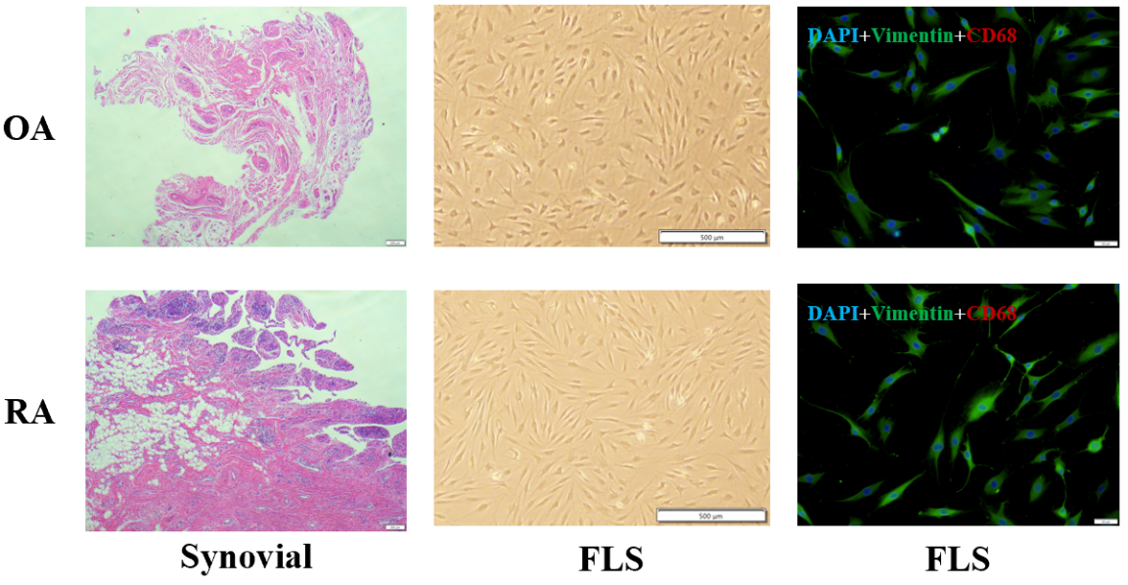
Supplementary Figure S1. Extraction and Identification of Synovial Fibroblasts (FLS)

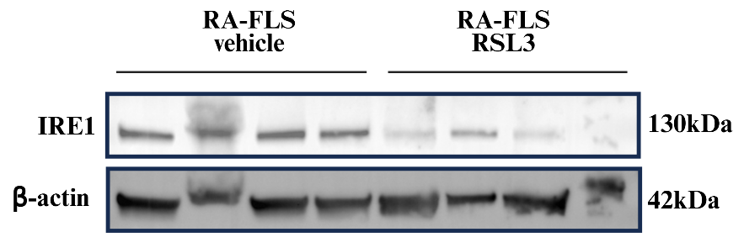
Supplementary Figure S2. IRE1 expression in RA-FLS before and after treatment with the ferroptosis inducer RSL3

