Supplementary File 2 for
Integrative proteomic and machine learning strategies identifies key biomarkers associated with response to JAK inhibitor in rheumatoid arthritis

Contents
Supplementary Table S2 Clinicodemographic characteristics of the study population ................................................. 2
Supplementary Table S3 Selected features from different data modalities .................................................................. 3
Supplementary Figure S1 Differentially expressed proteins in post-treatment samples ……………................................. 4
Supplementary Figure S2 Partial dependence plots of predictive models .................................................................... 5

Supplementary Table S2. Clinicodemographic characteristics of the study population
 | Baricitinib  (n=12) | Tofacitinib  (n=14) | Upadacitinib  (n=16) | P value
Age (years), median (IQR) | 56.0 (49.5-60.5) | 55.5 (45.0-72.0) | 62.0 (49.0-68.0) | 0.627
Female, n (%) | 8 (66.7) | 13 (92.9) | 12 (75.0) | 0.243
Baseline disease activity
DAS28, median (IQR) | 4.34 (2.36-5.30) | 3.52 (2.90-5.50) | 5.25 (4.12-5.36) | 0.372
Disease duration (months),  median (IQR) | 11.0 (2.3-12.0) | 10.0 (3.0-16.0) | 10.5 (6.5-14.5) | 0.959
RF (IU/ml), median (IQR) | 45.6 (16.7-88.7) | 98.7 (16.2-453.4) | 63.3 (15.6-716.6) | 0.404
ACPA (U/mL), median (IQR) | 53.0 (1.6-310.5) | 39.0 (1.5-197.0) | 466.5 (2.7-680.0) | 0.153
ESR (mm/h), median (IQR) | 15 (7-40) | 21 (12-89) | 35 (15-47) | 0.386
CRP (mg/dL), median (IQR) | 0.192 (0.093-1.185) | 1.109 (0.113-3.361) | 1.778 (0.689-2.856) | 0.215
Baseline csDMARD and glucocorticoid use
Glucocorticoid (mg/day),  median (IQR) | 5.0 (5.0-10.0) | 0 (0.0-5.0) | 10.0 (6.3-12.5) | 0.001
Cyclosporine, n (%) | 2 (16.7) | 0 (0.0) | 1 (6.2) | 0.254
Hydroxychloroquine, n (%) | 8 (66.7) | 8 (57.1) | 14 (87.5) | 0.169
Leflunomide, n (%) | 2 (16.7) | 3 (21.4) | 5 (31.2) | 0.647
Methotrexate, n (%) | 7 (58.3) | 7 (50.0) | 13 (81.2) | 0.180
Sulfasalazine, n (%) | 7 (58.3) | 2 (14.3) | 2 (12.5) | 0.011

Abbreviations: RF, rheumatoid factor; ACPA, anti-citrullinated protein antibody; ESR, erythrocyte sedimentation rate; CRP, C-reactive protein; DAS28, Disease Activity Score in 28 joints; csDMARDs, conventional synthetic DMARDs; and IQR, interquartile range.
Supplementary Table S3. Selected features from different data modalities
Data modalities | Selected methods | Selected Features
clinical | Ensemble feature selection | ACPA, Hydroxylchloroquine, ESR, Cyclosporine, Sex, CRP, Methotrexate, Disease duration, Steroid, Age, Leflunomide, RF
pretreatment | Ensemble feature selection | IL-12B (pretreatment), SAMD9L (pretreatment), PSPN (pretreatment), NBN (pretreatment), TANK (pretreatment), IL-17A (pretreatment), IFNG (pretreatment), SLAMF1 (pretreatment), CXCL9 (pretreatment), CD160 (pretreatment), SIGLEC1 (pretreatment), CXCL10 (pretreatment)
post-treatment | Ensemble feature selection | IL-12B (post-treatment), CD160 (post-treatment), SIGLEC1 (post-treatment), HLA-E (post-treatment), PNLIPRP2 (post-treatment), IL-33 (post-treatment), SIGLEC10 (post-treatment), NRTN (post-treatment), IL-1R2 (post-treatment), PSMG3 (post-treatment), PTPRM (post-treatment), CLEC4D (post-treatment)
delta | Ensemble feature selection | IL-17A (delta), ARTN (delta), SH2D1A (delta), KYNU (delta), CXCL8 (delta), CD276 (delta), CEP164 (delta), AMBN (delta), IL-32 (delta), SCGB3A2 (delta), HSD11B1 (delta), NBN (delta)
clinical + pretreatment | Ensemble feature selection | IL-12B (pretreatment), IFNG (pretreatment), Cyclosporine, IL-17A (pretreatment), IL-1R2 (pretreatment), PSPN (pretreatment), Methotrexate, TNFRSF11B (pretreatment), SLAMF1 (pretreatment), TANK (pretreatment), PROK1 (pretreatment), CXCL10 (pretreatment)
clinical +  post-treatment | Ensemble feature selection | IL-12B (post-treatment), Cyclosporine, CCL24 (post-treatment), IL-20 (post-treatment), IL-33 (post-treatment), Methotrexate, CLEC4C (post-treatment), NRTN (post-treatment), IL-1R2 (post-treatment), CCL3 (post-treatment), TPT1 (post-treatment), CD160 (post-treatment)
clinical + delta | Ensemble feature selection | IL-17A (delta), ARTN (delta), Hydroxylchloroquine, ACPA, Cyclosporine, IL-6 (delta), Methotrexate, IL-32 (delta), FGF5 (delta), HSD11B1 (delta), CTRC (delta), SLC39A5 (delta)
clinical + pretreatment + post-treatment | Ensemble feature selection | IL-12B (pretreatment), Cyclosporine (pretreatment), SIGLEC1 (pretreatment), IL-1R2 (post-treatment), IL-12B (post-treatment), IL-17A (pretreatment), Methotrexate, CLEC4C (post-treatment), Hydroxylchloroquine, PTPRM (post-treatment), CKAP4 (pretreatment), IL-1R2 (pretreatment)
clinical + pretreatment + delta | Ensemble feature selection | IL-12B (pretreatment), Cyclosporine, IL-17A (pretreatment), SIGLEC1 (pretreatment), SLC39A5 (delta), Hydroxylchloroquine, Methotrexate, CXCL9 (pretreatment), CD48 (pretreatment), LTA (pretreatment), Disease duration, HSD11B1 (delta)
selected DEPs | Statistical analysis from Table 1, Figure 2B, Figure S1 | Disease duration, ACPA, Hydroxylchloroquine, IL-17A, IL-12B, IFNG, IL-13 (post-treatment), TPT1 (post-treatment), IL-12B (post-treatment), IL-6 (post-treatment), MICA (post-treatment), IFNG (post-treatment)
Abbreviations: Delta, protein paired change; DEPs, differentially expressed proteins.

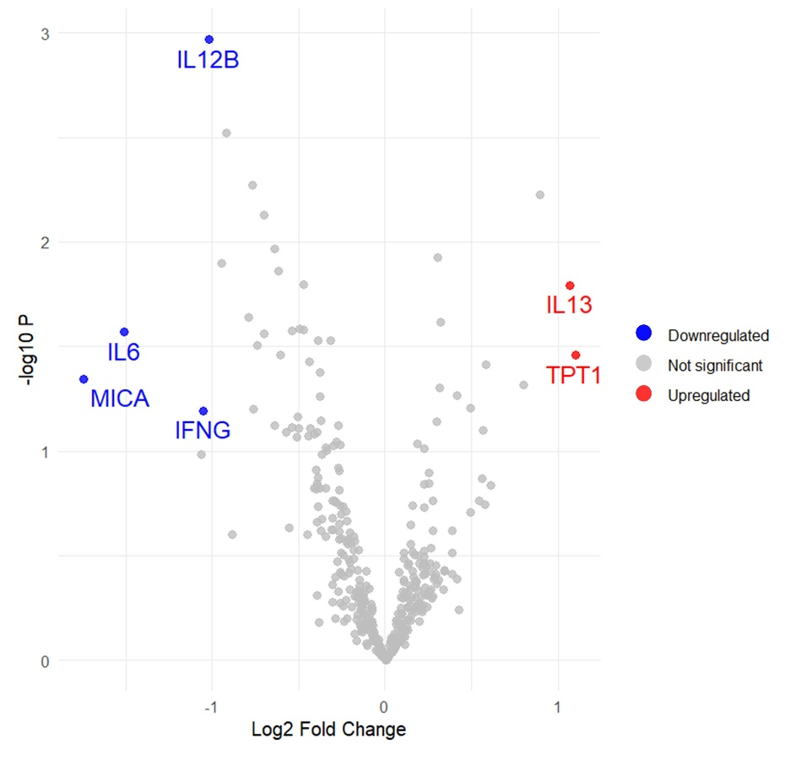
Supplementary Figure S1. Differentially expressed proteins (DEPs) in post-treatment samples.
Volcano plots of DEPs between responders and non-responders in the entire cohort. Red and blue dots represent significantly upregulated and downregulated proteins, respectively (|log₂ fold change| ≥ 1, p ≤ 0.05).

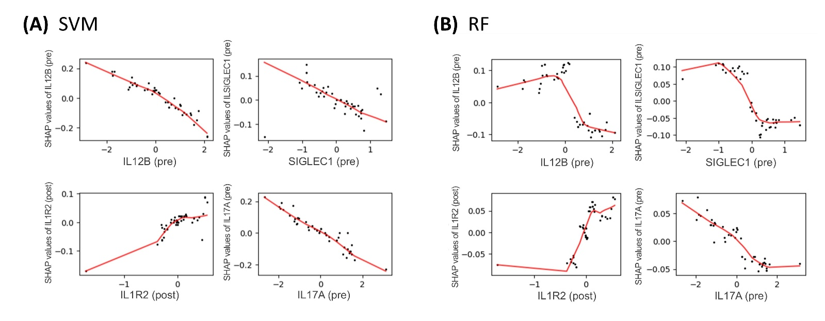
Supplementary Figure S2. Partial dependence plots of predictive models.
Partial dependence plots of IL12B (pretreatment), SIGLEC1 (pretreatment), IL1R2 (post-treatment), and IL17A (pretreatment) in the support vector machine (SVM) model (A) and the random forest (RF) model (B). Abbreviations: pre, pretreatment; post, post-treatment.

