Fig. S1. ADA titers by visit
A. Anti-PEG titers
B. Anti-uricase titers*

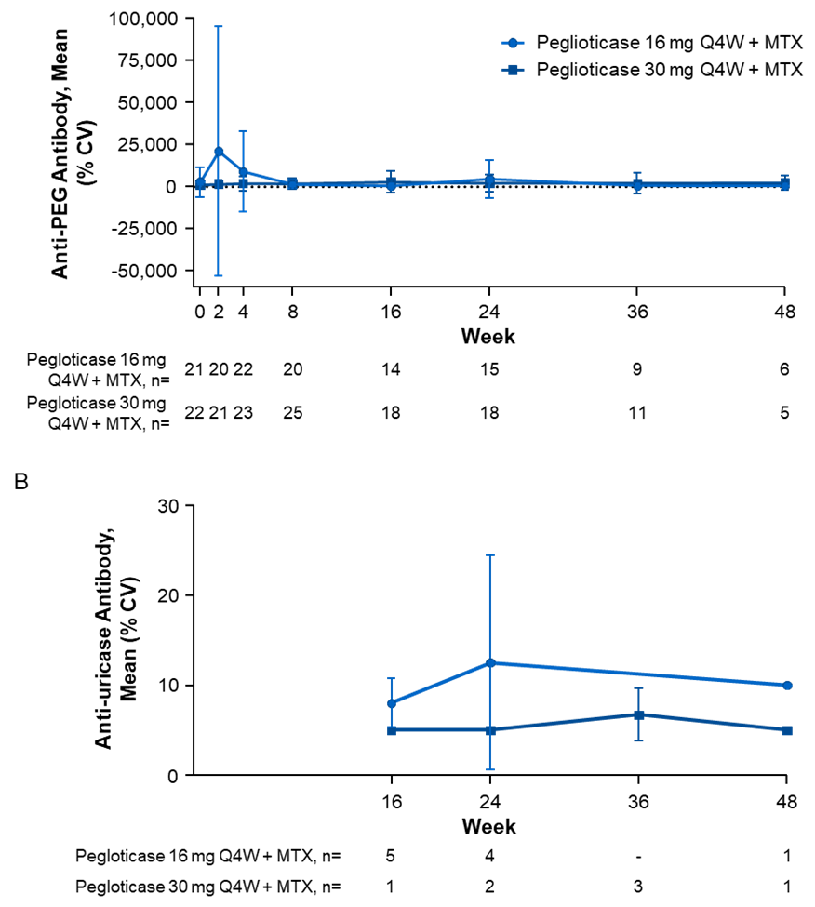
ADA titers were measured at specified visits.
*Titer summary is based on observed positive results. For titers < 10, 5 is used for analysis.
ADA, antidrug antibodies; CV, coefficient of variation; MTX, methotrexate; PEG, polyethylene glycol; Q4W, every 4 weeks.

Table S1. Summary of Month 12 MIROR RCT results [16]
 | Pegloticase  8 mg Q2W + MTX  (n = 100) | Pegloticase 8 mg Q2W + PBO  (n = 52)
Patient characteristics
Male, n (%) | 91 (91.0) | 44 (84.6)
Age, years, mean ± SD | 55.6 ± 12.7 | 53.0 ± 12.1
Race, n (%)
White | 69 (69.0) | 36 (69.2)
Black or African American | 16 (16.0) | 6 (11.5)
Asian | 8 (8.0) | 6 (11.5)
Native American or Pacific Islander | 4 (4.0) | 1 (1.9)
Other | 3 (3.0) | 3 (5.8)*
Gout characteristics
Time since first gout diagnosis, years, mean ± SD | 13.7 ± 10.6 | 14.3 ± 10.8
Presence of tophi at screening, n (%) | 74 (74.0) | 41 (78.8)
Treatment responders, %
Month 6 | 71.0 | 38.5
Month 12 | 60.0 | 30.8
 | Pegloticase  8 mg Q2W + MTX  (n = 96) | Pegloticase 8 mg Q2W + PBO  (n = 48)
Anti-PEG ADA positive, (%)
Baseline positive | 24 (25.0) | 14 (29.2)
Treatment-emergent positive | 30 (31.6)† | 28 (58.3)
 | Pegloticase  8 mg Q2W + MTX  (n = 96) | Pegloticase 8 mg Q2W + PBO  (n = 49)
TEAEs of special interest, n (%)
Gout flare | 64 (66.7) | 35 (71.4)
Infusion reaction | 3 (3.1) | 15 (30.6)
Anaphylaxis | 1 (1.0) | 0
Cardiac event | 1 (1.0) | 0
*One patient had missing race data.
†The percentage is relative to 95 patients.
ADA, antidrug antibody; MTX, methotrexate; PBO, placebo; PEG, polyethylene glycol; Q2W, every 2 weeks; RCT, randomized, controlled trial; SD, standard deviation; TEAE, treatment-emergent adverse event.

