Appendix A: Supplementary material

Supplementary Information 2
Let $Y$denote MDA (1 = yes), $T$ the treatment (tofacitinib, methotrexate, or etanercept), $X_{c}$ the clinical covariates, and $X_{m}$the metabolite predictors.
- Homogeneous treatment-effect model (HOM):
$$logit P(Y=1)=β_{0}+β_{T}^{⊤}T+β_{c}^{⊤}X_{c}+β_{m}^{⊤}X_{m}$$Assumes that predictor (biomarker) effects do not differ by treatment (no interactions).
- Heterogeneous treatment-effect model – Risk modelling (HTE–Risk):
First, compute a linear risk score $R=γ_{0}+γ_{c}^{⊤}X_{c}+γ_{m}^{⊤}X_{m}$(fitted in the whole cohort). Then fit:
$$logit P(Y=1)=β_{0}+β_{T}^{⊤}T+β_{R}R+β_{TR}^{⊤}(T×R)$$This model captures treatment-specific scaling of a single predictor-derived risk score (including both metabolites and clinical variables).
- Heterogeneous treatment-effect model – Effect modelling (HTE–Effect):
$$logit P(Y=1)=β_{0}+β_{T}^{⊤}T+β_{c}^{⊤}X_{c}+β_{m}^{⊤}X_{m}+δ_{c}^{⊤}(T×X_{c})+δ_{m}^{⊤}(T×X_{m})$$This model allows per-predictor treatment interactions. To reduce the complexity of the final model, interactions were selected using elastic net regularization with tuning by cross-validation.
Each model was optimized using nested cross-validation, with leave-one-out CV in both the inner and outer loop. The λ_{1se} was tuned in the inner loop. The model performance was determined in the outer loop.

Supplementary Information 3

To approximate the performance of the predictive models on an independent dataset, we implemented a full-process 10-fold cross-validation. The entire modelling pipeline, from predictor selection to model development, was rerun within each fold. All steps in predictor selection and model development were performed similarly as described in the methods sections 2.5-2.6.

Model performance was summarized as the mean AUC across the 10 rounds of CV. For the HTE-effect models, the reported AUC is the mean of only those CV rounds in which at least one interaction term was selected.

Supplementary Table 2
Table S2. Selected metabolomic markers
Common name | HMDB ID/ PubChem ID | Subclass | sPLS-DA | XGBoost
1-Methylhistidine | HMDB0000001 | Amino acid | X
3-Methylglutaric Acid | HMDB0000752 | Amino acid / Fatty acids |  | X
Deoxycarnitine / ɣ-butyrobetaine | HMDB0001161 | Amino acid / Fatty acids |  | X
Allantoin | HMDB0000462 | Imidazoles |  | X
cLPA 16:1 |  | Glycerophospholipids | X
LPI 20:4 | HMDB0062722 | Glycerophospholipids | X
5-HEPE | HMDB0005081 | Unsaturated fatty acids/ Eicosanoids | X
8,12-iso-iPF2α-VI isoprostane | 156593941 | Unsaturated fatty acids/ isoprostane | X
Sphinganine | HMDB0000269 | Sphingolipids | X
HMDB ID: Human Metabolome Database ID; Universal Protein identifier; sPLS-DA: sparse partial least squares discriminant analysis; XGBoost: extreme gradient tree boosting. cLPA 16:1: Cyclic-Lysophosphatidic acid 16:1; LPI (20:4): Lysophosphatidylinositol (20:4); 5-HEPE: 5-Hydroxy eicosapentaenoic Acid.

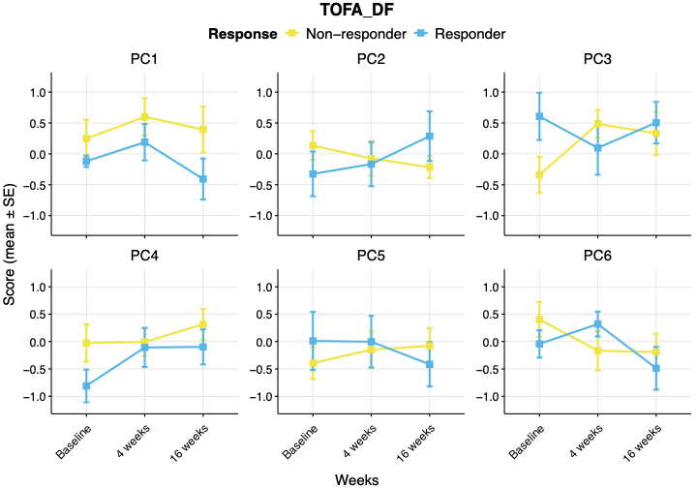
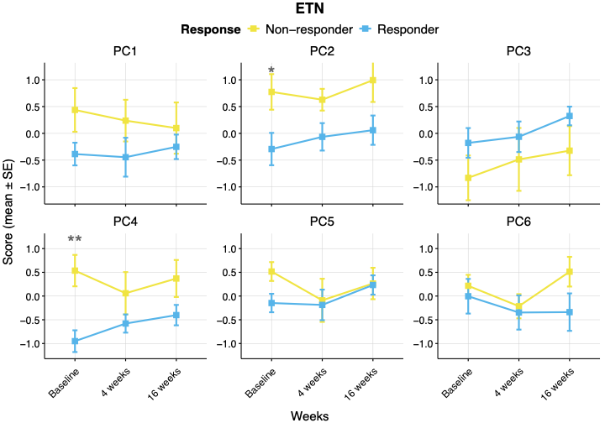
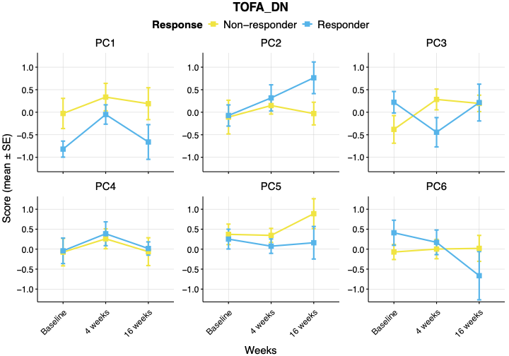
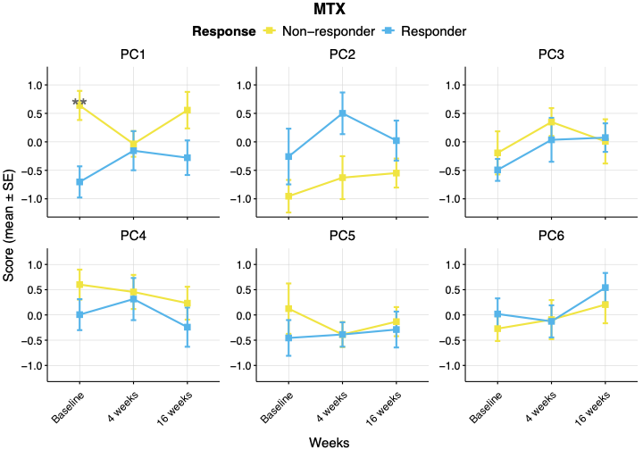
Supplementary Figure 1
Supplementary Figure 1. Longitudinal trajectories of PC scores over baseline, 4 and 16 weeks are shown for responders and non-responders for each treatment group (MTX, ETN, TOFA DN and TOFA DF). Mean PC scores are shown, and the bars represent the standard error. Significant differences between responders and non-responders are indicated by * (p ≤ 0.05), ** (p ≤ 0.01), or *** (p ≤ 0.001) at every time point.

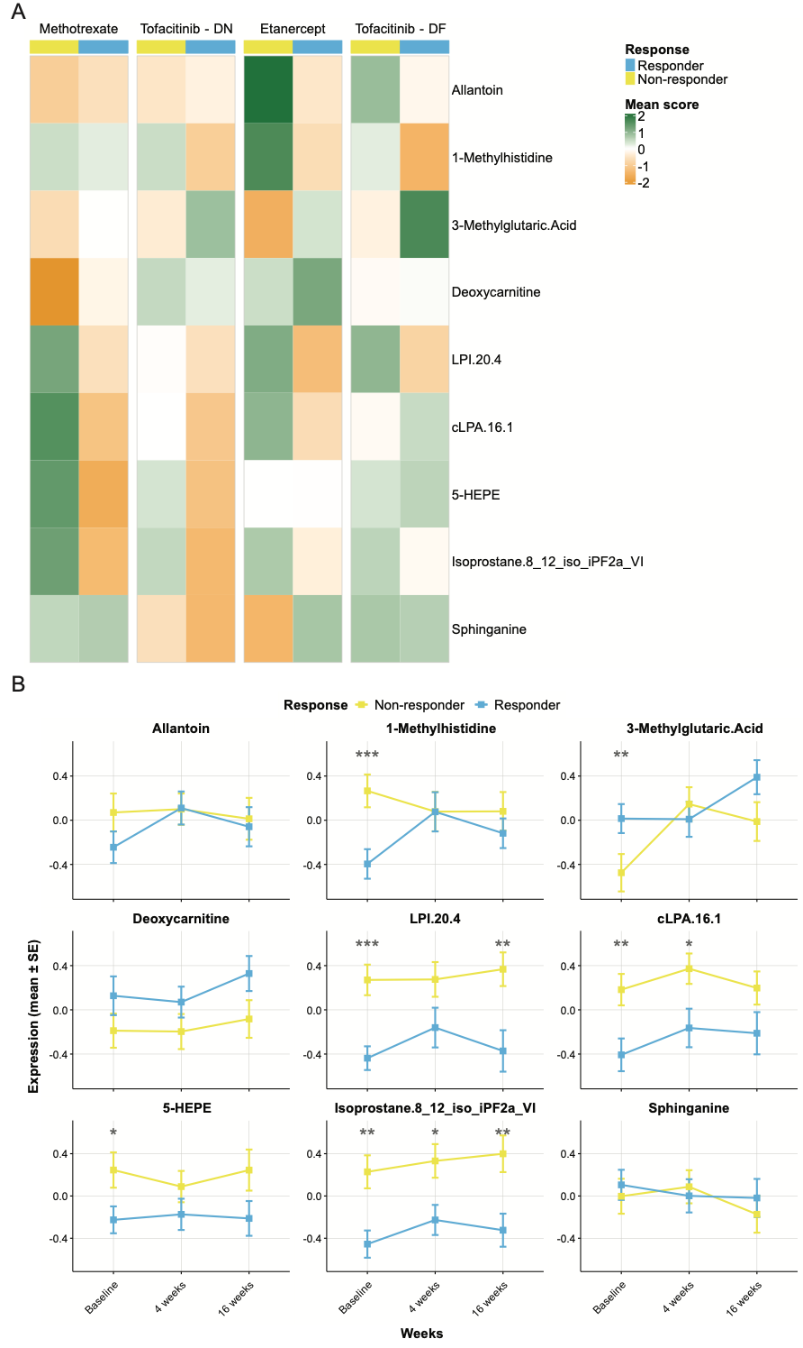
Supplementary Figure 2
Supplementary Figure 2. Exploration of selected metabolites. (A) Heatmap of normalised mean baseline metabolite expression across treatment groups and responder status. (B) Longitudinal trajectories of normalised and scaled metabolite expression over baseline, 4 and 16 weeks are shown for responders and non-responders. Mean expression is shown, and the bars represent the standard error. Significant differences between responders and non-responders at every time point are indicated by * (p ≤ 0.05), ** (p ≤ 0.01), or *** (p ≤ 0.001).

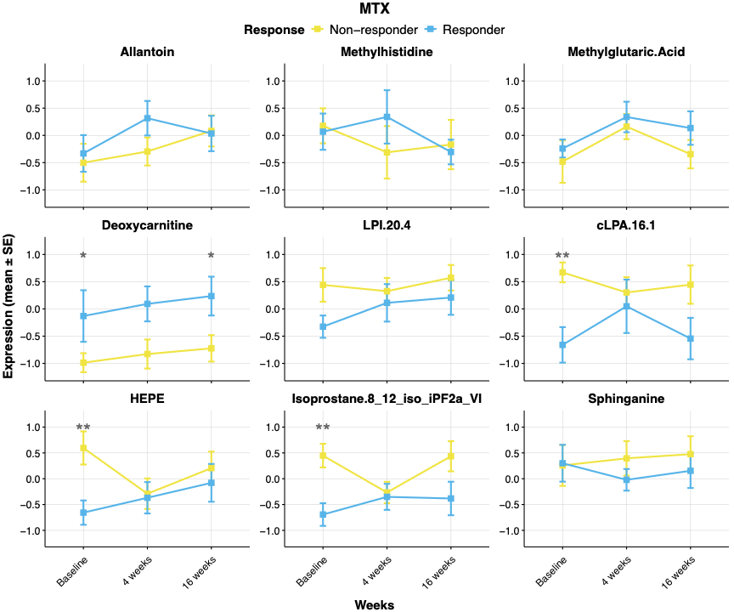
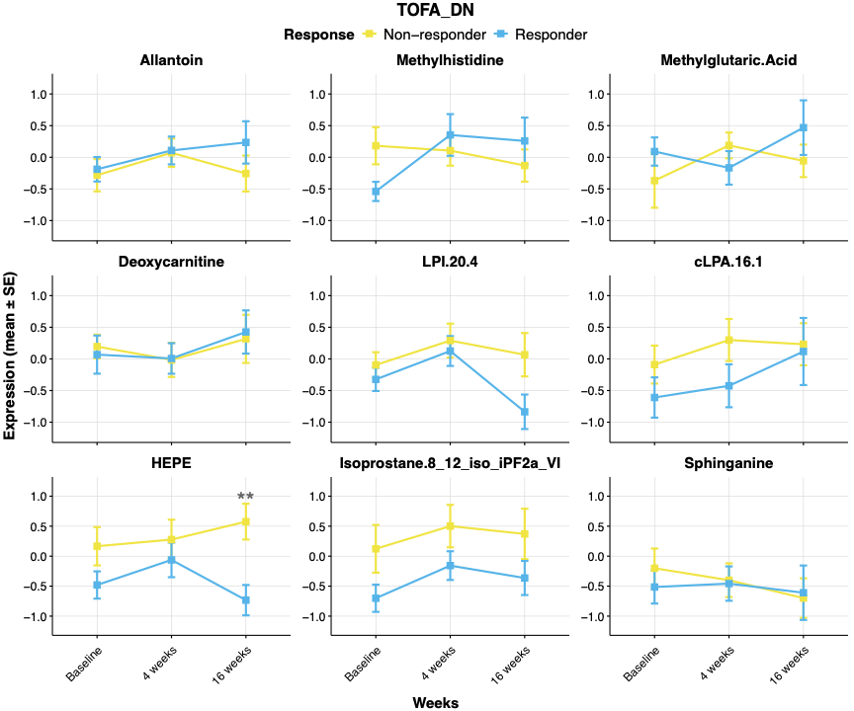
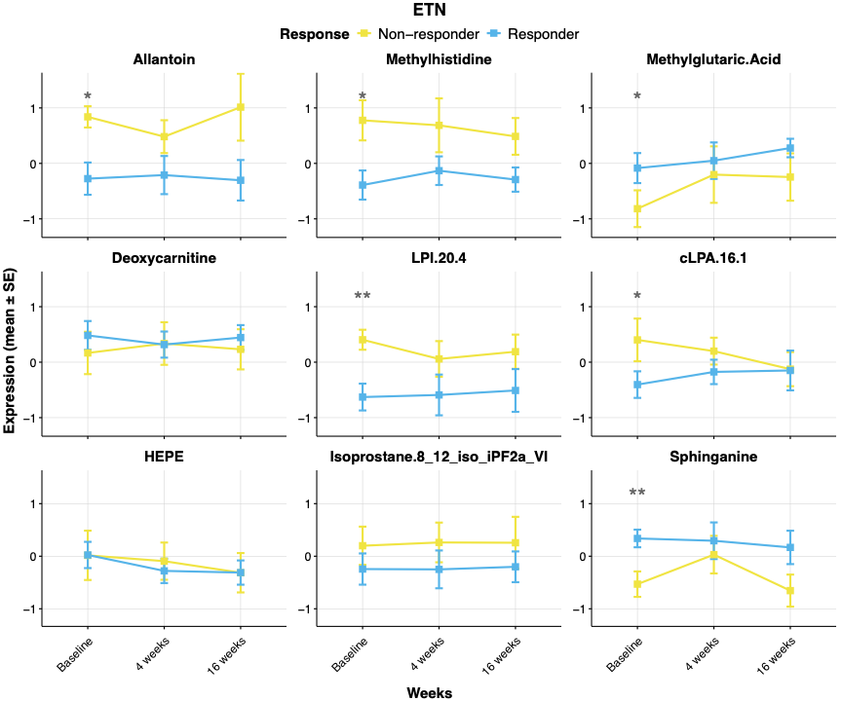
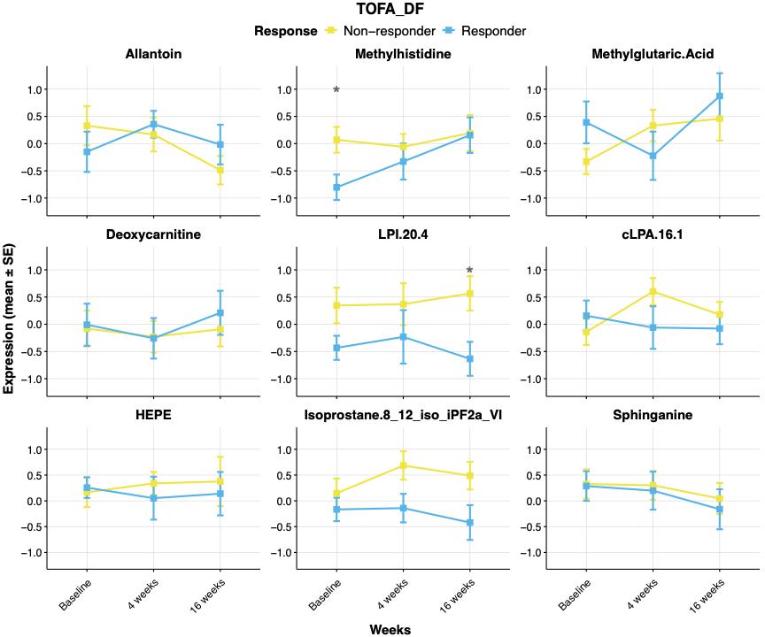
Supplementary Figure 3
Supplementary Figure 3. Longitudinal trajectories of normalised metabolite expression over baseline, 4 and 16 weeks are shown for responders and non-responders for each treatment group (MTX, ETN, TOFA DN and TOFA DF). Mean expression is shown, and the bars represent the standard error. Significant differences between responders and non-responders at every time point are indicated by * (p ≤ 0.05), ** (p ≤ 0.01), or *** (p ≤ 0.001).

