Supplementary Figure 1

A

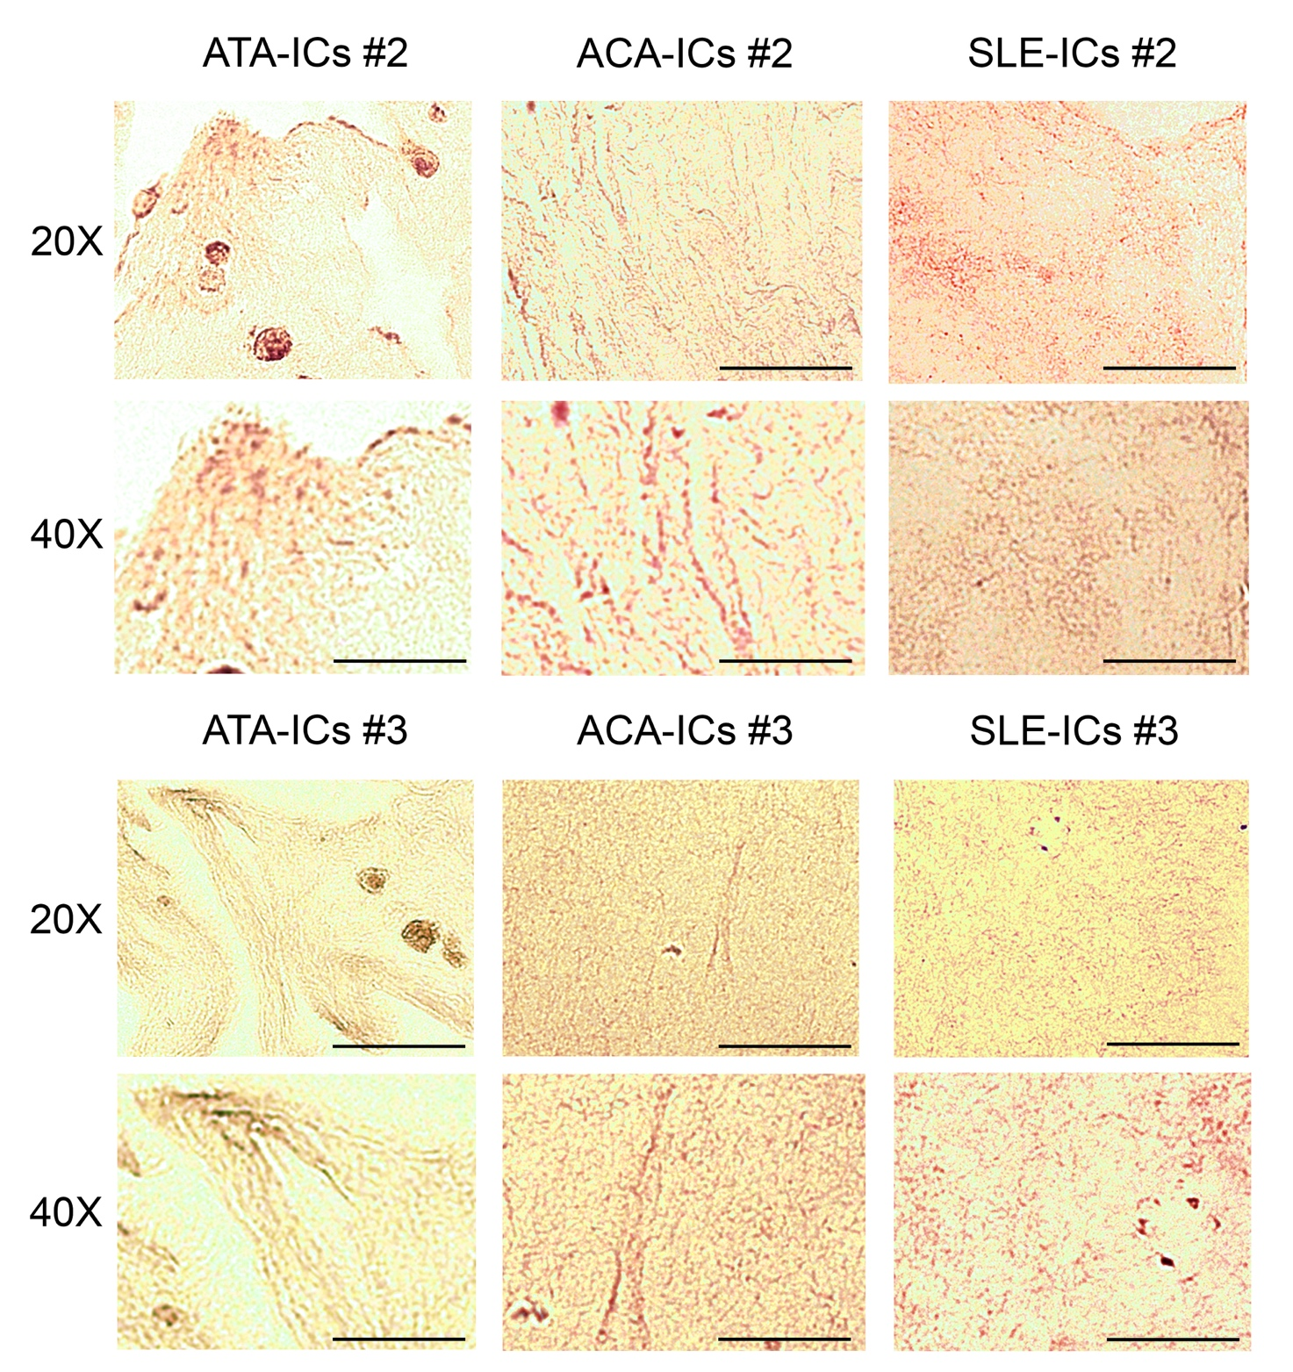

B

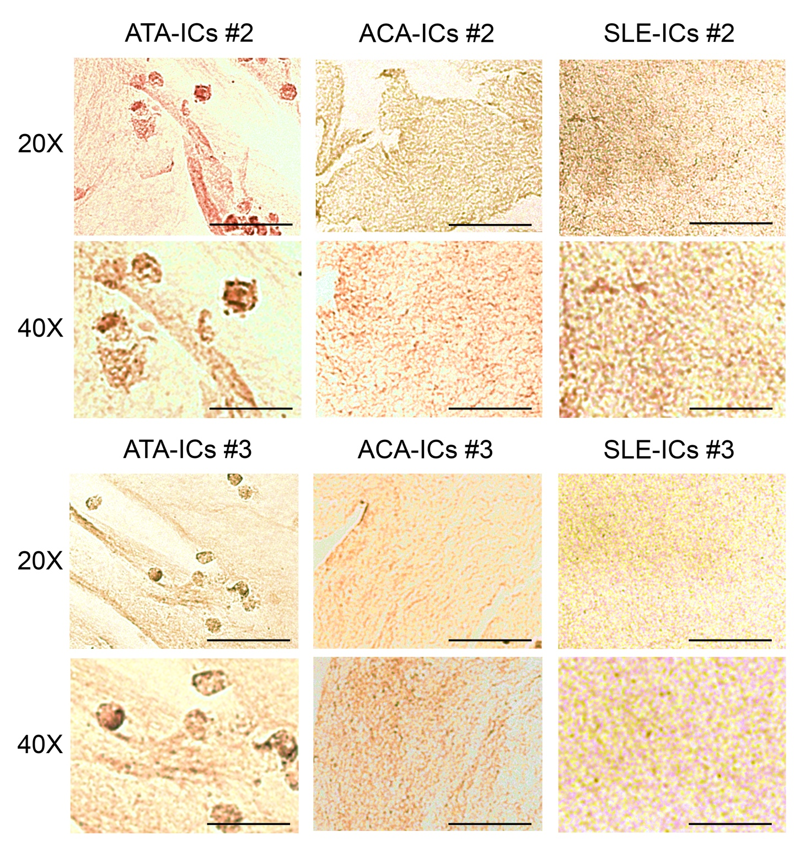

C

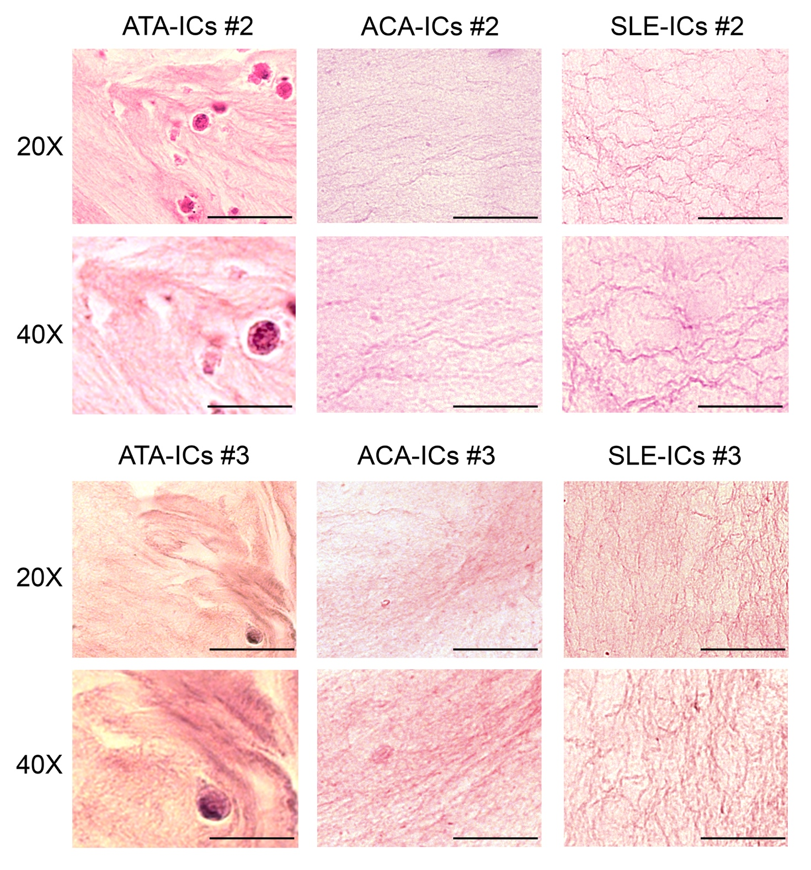
Supplementary Figure 1. Immunohistochemical analyses (1A, 1B) and immunohistological (1C) of porcine lung TissueSpec® ECM hydrogel encapsulating ECs after 48-hour incubation with ICs (ATA-ICs, ACA-ICs and SLE-ICs).
1A: CD31 and Haematoxylin staining
1B: CD34 and Haematoxylin staining
1C: H&E staining

Images are representative of 3 independent experiments (n=3).
Upper: original magnification 20X. Scale bars correspond to 50 µm.
Lower: original magnification 40X. Scale bars correspond to 25 µm.

Supplementary Figure 2

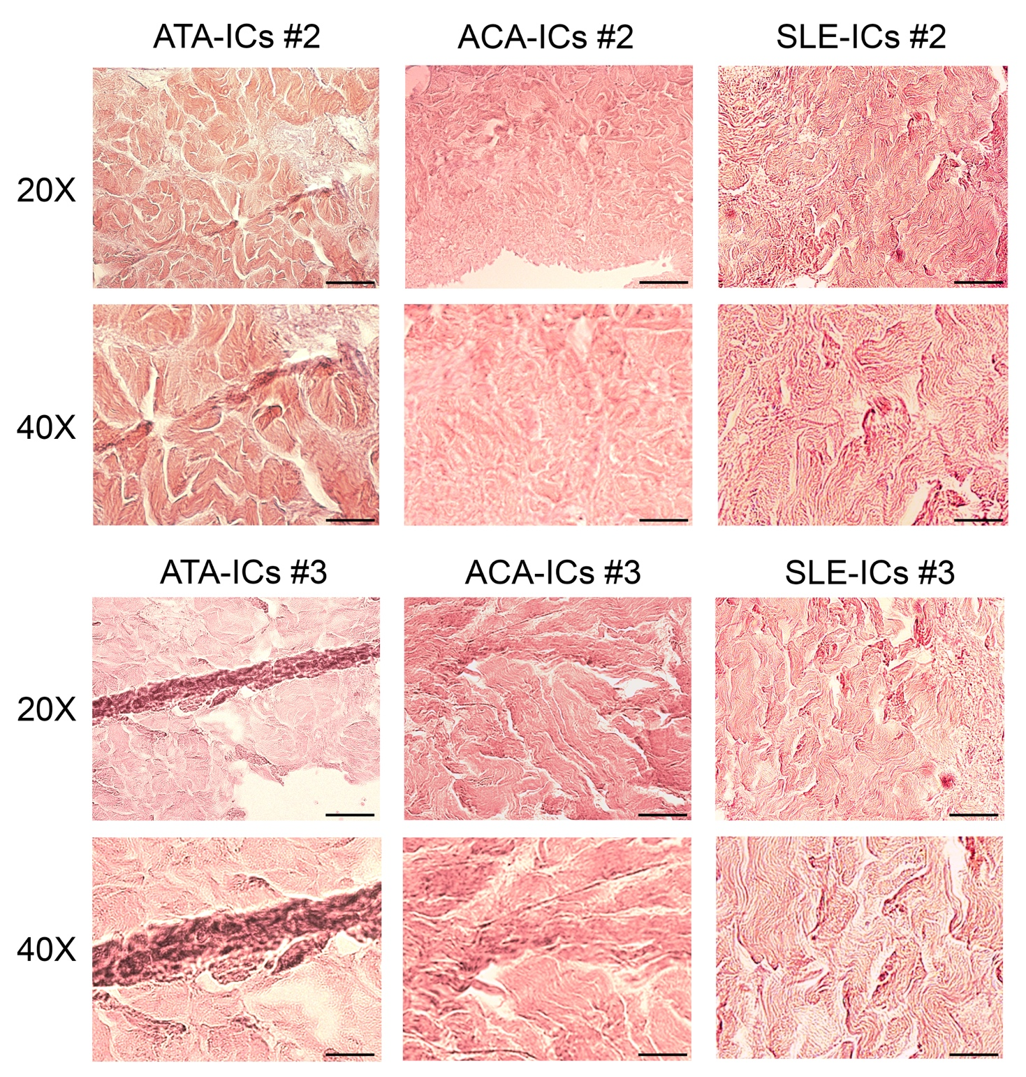

Supplementary Figure 2. H&E staining of sections of TissueSpec® Skin ECM Scaffold after 48-hour stimulation of ECs with IC preparations (ATA-ICs, ACA-ICs and SLE-ICs).
Images are representative of 3 independent experiments (n=3).
Upper: original magnification 20X. Scale bars correspond to 50 µm.
Lower: original magnification 40X. Scale bars correspond to 25 µm.

Supplementary Figure 3

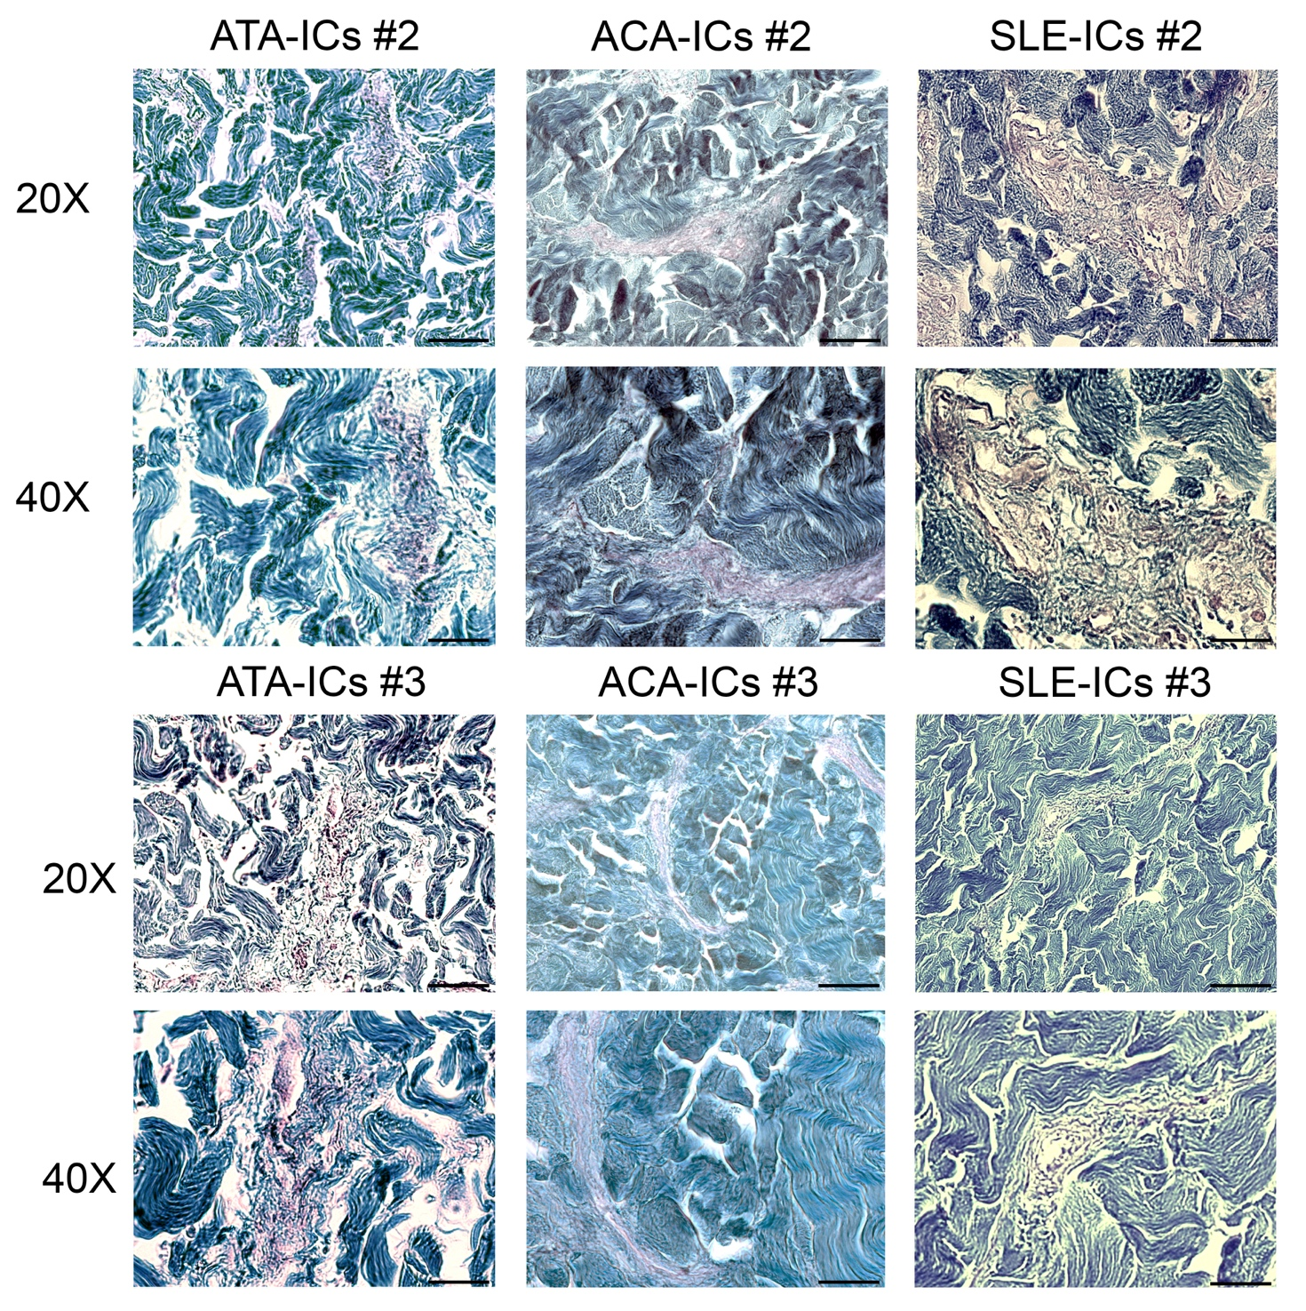
Supplementary Figure 3. GTR staining of sections of TissueSpec® Skin ECM Scaffold after 48-hour stimulation of ECs with IC preparations (ATA-ICs, ACA-ICs and SLE-ICs).
Images are representative of 3 independent experiments (n=3).
Upper: original magnification 20X. Scale bars correspond to 50 µm.
Lower: original magnification 40X. Scale bars correspond to 25 µm.

Supplementary Figure 4

A
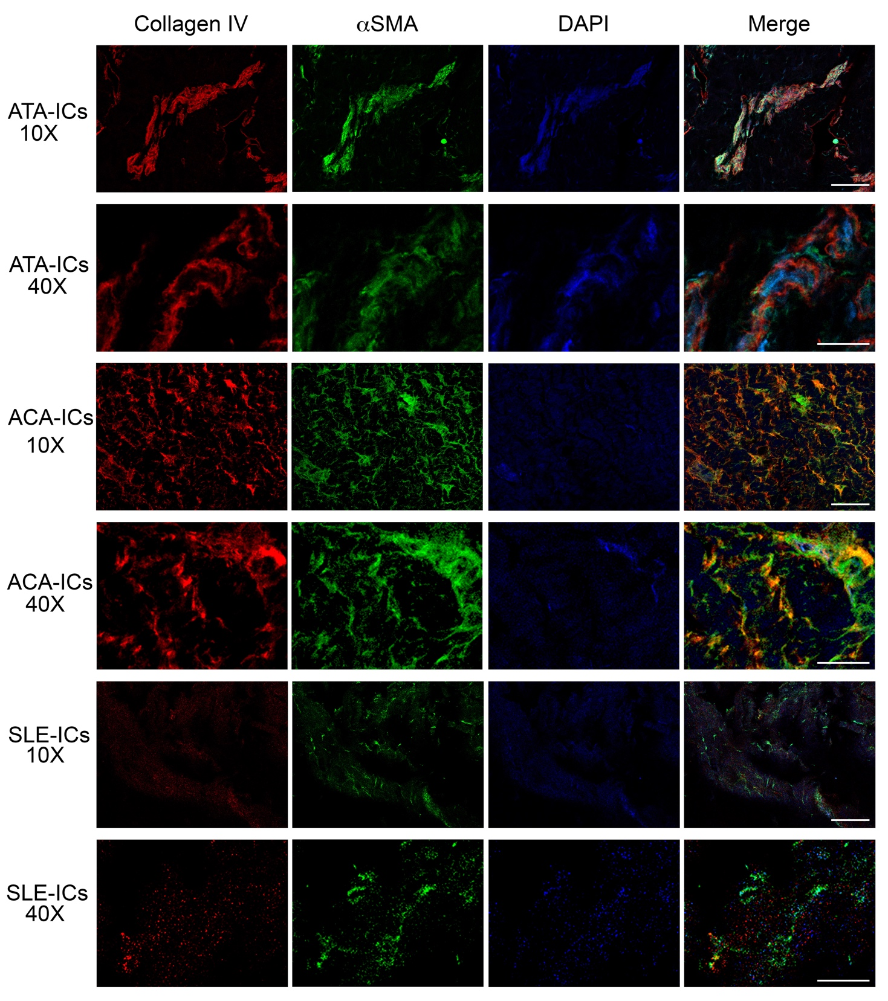

B
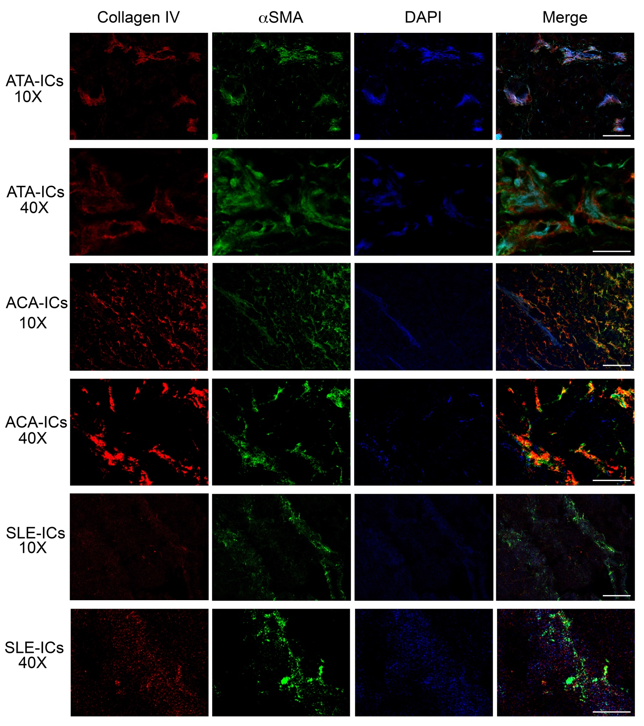
Supplementary Figures 4. Immunofluorescence analysis of sections of TissueSpec® Skin ECM Scaffold after 48-hour stimulation of ECs with IC preparations (ATA-ICs, ACA-ICs and SLE-ICs).
Panel A: patient #2.
Panel B: patient #3.
Collagen IV (red) and αSMA (green) and DAPI (blue).
Images are representative of 3 independent experiments (n=3).
Images were acquired using confocal ZEISS LSM900.
Original magnification 10X, scale bars correspond to 100 µm.
Original magnification 40X, scale bars correspond to 25 µm.

Supplementary Figure 5

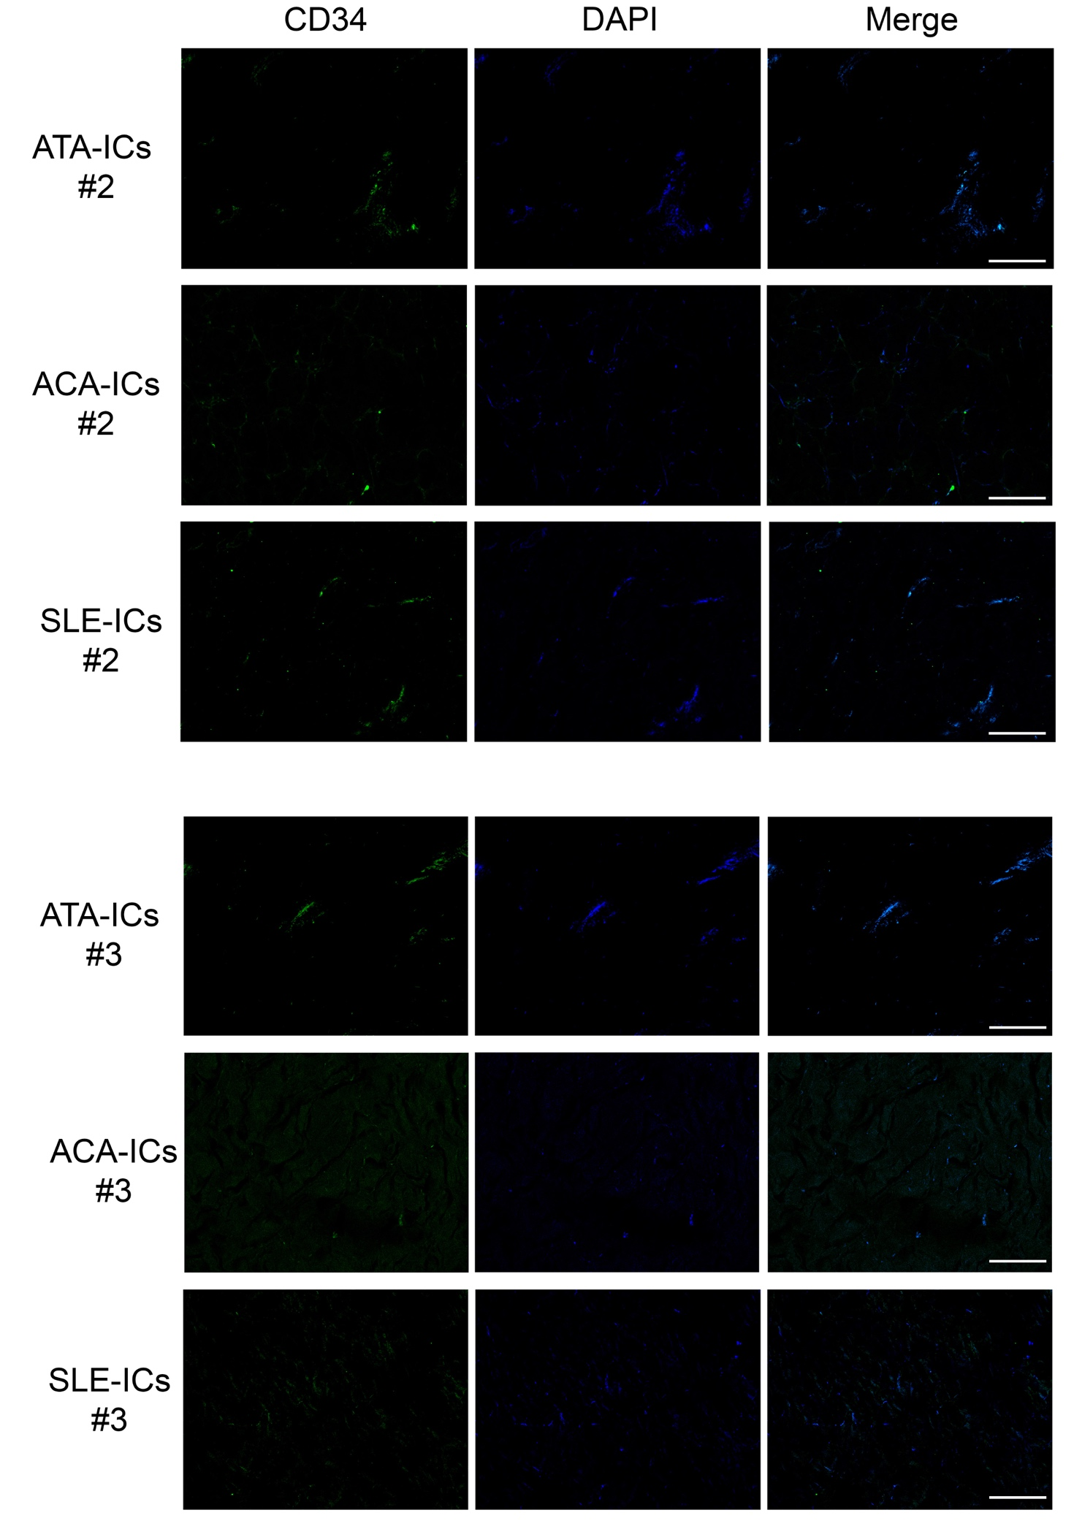
Supplementary Figure 5. Immunofluorescence analysis of sections of TissueSpec® Skin ECM Scaffold after 48-hour stimulation of ECs with IC preparations (ATA-ICs, ACA-ICs and SLE-ICs).
CD34 (green) and DAPI (blue).
Images are representative of 3 independent experiments (n=3).
Images were acquired using confocal confocal ZEISS LSM900.
Original magnification 10X, scale bars correspond to 100 µm.

