Supplementary Appendix
“Progression of sacroiliac joint structural lesions in axial spondyloarthritis: A longitudinal comparative study of MRI and radiography among European patients in routine clinical care”, by Steimer A, et al.

Supplementary Table S1. Description of ethical approvals from participating countries.
Country | Ethical approval | Reference
Czech Republic | Ethical approval for ATTRA was granted by the Czech Multicentre Research Ethics Committee. No additional ethical approval was required for the current analysis. All subjects provided their written consent for the collection and storage of data before participation. | No. 201611 S300.
Denmark | In Denmark, the Danish Patient Safety Authority approved the project, ethics approval was waived | Not applicable
Iceland | In Iceland, The National Bioethics Committee approved the project | 18-009-V17.
Slovenia | In Slovenia, the National Medical Ethics Committee of the Republic of Slovenia approved the project. | 0120-97/2022
Switzerland | The study was approved by the Ethics Committee of the Canton of Zurich.  Written informed consent was obtained from all patients. | BASEC 2022-00272

Supplementary Table S2. Inter-reader reliability of MRI scoring assessed using the intraclass correlation coefficient ICC(2,k) (two-way random-effects model, average measures, absolute agreement).
 | Intraclass correlation coefficients (ICC (2, k))
SPARCC domain | TP1 (95%CI) | TP2 (95%CI) | Change from TP1 to TP2 (95%CI)
Bone marrow oedema | 0.83 (0.58, 0.92) | 0.89 (0.80, 0.93) | 0.93 (0.88, 0.96)
Structural lesions
- Erosion | 0.76 (0.69, 0.82) | 0.60 (0.51, 0.69) | 0.63 (0.54, 0.71)
- Sclerosis | 0.18 (0.06, 0.31) | 0.20 (0.08, 0.33) | 0.11 (-0.01, 0.24)
- Ankylosis | 0.97 (0.96, 0.98) | 0.96 (0.94, 0.97) | 0.93 (0.91, 0.95)
- Fat lesions | 0.43 (0.15, 0.63) | 0.34 (0.11, 0.54) | 0.35 (0.23, 0.47)
- Backfill | 0.66 (0.57, 0.74) | 0.63 (0.53, 0.72) | 0.69 (0.61, 0.76)
TP1 = timepoint 1; TP2 = timepoint 2; SPARCC = Spondyloarthritis Research Consortium of Canada.

Supplementary Table S3. Cohen’s kappa coefficients for radiographic scoring.
 | Cohen’s kappa
 | TP1 | TP2 | Change from TP1 to TP2
Structural lesions
- Erosion | 0.01 | 0.02 | - 0.04
- Sclerosis | 0.14 | 0.08 | - 0.01
- Ankylosis | 0.63 | 0.60 | 0.00
In 7 cases only one reader and one adjudicator scored the image. These cases were omitted from the inter-reader reliability agreement calculation. TP1 = timepoint 1; TP2 = timepoint 2; SPARCC = Spondyloarthritis Research Consortium of Canada.

Supplementary Figure S1. “Progression” and “regression” of erosion, sclerosis, and incident ankylosis in SIJ radiograph (x-axes) and MRI (y-axes) between first and second assessment for the left and right SIJ, respectively in patients with radiographic axSpA (n=33). A. Change in erosion. B. Change in sclerosis. C. New ankylosis. SPARCC = Spondyloarthritis Research Consortium of Canada.
A.
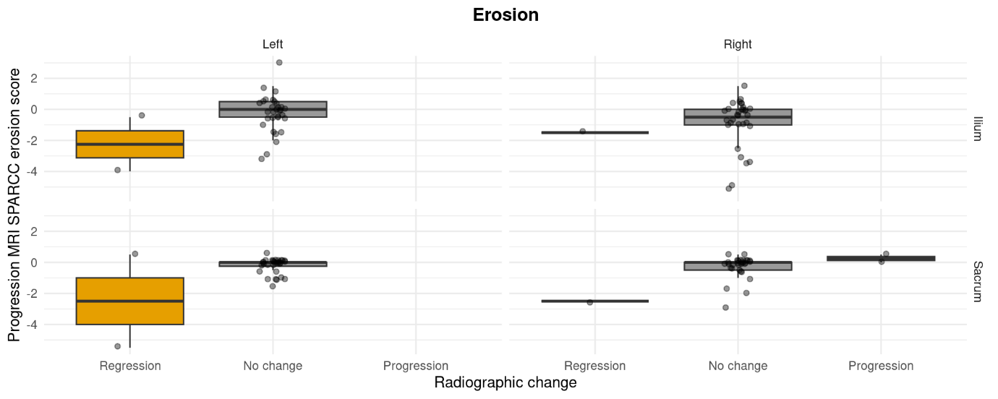
B.
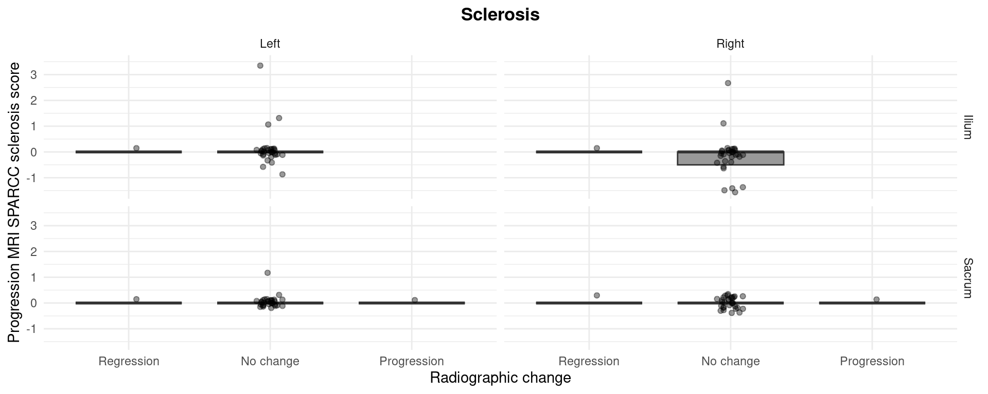
C.
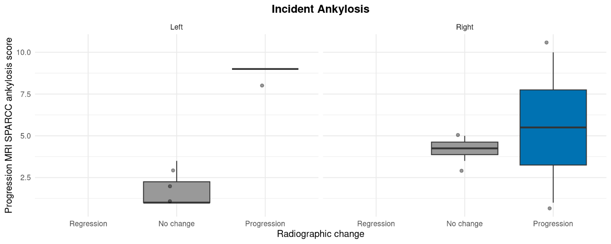
Supplementary Figure S2. “Progression” and “regression” of ankylosis in SIJ radiograph (x-axes) and MRI (y-axes) between first and second assessment for the left and right SIJ. MRI = magnetic resonance imaging; SPARCC = Spondyloarthritis Research Consortium of Canada.

