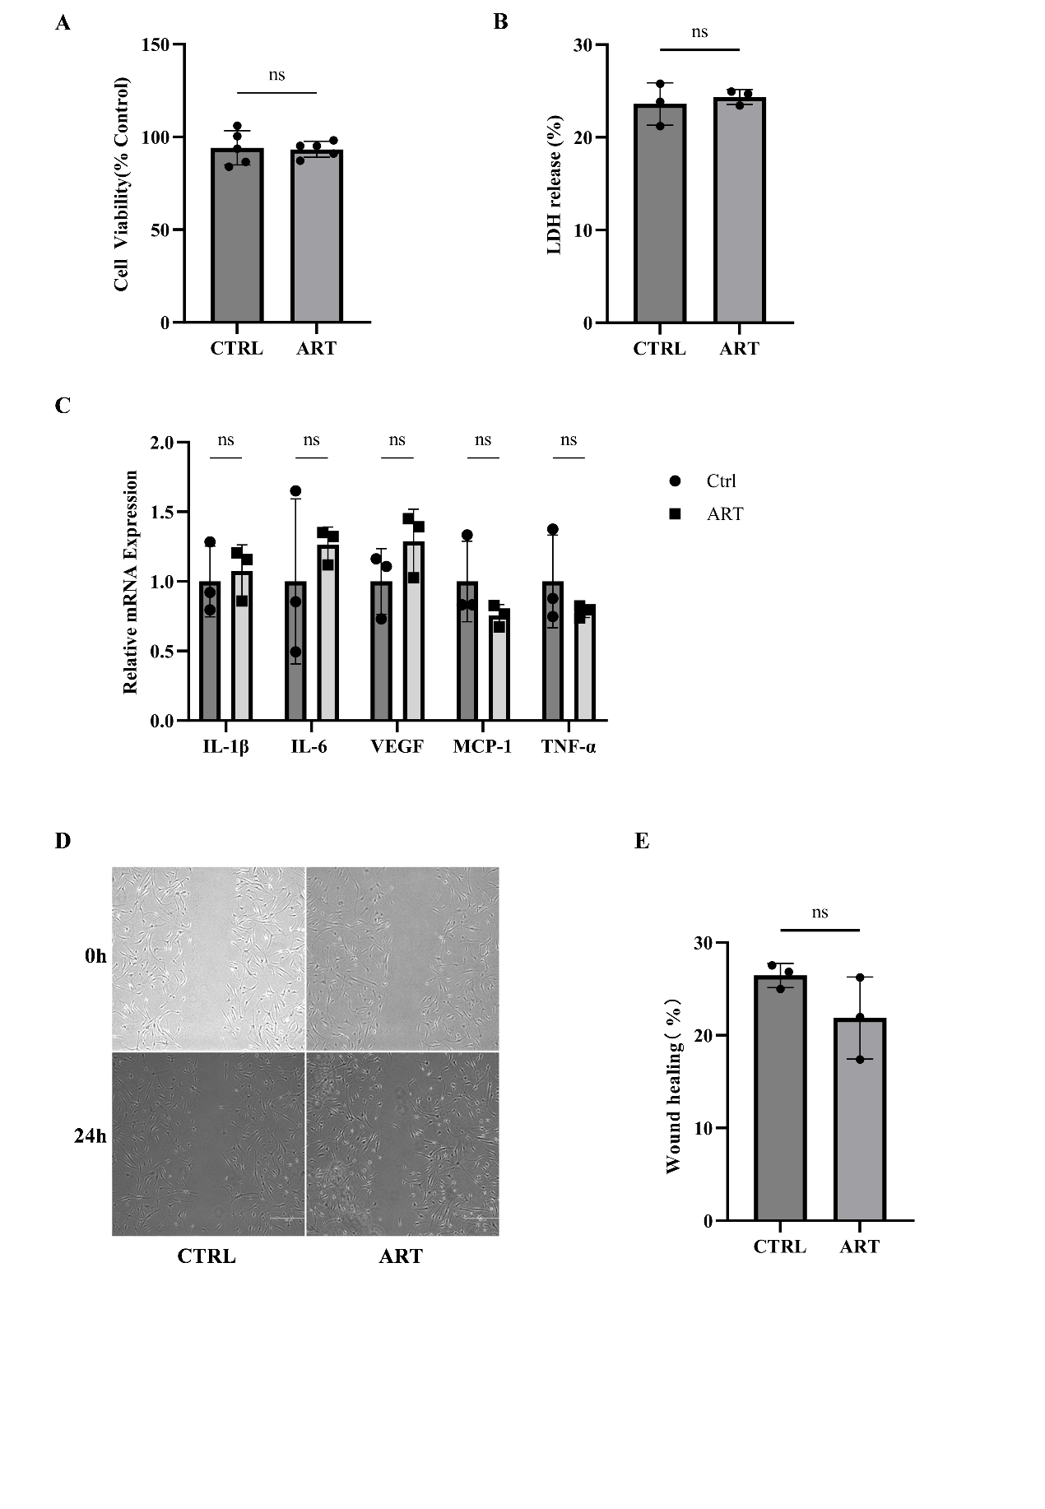

Figure S1 ART exerts no effects on proliferation, LDH release, cytokine secretion and migration of OASFs. OASFs were exposed to 30 μM ART for 24 hours, (A) Cell Counting Kit-8 assay was used to detect relative cell activity. (B) The level of LDH release was detected using the LDH release assay kit. (C) qPCR was used to detect mRNA levels of multiple inflammatory factors. (D-E) Cell scratch assay was used to assess cell migration levels. Data are presented as mean ± standard deviation (n = 3). *P < 0.05, **P < 0.01, ***P < 0.001, ****P < 0.0001 compared to the control group.

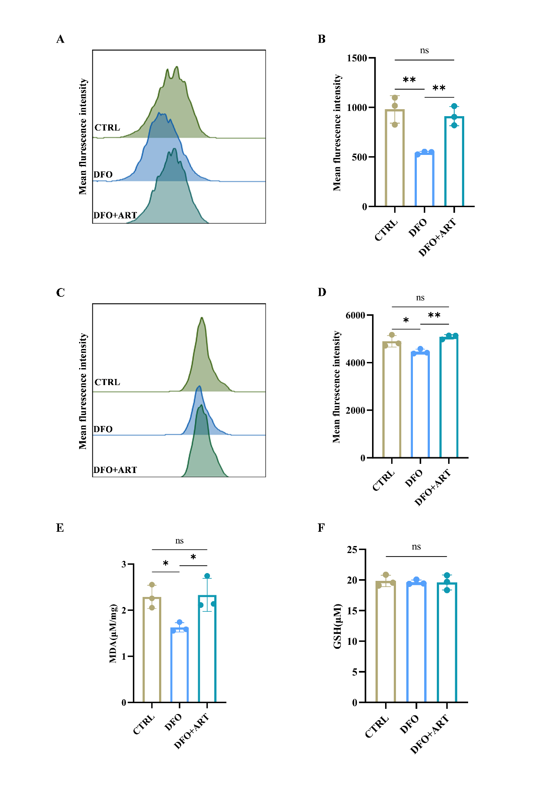

Figure S2 The inhibitory effect of ART on ferroptosis in RASFs can be reversed by DFO. RASFs were exposed to 30 μM ART for 24 hours with or without 2 μM DFO treatment. (A-B) Flow cytometry was used to detect the fluorescence intensity of the ROS probe. (C-D) Flow cytometry was used to detect the fluorescence intensity of the C11-BODIPY 581/591 probe. (E) MDA levels in cells were detected using an MDA assay kit. (F) GSH levels in cells were detected using a GSH assay kit. Data are presented as mean ± standard deviation (n = 3). *P < 0.05, **P < 0.01, ***P < 0.001, ****P < 0.0001 compared to the control group.

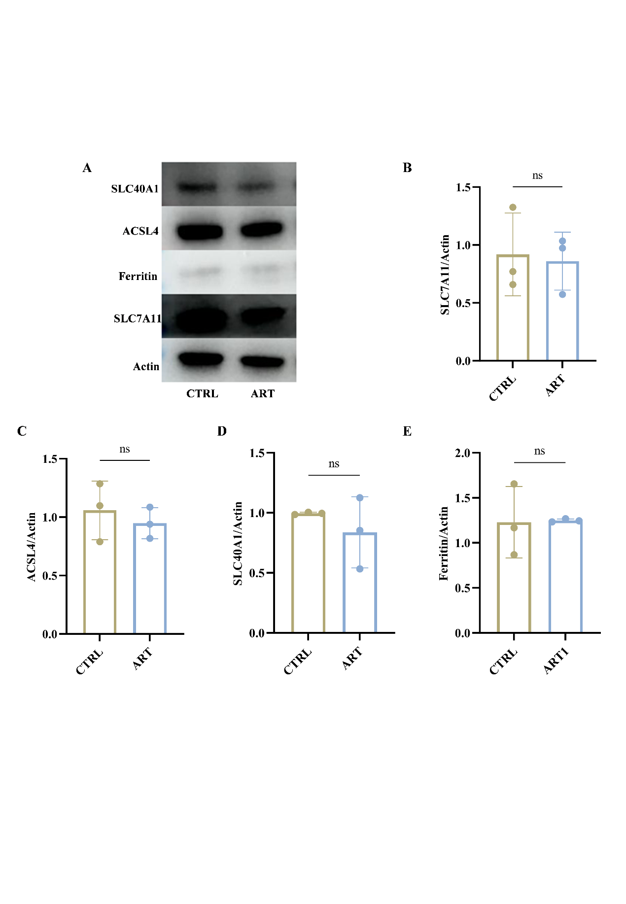

Figure S3 ART has no significant effect on the protein levels of SLC7A11, ferritin, ACSL4 and SLC40A1. (A-E) RASFs were exposed to 30 μM ART for 24 hours, western blotting was used to detect intracellular SLC7A11, ferritin, ACSL4 and SLC40A1 protein levels. Data are presented as mean ± standard deviation (n = 3). *P < 0.05, **P < 0.01, ***P < 0.001, ****P < 0.0001 compared to the control group.

