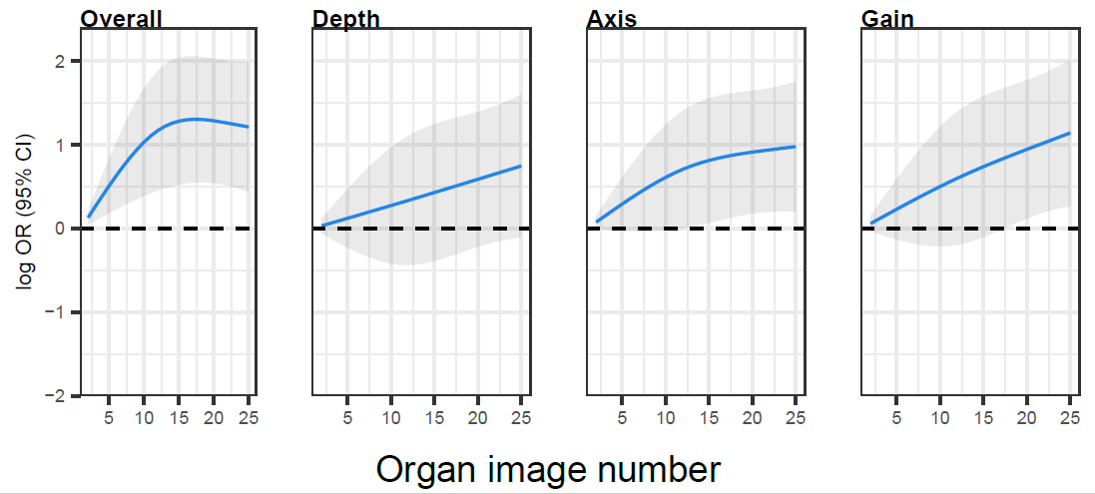
Additional file 1: Figure S1. Stacked bar charts of proportion of scores on a 5-Point Likert scale based on number of abdominal aorta examinations
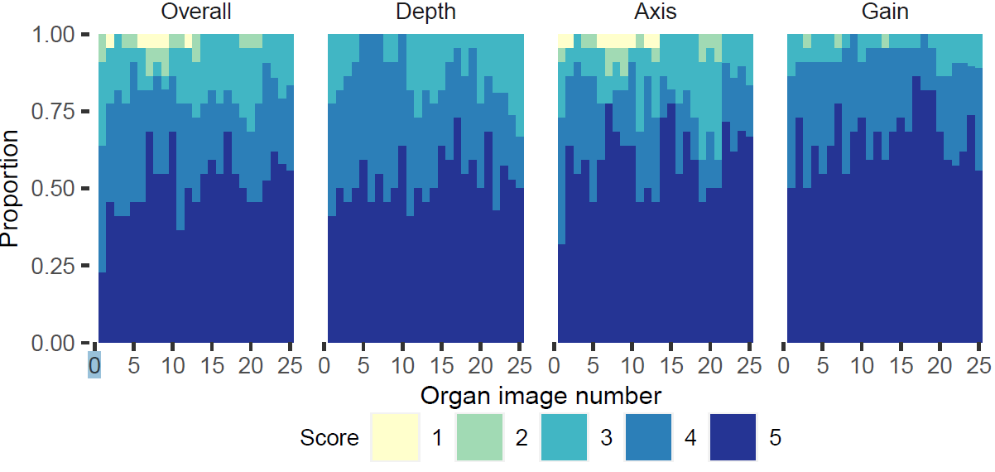
Additional file 1: Figure S2. Plateau Points for Abdominal Aorta Point-of-Care Ultrasound examinations
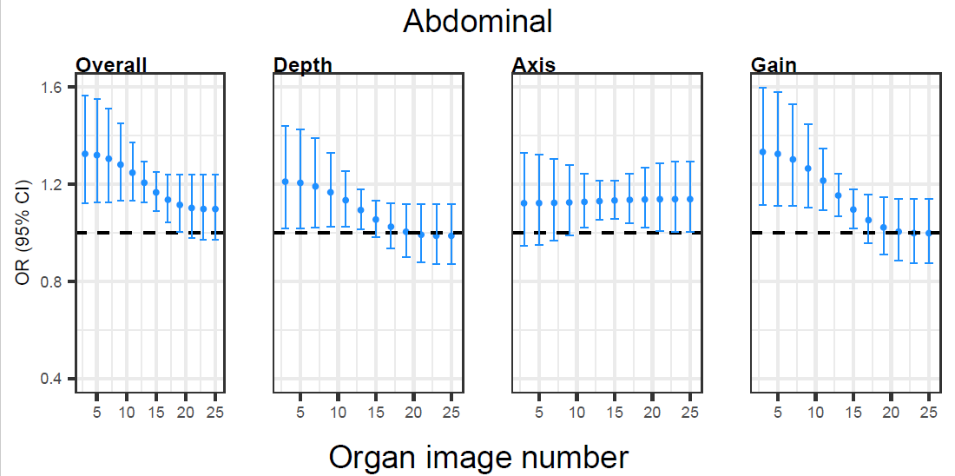
Additional file 1: Figure S3. Plateau Points for Bladder Point-of-Care Ultrasound examinations
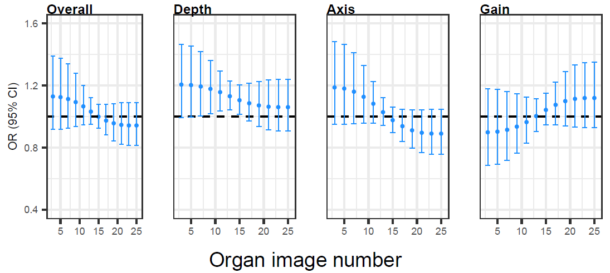
Additional file 1: Figure S4. Stacked bar charts of proportion of scores on a 5-Point Likert scale based on number of bladder examinations
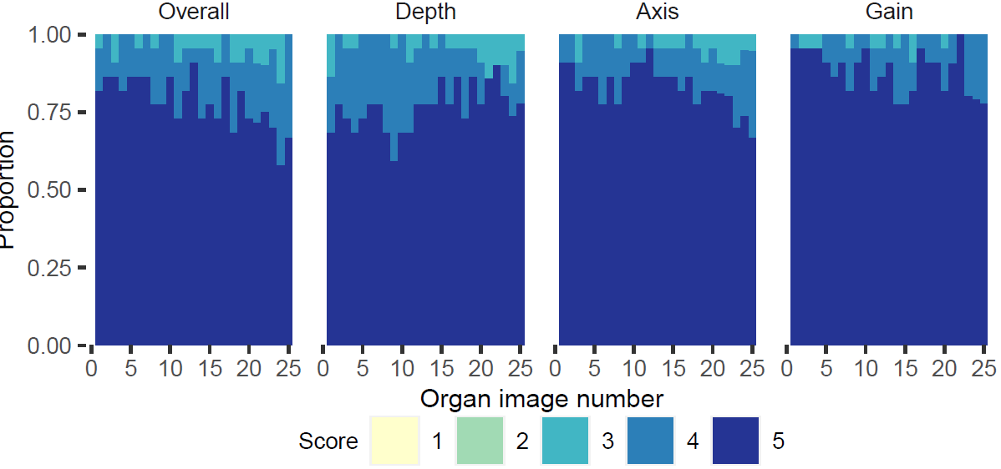
Additional file 1: Figure S5. Stacked bar charts of proportion of scores on a 5-Point Likert scale based on number of cardiac examinations.
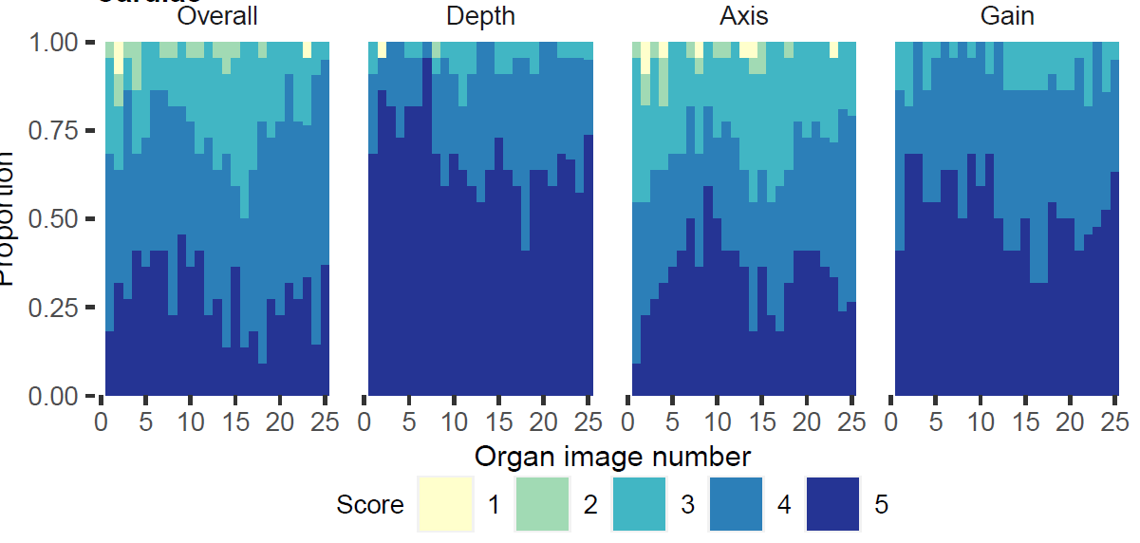
Additional file 1: Figure S6. Plateau Points for Cardiac Point-of-Care Ultrasound examinations
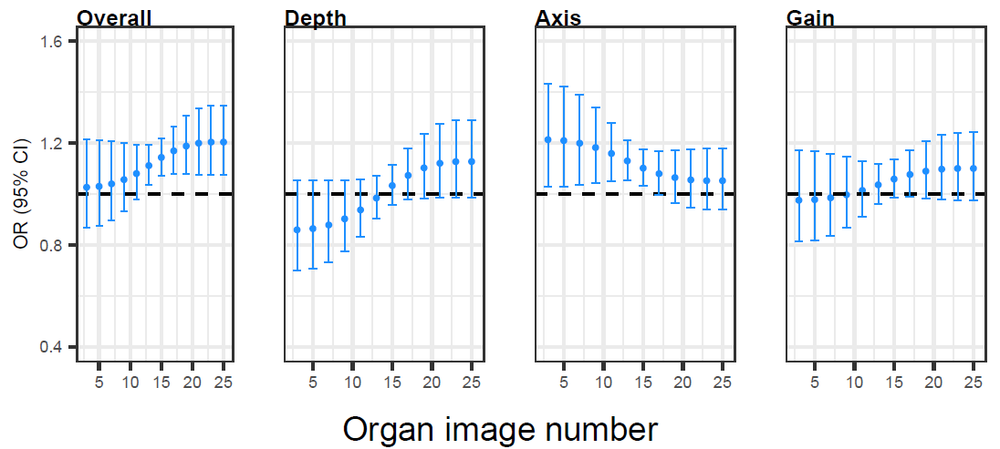
Additional file 1: Figure S7. Stacked bar charts of proportion of scores on a 5-Point Likert scale based on number of lung examinations
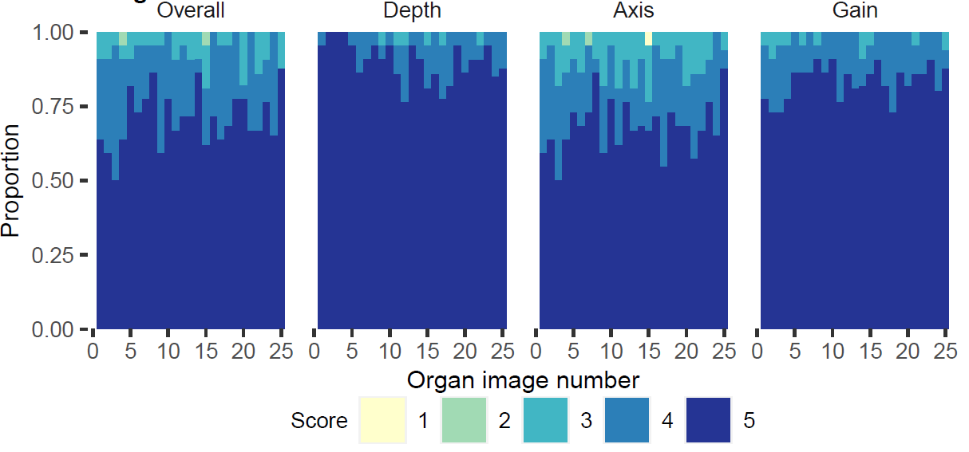
Additional file 1: Figure S8. Plateau Points for Lung Point-of-Care Ultrasound examinations
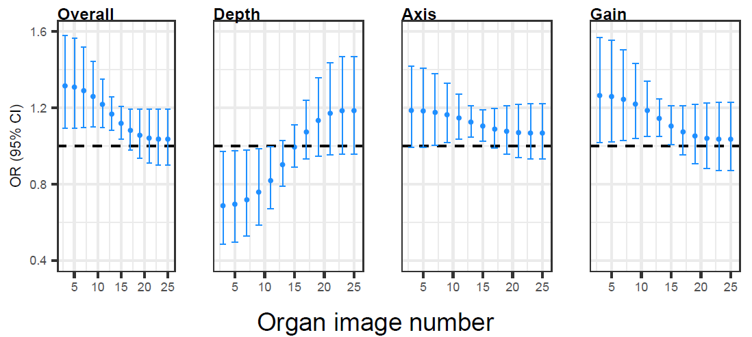
Additional file 1: Figure S9. Stacked bar charts of proportion of scores on a 5-Point Likert scale based on number of renal examinations.
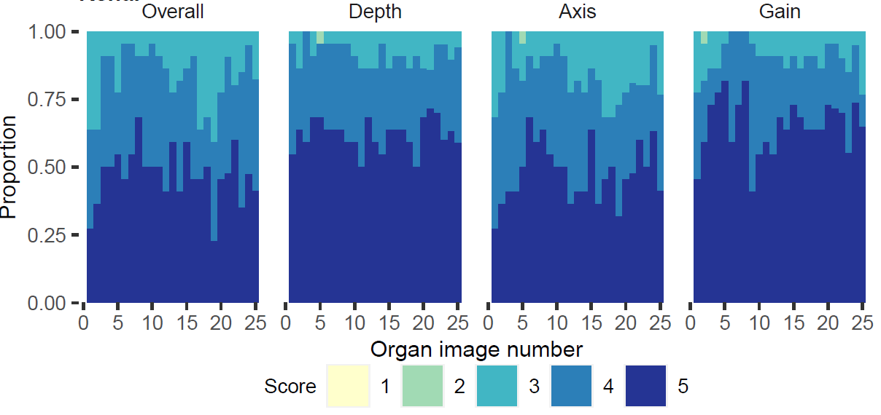
Additional file 1: Figure S10. Plateau Points for Renal Point-of-Care Ultrasound examinations
