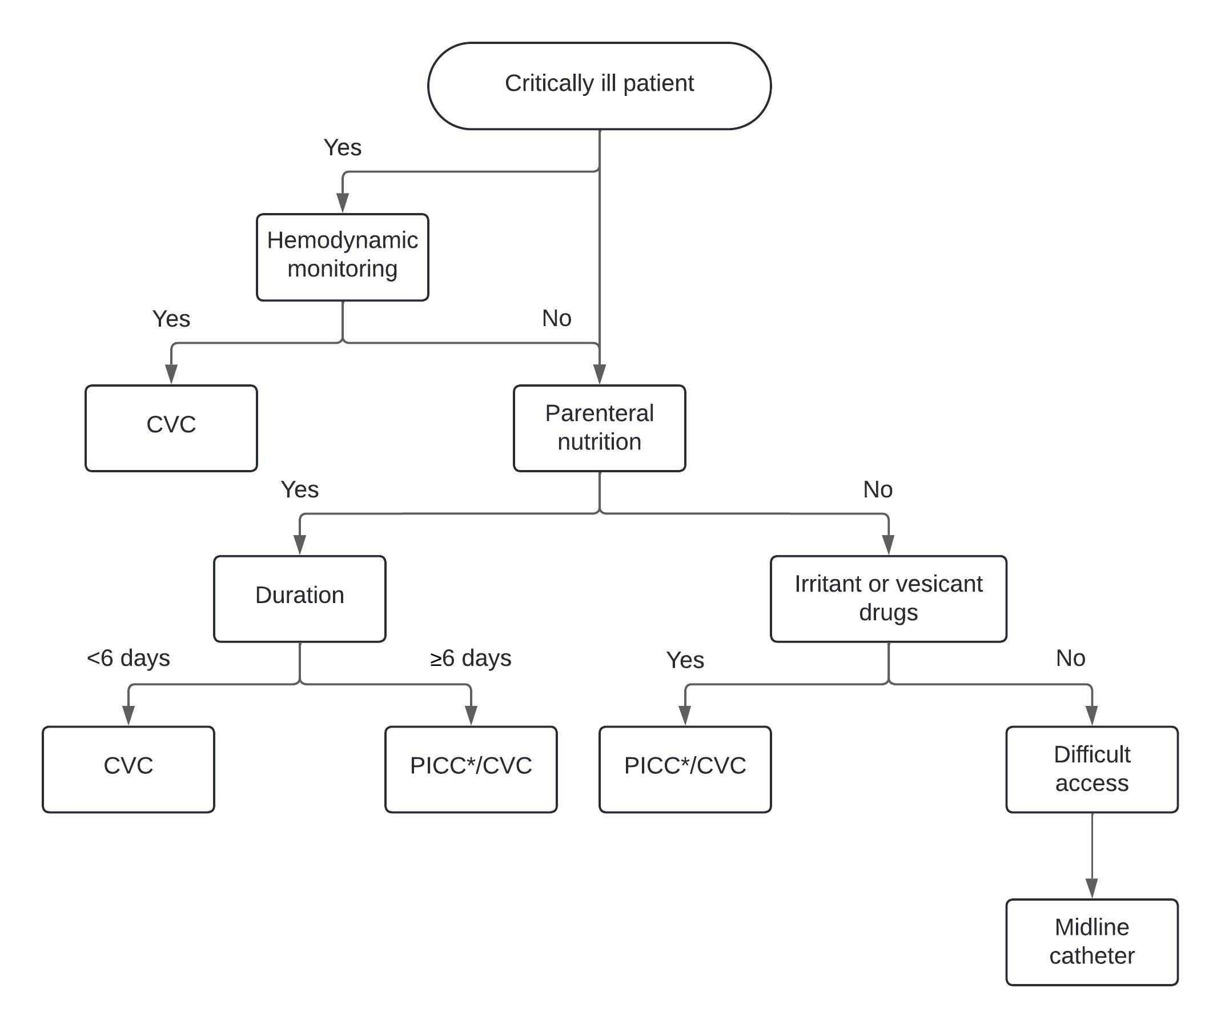
Fig. S2. Pathway for central vascular access in the intensive care unit. *Consider use of PICC according to the operator’s experience. CVC: Central venous catheter; PICC: peripherally inserted central venous catheter.

