Additional file 1: Figure S1
Comparing AUCs of the ROC models #0-5 evaluating of screen-detected T2D HbA1c ≥ 6.5% vs. NGT category neck circumference risk
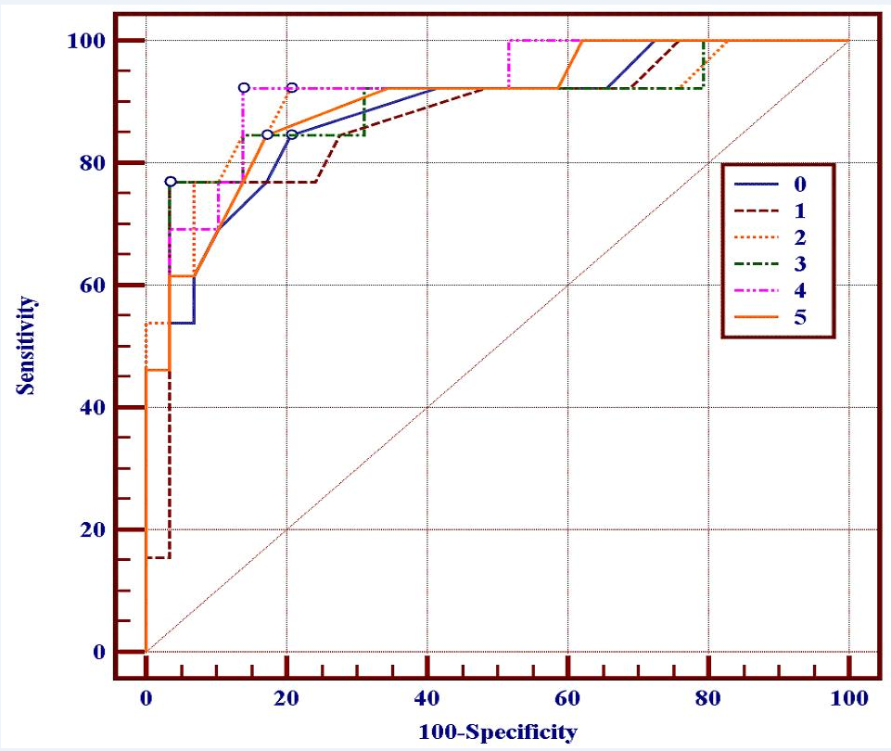
 | Models # and their adjusting
0 | Gender
1 | Gender + Stroke / MI history
2 | Gender +Personal childhood starvation
3 | Gender + BMI
4 | Gender +WC/HC
5 | Gender + High blood pressure

