Supplementary Table 1. Baseline information of the overall population after multiple imputation *
 | Total  (n=211,833) | non-Hypertension  (n=182,452) | Hypertension  (n=29,381) | p value
Age(years) | 38 (32-50) | 51(38-62) | 37(32-47) | < 0.001
Female (%) | 95,710 (45.2) | 8969(30.5) | 86741(47.5) | < 0.001
Current smoker (%) | 12,075 (5.7) | 1985(6.8) | 10090(5.5) | < 0.001
Current drinker (%) | 1,351 (0.6) | 335(1.1) | 1016(0.6) | < 0.001
Family history of diabetes (%) | 4,344 (2.1) | 444(1.5) | 3900(2.1) | < 0.001
SBP (mmHg) | 118 (107-130) | 144(138-153) | 115(106-125) | < 0.001
DBP (mmHg) | 73 (66-81) | 90(83-95) | 72(65-78) | < 0.001
BMI (kg/m²) | 23 (20.8-25.4) | 25.1(22.9-27.4) | 22.7(20.6-25.0) | < 0.001
FPG (mmol/L) | 4.92 (4.56-5.30) | 5.14(4.75-5.58) | 4.89(4.5-5.24) | < 0.001
ALT (U/L) | 18 (13-28) | 23(16-34) | 17.6(12.6-26.8) | < 0.001
AST (U/L) | 22 (18.6-26.7) | 24.1(20.5-30) | 21.6 (18.1-26.0) | < 0.001
BUN (mmol/L) | 4.56 (3.83-5.41) | 4.8(4.06-5.69) | 4.52(3.80-5.37) | < 0.001
SCr (μmol/L) | 70.9 (59-82) | 75(64-85) | 70(58.6-81.4) | < 0.001
TC (mg/dl) | 177.84 (157.35-201.81) | 189.43(166.24-214.18) | 177.06(155.41-199.87) | < 0.001
TG (mg/dl) | 94.8 (64.68-141.76) | 126.7(88.6-126.7) | 88.6(62.02-133.79) | < 0.001
LDL (mg/dl) | 102.45 (86.60-119.85) | 109.02(92.4-127.19) | 101.29(86.21-118.30) | < 0.001
HDL-c (mg/dl) | 51.80 (44.85-59.92) | 51.03(43.69-58.76) | 51.8(45.23-59.23) | < 0.001
Lipid Profile
TG/HDL-c | 1.81 (1.19-2.90) | 2.47(1.61-3.95) | 1.72(1.15-2.72) | < 0.001
TyG index | 8.33 (7.94-8.77) | 8.68(8.27-9.09) | 8.27(7.90-8.70) | < 0.001
TyG-BMI | 192.11 (167.61-219.73) | 218.8(194.25-243.64) | 187.75(164.90-214.22) | < 0.001
METS-IR | 32.87 (28.85-37.58) | 37.16(32.91-41.6) | 32.21(28.41-36.71) | < 0.001
*Continuous data are expressed as median (interquartile range) due to the skewed distribution. The p-value is a comparison between the normotension and hypertension groups.
FPG, fasting plasma glucose. TG, triglycerides. TC, total cholesterol. HDL-c, high-density lipoprotein cholesterol. LDL, low-density lipoprotein cholesterol. SCr, serum creatinine. BUN, blood urea nitrogen. ALT, alanine aminotransferase. AST, aspartate aminotransferase. BMI, Body mass index. TG/HDL-c, triglycerides/high-density lipoprotein cholesterol ratio. TyG index, Triglyceride-glucose index. TyG-BMI, TyG index with body mass index. METS-IR, metabolic score for insulin resistance. SBP, Systolic blood pressure. DBP, Diastolic blood pressure.

Supplementary Table 2. Multivariable logistic regression of four IR surrogates and the prevalence of hypertension after multiple imputation
 | Crude Model |  | Model 1 |  | Model 2
 | OR (95% CI) | p-value | OR (95% CI) | p-value | OR (95% CI) | p-value
TG/HDL-c
Q 1 (≤1.19) | Ref |  | Ref |  | Ref
Q 2 (1.19-1.81) | 1.766 (1.689-1.848) | < 0.001 | 1.394(1.330-1.461) | < 0.001 | 1.005(0.848-1.191) | 0.952
Q 3 (1.81-2.90) | 2.775(2.660-2.894) | < 0.001 | 1.850(1.770-1.935) | < 0.001 | 1.219(1.038-1.432) | 0.016
Q 4 (≥2.90) | 4.506(4.328-4.692) | < 0.001 | 2.604(2.494-2.719) | < 0.001 | 1.523(1.298-1.787) | < 0.001
p for trend | < 0.001 |  | < 0.001 |  | < 0.001
TyG index
Q 1 (≤7.94) | Ref |  | Ref |  | Ref
Q 2 (7.94-8.33) | 1.914(1.824-2.007) |  | 1.448(1.378-1.522) | < 0.001 | 1.396(1.160-1.680) | < 0.001
Q 3 (8.33-8.77) | 3.288(3.144-3.438) |  | 1.989(1.898-2.084) | < 0.001 | 1.395(1.165-1.670) | < 0.001
Q 4 (≥8.77) | 5.793(5.551-6.407) |  | 2.999(2.866-3.139) | < 0.001 | 1.953(1.630-2.340) | < 0.001
p for trend | < 0.001 |  | < 0.001 |  | < 0.001
TyG-BMI
Q 1 (≤167.61) | Ref |  | Ref |  | Ref
Q 2 (167.61-192.11) | 2.372(2.248-2.503) | < 0.001 | 1.705(1.613-1.802) | < 0.001 | 1.518(1.218-1.892) | < 0.001
Q 3 (192.11-219.73) | 4.741(4.510-4.985) | < 0.001 | 2.729(2.590-2.876) | < 0.001 | 1.822(1.445-2.296) | < 0.001
Q 4 (≥219.73) | 9.525(9.078-9.995) | < 0.001 | 5.239(4.979-5.512) | < 0.001 | 2.456(1.866-3.233) | < 0.001
p for trend | < 0.001 |  | < 0.001 |  | < 0.001
METS-IR
Q 1 (≤28.85) | Ref |  | Ref |  | Ref
Q 2 (28.85-32.87) | 2.210(2.100-2.325) |  | 1.691(1.604-1.782) |  | 1.234(1.008-1.512) | 0.042
Q 3 (32.87-37.58) | 4.143(3.951-4.344) |  | 2.622(2.495-2.756) |  | 1.418(1.146-1.754) | 0.001
Q 4 (≥37.58) | 7.976(7.622-8.347) |  | 4.780(4.555-5.017) |  | 1.747(1.356-2.250) | < 0.001
p for trend | < 0.001 |  | < 0.001 |  | < 0.001
OR, odds ratio. CI, confidence interval. Q, quartile. IR, insulin resistance. TG/HDL-c, triglycerides/high-density lipoprotein cholesterol ratio. TyG index, Triglyceride-glucose index. TyG-BMI, TyG index with body mass index. METS-IR, metabolic score for insulin resistance.
Model 1 adjust age and gender.
Model 2 adjust Model 1+ BMI (kg/m²), FPG (mmol/L), ALT(U/L), AST(U/L), BUN, Scr, king status (current smoker or not), drinking status (current drinker or not), family history of diabetes (Yes or No).

Supplementary table 3. Predictive value of four IR substitutes for the prevalence of hypertension after multiple imputation
 | AUC | 95%CI | Cut-off Point | Sensitivity (%) | Specificity (%)
TyG index | 0.679 | 0.676-0.682 | 8.42 | 67.5 | 59.5
TyG-BMI | 0.720 | 0.717-0.723 | 177.08 | 88.2 | 38.9
TG/HDL-c | 0.657 | 0.654-0.661 | 2.02 | 64.2 | 59.3
METS-IR | 0.707 | 0.704-0.710 | 29.69 | 89.2 | 34.3
TyG index+Age | 0.752 | 0.749-0.755 | 0.131* | 70.2 | 68.1
TG/HDL-c+Age | 0.749 | 0.746-0.752 | 0.134* | 68.2 | 69.7
TyG-BMI+ Age | 0.775 | 0.773-0.778 | 0.120* | 78.3 | 63.6
METS-IR+ Age | 0.774 | 0.771-0.777 | 0.134* | 73.4 | 68.2
TG/HDL-c, triglycerides/high-density lipoprotein cholesterol ratio. TyG index, Triglyceride-glucose index. TyG-BMI, TyG index with body mass index. METS-IR, metabolic score for insulin resistance. AUC, area under the curve.
*refers to the predicted probability calculated by logistic regression.

Supplementary Figure 1. Bayesian network model of hypertension prevalence and all clinical characteristics after multiple imputation.
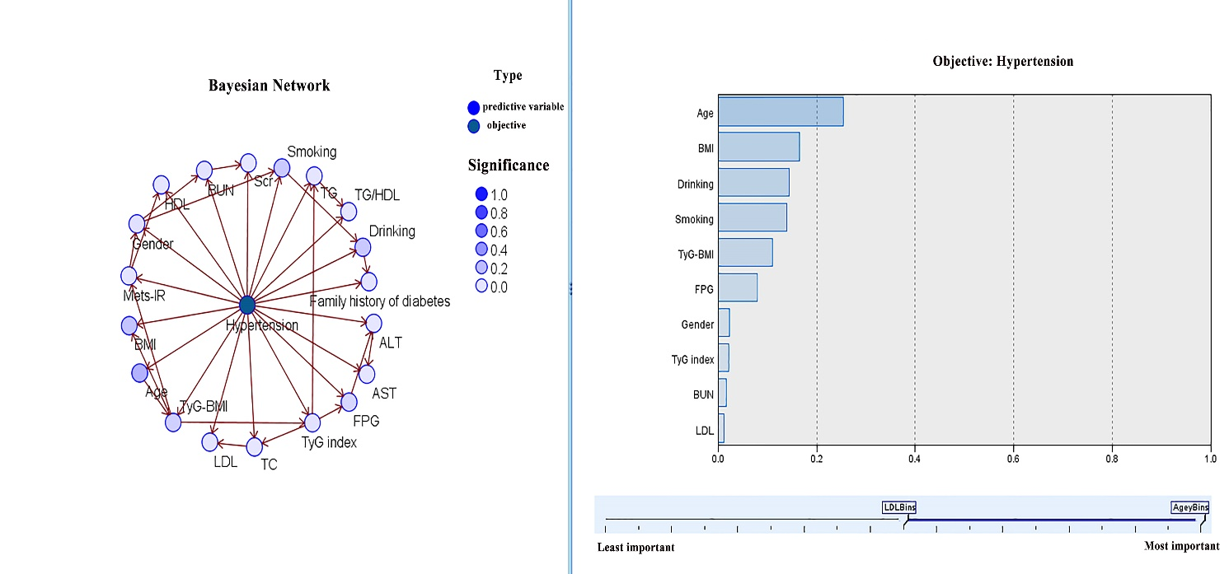

Supplementary Figure 2. Bayesian network model of hypertension prevalence and four IR surrogates-related characteristics after multiple imputation
