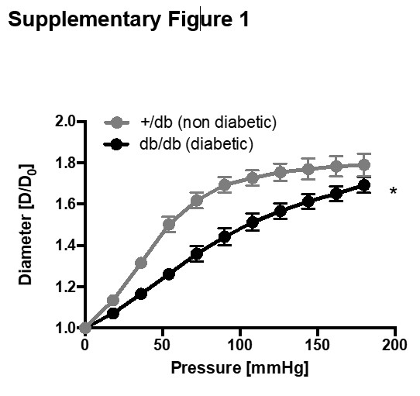
Suppl.Fig.1. db/db mice exhibit increased structural aortic stiffness
Aortic pressure diameter curves from db/db mice vs. +/db controls. * p<0.05 vs. +/db controls. (n=5/group).

