Additional file 1

Li et al. A novel inflammatory biomarker, high-sensitive C-reactive protein-to-albumin ratio, is associated with 5-year outcomes in patients with type 2 diabetes who undergo percutaneous coronary intervention

Contents
Figure S1. Correlation analysis between hs-CRP and albumin
Table S1. Propensity score-matched analysis
Figure S1. Correlation analysis between hs-CRP and albumin
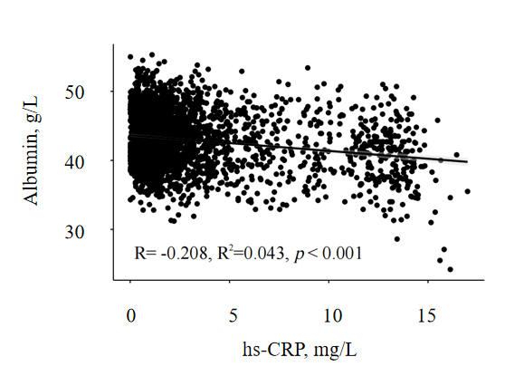
hs-CRP: high-sensitivity C reactive protein.

Table S1. Propensity score-matched analysis
Outcomes | Events/subjects | HR (95% CI) | P Value
All-cause mortality | 99 (4.7) | 1.484 (1.000–2.201) | <0.050
Cardiac mortality | 56 (2.6) | 1.691 (1.001–2.856) | <0.050
HR: hazard ratio; CI: confidence interval.

