Supplementary Materials
Supplementary Figures
Figure S1. Flowchart of the patient selection
Figure S2. The dose-response association of luteolin intake (excluding potential outliers) with all-cause mortality (A) and cardiac mortality (B) among patients with type 2 diabetes mellitus
Figure S3. Subgroup analyses of luteolin intake with all-cause mortality among patients with type 2 diabetes mellitus

Supplementary Tables
Table S1. Dietary dictionary of luteolin in foods and beverages (≥1mg/100mg)
Table S2. Definition and proportion of cause of death
Table S3. Classification of flavonoids
Table S4. RR (95% CI) for all-cause and cardiac mortality based on luteolin intake among patients with type 2 diabetes mellitus
Table S5. HR (95% CI) for all-cause and cardiac mortality based on luteolin intake (additionally adjusting for multiple flavonoids) among patients with type 2 diabetes mellitus
Table S6. HR (95% CI) for cause-specific death based on luteolin intake among patients with type 2 diabetes mellitus
Table S7. Association between luteolin intake and baseline cardiometabolic risk factors among patients with type 2 diabetes mellitus

Figure S1. Flowchart of the patient selection
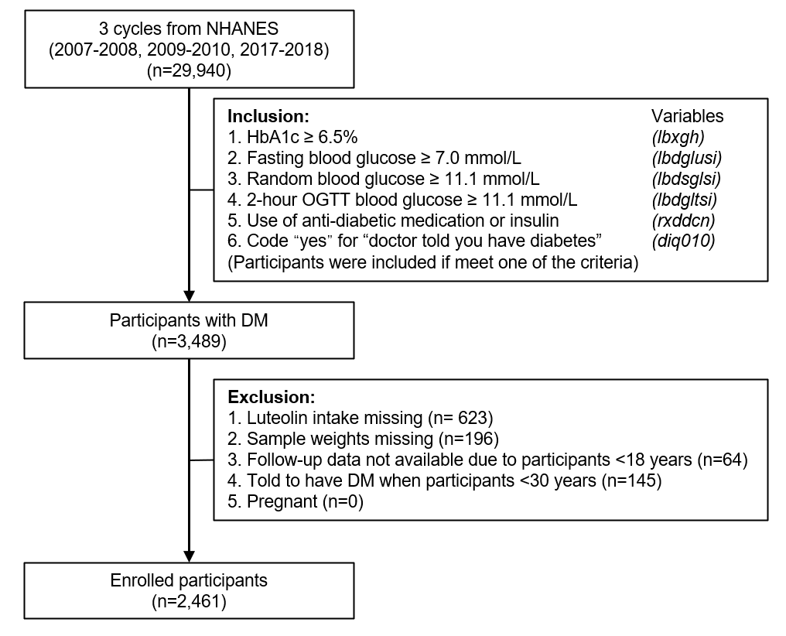

Figure S2. The dose-response association of luteolin intake (excluding potential outliers) with all-cause mortality (A) and cardiac mortality (B) among patients with type 2 diabetes mellitus
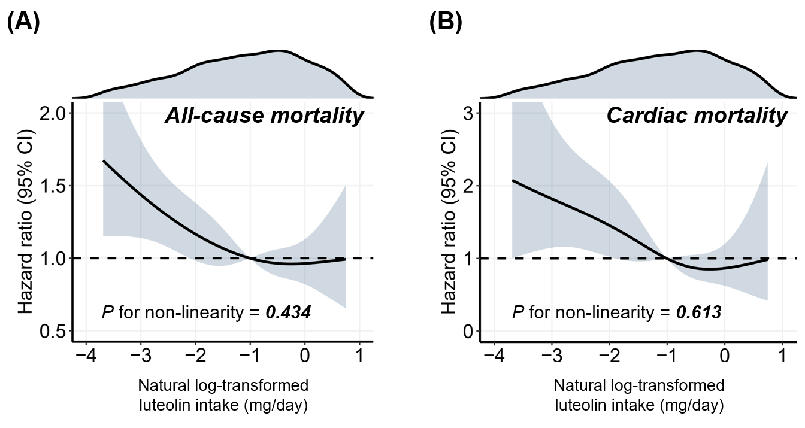
To avoid the potential effect of outliers, we excluded patients with luteolin intake outside the 5th and 95th percentile (excluding 273 samples). Then, a restricted cubic spline model was employed to visualize the relationship between luteolin intake (0.020-2.17mg/day) and mortality risk with four knots determined at the 5th, 35th, 65th, and 95th percentiles. For more details on the spline model, refer to Figure 3.

Figure S3. Subgroup analyses of luteolin intake with all-cause mortality among patients with type 2 diabetes mellitus
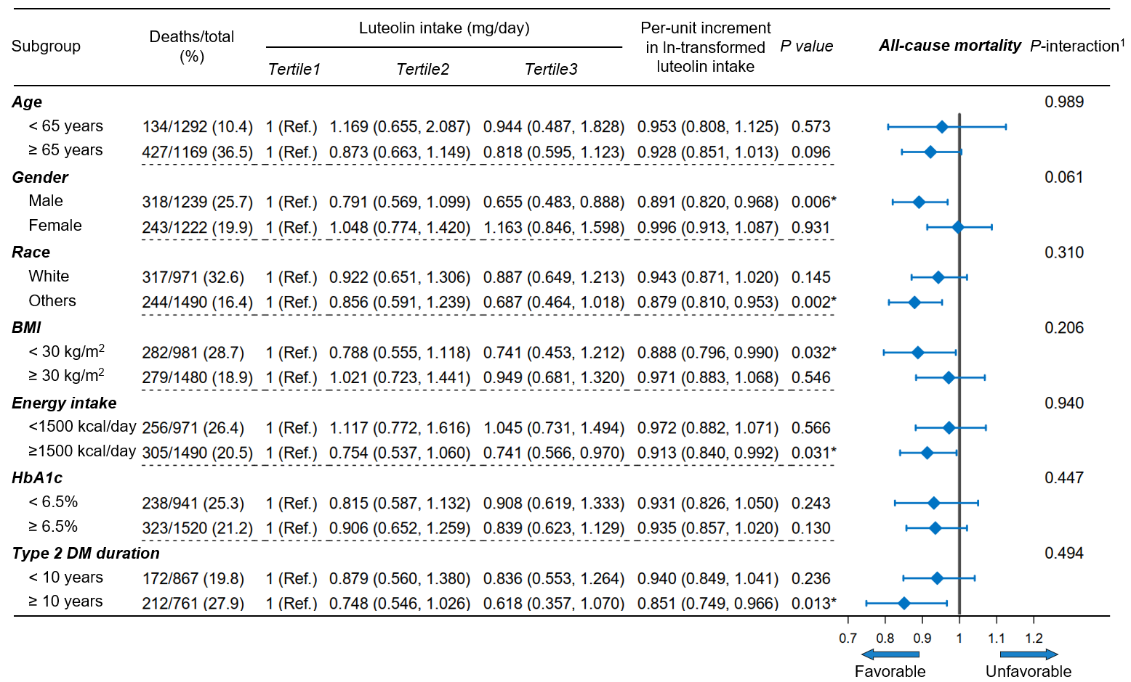
HR (95% CI) was assessed by Cox proportional hazards model. The model was adjusted for covariates including age, race, gender, body mass index, income-poverty ratio, smoking, drinking, energy intake, physical activity, hypertension, hyperlipidemia, HbA1c level, and use of oral anti-diabetic agents or insulin (except the stratified variable itself). Due to not being informed of their diabetes, 833 patients were unable to determine the diabetes duration and were excluded from the stratified analysis of type 2 DM duration.
¹ The interaction between luteolin intake (continuous) and the stratified variable was assessed by the Wald test.
*P<0.05

Table S1. Dietary dictionary of luteolin in foods and beverages (≥1mg/100mg)
Rank | Luteolin Value  (mg/100g) |  | Food Description
1 | 37.98 |  | Radicchio, raw
2 | 6.32 |  | Pepper, banana, raw
3 | 5.53 |  | Pimiento
4 | 5.29 |  | Pepper, hot chili, raw
5 | 4.74 |  | Pepper, hot, pickled
6 | 4.71 |  | Pepper, poblano, raw
7 | 4.71 |  | Pepper, sweet, green, raw
8 | 4.53 |  | Hot peppers, cooked
9 | 4.3 |  | Green pepper, cooked, as ingredient
10 | 4.14 |  | Pepper, Serrano, raw
11 | 4.04 |  | Peppers, green, cooked
12 | 3.28 |  | Pepper, raw, NFS
13 | 3.28 |  | Pepper, for use on a sandwich
14 | 2.82 |  | Okra, fresh, cooked, no added fat
15 | 2.8 |  | Olives, NFS
16 | 2.8 |  | Olives, black
17 | 2.75 |  | Stuffed pepper, with meat
18 | 2.74 |  | Okra, NS as to form, cooked
19 | 2.74 |  | Okra, fresh, cooked, fat added
20 | 2.74 |  | Luffa, cooked
21 | 2.73 |  | Vegetable mixture, dried
22 | 2.58 |  | Stuffed pepper, with rice, meatless
23 | 2.5 |  | Horseradish
24 | 2.5 |  | Wasabi paste
25 | 2.44 |  | Stuffed green pepper, Puerto Rican style
26 | 2.37 |  | Okra, frozen, cooked, no added fat
27 | 2.33 |  | Blueberries, dried
28 | 2.31 |  | Peppers, pickled
29 | 2.3 |  | Okra, frozen, cooked, fat added
30 | 2.18 |  | Okra, pickled
31 | 2.03 |  | Lime, raw
32 | 1.97 |  | Topping from vegetable pizza
33 | 1.9 |  | Lemon, raw
34 | 1.89 |  | Puerto Rican seasoning without ham and tomato sauce
35 | 1.83 |  | Lemon juice, 100%, canned or bottled
36 | 1.81 |  | Vada, fried dumpling
37 | 1.8 |  | Blueberries, frozen
38 | 1.78 |  | Winter squash, cooked, no added fat
39 | 1.74 |  | Chiles rellenos, cheese-filled
40 | 1.72 |  | Winter squash, cooked, fat added
41 | 1.68 |  | Chiles rellenos, filled with meat and cheese
42 | 1.63 |  | Winter squash, raw
43 | 1.61 |  | Stuffed pepper, with rice and meat
44 | 1.6 |  | Pumpkin, canned, cooked
45 | 1.59 |  | Puerto Rican seasoning with ham and tomato sauce
46 | 1.59 |  | Olive tapenade
47 | 1.54 |  | Pepper steak
48 | 1.52 |  | Peppers and onions, cooked, no added fat
49 | 1.48 |  | Peppers and onions, cooked, fat added
50 | 1.45 |  | Puerto Rican seasoning with ham
51 | 1.44 |  | Pumpkin, cooked
52 | 1.44 |  | Calabaza, cooked
53 | 1.37 |  | Squash, winter, souffle
54 | 1.3 |  | Kohlrabi, raw
55 | 1.25 |  | Bean chips
56 | 1.23 |  | Spaghetti squash, cooked
57 | 1.14 |  | Cactus, raw
58 | 1.11 |  | Lentils, from dried, no added fat
59 | 1.11 |  | Kohlrabi, cooked
60 | 1.11 |  | Olives, stuffed
61 | 1.1 |  | Sausage and peppers, no sauce
62 | 1.09 |  | Parsley, raw
63 | 1.07 |  | Summer squash, yellow or green, frozen, cooked, no added fat
64 | 1.05 |  | Celery, raw
65 | 1.05 |  | Celery juice
66 | 1.04 |  | Lentils, NFS
67 | 1.04 |  | Lentils, from dried, fat added
68 | 1.04 |  | Lentils, from canned
69 | 1.04 |  | Summer squash, yellow, raw
70 | 1.04 |  | Summer squash, yellow or green, frozen, cooked, fat added, NS as to fat type
71 | 1.04 |  | Summer squash, yellow or green, frozen, cooked with oil
72 | 1.04 |  | Summer squash, yellow or green, frozen, cooked with butter or margarine
73 | 1.02 |  | Summer squash, yellow or green, fresh, cooked, no added fat
74 | 1.02 |  | Summer squash, cooked, as ingredient
75 | 1.01 |  | Summer squash, green, raw

Table S2. Definition and proportion of cause of death
Cause of death (ICD-10 codes) | Count | Proportion (%)
All other causes (residual) | 143 | 25.5
Diseases of heart (I00-I09, I11, I13, I20-I51) | 136 | 24.2
Malignant neoplasms (C00-C97) | 124 | 22.1
Diabetes mellitus (E10-E14) | 44 | 7.8
Cerebrovascular diseases (I60-I69) | 38 | 6.8
Chronic lower respiratory diseases (J40-J47) | 29 | 5.2
Influenza and pneumonia (J09-J18) | 16 | 2.9
Alzheimer's disease (G30) | 12 | 2.1
Nephritis, nephrotic syndrome and nephrosis (N00-N07, N17-N19, N25-N27) | 12 | 2.1
Accidents (unintentional injuries) (V01-X59, Y85-Y86) | 7 | 1.3
Total | 561 | 100
The survival outcomes were as of December 31, 2019. The causes of death were defined by the International Classification of Diseases, Tenth Revision (ICD-10).
Table S3. Classification of flavonoids
Flavonoid class | Flavonoid
Flavones | 1 | Luteolin
Flavones | 2 | Apigenin
Anthocyanidins | 3 | Cyanidin
Anthocyanidins | 4 | Delphinidin
Anthocyanidins | 5 | Malvidin
Anthocyanidins | 6 | Pelargonidin
Anthocyanidins | 7 | Peonidin
Anthocyanidins | 8 | Petunidin
Flavan-3-ols | 9 | (-)-Epicatechin
Flavan-3-ols | 10 | (-)-Epicatechin 3-gallate
Flavan-3-ols | 11 | (-)-Epigallocatechin
Flavan-3-ols | 12 | (-)-Epigallocatechin 3-gallate
Flavan-3-ols | 13 | (+)-Catechin
Flavan-3-ols | 14 | (+)-Gallocatechin
Flavan-3-ols | 15 | Theaflavin
Flavan-3-ols | 16 | Theaflavin-3,3'-digallate
Flavan-3-ols | 17 | Theaflavin-3'-gallate
Flavan-3-ols | 18 | Theaflavin-3-gallate
Flavan-3-ols | 19 | Thearubigins
Flavanones | 20 | Eriodictyol
Flavanones | 21 | Hesperetin
Flavanones | 22 | Naringenin
Flavonols | 23 | Isorhamnetin
Flavonols | 24 | Kaempferol
Flavonols | 25 | Myricetin
Flavonols | 26 | Quercetin
Isoflavones | 27 | Daidzein
Isoflavones | 28 | Genistein
Isoflavones | 29 | Glycitein
The flavonoid database was part of the Food and Nutrient Database for Dietary Studies (FNDDS) and was managed by the United States Department of Agriculture (USDA). The flavonoid database calculated the amounts of 29 flavonoids (6 flavonoid classes) in all foods and beverages corresponding to the NHANES dietary data.
Table S4. RR (95% CI) for all-cause and cardiac mortality based on luteolin intake among patients with type 2 diabetes mellitus
Characteristic | Luteolin intake (mg/day)
Characteristic | Tertile 1: 0.005-0.190 | Tertile 2: 0.190-0.635 | Tertile 3: 0.635-9.870
All-cause mortality
No. deaths/total (%) | 228/877 (26) | 205/866 (23.7) | 158/863 (18.3)
RR | 1 (reference) | 0.910 (0.770, 1.076) | 0.689 (0.573, 0.829)
Cardiac mortality
No. deaths/total (%) | 64/877 (7.3) | 49/866 (5.7) | 32/863 (3.7)
RR | 1 (reference) | 0.760 (0.524, 1.102) | 0.481 (0.313,0.740)
RR indicates relative risk.
Table S5. HR (95% CI) for all-cause and cardiac mortality based on luteolin intake (additionally adjusting for multiple flavonoids) among patients with type 2 diabetes mellitus
Characteristic | Luteolin intake (mg/day) |  |  | Per-unit increment  of luteolin intake  (Ln-transformed) | P value
Characteristic | Tertile 1 | Tertile 2 | Tertile 3 | Per-unit increment  of luteolin intake  (Ln-transformed) | P value
Characteristic | [0.005, 0.195) | [0.195, 0.640) | [0.640, 9.870] | Per-unit increment  of luteolin intake  (Ln-transformed) | P value
All-cause mortality
No. deaths/total (%) | 221/841 (26.3) | 192/803 (23.9) | 148/817 (18.1) | 561/2461 (22.8)
Model 1 (Total Anthocyanidins) | 1 (Ref.) | 0.871 (0.672, 1.130) | 0.833 (0.651, 1.065) | 0.923 (0.859, 0.992) | 0.030*
Model 2 (Total Flavan-3-ols) | 1 (Ref.) | 0.872 (0.675, 1.127) | 0.844 (0.674, 1.058) | 0.926 (0.865, 0.991) | 0.026*
Model 3 (Total Flavanones) | 1 (Ref.) | 0.852 (0.653, 1.111) | 0.823 (0.668, 1.015) | 0.918 (0.862, 0.978) | 0.008*
Model 4 (Total Flavonols) | 1 (Ref.) | 0.897 (0.692, 1.162) | 0.869 (0.672, 1.124) | 0.933 (0.864, 1.008) | 0.079
Model 5 (Total Isoflavones) | 1 (Ref.) | 0.877 (0.673, 1.143) | 0.847 (0.68, 1.056) | 0.927 (0.868, 0.989) | 0.022*
Model 6 (Apigenin) | 1 (Ref.) | 0.917 (0.704, 1.193) | 0.909 (0.731, 1.129) | 0.945 (0.883, 1.012) | 0.105
Cardiac mortality
No. deaths/total (%) | 62/841 (7.4) | 45/803 (5.6) | 29/817 (3.5) | 136/2461 (5.5)
Model 1 (Total Anthocyanidins) | 1 (Ref.) | 0.667 (0.408, 1.090) | 0.495 (0.282, 0.867) | 0.776 (0.664, 0.906) | 0.001*
Model 2 (Total Flavan-3-ols) | 1 (Ref.) | 0.689 (0.418, 1.136) | 0.502 (0.293, 0.861) | 0.782 (0.675, 0.905) | 0.001*
Model 3 (Total Flavanones) | 1 (Ref.) | 0.646 (0.396, 1.055) | 0.475 (0.273, 0.827) | 0.768 (0.659, 0.895) | 0.001*
Model 4 (Total Flavonols) | 1 (Ref.) | 0.711 (0.430, 1.175) | 0.531 (0.311, 0.908) | 0.791 (0.684, 0.914) | 0.001*
Model 5 (Total Isoflavones) | 1 (Ref.) | 0.664 (0.413, 1.066) | 0.488 (0.285, 0.836) | 0.775 (0.669, 0.897) | 0.001*
Model 6 (Apigenin) | 1 (Ref.) | 0.653 (0.405, 1.054) | 0.475 (0.265, 0.851) | 0.764 (0.653, 0.894) | 0.001*
HR (95% CI) was assessed by Cox proportional hazards model. All models were adjusted for age, race, gender, body mass index, income-poverty ratio, smoking, drinking, energy intake, physical activity, hypertension, hyperlipidemia, HbA1c level, and use of oral anti-diabetic agents or insulin. Moreover, we additionally adjusted for the other 5 types of flavonoid intakes (anthocyanidins, flavan-3-ols, flavanones, flavonols, isoflavones) and apigenin intake, respectively (all in continuous). For more details on the classification of flavonoids, see Table S2.
*P<0.05

Table S6. HR (95% CI) for cause-specific death based on luteolin intake among patients with type 2 diabetes mellitus
Causes of death | Luteolin intake (mg/day) |  |  | P-trend | Per-unit increment  in ln-transformed  luteolin intake | P value
Causes of death | Tertile 1  [0.005,0.195) | Tertile 2  [0.195,0.640) | Tertile 3  [0.640,9.870] | P-trend | Per-unit increment  in ln-transformed  luteolin intake | P value
Malignant neoplasms (C00-C97)
No. deaths/total (%) | 42/841 (5) | 42/803 (5.2) | 40/817 (4.9) |  | 124/2461 (5.0)
Model 1 | 1 (reference) | 0.880 (0.524, 1.478) | 0.987 (0.541, 1.804) | 0.927 | 0.945 (0.801, 1.115) | 0.506
Model 2 | 1 (reference) | 1.006 (0.603, 1.679) | 1.300 (0.712, 2.372) | 0.358 | 1.033 (0.876, 1.219) | 0.698
Model 3 | 1 (reference) | 0.983 (0.589, 1.638) | 1.301 (0.722, 2.346) | 0.336 | 1.036 (0.879, 1.222) | 0.671
Diabetes mellitus (E10-E14)
No. deaths/total (%) | 18/841 (2.1) | 16/803 (2.0) | 10/817 (1.2) |  | 44/2461 (1.8)
Model 1 | 1 (reference) | 1.292 (0.530, 3.149) | 0.558 (0.186, 1.670) | 0.184 | 0.997 (0.818, 1.216) | 0.978
Model 2 | 1 (reference) | 1.318 (0.561, 3.095) | 0.849 (0.278, 2.589) | 0.675 | 1.138 (0.932, 1.391) | 0.205
Model 3 | 1 (reference) | 1.214 (0.502, 2.935) | 0.794 (0.272, 2.318) | 0.598 | 1.112 (0.918, 1.348) | 0.278
Cerebrovascular diseases (I60-I69)
No. deaths/total (%) | 15/841 (1.8) | 12/803 (1.5) | 11/817 (1.3) |  | 44/2461 (1.8)
Model 1 | 1 (reference) | 0.686 (0.297, 1.582) | 0.569 (0.188, 1.719) | 0.372 | 0.852 (0.645, 1.125) | 0.258
Model 2 | 1 (reference) | 0.669 (0.262, 1.709) | 0.548 (0.163, 1.844) | 0.381 | 0.845 (0.629, 1.136) | 0.265
Model 3 | 1 (reference) | 0.633 (0.252, 1.592) | 0.576 (0.174, 1.907) | 0.435 | 0.863 (0.646, 1.152) | 0.317
HR (95% CI) for specific causes of death was assessed by Cox proportional hazards model. As for the adjusted covariates in models, refer to Table 2. Specific causes of death included malignant neoplasms (ICD-10, C00 to C97), diabetes mellitus (ICD-10, E10 to E14), and cerebrovascular diseases (ICD-10, I60 to I69). Linear trends in hazard ratios across categories were examined by entering the median luteolin intake for each category as a numeric variable.
Table S7. Association between luteolin intake and baseline cardiometabolic risk factors among patients with type 2 diabetes mellitus
Cardiometabolic risk factors  (Outcomes) | Per-unit increment in luteolin intake (Ln-transformed) |  | P value
Cardiometabolic risk factors  (Outcomes) | Adjusted-beta | 95% Confidence Interval | P value
HbA1c | 0.007 | (-0.037, 0.051) | 0.766
FBG | 0.071 | (-0.022, 0.163) | 0.135
HOMA-IR¹ | 0.314 | (-0.154, 0.782) | 0.189
HOMA-IS² | 0.002 | (-0.012, 0.016) | 0.808
HOMA-β³ | -121.781 | (-676.045, 432.483) | 0.667
SBP | -0.235 | (-0.806, 0.337) | 0.421
DBP | -0.178 | (-0.523, 0.166) | 0.310
LDL-C | -0.005 | (-0.044, 0.035) | 0.823
CRP | -0.332 | (-0.541, -0.122) | 0.002*
Beta (95% CI) was assessed by the linear regression model and accounted for age, race, gender, body mass index, income-poverty ratio, smoking, drinking, energy intake, physical activity, hypertension (except for SBP and DBP outcomes), hyperlipidemia (except for LDL outcome), and HbA1c level (except for HbA1c, FBG, HOMA-IR, HOMA-IS, and HOMA-β outcomes). HOMA indicates homeostasis model assessment; IR, insulin resistance; IS, insulin sensitivity; FBG, fasting blood glucose; SBP, systolic blood pressure; DBP, diastolic blood pressure; LDL-C, low-density lipoprotein cholesterol; CRP, C-reactive protein.
¹ HOMA-IR reflects insulin resistance and is calculated as (fasting glucose, mmol/L) _{plasma} × (fasting insulin, μU/mL) _{plasma} / 22.5.
² HOMA-IS reflects insulin sensitivity and is calculated as 1/HOMA-IR.
³ HOMA-β reflects the function of pancreatic β cells and is calculated as 20 × (fasting insulin, μU/mL) _{plasma} / ((fasting glucose, mmol/L) _{plasma} -3.5) (%)
*P<0.05

