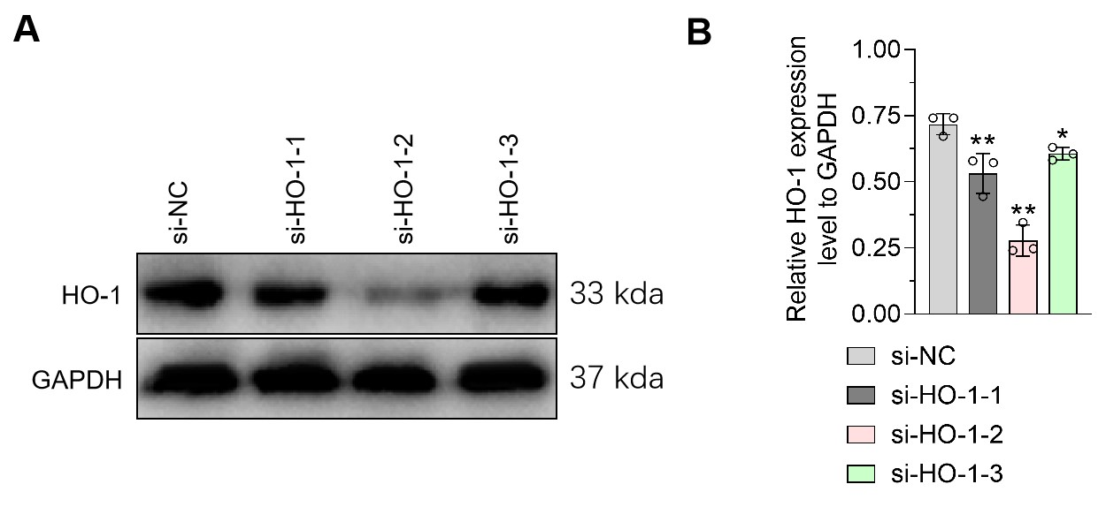
Supplementary figure 1: Effect of HO-1 siRNA on HO-1 expression in podocytes.
A. The effect of HO-1 siRNA on HO-1 protein content in MPC5 cells was detected by WB, GAPDH was used as an internal control. B. Statistical chart of gray value of strips in A; Data are presented as Mean± SD and one-way analysis of variance was used to detect statistical differences between groups. * p<0.05, ** p<0.01 VS. si-NC.
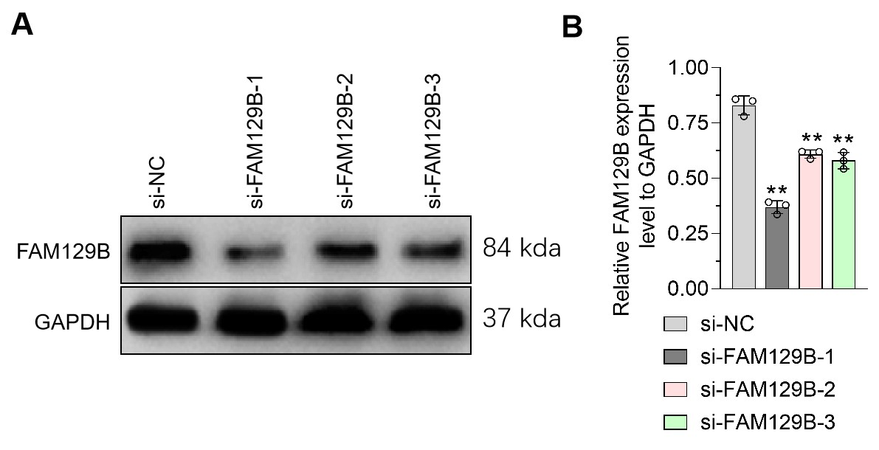
Supplementary Figure2. Effect of FAM129B siRNA on FAM129B expression in podocytes.
A. WB was used to detect the effect of FAM129B siRNA on FAM129B protein content in MPC5 cells, with GAPDH as an internal control. B. Statistical chart of gray value of strips in A; Data are presented as Mean± SD and one-way analysis of variance was used to detect statistical differences between groups. ** p<0.01 VS. si-NC.
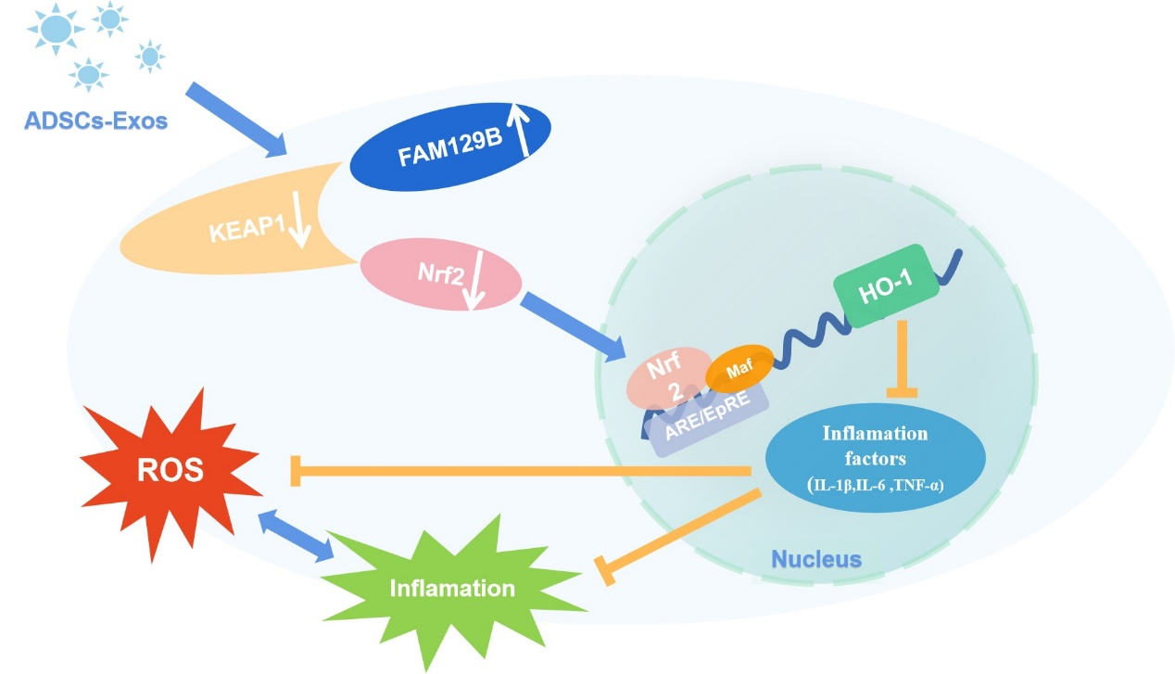
Summary schematic diagram：ADSCs-Exos relieve HG-induced oxidative stress and inflammation in podocytes by upregulating FAM129B and reactivating the Nrf2-HO-1 pathway

