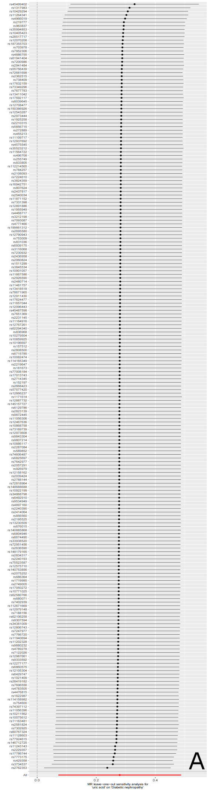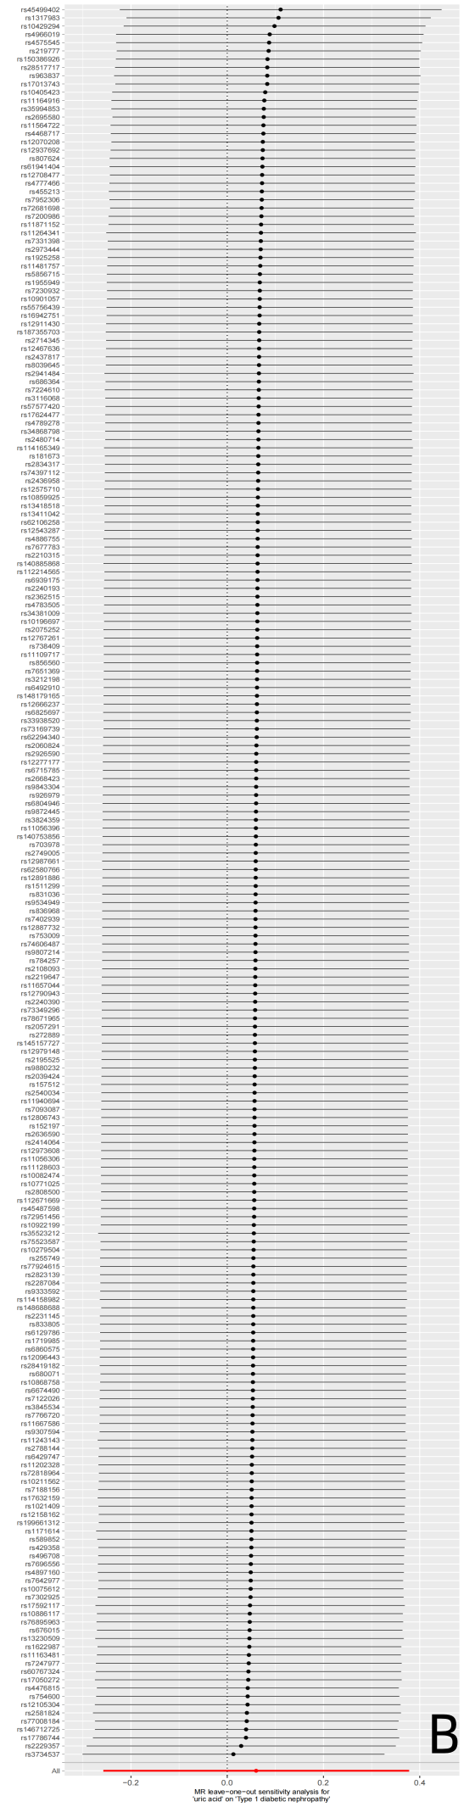
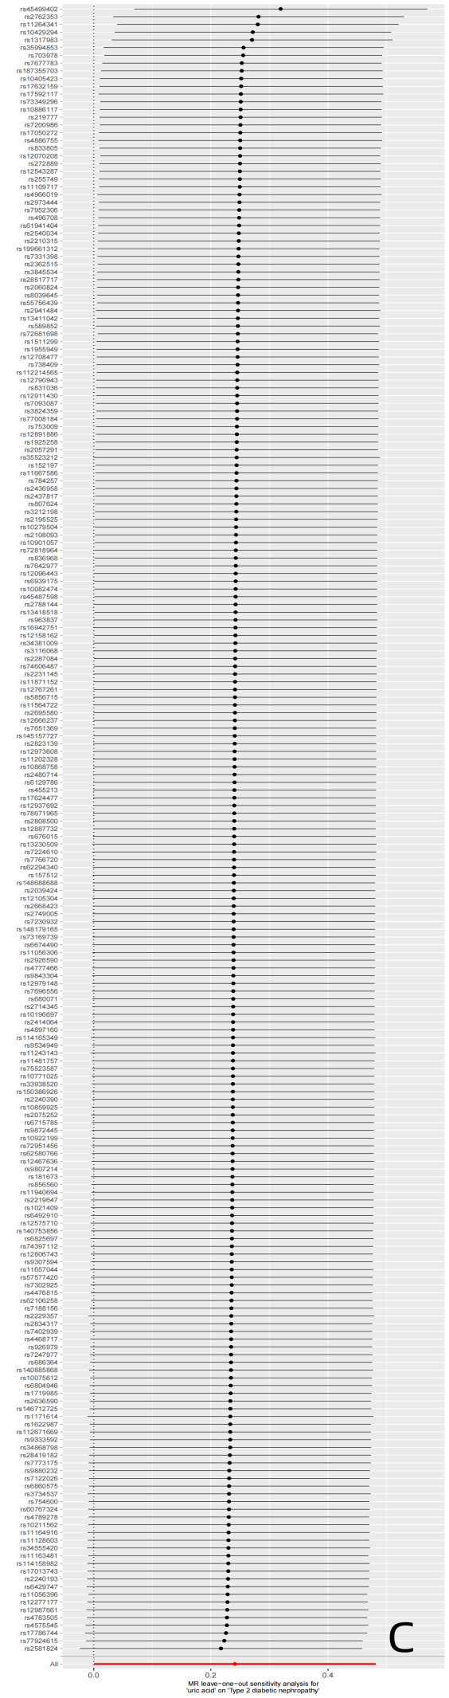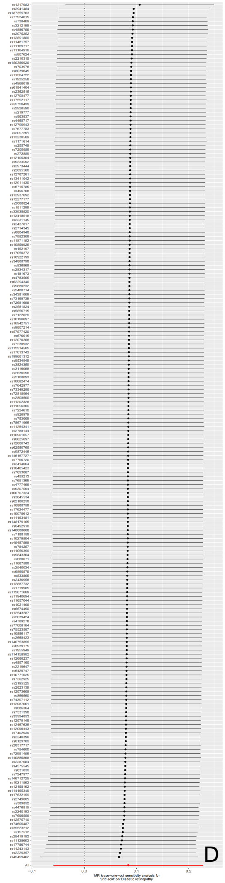
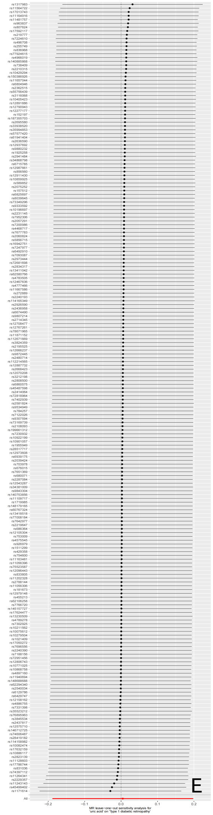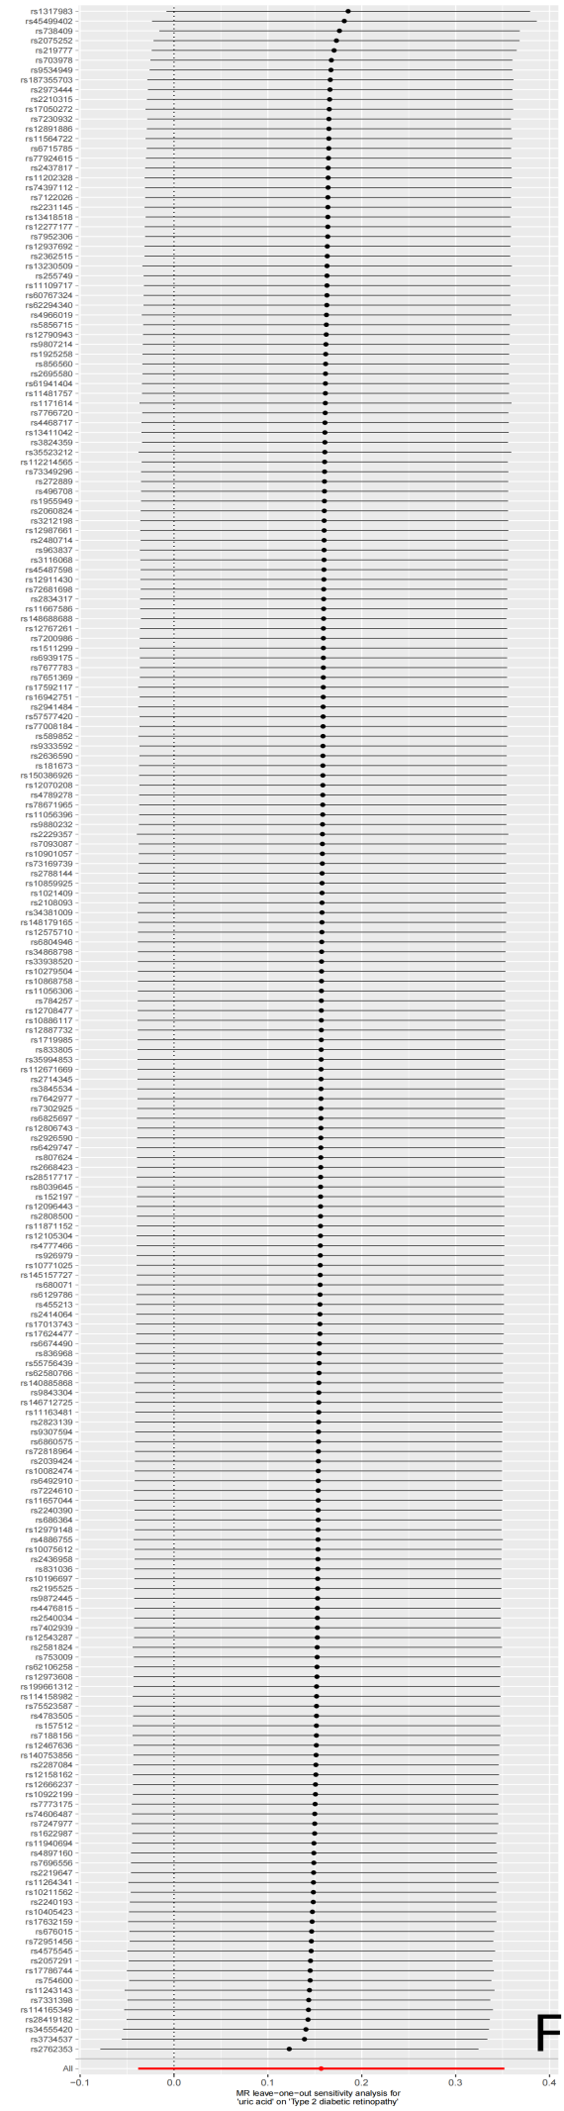
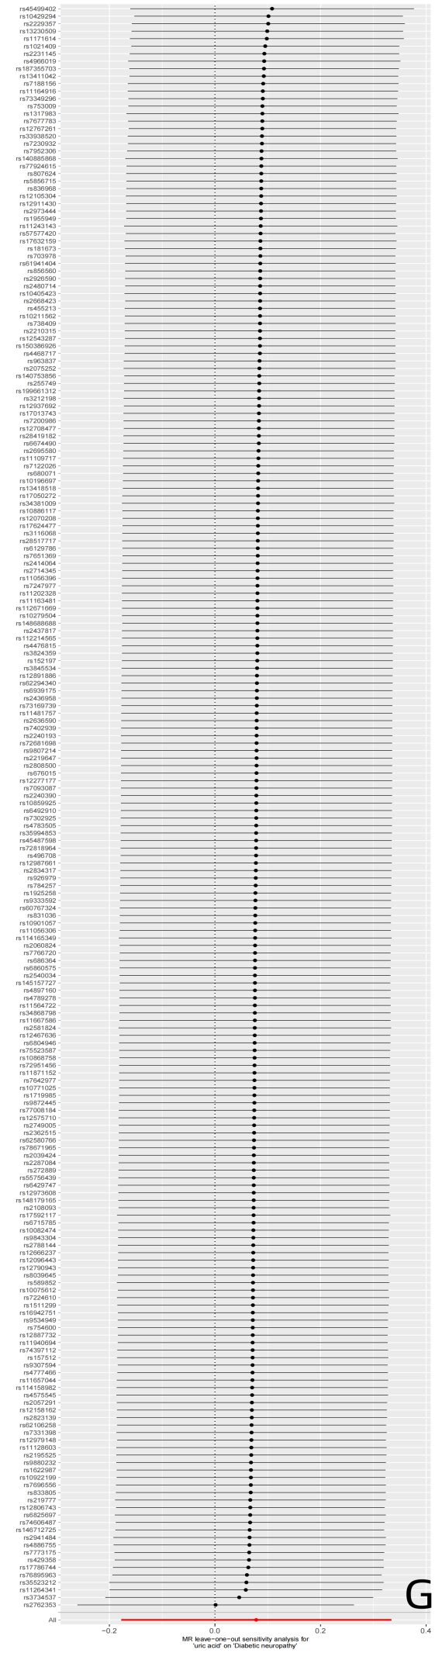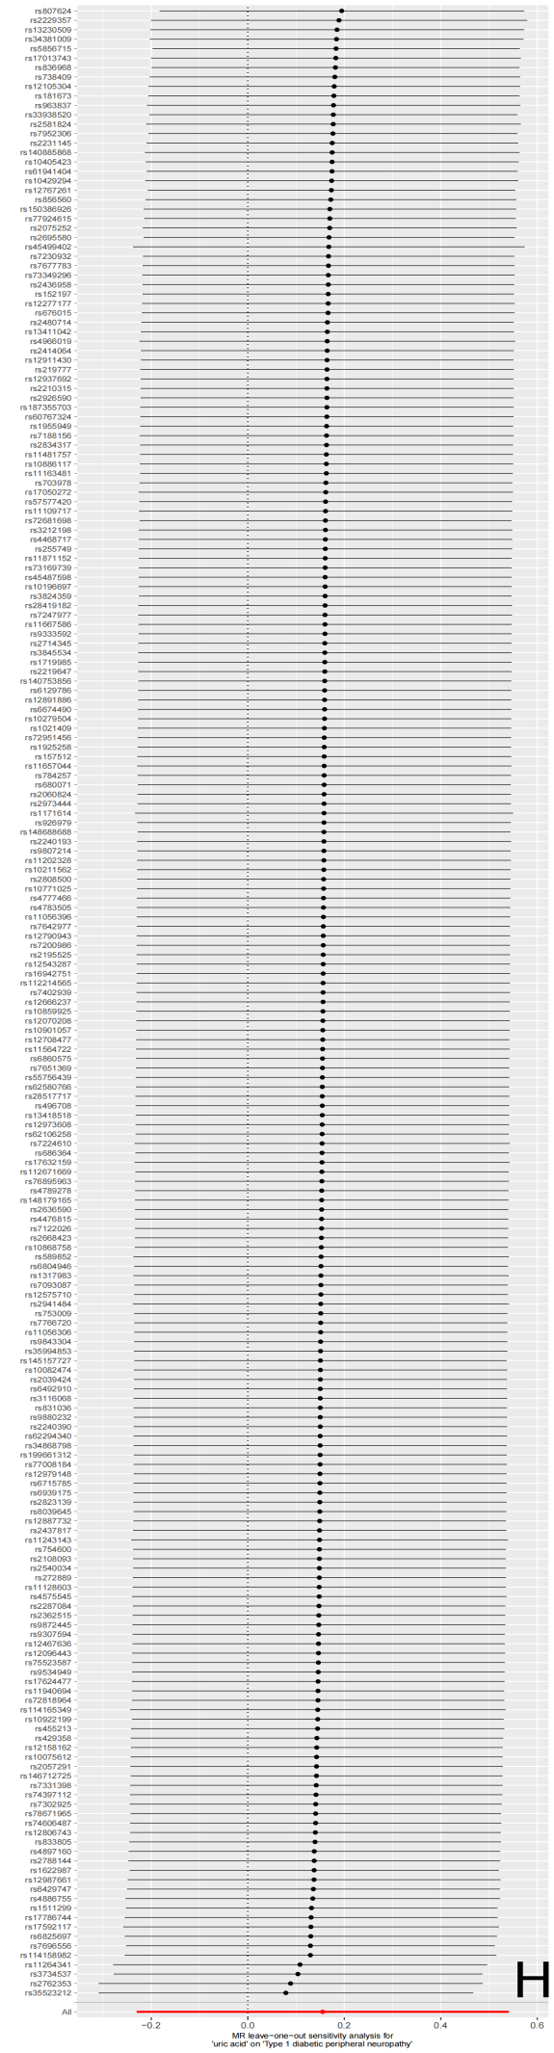
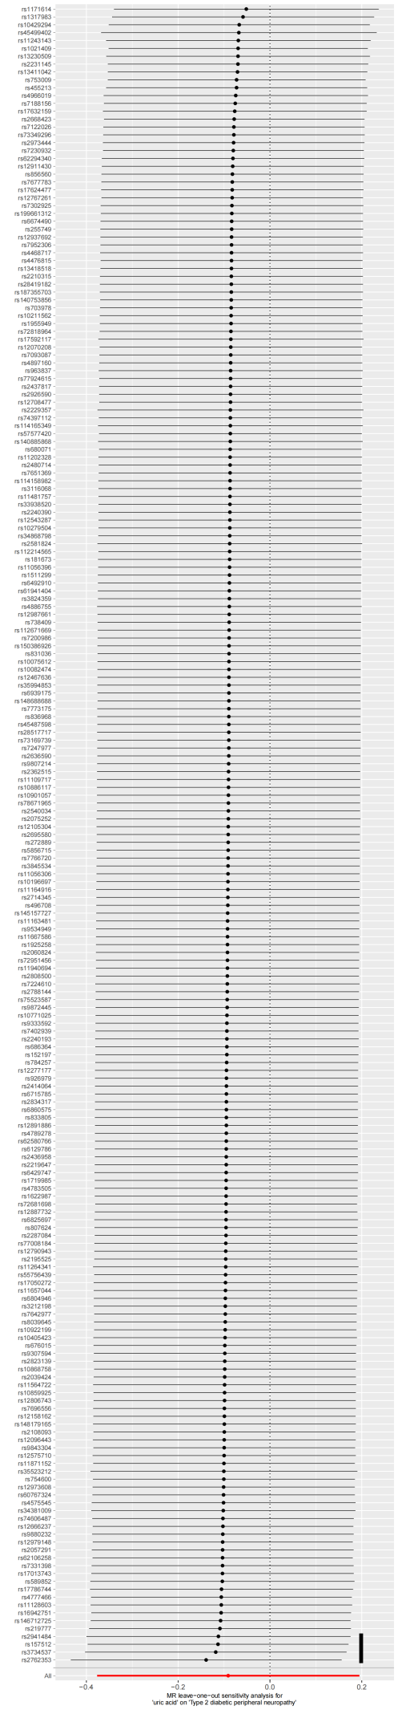
Supplementary Figure 1. The plots of “leave-one-out” analysis method to show the influence of individual SNP on the causal effect of genetically predicted SUA on diabetic microvascular complications.（A）Diabetic nephropathy;（B）T1DM with renal complications;（C）T2DM with renal complications;（D）Diabetic retinopathy（E）T1DM with ophthalmic complications;（F）T2DM with ophthalmic complications;（G）Diabetic neuropathy;（H）T1DM with neurological complications;（I）T2DM with neurological complications

