Table S1. Search strategy in PubMed and Scopus
Database | Syntax | Number of identified paper
PubMed | ("maternal diabetes"[All Fields] OR "gestational diabetes"[All Fields] OR "pregnancy diabetes"[All Fields] OR "infants of diabetic mothers"[All Fields] OR "DM"[All Fields] OR "GDM"[All Fields] OR "diabetes"[All Fields]) AND ("respiratory distress syndrome"[All Fields] OR "hyaline membrane disease"[All Fields] OR "RDS"[All Fields] OR "respiratory distress"[All Fields] OR "acute respiratory distress syndrome"[All Fields]) | 2653
Embase | ('maternal diabetes'/exp OR 'maternal diabetes' OR 'gestational diabetes'/exp OR 'gestational diabetes' OR 'pregnancy diabetes'/exp OR 'pregnancy diabetes' OR 'infants of diabetic mothers' OR 'dm' OR 'gdm' OR 'diabetes'/exp OR 'diabetes') AND ('respiratory distress syndrome'/exp OR 'respiratory distress syndrome' OR 'hyaline membrane disease'/exp OR 'hyaline membrane disease' OR 'rds'/exp OR 'rds' OR 'respiratory distress'/exp OR 'respiratory distress' OR 'acute respiratory distress syndrome'/exp OR 'acute respiratory distress syndrome') | 10,992
Scopus | TITLE-ABS-KEY (("maternal diabetes" OR "gestational diabetes" OR "pregnancy diabetes" OR "infants of diabetic mothers" OR "DM" OR "GDM" OR "diabetes" ) AND ( "respiratory distress syndrome" OR "hyaline membrane disease" OR "RDS" OR "respiratory distress" OR "acute respiratory distress syndrome")) | 7230

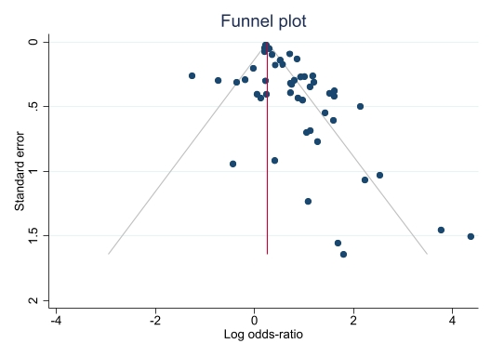
Figure S1. Publication bias assessment, showing no significant publication bias in studies included.
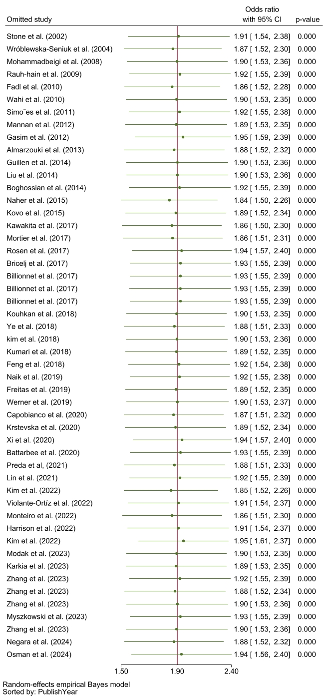
Figure S2. Sensitivity analysis of the meta-analysis. Sensitivity analysis on addjusted ORs revealed that exclusion of any 1 study had no influence on the pooled odds ratio. ORs in here are presented as log.

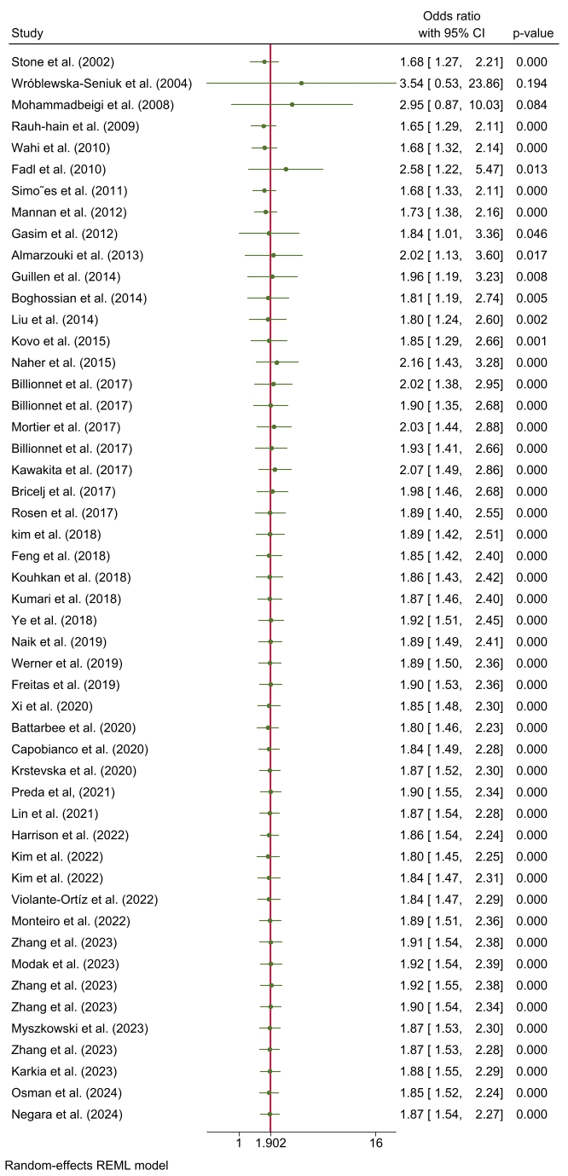
Figure S3. Cumulative meta-analysis suggested a progressively increasing association, which remained statistically significant as evidence accumulated 00

