Evaluating the overall renal outcomes of sodium-glucose cotransporter-2 (SGLT2) inhibitors in patients with chronic kidney disease (CKD)
Tables
Table S1. Electronic search strategies (Search data: June-8, 2023) 2
Table S2. Patient demographics and clinical characteristics of included studies 5
Table S3. Quality assessment results of included randomized controlled trials. 6
Table S4. Sensitivity analysis for main efficacy outcomes ……………………………………7
Table S5. Sensitivity analysis for main safety outcomes ………………………………………8
Table S6. PRISMA Checklist…………………………………………………………………11
Figures
Figure S1. Funnel plot of main efficacy outcomes 14
Figure S2. Funnel plot of main safety outcomes………………………………………………15

References…………………………………………………………………………………... 16

Abbreviations in Supplementary Figures
eGFR, estimated glomerular filtration rate; UACR, urine albumin creatine ratio; AE, adverse event

Table S1. Electronic search strategies (Search data: June-7, 2023)
Search items | Items found
Medline | 2805
- #1((((((((((((((((((((((((((((((((((((((((((((((((((((((((sodium,glucose,transporter,2 inhibitors[Title/Abstract])),OR,(sodium,glucose,transporter,2,inhibitors[MeSH,Terms])),OR,(sodium,glucose,transporter,ii,inhibitor[Title/Abstract])),OR,(sodium,glucose,transporter,ii,inhibitor[MeSH,Terms])),OR,(Sodiumglucose,cotransporter,2,inhibitors[Title/Abstract])),OR, (Sodium-glucose, cotransporter, 2, inhibitors[MeSH,Terms])),OR, SGLT-2,Inhibitors[Title/Abstract])),OR,(SGLT 2,Inhibitors[MeSH,Terms])),OR,(Gliflozins[Title/Abstract])),OR,(Gliflozins[MeSH,Terms])),OR,(Canagliflozin[Title/Abstract])),OR,(Canagliflozin[MeSH,Terms])),OR,(Invokana[Title/Abstract])),OR,(Invokana[MeSH,Terms])),OR,(Dapagliflozin[Title/Abstract])),OR,(Dapagliflozin[MeSH,Terms])),OR,(Forxiga[Title/Abstract])),OR,(Forxiga[MeSH,Terms])),OR,(BMS-512148 [Title/ Abstract])),OR,(BMS-512148[MeSH,Terms])), OR, (Empagliflozin[Title/ Abstract])),OR,(Empagliflozin[MeSH,Terms])),OR,(,Jardiance,[Title/Abstract])),OR,(,Jardiance,[MeSH,Terms])),OR,(Luseogliflozin[Title/Abstract])),OR,(Luseogliflozin[MeSH,Terms])),OR,(,Lusefi[Title/Abstract])),OR,(,Lusefi[MeSH,Terms])),OR,(Ipragliflozin[Title/Abstract])),OR,(Ipragliflozin[MeSH,Terms])),OR,(Suglat,[Title/Abstract])),OR,(Suglat,[MeSH,Terms])),OR,(Tofogliflozin[Title/Abstract])),OR,(Tofogliflozin[MeSH,Terms])),OR,(Apleway[Title/Abstract])),OR,(Apleway[MeSH,Terms])),OR,(Deberza[Title/Abstract])),OR,(Deberza[MeSH,Terms])),OR,(Sotagliflozin[Title/Abstract])),OR,(Sotagliflozin[MeSH,Terms])),OR,(LX4211[Title/Abstract])),OR,(LX4211[MeSH,Terms])),OR,(ertugliflozin[Title/Abstract])),OR,(ertugliflozin[MeSH,Terms])),OR,(MK-8835[Title/Abstract])),OR,(MK-8835[MeSH,Terms])),OR,(PF-04971729 [Title/Abstract])),OR,(PF-04971729[MeSH, Terms])),OR,(remogliflozin [Title/Abstract])),OR,(remogliflozin[MeSH,Terms])),OR,(BHV091009[Title/Abstract])),OR,(BHV091009[MeSH,Terms])),OR,(sergliflozin[Title/Abstract])),OR,(sergliflozin[MeSH,Terms])),OR,(GW869682X[Title/Abstract])),OR,(GW869682X[MeSH,Terms])
- #2 ((((((randomized controlled trial) [ARTICLE TYPE]) OR ((randomised controlled trial) [ARTICLE TYPE])) OR ((clinical trial) [ARTICLE TYPE])) OR ((randomized controlled trials) [ARTICLE TYPE])) OR ((clinical trials) [ARTICLE TYPE])) OR ((randomised controlled trials) [ARTICLE TYPE])
- #1 and #2
EMBASE | 1716
- #1 'sodium glucose transporter 2 inhibitors'/exp OR (('sodium'/exp OR sodium) AND ('glucose'/exp OR glucose) AND ('transporter'/exp OR transporter) AND ('2'/exp OR 2) AND ('inhibitors'/exp OR inhibitors)) OR (('sodium'/exp OR sodium) AND ('glucose'/exp OR glucose) AND ('transporter'/exp OR transporter) AND ('ii '/exp OR ii) AND ('inhibitor'/exp OR inhibitor)) OR (('sodium-glucose'/exp OR sodium-glucose) AND ('cotransporter'/exp OR cotransporter) AND ('2'/exp OR 2) AND ('inhibitors'/exp OR inhibitors)) OR (('sglt 2'/exp OR sglt 2) AND ('inhibitors'/exp OR inhibitors)) OR 'tofogliflozin'/exp OR 'apleway'/exp OR 'deberza'/exp OR 'csg452'/exp OR 'empagliflozin'/exp OR 'jardiance'/exp OR 'dapagliflozin'/exp OR 'farxiga'/exp OR 'forxiga'/exp OR 'bms 512148'/exp OR 'canagliflozin'/exp OR 'invokana'/exp OR 'sotagliflozin'/exp OR 'lx4211'/exp OR 'luseogliflozin'/exp OR 'lusefi'/exp OR 'ipragliflozin'/exp OR 'suglat'/exp OR 'remogliflozin'/exp OR 'bhv091009'/exp OR 'sergliflozin'/exp OR 'gw869682x'/exp OR 'ertugliflozin'/exp OR 'mk 8835'/exp OR 'pf 04971729'/exp
- #2 'sodium glucose co-transporter':ti,ab,kw OR sglt2:ti,ab,kw OR 'sglt 2':ti,ab,kw OR 'sodium glucose cotransporter 2 inhibitor':ti,ab,kw OR tofogliflozin:ti,ab,kw OR apleway:ti,ab,kw OR deberza:ti,ab,kw OR csg452:ti,ab,kw OR empagliflozin:ti,ab,kw OR jardiance:ti,ab,kw OR dapagliflozin:ti,ab,kw OR farxiga:ti,ab,kw OR forxiga:ti,ab,kw OR 'bms 512148':ti,ab,kw OR canagliflozin:ti,ab,kw OR invokana:ti,ab,kw OR sotagliflozin:ti,ab,kw OR lx4211:ti,ab,kw OR luseogliflozin:ti,ab,kw OR lusefi:ti,ab,kw OR ipragliflozin:ti,ab,kw OR suglat:ti,ab,kw OR remogliflozin:ti,ab,kw OR bhv091009:ti,ab,kw OR sergliflozin:ti,ab,kw OR gw869682x:ti,ab,kw OR ertugliflozin:ti,ab,kw OR 'mk 8835':ti,ab,kw OR 'pf 04971729':ti,ab,kw
- 'randomized controlled trial':ti,ab,kw OR 'randomised controlled trial':ti,ab,kw OR 'clinical trial':ti,ab,kw OR 'randomized controlled trials':ti,ab,kw OR 'clinical trials':ti,ab,kw
- #1 OR #2 AND #3 AND [embase]/lim NOT ([embase]/lim AND [medline]/lim)
COCHRANE | 1684
#1 (tofogliflozin): ti, ab,kw OR (Apleway):ti,ab, kw OR (Deberza): ti,ab,kw OR (CSG452):ti,ab,kw
#2 (empagliflozin): ti,ab,kw OR (Jardiance):ti,ab,kw
#3 (dapagliflozin): ti,ab,kw OR (Forxiga):ti,ab,kw OR (BMS-512148): ti,ab,kw
#4 (canagliflozin): ti,ab,kw OR (Invokana):ti,ab,kw
#5 (sotagliflozin): ti,ab,kw OR (LX4211):ti,ab,kw
#6 (luseogliflozin): ti,ab,kw OR (Lusefi):ti,ab,kw
#7 (ipragliflozin): ti,ab,kw OR (Suglat):ti,ab,kw
#8 (remogliflozin): ti,ab,kw OR (BHV091009):ti,ab,kw
#9 (sergliflozin): ti,ab,kw OR (GW869682X):ti,ab,kw
#10 (ertugliflozin): ti,ab,kw OR (MK-8835):ti,ab,kw OR (PF-04971729): ti,ab,kw
#11 (Sodium glucose co-transporter): ti,ab,kw OR (SGLT2):ti,ab,kw OR (SGLT-2):ti,ab,kw OR (SGLT 2):ti,ab,kw
#12 #1 or #2 or #3 or #4 or #5 or #6 or #7 or #8 or #9 or #10 or #11
#13 (randomized controlled trial): ti,ab,kw OR (randomised controlled trial): ti,ab,kw (clinical trial): ti,ab,kw OR (randomized controlled trials): ti,ab,kw OR (randomised controlled trial): ti,ab,kw OR (clinical trials): ti,ab,kw
#14 #1 or #2 or #3 or #4 or #5 or #6 or #7 or #8 or #9 or #10 or #11 or #12 and #13
Overall | 6205
Duplication | 3092

TABLE S2. Patient demographics and clinical characteristics of included studies
Study | No. | Age (y) | Male (%) | Asian (%) | Black (%) | White (%) | DD (y) | BMI | HbA1c（%） | eGFR | RASi (%)# | GLP-1RA (%) | follow-up (w)
Barnett AH (2014) | 738 | 63.9 | 58.3 | 36.0 | 3.0 | 60.3 | NR | 27.7 | 8.0 | 53.2 | 74 | NR | 52
Yale JF (2014) | 269 | 68.5 | 60.6 | 27.0 | 1.9 | 79.9 | 16.3 | 33.0 | 8.0 | 39.4 | 87.4 | NR | 52
Wanner C (2016) | 1819 | 67.1 | 67.8 | 21.8 | 4.6 | 72.7 | NR | 31.0 | 8.1 | 48.5 | 84.3 | NR | 161
Herrington WG (2022) | 6609 | 63.9 | 33.2 | 36.2 | 4.0 | 58.4 | NR | 29.8 | 6.3 | 37.4 | 85.2 | 5.1 | 104
Fioretto P (2018) | 321 | 65.7 | 56.7 | 4.0 | 7.2 | 87.5 | 14.4 | 32.1 | 8.2 | 53.5 | 83.8 | NR | 24
Perkovic V (2018) | 2039 | 67.6 | 58.0 | 11.0 | 2.0 | 82.0 | 15.9 | 32.3 | 8.3 | 49.1 | 81.0 | 4.0 | 142
Perkovic V (2019) | 4410 | 63.0 | 66.1 | 19.9 | 5.1 | 66.6 | 15.8 | 31.3 | 8.3 | 56.2 | 99.9 | 4.2 | 136
Bhatt DL (2020) | 10584 | 69.0 | 55.1 | 6.5 | 3.5 | 82.7 | NR | 31.8 | 8.3 | 44.5 | 88.5 | 6.0 | 57
Cherney DZI (2021) | 277 | 67.4 | 48.7 | 1.8 | 5.8 | 81.9 | 19.6 | 31.6 | 8.1 | 24.0 | 76.2 | 4.7 | 52
Heerspink HJL (2020） | 4304 | 61.8 | 69.9 | 34.1 | 4.4 | 53.2 | NR | 29.5 | NR | 43.1 | 66.7 | NR | 125
Cherney DZI (2020) | 1776 | 68.2 | 64.3 | 7.5 | 2.6 | 86.1 | 15.6 | 32.4 | 8.2 | 49.3 | NR | 3.9 | 182
Mosenzon O (2018) | 8997 | 66.4 | 63.1 | NR | NR | 82.3 | 12.8 | 32.4 | 8.1 | 73.4 | 83.5 | 4.5 | 218
Jhund PS (2019) | 1926 | 70.9 | 72.3 | 19.0 | NR | NR | NR | 28.4 | 6.6 | 47.0 | 91.1 | 0.8 | 73
Causland FR (2022) | 3070 | 74.5 | 50.9 | 20.7 | 2.5 | 71.4 | NR | 29.9 | NR | 44.6 | 70.9 | NR | 120
Zannad F (2021) | 1978 | 70.2 | 74.5 | 15.5 | 15.5 | 74.0 | NR | 28.0 | NR | 47.0 | NR | NR | 64
Sharma A (2023) | 3198 | 74.2 | 51.4 | 12.7 | 4.0 | 77.5 | NR | 30.1 | NR | 46.3 | NR | NR | 104
#Patients use ACEI or ARB or ARNI (%); No. number; DD, diabetic duration; BMI (kg/m²), body mass index; HbA1c, glycosylated hemoglobin; eGFR (mL/min), estimated glomerular filtration rate; RASi, renin-angiotensin-system inhibitors; GLP-1R, glucagon-like peptide-1 receptor agonists; NR, not Reported.

TABLE S3 Quality assessment results of included randomized controlled trials
Study | Random sequence generation | Allocation concealment | Blinding of participants and personnel | Blinding of outcome assessment | Incomplete outcome data | Selective reporting
Barnett AH (2014) | L | L | L | M | L | L
Yale JF (2014) | L | U | L | U | L | L
Wanner C (2016) | L | L | L | L | L | L
Herrington WG (2022) | U | U | L | M | L | L
Fioretto P (2018) | L | L | L | U | L | L
Perkovic V (2018) | L | L | L | L | L | L
Perkovic V (2019) | L | L | L | M | L | L
Bhatt DL (2020) | L | L | L | U | L | L
Cherney DZI (2021) | L | M | L | U | L | L
Heerspink HJL (2020） | L | L | L | M | L | L
Cherney DZI (2020) | L | L | L | M | L | L
Mosenzon O (2018) | L | L | L | L | L | L
Jhund PS (2019) | L | L | L | L | L | L
Causland FR (2022) | L | L | L | L | L | L
Zannad F (2021) | L | U | L | U | L | L
Sharma A (2023) | L | L | L | U | L | L
L, low risk; M, moderate risk; U, unclear. The included RCTs satisfied six tool items (random sequence generation, blinding of participants and personnel, allocation concealment, blinding of participants and personnel, incomplete outcome data, selective reporting). All trials were judged as low risk bias on “blinding of participants and personnel”, “incomplete outcome data” and “selective reporting” parts. One study did not describe the generation of random sequence and was considered unclear risk bias. Three studies did not state the allocation concealment method and were evaluated as unclear risk bias, while one study did not satisfy the item of allocation concealment, and was judged as moderate risk bias. Six trials did not present “who assessed the outcomes” and were evaluated as unclear risk bias in terms of “Blinding of outcome assessment”, while five studies were judged to have a moderate risk of bias and the remaining were considered a low risk of bias.

Table S4. Sensitivity analysis for main efficacy outcomes
Study omitted | WMD | 95%Conf. Interval | Study omitted | HR | 95%Conf. Interval
Change in eGFR |  |  | Main kidney composites
Barnett, A. H. (2014) | 1.470 | 1.454 1.486 | Wanner C (2016) | 0.669 | 0.613 0.724
Yale JF (2014) | 1.469 | 1.454 1.485 | Herrington WG (2022) | 0.610 | 0.550 0.669
Wanner C (2016) | 1.468 | 1.452 1.483 | Perkovic V (2018) | 0.651 | 0.600 0.702
Herrington WG (2022) | 1.473 | 1.457 1.489 | Perkovic V (2019) | 0.652 | 0.598 0.70
Fioretto P (2018) | 1.469 | 1.453 1.485 | Bhatt DL (2020) | 0.652 | 0.601 0.703
Perkovic V (2018) | 1.470 | 1.454 1.486 | Heerspink HJL (2020) | 0.675 | 0.619 0.731
Perkovic V (2019) | 1.469 | 1.453 1.485 | Mosenzon O（2018） | 0.666 | 0.613 0.720
Bhatt DL (2020) | 1.479 | 1.463 1.495 | Mc Causland FR (2022) | 0.650 | 0.600 0.701
Cherney DZI (2021) | 1.469 | 1.454 1.485 | Zannad F (2021) | 0.657 | 0.605 0.708
Heerspink HJL (2020) | 1.470 | 1.455 1.486 | Sharma A (2023) | 0.645 | 0.594 0.696
Cherney DZI (2020) | 1.469 | 1.454 1.485 | Change in UACR | Effect
Mosenzon O (2018) | 1.472 | 1.456 1.488 | Yale JF (2014) | -23.838 | -26.783 -20.893
Jhund PS (2019) | 0.140 | 0.099 0.182 | Herrington WG (2022) | -29.666 | -34.000 -25.331
Mc Causland FR (2022) | 1.664 | 1.648 1.681 | Fioretto P (2018) | -24.340 | -27.300 -21.381
Zannad F (2021) | 1.469 | 1.453 1.485 | Perkovic V (2019) | -18.624 | -22.507 -14.742
Sharma A (2023) | 1.469 | 1.453 1.485 | Cherney DZI (2021) | -23.923 | -26.886 -20.958
Abbreviations:
WMD, Weighted Mean Difference; HR, hazard ratio; eGFR, estimated glomerular filtration rate; UACR, urine albumin creatine ratio

Table S5. Sensitivity analysis for main safety outcomes
Study omitted | RR | 95% Conf. | Interval | Study omitted | RR | 95% Conf. | Interval
Urinary tract |  |  |  | Genital mycotic
Barnett AH (2014) | 1.061 | 0.991 | 1.137 | Barnett AH (2014) | 2.882 | 2.308 | 3.599
Yale JF (2014) | 1.061 | 0.991 | 1.135 | Yale JF (2014) | 2.509 | 2.037 | 3.090
Wanner C (2016) | 1.061 | 0.987 | 1.141 | Wanner C (2016) | 2.367 | 1.907 | 2.938
Herrington WG (2022) | 1.064 | 0.994 | 1.139 | Herrington WG (2022) | 2.464 | 2.005 | 3.028
Fioretto P (2018) | 1.062 | 0.993 | 1.136 | Fioretto P (2018) | 2.467 | 2.006 | 3.035
Perkovic V (2019) | 1.052 | 0.977 | 1.132 | Perkovic V (2019) | 2.299 | 1.846 | 2.862
Bhatt DL (2020) | 1.073 | 0.983 | 1.170 | Bhatt DL (2020) | 2.282 | 1.761 | 2.957
Cherney DZI（2021） | 1.066 | 0.996 | 1.141 | Cherney DZI（2021） | 2.457 | 2.000 | 3.020
Heerspink HJL (2020) | 1.057 | 0.988 | 1.131 | Heerspink HJL (2020) | 2.451 | 1.994 | 3.011
Cherney DZI (2020) | 1.059 | 0.987 | 1.135 | Cherney DZI (2020) | 2.410 | 1.944 | 2.988
Zannad F (2021) | 1.058 | 0.988 | 1.133 | Zannad F (2021) | 2.421 | 1.962 | 2.987
Sharma A (2023) | 1.052 | 0.979 | 1.129 | Sharma A (2023) | 2.407 | 1.940 | 2.987
Diabetic Ketoacidosis |  |  |  | Serious hypoclycaemia
Wanner C (2016) | 2.630 | 1.552 | 4.458 | Barnett AH (2014) | 0.949 | 0.870 | 1.035
Herrington WG (2022) | 2.344 | 1.377 | 3.989 | Yale JF (2014) | 0.949 | 0.875 | 1.030
Fioretto P (2018) | 2.524 | 1.511 | 4.215 | Wanner C (2016) | 0.961 | 0.885 | 1.043
Perkovic V (2019) | 2.087 | 1.215 | 3.586 | Herrington WG (2022) | 0.949 | 0.872 | 1.032
Bhatt DL (2020) | 3.371 | 1.389 | 8.183 | Fioretto P (2018) | 0.954 | 0.879 | 1.036
Cherney DZI（2021） | 2.524 | 1.511 | 4.215 | Perkovic V (2019) | 0.959 | 0.879 | 0.051
Heerspink HJL (2020) | 2.849 | 1.663 | 4.884 | Bhatt DL (2020） | 0.952 | 0.876 | 1.035
 |  |  |  | Cherney DZI（2021) | 0.961 | 0.884 | 1.044
 |  |  |  | Heerspink HJL (2020) | 0.967 | 0.891 | 1.049
 |  |  |  | Cherney DZI (2020) | 0.949 | 0.856 | 1.052
 |  |  |  | Jhund PS（2019） | 0.950 | 0.876 | 1.030
 |  |  |  | Mc Causland FR (2022) | 0.952 | 0.871 | 1.033
 |  |  |  | Zannad F (2021) | 0.945 | 0.871 | 1.026
 |  |  |  | Sharma A (2023) | 0.946 | 0.870 | 1.028
Acute kidney injury |  |  |  | Volume-related AEs
Barnett AH (2014) | 0.949 | 0.870 | 1.035 | Barnett AH (2014) | 1.232 | 1.124 | 1.351
Yale JF (2014) | 0.949 | 0.875 | 1.030 | Yale JF (2014) | 1.226 | 1.118 | 1.344
Wanner C (2016) | 0.961 | 0.885 | 1.043 | Wanner C (2016) | 1.265 | 1.150 | 1.392
Herrington WG (2022) | 0.949 | 0.872 | 1.032 | Herrington WG (2022) | 1.243 | 1.130 | 1.369
Fioretto P (2018) | 0.954 | 0.879 | 1.036 | Fioretto P (2018) | 1.225 | 1.118 | 1.343
Perkovic V (2019) | 0.959 | 0.874 | 1.051 | Perkovic V (2019) | 1.225 | 1.109 | 1.353
Bhatt DL (2020) | 0.952 | 1.051 | 1.035 | Bhatt DL (2020) | 1.201 | 1.078 | 1.337
Cherney DZI（2021） | 0.961 | 0.884 | 1.044 | Cherney DZI（2021） | 1.231 | 1.123 | 1.350
Heerspink HJL (2020) | 0.967 | 0.891 | 1.049 | Heerspink HJL (2020) | 1.205 | 1.093 | 1.329
Cherney DZI (2020) | 0.949 | 1.030 | 1.052 | Zannad F (2021) | 1.255 | 1.137 | 1.385
Jhund PS（2019） | 0.950 | 0.876 | 1.030 | Sharma A (2023) | 1.203 | 1.091 | 1.327
Mc Causland FR (2022) | 0.952 | 0.877 | 1.033
Zannad F (2021) | 0.945 | 0.871 | 1.026
Sharma A (2023) | 0.946 | 0.870 | 1.028
Renal and urinary disorders |  |  |  | Any AEs
Perkovic V (2019) | 0.799 | 0.672 | 0.951 | Barnett AH (2014) | 0.982 | 0.970 | 0.994
Cherney DZI（2021） | 0.792 | 0.713 | 0.880 | Yale JF (2014) | 0.983 | 0.970 | 0.995
Heerspink HJL (2020) | 0.833 | 0.741 | 0.936 | Wanner C (2016) | 0.984 | 0.971 | 0.997
Cherney DZI (2020) | 0.781 | 0.699 | 0.873 | Fioretto P (2018) | 0.983 | 0.971 | 0.996
Combined | 0.800 | 0.721 | 0.888 | Perkovic V (2019) | 0.988 | 0.974 | 1.002
 |  |  |  | Bhatt DL (2020) | 0.976 | 0.963 | 0.989
 |  |  |  | Cherney DZI（2021） | 0.982 | 0.970 | 0.995
 |  |  |  | Cherney DZI (2020) | 0.981 | 0.968 | 0.994
 |  |  |  | Zannad F (2021) | 0.984 | 0.971 | 0.997
 |  |  |  | Sharma A (2023) | 0.980 | 0.966 | 0.994
Serious AE |  |  |  | AE to death
Barnett AH (2014) | 0.911 | 0.883 | 0.939 | Barnett AH (2014) | 0.828 | 0.725 | 0.947
Yale JF (2014) | 0.910 | 0.882 | 0.939 | Yale JF (2014) | 0.823 | 0.720 | 0.941
Wanner C (2016) | 0.914 | 0.885 | 0.944 | Wanner C (2016) | 0.820 | 0.711 | 0.946
Fioretto P (2018) | 0.910 | 0.883 | 0.939 | Fioretto P (2018) | 0.824 | 0.721 | 0.942
Perkovic V (2019) | 0.909 | 0.879 | 0.940 | Bhatt DL (2020) | 0.768 | 0.643 | 0.918
Bhatt DL (2020) | 0.903 | 0.873 | 0.935 | Cherney DZI（2021） | 0.829 | 0.725 | 0.948
Cherney DZI（2021） | 0.910 | 0.882 | 0.938 | Heerspink HJL (2020) | 0.909 | 0.773 | 1.068
Heerspink HJL (2020) | 0.916 | 0.887 | 0.947 | Cherney DZI (2020) | 0.794 | 0.690 | 0.914
Cherney DZI (2020) | 0.906 | 0.878 | 0.936
Zannad F (2021) | 0.909 | 0.880 | 0.940
Sharma A (2023) | 0.906 | 0.874 | 0.938
RR, relative risk; AE, adverse event;

TABLE S6. PRISMA Checklist
Section/topic | # | Checklist item | Reported on page #
TITLE
Title | 1 | Identify the report as a systematic review, meta-analysis, or both. | 1
ABSTRACT
Structured summary | 2 | Provide a structured summary including, as applicable: background; objectives; data sources; study eligibility criteria, participants, and interventions; study appraisal and synthesis methods; results; limitations; conclusions and implications of key findings; systematic review registration number. | 1
INTRODUCTION
Rationale | 3 | Describe the rationale for the review in the context of what is already known. | 2
Objectives | 4 | Provide an explicit statement of questions being addressed with reference to participants, interventions, comparisons, outcomes, and study design (PICOS). | 2
METHODS
Protocol and registration | 5 | Indicate if a review protocol exists, if and where it can be accessed (e.g., Web address), and, if available, provide registration information including registration number. | 3
Eligibility criteria | 6 | Specify study characteristics (e.g., PICOS, length of follow-up) and report characteristics (e.g., years considered, language, publication status) used as criteria for eligibility, giving rationale. | 3
Information sources | 7 | Describe all information sources (e.g., databases with dates of coverage, contact with study authors to identify additional studies) in the search and date last searched. | 3
Search | 8 | Present full electronic search strategy for at least one database, including any limits used, such that it could be repeated. | 3
Study selection | 9 | State the process for selecting studies (i.e., screening, eligibility, included in systematic review, and, if applicable, included in the meta-analysis). | 3
Data collection process | 10 | Describe method of data extraction from reports (e.g., piloted forms, independently, in duplicate) and any processes for obtaining and confirming data from investigators. | 3
Data items | 11 | List and define all variables for which data were sought (e.g., PICOS, funding sources) and any assumptions and simplifications made. | 3
Risk of bias in individual studies | 12 | Describe methods used for assessing risk of bias of individual studies (including specification of whether this was done at the study or outcome level), and how this information is to be used in any data synthesis. | 3-4
Summary measures | 13 | State the principal summary measures (e.g., risk ratio, difference in means). | 3-4
Synthesis of results | 14 | Describe the methods of handling data and combining results of studies, if done, including measures of consistency (e.g., I²) for each meta-analysis. | 3-4

Page 1 of 2
Section/topic | # | Checklist item | Reported on page #
Risk of bias across studies | 15 | Specify any assessment of risk of bias that may affect the cumulative evidence (e.g., publication bias, selective reporting within studies). | 3-4
Additional analyses | 16 | Describe methods of additional analyses (e.g., sensitivity or subgroup analyses, meta-regression), if done, indicating which were pre-specified. | 3-4
RESULTS
Study selection | 17 | Give numbers of studies screened, assessed for eligibility, and included in the review, with reasons for exclusions at each stage, ideally with a flow diagram. | 4
Study characteristics | 18 | For each study, present characteristics for which data were extracted (e.g., study size, PICOS, follow-up period) and provide the citations. | 4
Risk of bias within studies | 19 | Present data on risk of bias of each study and, if available, any outcome level assessment (see item 12). | 4-5
Results of individual studies | 20 | For all outcomes considered (benefits or harms), present, for each study: (a) simple summary data for each intervention group (b) effect estimates and confidence intervals, ideally with a forest plot. | 4
Synthesis of results | 21 | Present results of each meta-analysis done, including confidence intervals and measures of consistency. | 4
Risk of bias across studies | 22 | Present results of any assessment of risk of bias across studies (see Item 15). | 5
Additional analysis | 23 | Give results of additional analyses, if done (e.g., sensitivity or subgroup analyses, meta-regression [see Item 16]). | 5-6
DISCUSSION
Summary of evidence | 24 | Summarize the main findings including the strength of evidence for each main outcome; consider their relevance to key groups (e.g., healthcare providers, users, and policy makers). | 6-7
Limitations | 25 | Discuss limitations at study and outcome level (e.g., risk of bias), and at review-level (e.g., incomplete retrieval of identified research, reporting bias). | 8-9
Conclusions | 26 | Provide a general interpretation of the results in the context of other evidence, and implications for future research. | 9
FUNDING
Funding | 27 | Describe sources of funding for the systematic review and other support (e.g., supply of data); role of funders for the systematic review. | 9

From: Moher D, Liberati A, Tetzlaff J, Altman DG, The PRISMA Group (2009). Preferred Reporting Items for Systematic Reviews and Meta-Analyses: The PRISMA Statement. PLoS Med 6(6): e1000097. doi:10.1371/journal.pmed1000097
For more information, visit: www.prisma-stateme
Figure S1. Funnel plot of main efficacy outcome
A Change in eGFR B Change in UACR
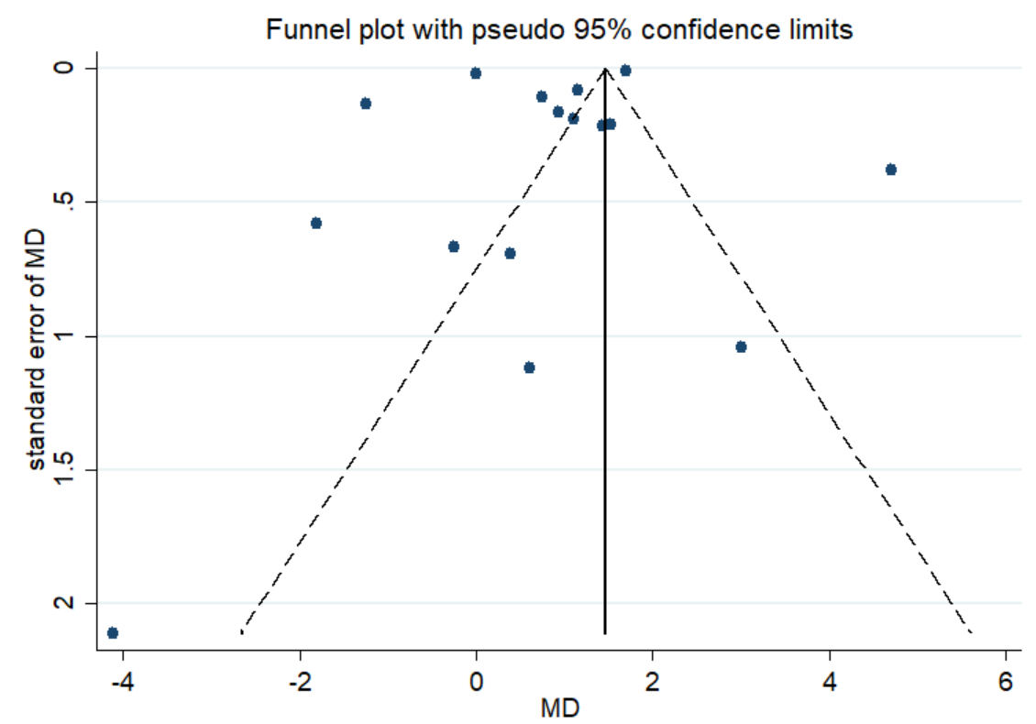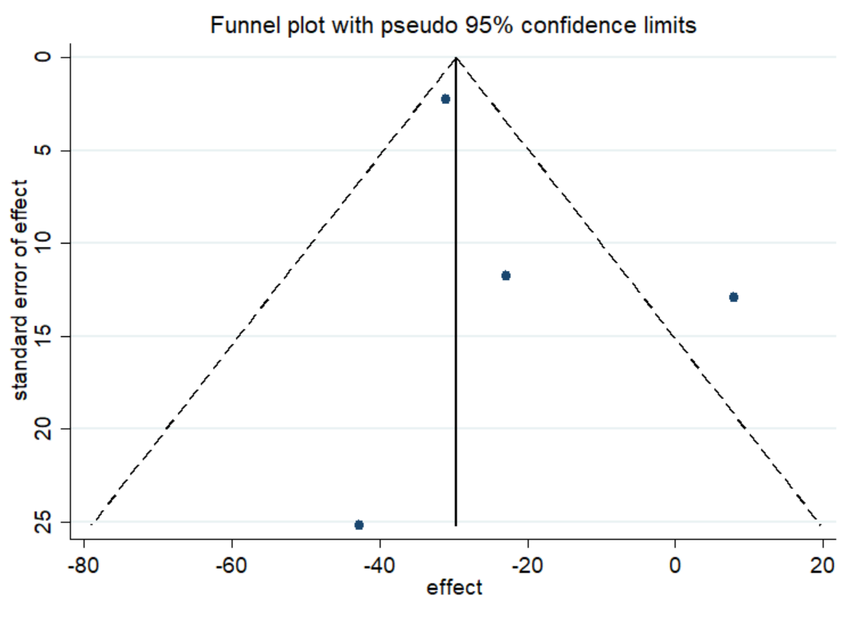
P=0.192 (Begg’s Test) and P=0.269 (Egger’s Test) P= 0.734 (Begg’s Test) and P= 0.453 (Egger’s Test)

C Main kidney composites
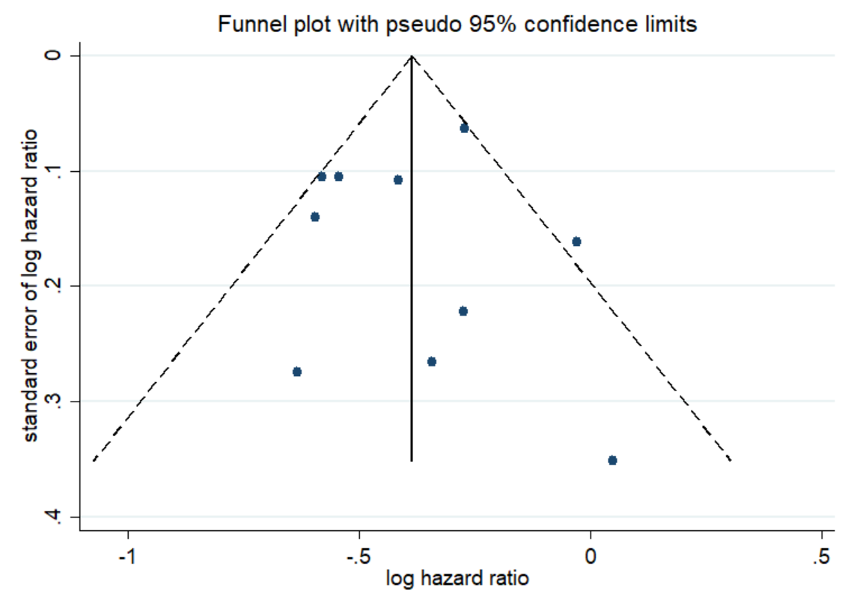
P=0.592 (Begg’s Test) and P=0.948 (Egger’s Test)

Figure S2. Funnel plot of main safety outcome
A Any AE B Serious AE
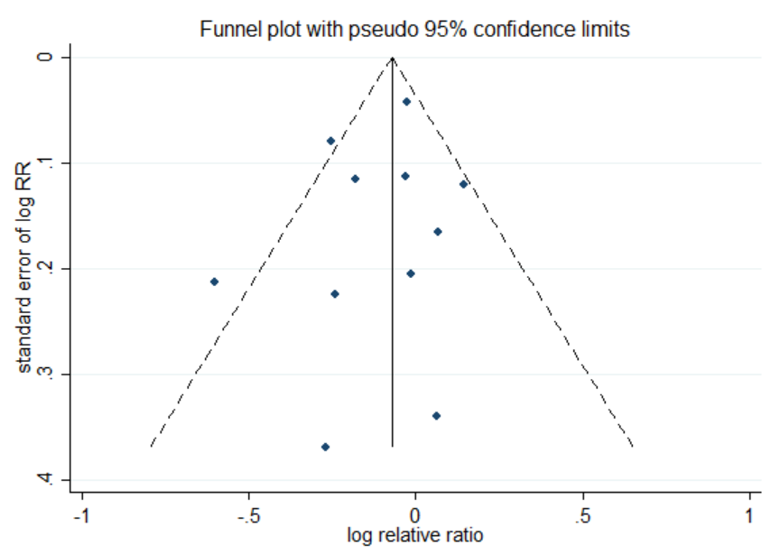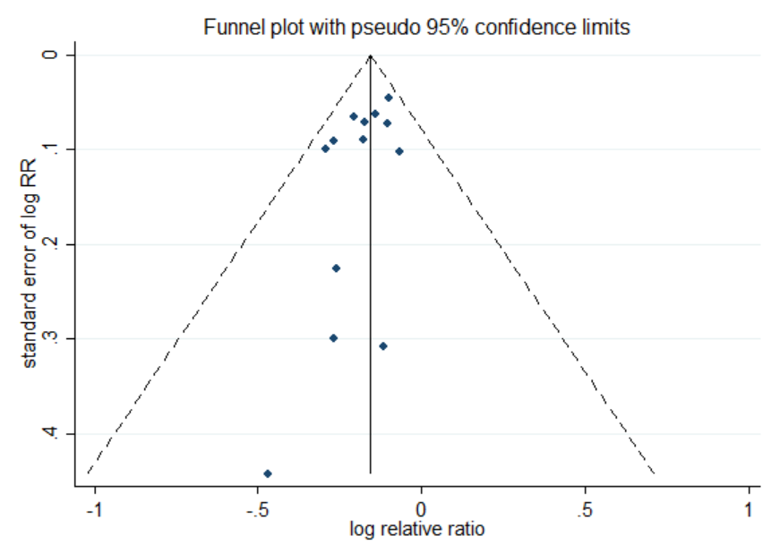
P=0.640 (Begg’s Test) and P=0.453 (Egger’s Test) P=0.837 (Begg’s Test) and P=0.922 (Egger’s Test)

C AE to death D Serious hypoglycemia
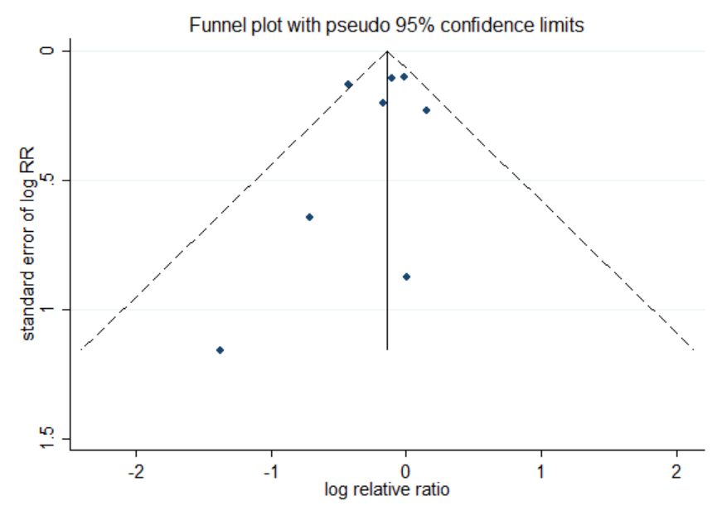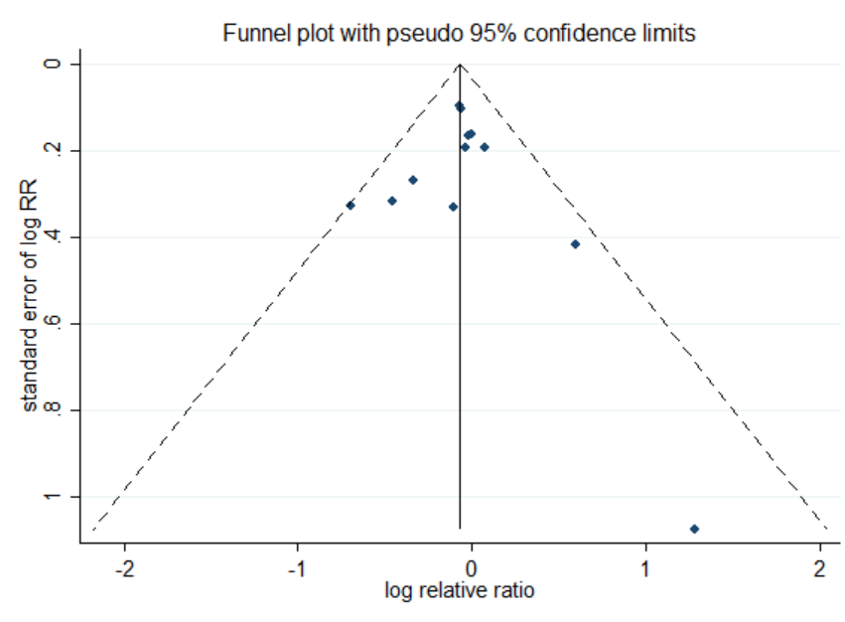
P=0.266 (Begg’s Test) and P=0.513 (Egger’s Test) P=0.837 (Begg’s Test) and P=0.922 (Egger’s Test)

E Diabetic ketoacidosis F Renal and urinary disorders
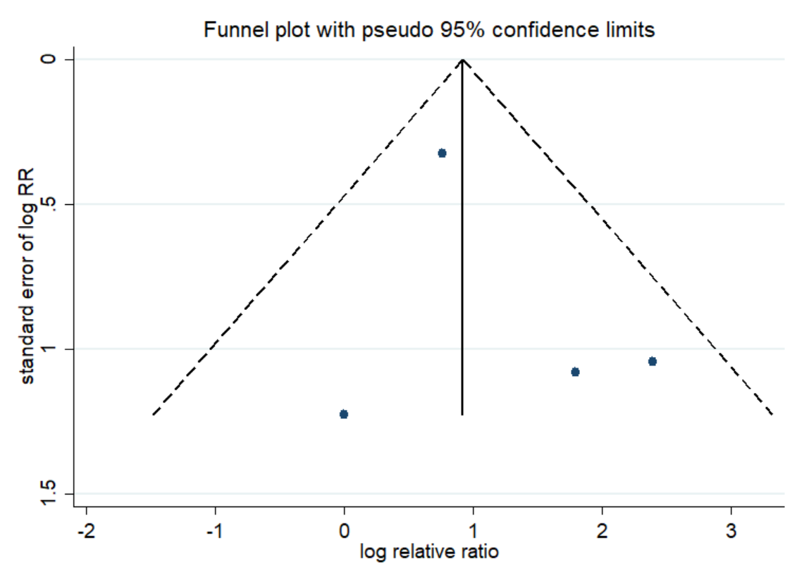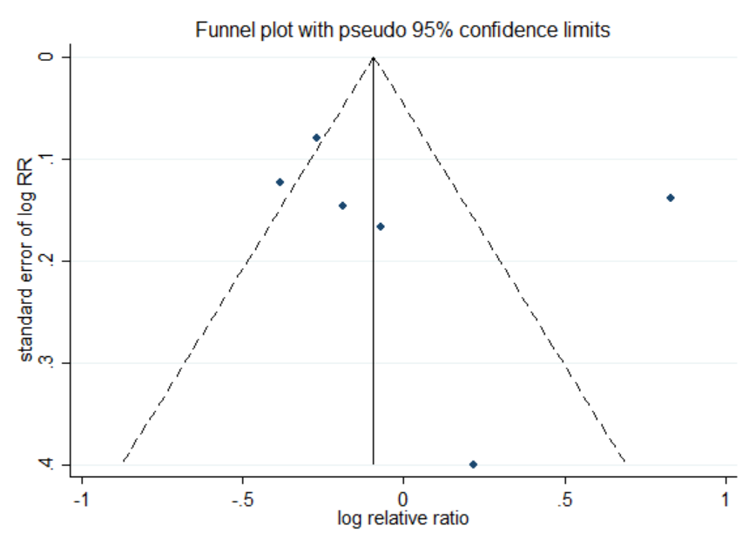
P=1.000 (Begg’s Test) and P=0.514 (Egger’s Test) P=0.133 (Begg’s Test) and P=0.505 (Egger’s Test)

G Urinary tract H Genital mycotic
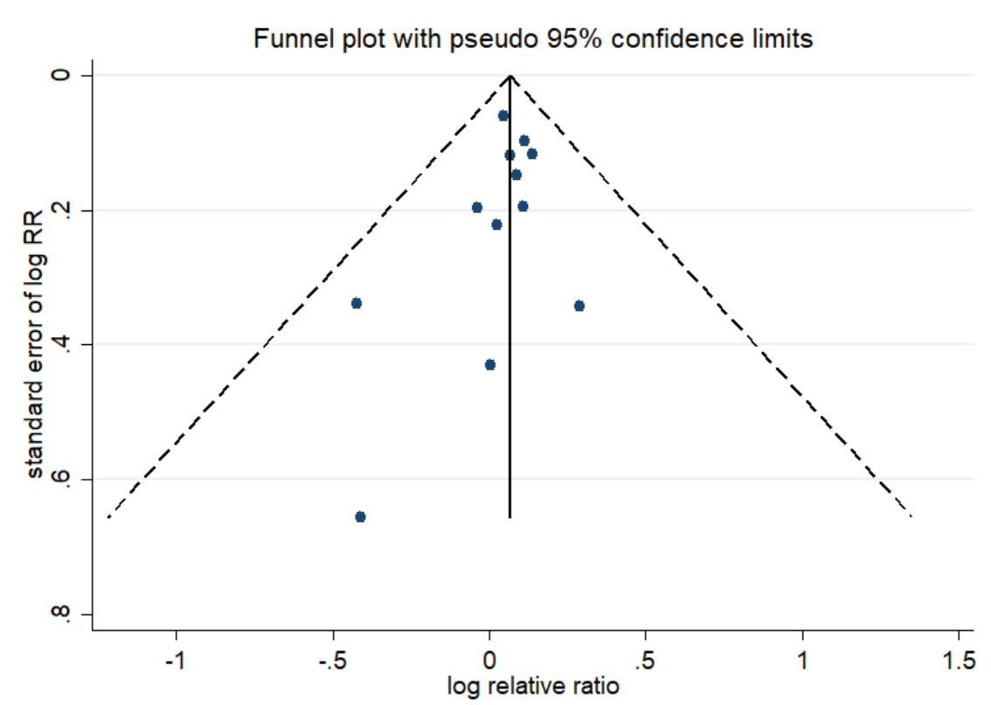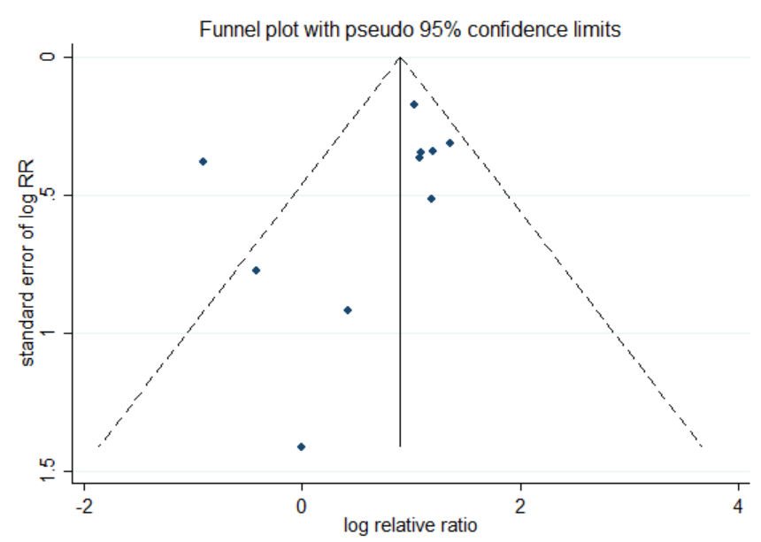
P=0.244 (Begg’s Test) and P=0.323 (Egger’s Test) P=0.020 (Begg’s Test) and P=0.319 (Egger’s Test)

I Acute kidney injury J Volume-related AEs
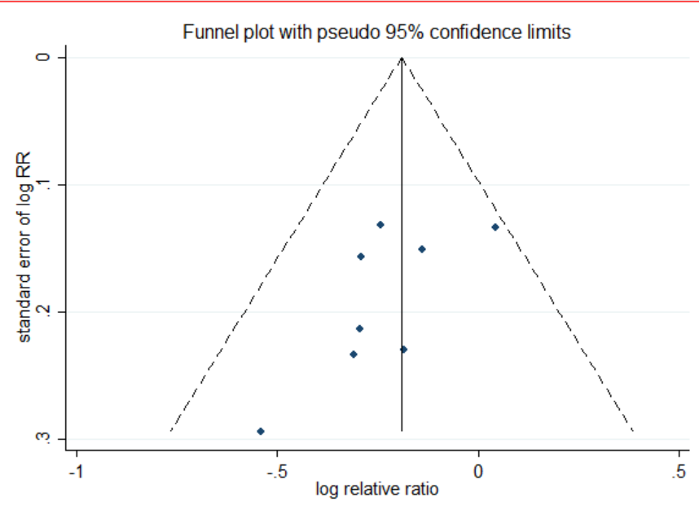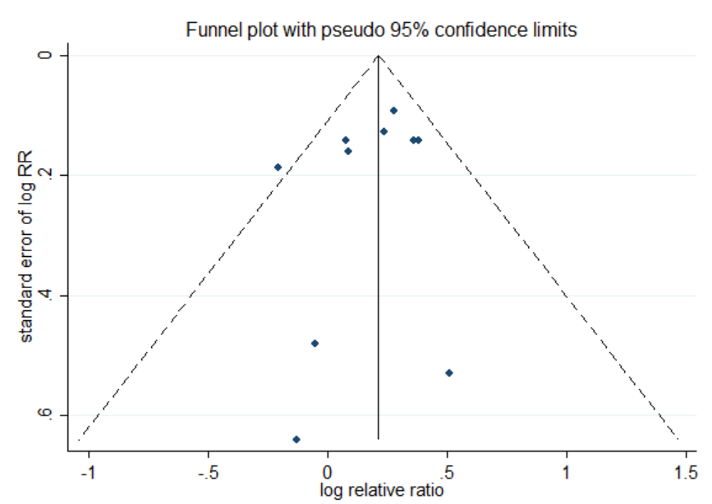
P=0.108 (Begg’s Test) and P=0.102 (Egger’s Test) P=0.592 (Begg’s Test) and P=0.384 (Egger’s Test)

Included References
[1] Perkovic V, de Zeeuw D, Mahaffey KW, Fulcher G, Erondu N, Shaw W, Barrett TD, Weidner-Wells M, Deng H, Matthews DR, Neal B. Canagliflozin and renal outcomes in type 2 diabetes: results from the CANVAS Program randomised clinical trials. Lancet Diabetes Endocrinol. 2018 Sep;6(9):691-704. doi: 10.1016/S2213-8587(18)30141-4. Epub 2018 Jun 21. PMID: 29937267.
[2] Neuen BL, Ohkuma T, Neal B, Matthews DR, de Zeeuw D, Mahaffey KW, Fulcher G, Desai M, Li Q, Deng H, Rosenthal N, Jardine MJ, Bakris G, Perkovic V. Cardiovascular and Renal Outcomes With Canagliflozin According to Baseline Kidney Function. Circulation. 2018 Oct 9;138(15):1537-1550. doi: 10.1161/CIRCULATIONAHA.118.035901. PMID: 29941478; PMCID: PMC6181277.
[3] Heerspink HJL, Jongs N, Chertow GM, Langkilde AM, McMurray JJV, Correa-Rotter R, Rossing P, Sjöström CD, Stefansson BV, Toto RD, Wheeler DC, Greene T; DAPA-CKD Trial Committees and Investigators. Effect of dapagliflozin on the rate of decline in kidney function in patients with chronic kidney disease with and without type 2 diabetes: a prespecified analysis from the DAPA-CKD trial. Lancet Diabetes Endocrinol. 2021 Nov;9(11):743-754. doi: 10.1016/S2213-8587(21)00242-4. Epub 2021 Oct 4. Erratum in: Lancet Diabetes Endocrinol. 2022 Oct;10(10):e10. PMID: 34619108.
[4] Cherney DZI, Cosentino F, Dagogo-Jack S, McGuire DK, Pratley R, Frederich R, Maldonado M, Liu CC, Liu J, Pong A, Cannon CP; VERTIS CV Investigators. Ertugliflozin and Slope of Chronic eGFR: Prespecified Analyses from the Randomized VERTIS CV Trial. Clin J Am Soc Nephrol. 2021 Sep;16(9):1345-1354. doi: 10.2215/CJN.01130121. Epub 2021 Jun 18. PMID: 34497110; PMCID: PMC8729577.
[5] Dagogo-Jack S, Pratley RE, Cherney DZI, McGuire DK, Cosentino F, Shih WJ, Liu J, Frederich R, Mancuso JP, Raji A, Gantz I. Glycemic efficacy and safety of the SGLT2 inhibitor ertugliflozin in patients with type 2 diabetes and stage 3 chronic kidney disease: an analysis from the VERTIS CV randomized trial. BMJ Open Diabetes Res Care. 2021 Oct;9(1):e002484. doi: 10.1136/bmjdrc-2021-002484. PMID: 34620621; PMCID: PMC8499340.
[6] Mosenzon O, Wiviott SD, Cahn A, Rozenberg A, Yanuv I, Goodrich EL, Murphy SA, Heerspink HJL, Zelniker TA, Dwyer JP, Bhatt DL, Leiter LA, McGuire DK, Wilding JPH, Kato ET, Gause-Nilsson IAM, Fredriksson M, Johansson PA, Langkilde AM, Sabatine MS, Raz I. Effects of dapagliflozin on development and progression of kidney disease in patients with type 2 diabetes: an analysis from the DECLARE-TIMI 58 randomised trial. Lancet Diabetes Endocrinol. 2019 Aug;7(8):606-617. doi: 10.1016/S2213-8587(19)30180-9. Epub 2019 Jun 10. Erratum in: Lancet Diabetes Endocrinol. 2019 Aug;7(8):e20. PMID: 31196815.
[7] Jhund PS, Solomon SD, Docherty KF, Heerspink HJL, Anand IS, Böhm M, Chopra V, de Boer RA, Desai AS, Ge J, Kitakaze M, Merkley B, O'Meara E, Shou M, Tereshchenko S, Verma S, Vinh PN, Inzucchi SE, Køber L, Kosiborod MN, Martinez FA, Ponikowski P, Sabatine MS, Bengtsson O, Langkilde AM, Sjöstrand M, McMurray JJV. Efficacy of Dapagliflozin on Renal Function and Outcomes in Patients With Heart Failure With Reduced Ejection Fraction: Results of DAPA-HF. Circulation. 2021 Jan 26;143(4):298-309. doi: 10.1161/CIRCULATIONAHA.120.050391. Epub 2020 Oct 12. PMID: 33040613; PMCID: PMC7834909.
[8] Mc Causland FR, Claggett BL, Vaduganathan M, Desai AS, Jhund P, de Boer RA, Docherty K, Fang J, Hernandez AF, Inzucchi SE, Kosiborod MN, Lam CSP, Martinez F, Saraiva JFK, McGrath MM, Shah SJ, Verma S, Langkilde AM, Petersson M, McMurray JJV, Solomon SD. Dapagliflozin and Kidney Outcomes in Patients With Heart Failure With Mildly Reduced or Preserved Ejection Fraction: A Prespecified Analysis of the DELIVER Randomized Clinical Trial. JAMA Cardiol. 2023 Jan 1;8(1):56-65. doi: 10.1001/jamacardio.2022.4210. PMID: 36326604; PMCID: PMC9634592.
[9] Zannad F, Ferreira JP, Pocock SJ, Zeller C, Anker SD, Butler J, Filippatos G, Hauske SJ, Brueckmann M, Pfarr E, Schnee J, Wanner C, Packer M. Cardiac and Kidney Benefits of Empagliflozin in Heart Failure Across the Spectrum of Kidney Function: Insights From EMPEROR-Reduced. Circulation. 2021 Jan 26;143(4):310-321. doi: 10.1161/CIRCULATIONAHA.120.051685. Epub 2020 Oct 23. Erratum in: Circulation. 2021 Jan 26;143(4):e29. PMID: 33095032; PMCID: PMC7834910.
[10] Sharma A, Ferreira JP, Zannad F, Pocock SJ, Filippatos G, Pfarr E, Petrini M, Kraus BJ, Wanner C, Packer M, Butler J, Anker SD. Cardiac and kidney benefits of empagliflozin in heart failure across the spectrum of kidney function: Insights from the EMPEROR-Preserved trial. Eur J Heart Fail. 2023 Aug;25(8):1337-1348. doi: 10.1002/ejhf.2857. Epub 2023 May 4. PMID: 37062851.
[11] Cherney DZI, Charbonnel B, Cosentino F, Dagogo-Jack S, McGuire DK, Pratley R, Shih WJ, Frederich R, Maldonado M, Pong A, Cannon CP; VERTIS CV Investigators. Effects of ertugliflozin on kidney composite outcomes, renal function and albuminuria in patients with type 2 diabetes mellitus: an analysis from the randomised VERTIS CV trial. Diabetologia. 2021 Jun;64(6):1256-1267. doi: 10.1007/s00125-021-05407-5. Epub 2021 Mar 4. PMID: 33665685; PMCID: PMC8099851.
[12] Wiviott SD, Raz I, Bonaca MP, Mosenzon O, Kato ET, Cahn A, Silverman MG, Zelniker TA, Kuder JF, Murphy SA, Bhatt DL, Leiter LA, McGuire DK, Wilding JPH, Ruff CT, Gause-Nilsson IAM, Fredriksson M, Johansson PA, Langkilde AM, Sabatine MS; DECLARE–TIMI 58 Investigators. Dapagliflozin and Cardiovascular Outcomes in Type 2 Diabetes. N Engl J Med. 2019 Jan 24;380(4):347-357. doi: 10.1056/NEJMoa1812389. Epub 2018 Nov 10. PMID: 30415602.
[13] McMurray JJV, Solomon SD, Inzucchi SE, Køber L, Kosiborod MN, Martinez FA, Ponikowski P, Sabatine MS, Anand IS, Bělohlávek J, Böhm M, Chiang CE, Chopra VK, de Boer RA, Desai AS, Diez M, Drozdz J, Dukát A, Ge J, Howlett JG, Katova T, Kitakaze M, Ljungman CEA, Merkely B, Nicolau JC, O'Meara E, Petrie MC, Vinh PN, Schou M, Tereshchenko S, Verma S, Held C, DeMets DL, Docherty KF, Jhund PS, Bengtsson O, Sjöstrand M, Langkilde AM; DAPA-HF Trial Committees and Investigators. Dapagliflozin in Patients with Heart Failure and Reduced Ejection Fraction. N Engl J Med. 2019 Nov 21;381(21):1995-2008. doi: 10.1056/NEJMoa1911303. Epub 2019 Sep 19. PMID: 31535829.
[14] Solomon SD, McMurray JJV, Claggett B, de Boer RA, DeMets D, Hernandez AF, Inzucchi SE, Kosiborod MN, Lam CSP, Martinez F, Shah SJ, Desai AS, Jhund PS, Belohlavek J, Chiang CE, Borleffs CJW, Comin-Colet J, Dobreanu D, Drozdz J, Fang JC, Alcocer-Gamba MA, Al Habeeb W, Han Y, Cabrera Honorio JW, Janssens SP, Katova T, Kitakaze M, Merkely B, O'Meara E, Saraiva JFK, Tereshchenko SN, Thierer J, Vaduganathan M, Vardeny O, Verma S, Pham VN, Wilderäng U, Zaozerska N, Bachus E, Lindholm D, Petersson M, Langkilde AM; DELIVER Trial Committees and Investigators. Dapagliflozin in Heart Failure with Mildly Reduced or Preserved Ejection Fraction. N Engl J Med. 2022 Sep 22;387(12):1089-1098. doi: 10.1056/NEJMoa2206286. Epub 2022 Aug 27. PMID: 36027570.
[15] Packer M, Anker SD, Butler J, Filippatos G, Pocock SJ, Carson P, Januzzi J, Verma S, Tsutsui H, Brueckmann M, Jamal W, Kimura K, Schnee J, Zeller C, Cotton D, Bocchi E, Böhm M, Choi DJ, Chopra V, Chuquiure E, Giannetti N, Janssens S, Zhang J, Gonzalez Juanatey JR, Kaul S, Brunner-La Rocca HP, Merkely B, Nicholls SJ, Perrone S, Pina I, Ponikowski P, Sattar N, Senni M, Seronde MF, Spinar J, Squire I, Taddei S, Wanner C, Zannad F; EMPEROR-Reduced Trial Investigators. Cardiovascular and Renal Outcomes with Empagliflozin in Heart Failure. N Engl J Med. 2020 Oct 8;383(15):1413-1424. doi: 10.1056/NEJMoa2022190. Epub 2020 Aug 28. PMID: 32865377.
[16] Packer M, Butler J, Zannad F, Filippatos G, Ferreira JP, Pocock SJ, Carson P, Anand I, Doehner W, Haass M, Komajda M, Miller A, Pehrson S, Teerlink JR, Schnaidt S, Zeller C, Schnee JM, Anker SD. Effect of Empagliflozin on Worsening Heart Failure Events in Patients With Heart Failure and Preserved Ejection Fraction: EMPEROR-Preserved Trial. Circulation. 2021 Oct 19;144(16):1284-1294. doi: 10.1161/CIRCULATIONAHA.121.056824. Epub 2021 Aug 29. PMID: 34459213; PMCID: PMC8522627.

