Supplemental Material
Supplement – Sample study flowchart.
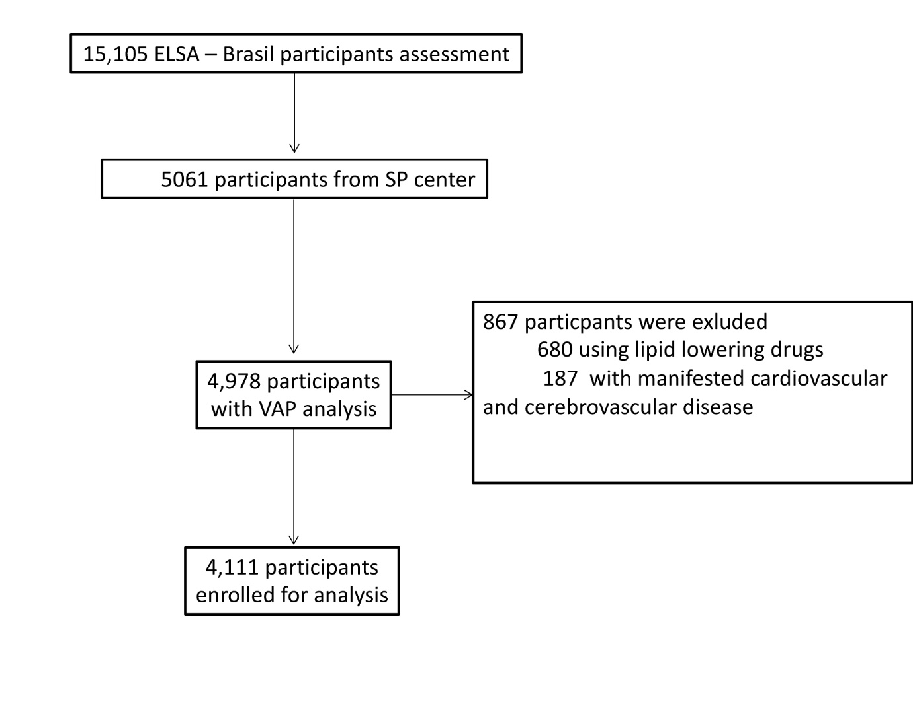
Supplement 1 (S1) - Sample characteristics according to large and buoyant LDL-c percentiles
Clinical Profile | Large buoyant LDL-C |  | P value
Clinical Profile | p < 50th | p ≥ 50th | P value
Age | 49.5 (± 8.6) | 51.1 (± 8.5) | < 0.0001
Male (n, %) | 1,120 (59) | 751 (33.9) | < 0.0001
Race (n, %)  White  Black  Brown  Others | 1,036 (54.58)  285 (15.02)  457 (24.08) | 1346 (60.82)  295 (13.33)  440 (19.88) | 0.001
Total Cholesterol (mg/dL) | 191.1 (± 41.2) | 228.65 (± 37.0) | < 0.0001
LDL-c(mg/dL) | 117.0 (± 29.9) | 145.6 (± 32.1) | < 0.0001
HDL-c (mg/dL) | 50.2 (± 12.2) | 61.7 (± 14.2) | < 0.0001
Triglycerides (mg/dl) | 103 (70–160) | 116 (86–158) | < 0.0001
T2D (n, %) | 387 (20.4) | 301 (13.6) | < 0.0001
FPG (mg/dL) | 110.87 (± 32.0) | 108.39 (± 22.4) | 0.003
HbA1c (%) | 5.417 (± 1.02) | 5.43 (± 0.81) | 0.55
Hypertension (n, %) | 562 (29.6) | 537 (24.2) | < 0.0001
SBP (mmHg) | 121.1 (± 16.6) | 117.3 (± 15.9) | < 0.0001
DBP (mmHg) | 76.44 (± 10.9) | 73.9 (± 10.5) | < 0.0001
Smoking (n, %)  Current  Former | 344 (18.1)  590 (31.1) | 343 (15.5)  625 (28.2) | 0.002
WC | 90.8 (± 12.4) | 87.8 (± 12.2) | < 0.0001

SD: standard deviation; % percentage; BMI: body mass index; DLP: Dyslipidemia; SBP: systolic blood pressure; DBP: diastolic blood pressure; HbA1C: glycated hemoglobin WC: waist circumference. Total cholesterol, LDL-c, HDL-c, and TG were determined by conventional analysis (not VAP).
Supplement 2 (S2) - Multivariate logistic regression for the association of lbLDL-c, sdLDL-c with BMI and WC
sdLDL-c (per 1SD increase) | Non-T2D | T2D | interaction p-value
WC [57] | 0.18 (0.12; 0.25) | 0.008 (-0.12; -0.14) | < 0.001
BMI (kg/m²) | 0.31 (0.15; 0.47) | 0.003 (-0.31; 0.31) | 0.038
lbLDL-c (per 1SD increase) | Non-T2D | T2D | interaction p-value
WC | 0.001 (-0.05; 0.05) | -0.09 (-0.18; -0.001) | 0.009
BMI (kg/m²) | 0.015 (-0.11; 0.14) | -0.17 (-0.39; 0.04) | 0.11

Results are presented in β (95% CI). lbLDL: large buoyant LDL subfractions; sdLDL: small and dense LDL subfractions; WC: waist circumference; BMI: body mass index.
Supplement 3 (S3) - Univariate linear regression for the association of sdLDL-c and lbLDL-c with for WC and BMI
HOMA IR
sdLDL-c  (per 1 SD increase) | p < 50 | p > 50 | interaction  p-value
 | β (-/SD) | β (-/SD)
WC | .27 (.05) | .08 (.05) | < .001
BMI (kg/m²) | .58 (.13) | .04 (.11) | .001

lbLDL-c  (per 1 SD increase) | p < 50 | p > 50 | XXXinteraction  p-value
 | β (-/SD) | β (-/SD)
WC [57] | .05 (.04) | .04 (.03) | .019
BMI (kg/m²) | .08 (.08) | .08 (.08) | .038

lbLDL-c: large and buoyant LDL-c; WC: waist circumference; BMI: body mass index; SD: standard deviation
Supplement 4 (S4)– Multivariate linear regression for the association of sdLDL-c and lbLDL-c with for WC and BMI
HOMA IR
sdLDL-c  (per 1 SD increase) | p < 50 | p > 50 | interaction  p-value
 | β (-/SD) | β (-/SD)
WC | 0.27 (0.17; 0.38) | 0.08 (-0.01; 0.18) | < .001
BMI (kg/m²) | 0.58 (0.32; 0.84) | 0.04 (-0.18; 0.27) | 0.001
lbLDL-c  (per 1 SD increase) | p < 50 | p > 50 | interaction  p-value
 | β (-/SD) | β (-/SD)
WC | 0.05 (-0.03; 0.14) | 0.04 (-0.03; 0.11) | .019
BMI (kg/m²) | 0.17 (-0.04; 0.40) | 0.08 (-0.08; 0.24) | .038
lbLDL-c: large and buoyant LDL-c; WC: waist circumference; BMI: body mass index; SD: standard deviation

