Table S1 Collinearity screening
 | Step 1 | Step 2
eGDR | 1.2 | 1.2
Gender | 2.8 | 2.8
Age | 1.3 | 1.3
Living place | 1.1 | 1.1
Education level | 1.3 | 1.3
Married | 1.1 | 1.1
Smoking status | 2 | 2
Drinking status | 1.5 | 1.5
BMI | 1 | 1
FPG | 1.1 | 1.1
CRP | 1.1 | 1.1
WBC | 1.2 | 1.2
Platelets | 1.1 | 1.1
BUN | 1.2 | 1.2
Scr | 1.5 | 1.5
TC | 15.7 | NA
TG | 6.3 | 1.5
HDL-c | 3.5 | 1.4
LDL-c | 12.9 | 1.1
UA | 1.5 | 1.5
Variables excluded from collinearity screening: TC
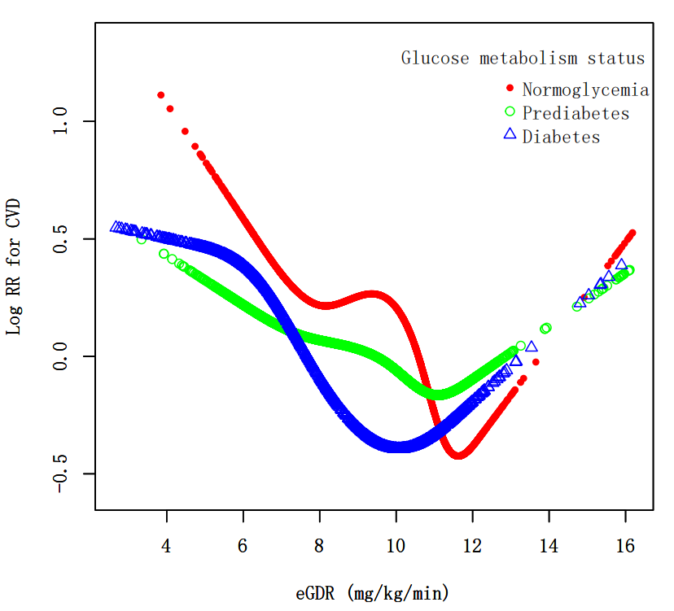
Fig.S1 Non-linear associations between eGDR and CVD risk stratified by glucose metabolism status in adults aged 50 and above. The association was evaluated using RCS models. Models were adjusted for gender, age, living place, education level, marital status, drinking status, smoking status, CRP, WBC, platelets, FPG, BUN, Scr, UA, TG, HDL-c, LDL-c, BMI.

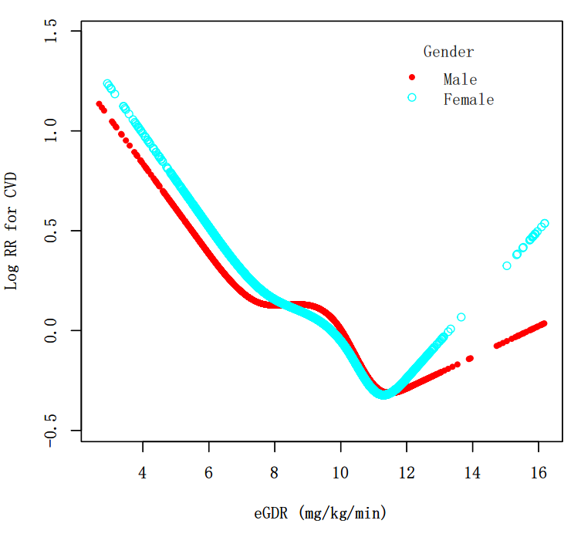
Fig.S2 Non-linear associations between eGDR and CVD risk stratified by gender. The association was evaluated using RCS models. Models were adjusted for age, living place, education level, marital status, drinking status, smoking status, CRP, WBC, platelets, FPG, BUN, Scr, UA, TG, HDL-c, LDL-c, BMI.

Fig. S3-S10
