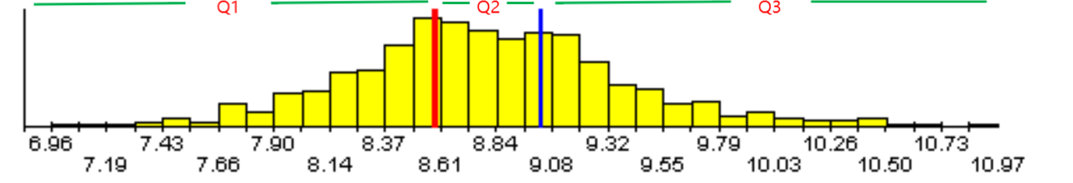
Supplementary Figure 1 Visual tripartite grouping based on TyG level

(the ordinate: the number of cases; the abscissa: TyG. Q1: quartile 1, Q2: quartile 2, Q3: quartile 3.)

Supplementary Table 1 Logistic regression analysis of influencing factors in older OSA patients with high risk of sarcopenia
Variable | β | OR(95%CI) | P value
TyG | 0.964 | 2.623(2.031-3.389) | <0.001
Age | 0.214 | 1.239(1.205-1.274) | <0.001
BMI | -0.011 | 0.989(0.955-1.023) | 0.513
Ccr | -0.018 | 0.982(0.977-0.987) | <0.001
HDL-C | 0.287 | 1.333(0.954-1.863) | 0.092
HB | -0.003 | 0.997(0.989-1.005) | 0.476
AHI | 0.008 | 1.008(1.001-1.014) | 0.017
T90 | 0.012 | 1.012(1.005-1.018) | 0.001
Mean SpO₂ | -0.077 | 0.926(0.892-0.961) | <0.001
Sex | 0.055 | 1.057(0.800-1.397) | 0.697
Smoking | -0.013 | 0.987(0.715-1.363) | 0.938
Drinking | 0.441 | 1.554(1.044-2.315) | 0.030
Hypertension | 0.617 | 1.854(1.371-2.508) | <0.001
CA | 0.675 | 1.963(1.455-2.650) | <0.001
BMI: body mass index; Ccr: creatinine clearance rate; HDL-C: high-density lipoprotein cholesterol; HB: hemoglobin; AHI: apnea-hypopnea index; T90: the proportion of time corresponding to pulse oxygen saturation less than 90% in total sleep time; SpO₂: peripheral oxygen saturation; CA: carotid atherosclerosis.

