Appendix A. Supplementary data

Associations between metal exposure and metabolic syndrome: Exploring the mediating role of biological aging among US adults

Supplementary Table S1. Distribution of metal levels in NHANES 1999-2018 (n = 11, 541).
Supplementary Table S2. Posterior inclusion probabilities (PIP) in BKMR model in NHANES 1999-2018.

Supplementary Figure S1. Directed acyclic graph.
Supplementary Figure S2. Spearman’s correlation matrix among Ln-transformed urinary metals in the study population.
Supplementary Figure S3. Sensitivity analysis of WQS model regression index weights for metabolic syndrome and its components with further excluded participants with metabolic syndrome related medication use (n = 11, 541).
Supplementary Figure S4. Sensitivity analysis of WQS model regression index weights for metabolic syndrome and its components with 11 metals were included in the WQS model (n = 4, 925).
Supplementary Figure S5. Sensitivity analysis of WQS model regression index weights for metabolic syndrome and its components with creatinine as an adjustment variable (n = 11, 541).
Supplementary Figure S6. Sensitivity analysis of WQS model regression index weights for metabolic syndrome and its components with further excluded participants with abnormal urinary creatinine (n = 11, 541).
Supplementary Figure S7. Sensitivity analysis of WQS model regression index weights for metabolic syndrome and its components with further further adjustments to the Healthy Eating Index-2020 (n = 8, 017).
Supplemental Figure S8. Sensitivity analysis of Group WQS model regression index weights for metabolic syndrome and its components (n = 11, 541).
Supplemental Figure S9. The restricted cubic spline for the associations between urinary essential metals and metabolic syndrome (n = 11, 541).

Supplementary Table S1. Distribution of metal levels in NHANES 1999-2018 (n = 11, 541).
Variable | LLOD | Detection rate (%) | 0th percentile | 25th percentile | 50th percentile | 75th percentile | 100th percentile
Ba (ug/L) | 0.060 | 99.90 | 0.000 | 0.590 | 1.200 | 2.290 | 101.000
Cd (ug/L) | 0.036 | 96.00 | 0.000 | 0.125 | 0.250 | 0.491 | 36.777
Co (ug/L) | 0.023 | 99.99 | 0.000 | 0.213 | 0.353 | 0.555 | 127.870
Cs (ug/L) | 0.086 | 99.99 | 0.000 | 2.750 | 4.550 | 6.820 | 552.120
Mo (ug/L) | 0.800 | 99.99 | 0.000 | 21.485 | 40.900 | 69.600 | 1215.900
Pb (ug/L) | 0.030 | 99.80 | 0.000 | 0.260 | 0.500 | 0.900 | 52.300
Sb (ug/L) | 0.022 | 92.50 | 0.000 | 0.030 | 0.057 | 0.105 | 5.590
Tl (ug/L) | 0.018 | 99.30 | 0.000 | 0.093 | 0.160 | 0.249 | 7.658
Tu (ug/L) | 0.018 | 90.30 | 0.000 | 0.030 | 0.067 | 0.130 | 32.910
Abbreviation: LLOD: lower limit of detection.

Supplementary Table S2. Posterior inclusion probabilities (PIP) in BKMR model in NHANES 1999-2018.
Exposures | MetS | Hypertriglyceridemia | Low HDL | Central obesity | Hypertension | Hyperglycemia
Ba | 0.674 | 1.000 | 1.000 | 0.000 | 0.158 | 1.000
Cd | 1.000 | 1.000 | 1.000 | 1.000 | 0.958 | 1.000
Co | 0.126 | 1.000 | 1.000 | 0.000 | 0.766 | 0.904
Cs | 0.404 | 1.000 | 0.998 | 0.000 | 0.898 | 1.000
Mo | 0.474 | 0.464 | 1.000 | 0.000 | 0.072 | 1.000
Pb | 1.000 | 1.000 | 0.992 | 0.046 | 0.000 | 0.468
Sb | 0.000 | 0.632 | 1.000 | 0.000 | 0.488 | 1.000
Tl | 0.162 | 0.996 | 1.000 | 0.000 | 0.686 | 0.928
Tu | 0.000 | 0.068 | 0.950 | 0.000 | 0.000 | 0.428
Models were adjusted for sex, age, race/ethnicity, education, family income-to-poverty ratio, marital status, body mass index, physical activity, drinking alcohol status, daily total energy intake, and serum cotinine. The concentrations of metals were all corrected by urinary creatinine, were expressed as micrograms per gram creatinine and were ln-transformed.

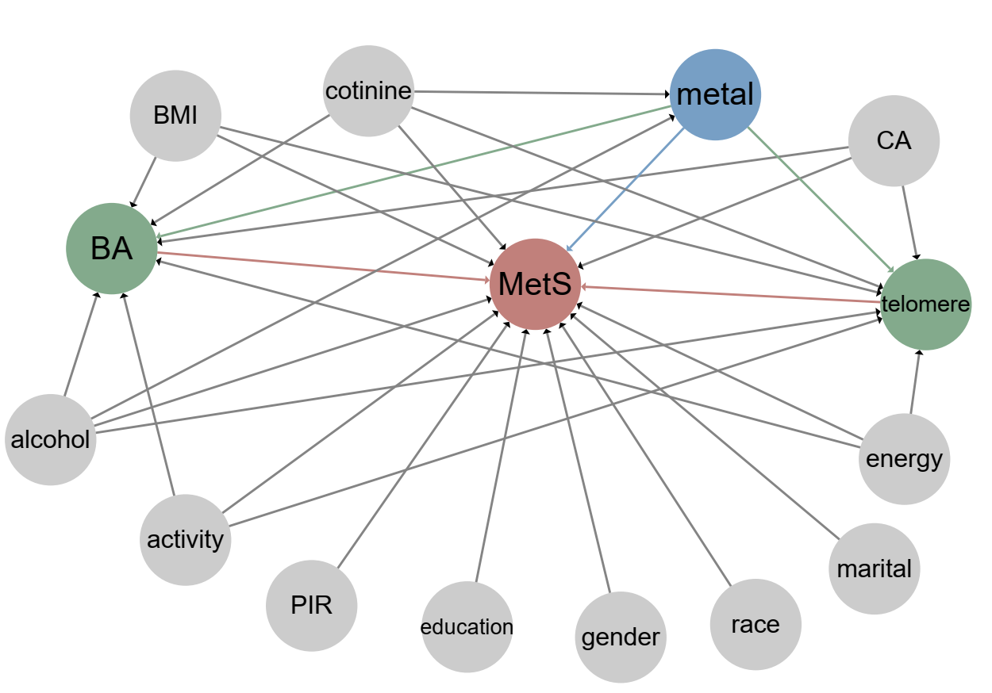
Supplementary Figure S1. Directed acyclic graph. were presenting the outcome variables. were presenting the exposure variables. were presenting the mediating factor. were presenting the covariable. The grey lines showed the association between confounding factor and outcomes. The blue lines showed the association between exposures and outcomes. The red lines showed the association between mediating factor and outcomes. The green lines showed the association between exposures and mediating factor. Abbreviation: MetS: Metabolic syndrome. CA: Chronological age. BA: Biological age. PIR: the ratio of family income to poverty. BMI: body mass index.

Supplementary Figure S2. Spearman’s correlation matrix among Ln-transformed urinary metals in the study population.

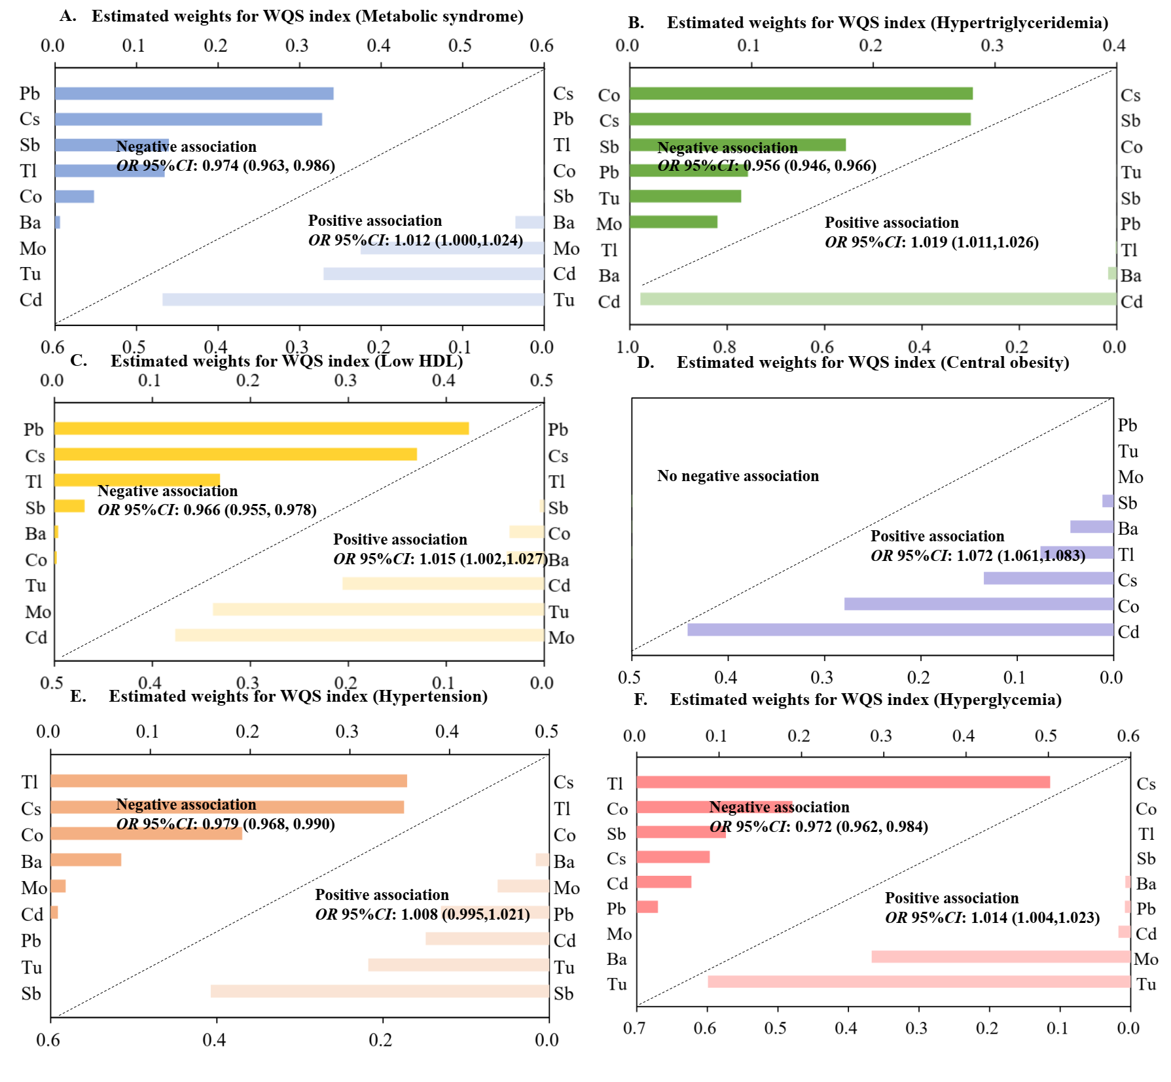
Supplementary Figure S3. Sensitivity analysis of WQS model regression index weights for metabolic syndrome and its components with further excluded participants with metabolic syndrome related medication use (n = 11, 541).
Abbreviation: WQS: weighted quantile sum. MetS: Metabolic syndrome.
Models were adjusted for sex, age, race/ethnicity, education, family income-to-poverty ratio, marital status, body mass index, physical activity, drinking alcohol status, daily total energy intake and serum cotinine.
The concentrations of metals were all corrected by urinary creatinine, were expressed as micrograms per gram creatinine and were ln-transformed.

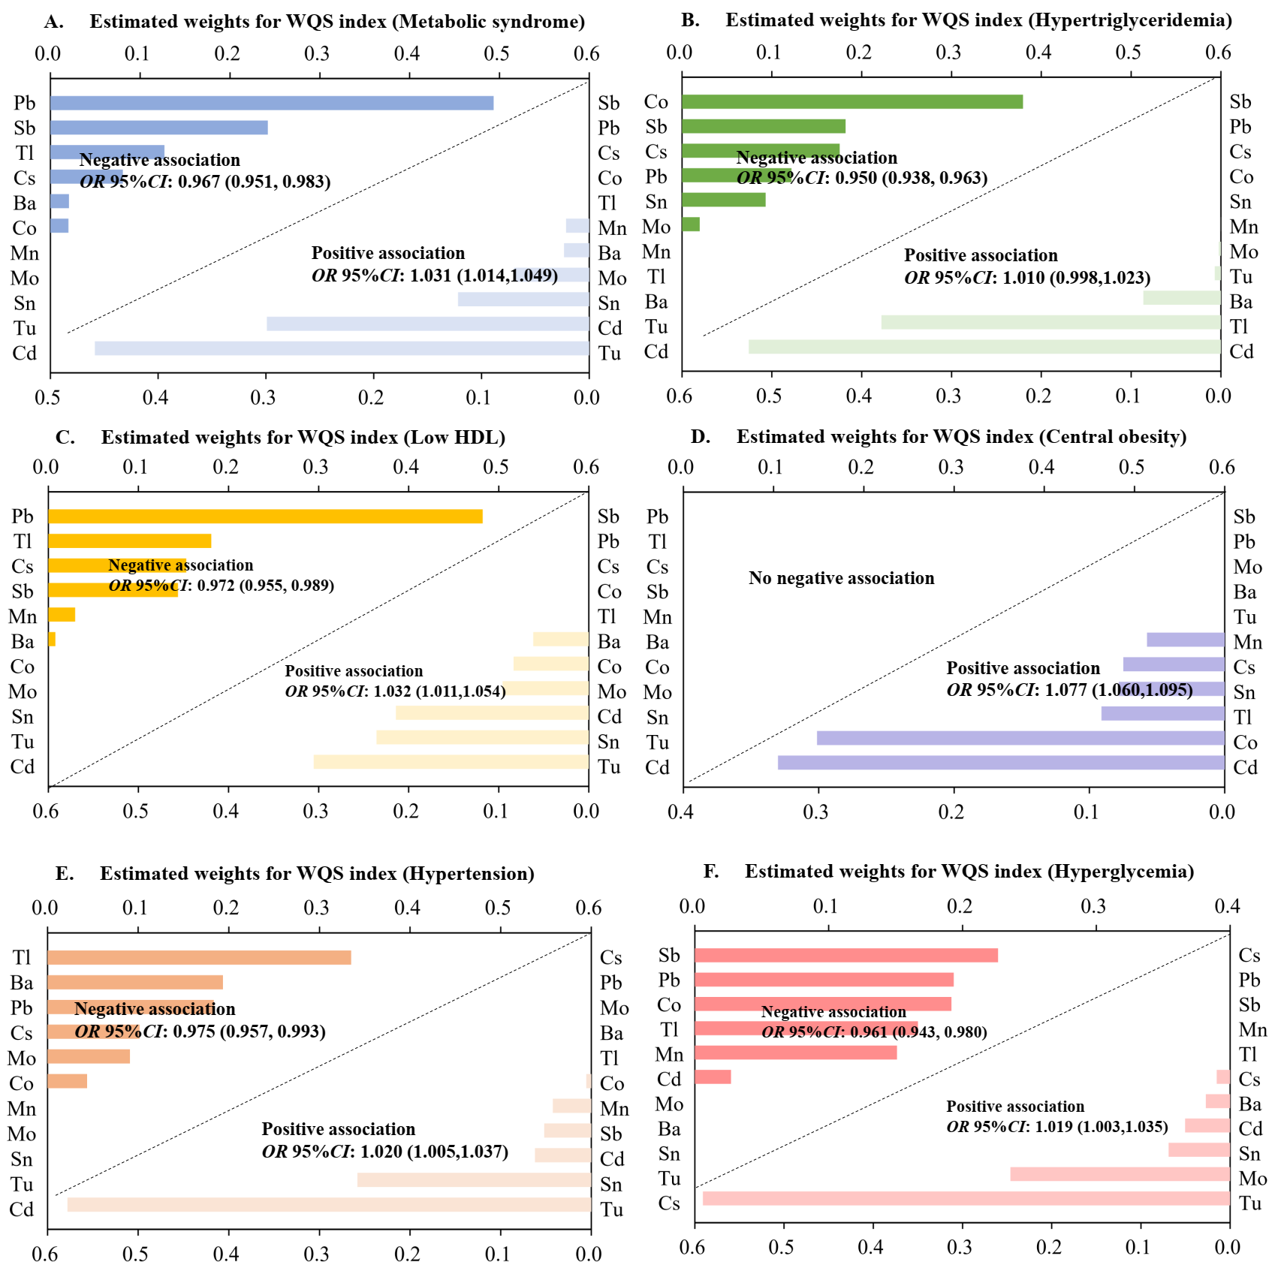
Supplementary Figure S4. Sensitivity analysis of WQS model regression index weights for metabolic syndrome and its components with 11 metals were included in the WQS model (n = 4, 925).
Abbreviation: WQS: weighted quantile sum. MetS: Metabolic syndrome.
Models were adjusted for sex, age, race/ethnicity, education, family income-to-poverty ratio, marital status, body mass index, physical activity, drinking alcohol status, daily total energy intake and serum cotinine.
The concentrations of metals were all corrected by urinary creatinine, were expressed as micrograms per gram creatinine and were ln-transformed.

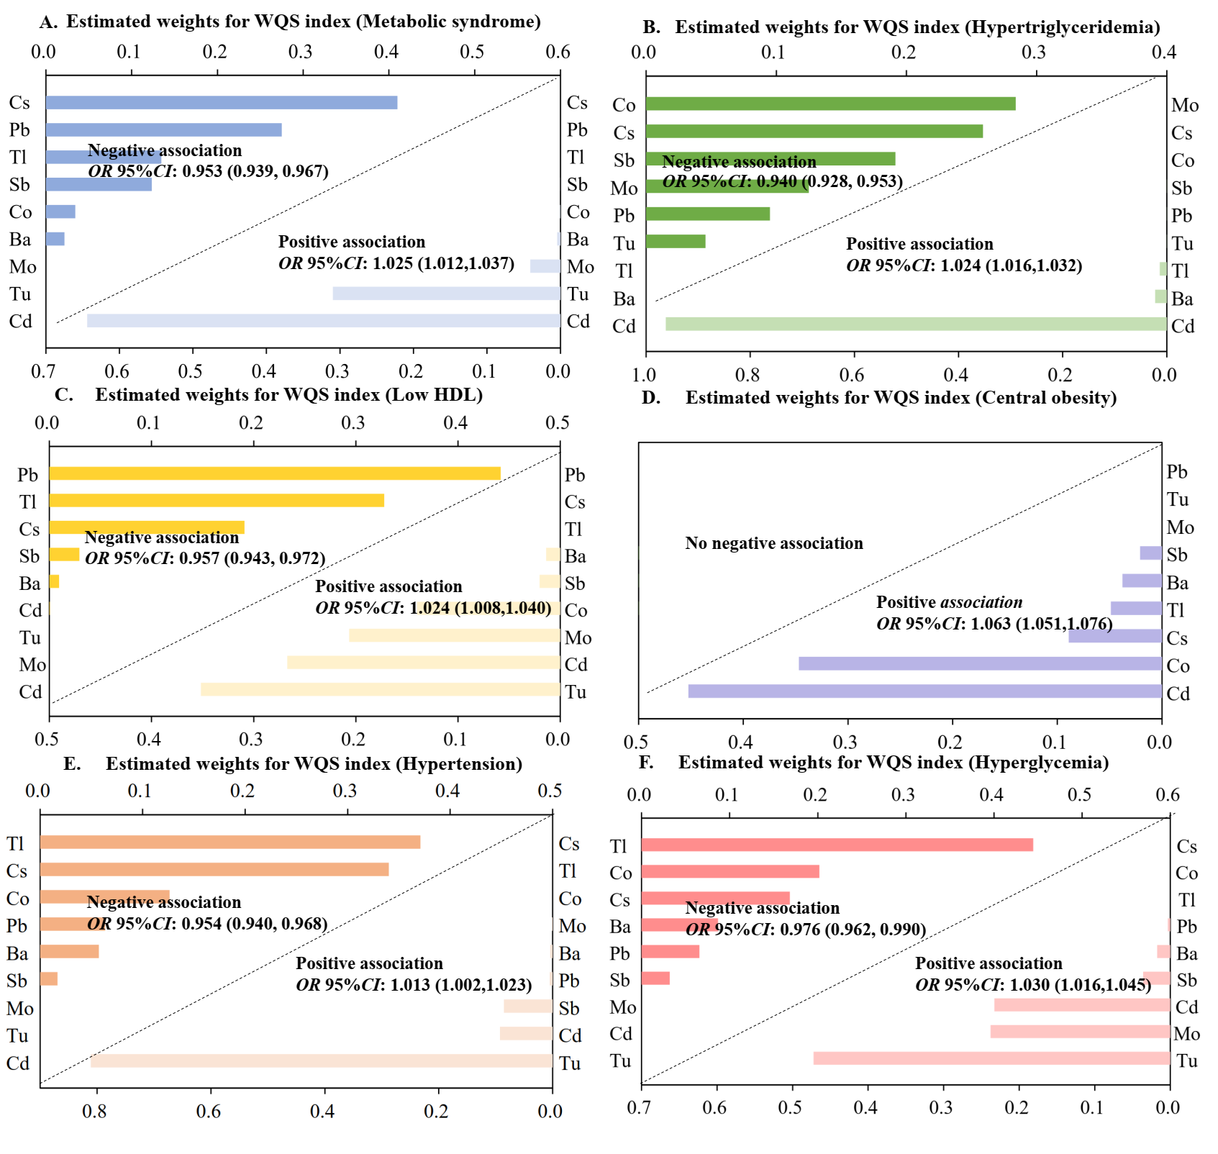
Supplementary Figure S5. Sensitivity analysis of WQS model regression index weights for metabolic syndrome and its components with creatinine as an adjustment variable (n = 11, 541).
Abbreviation: WQS: weighted quantile sum. MetS: Metabolic syndrome.
Models were adjusted for sex, age, race/ethnicity, education, family income-to-poverty ratio, marital status, body mass index, physical activity, drinking alcohol status, daily total energy intake and serum cotinine.

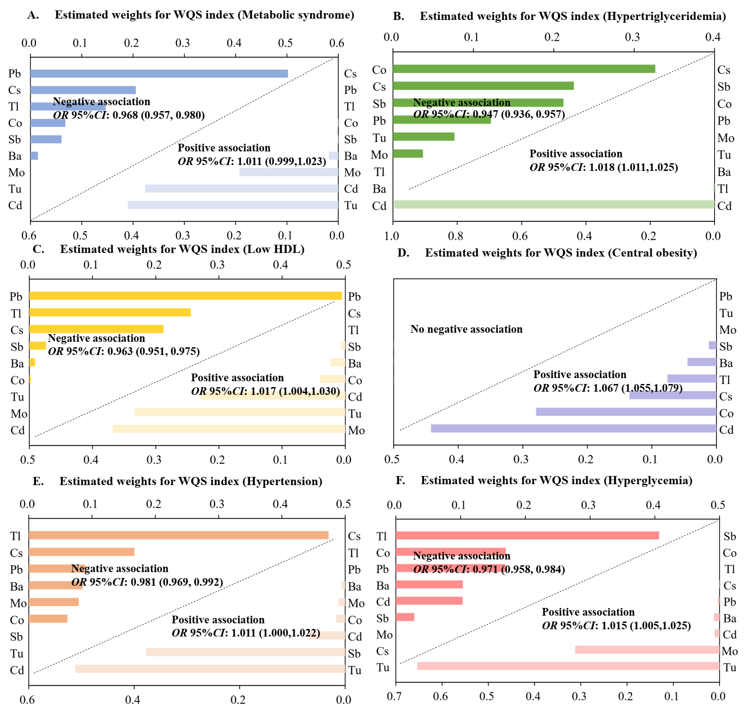
Supplementary Figure S6. Sensitivity analysis of WQS model regression index weights for metabolic syndrome and its components with further excluded participants with abnormal urinary creatinine (n = 11, 541).
Abbreviation: WQS: weighted quantile sum. MetS: Metabolic syndrome.
Models were adjusted for sex, age, race/ethnicity, education, family income-to-poverty ratio, marital status, body mass index, physical activity, drinking alcohol status, daily total energy intake and serum cotinine.
The concentrations of metals were all corrected by urinary creatinine, were expressed as micrograms per gram creatinine and were ln-transformed.

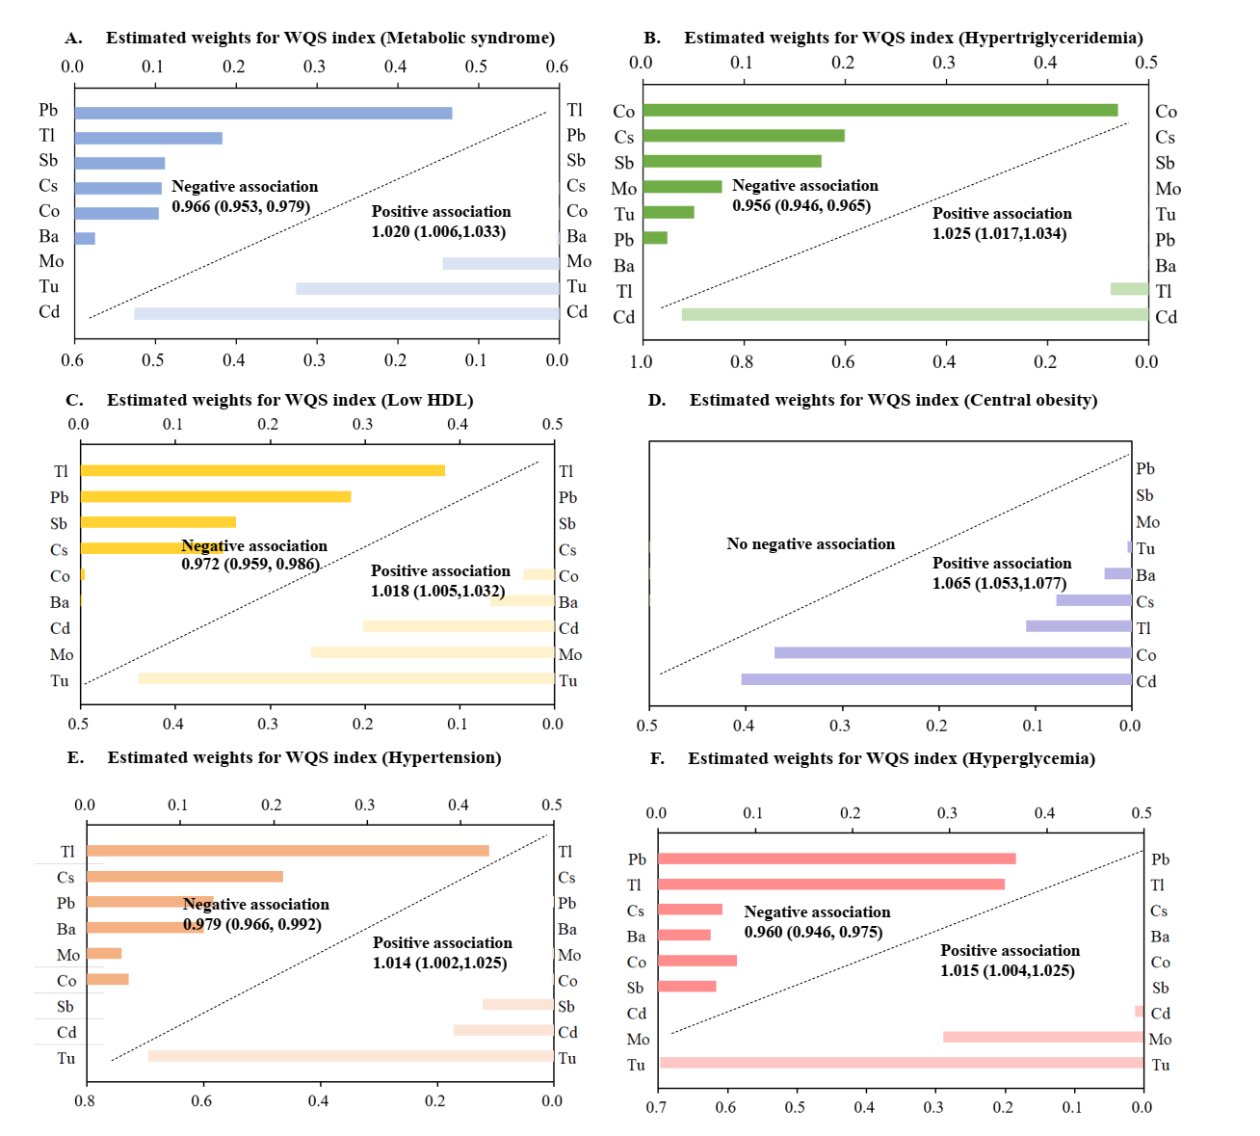
Supplementary Figure S7. Sensitivity analysis of WQS model regression index weights for metabolic syndrome and its components with further further adjustments to the Healthy Eating Index-2020 (n = 8, 017).
Abbreviation: WQS: weighted quantile sum. MetS: Metabolic syndrome.
Models were adjusted for sex, age, race/ethnicity, education, family income-to-poverty ratio, marital status, body mass index, physical activity, drinking alcohol status, daily total energy intake, Healthy Eating Index-2020 and serum cotinine.
The concentrations of metals were all corrected by urinary creatinine, were expressed as micrograms per gram creatinine and were ln-transformed.

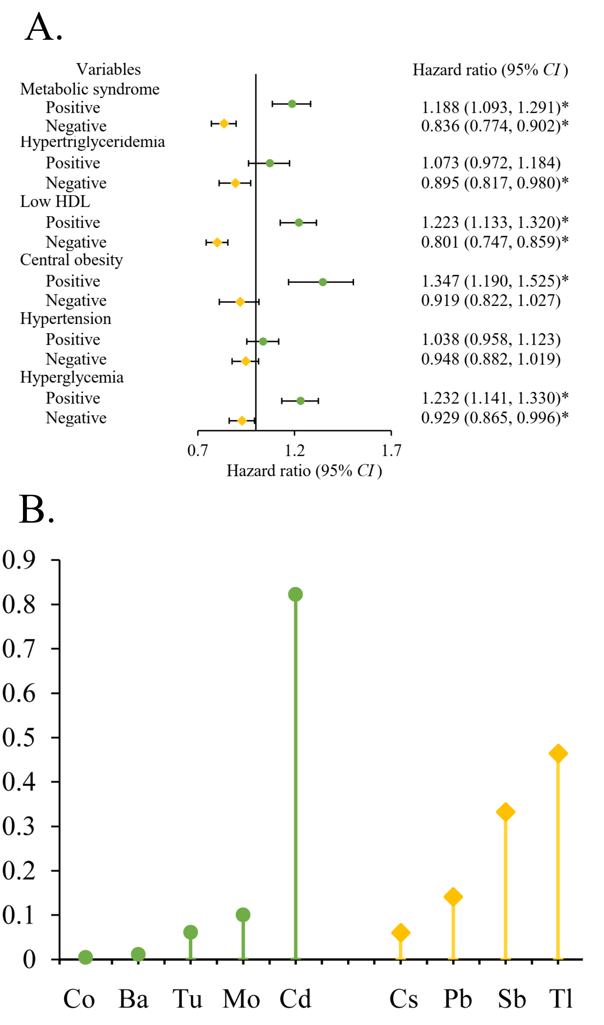
Supplemental Figure S8. Sensitivity analysis of Group WQS model regression index weights for metabolic syndrome and its components (n = 11, 541).
Models were adjusted for sex, age, race/ethnicity, education, family income-to-poverty ratio, marital status, body mass index, physical activity, drinking alcohol status, survey wave, daily total energy intake and serum cotinine. * resenting for p<0.05.
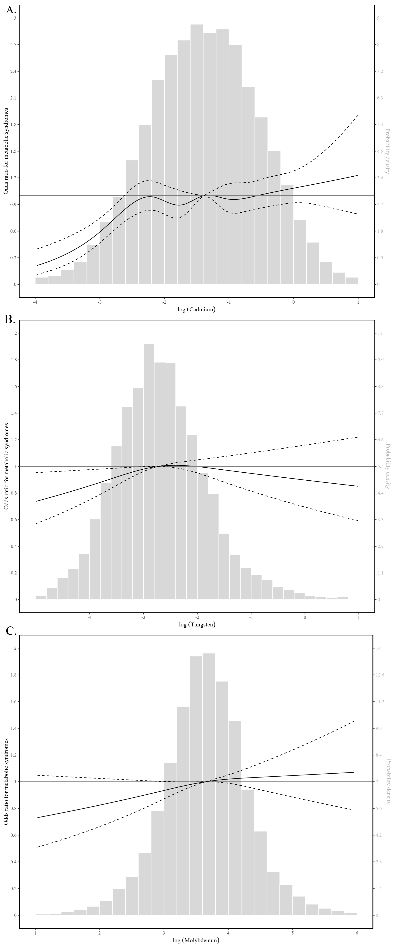
Supplemental Figure S9. The restricted cubic spline for the associations between urinary essential metals and metabolic syndrome (n = 11, 541).
Panel A: the associations between urinary cadmium and metabolic syndrome; Panel B: the associations between urinary tungsten and metabolic syndrome; Panel C: the associations between urinary molybdenum and metabolic syndrome.
Models were adjusted for sex, age, race/ethnicity, education, family income-to-poverty ratio, marital status, body mass index, physical activity, drinking alcohol status, survey wave, daily total energy intake and serum cotinine.

