Supplementary table (1) the criteria that were used to select only those specific genes and miRNA
Criteria | Selection Process/Rationale | Key Parameters/Examples
Differential Expression Analysis  (to ensure that the chosen genes closely linked to T2DM | - GEO Datasets: Filtered using keywords ("T2DM," "Insulin Resistance") and inclusion criteria (array data, ≥5 samples per group).  - DEG Identification: Applied GEO2R/limma (R package) with thresholds: |logFC| > 0.5, p < 0.05. | • Datasets: Publicly available raw data (Supplementary Table S1).  • Examples: DEGs like IGF1R, NFKB1.
Functional Relevance  to verify that the chosen genes linked to molecular pathways implicated in T2DM pathogenesis and complications | - Gene Ontology (GO): Filtered via GeneCards for T2DM pathways (insulin signaling, inflammation, autophagy).  - PPI Networks: STRING database identified hub genes (medium confidence: 0.4; FDR: 5%). | • GO categories: Insulin signaling (IGF1R, mTOR), inflammation (NFKB1), autophagy (RB1CC1).  • PPI hubs: HSPA1B, DDX58.
miRNA Selection | - miRNA-mRNA Interaction: Predicted by mirWalk (e.g., miR-342-5p targets NFKB1 and IGF1R).  - Sequence Alignment: Validated via EMBOSS Water tool (miRDB for miRNAs; NCBI Nucleotide for mRNAs). | • Identity/Similarity scores (Supplementary Table):  - miR-342-5p: Identity 32.4–65%, Similarity 50–80%.  - miR-611: Identity 51.6–65%, Similarity 61.3–65%.
Considered but Excluded | - Genes/miRNAs with inconsistent expression across datasets.  - Biomarkers lacking functional annotations in T2DM pathways (e.g., non-inflammatory genes). | • Example exclusions: Genes unrelated to autophagy or insulin resistance.
Previous Literature Validation | Selected markers validated by prior studies (e.g., NFKB1 in inflammation, miR-15b-5p in early T2DM detection). | • References: Supporting studies for RET in neuronal pathways, DDX58 in diabetic nephropathy.

Supplementary table 2: : Differentially expressed genes (DEGs) were identified using the GEO2Data base

Accession number | Platform | Organism | Experiment type | Design | Number of samples
 |  |  |  |  | Case | Control
GSE78721 | GPL15207[PrimeView] Affymetrix Human Gene Expression Array | Homo sapiens | Expression profiling by array | 30 controls & 30 diabetic subjects undergoing femur bone surgery and 16 controls & 19 diabetic subjects undergoing abdominal surgery (two samples from each subject, one subcutaneous and one visceral fat biopsy were extracted). So total 130 samples were obtained and analyzed for genome –wide gene expression profile of Adipocytes and infiltration macrophages from three different depots of adipose tissue. | 68 | 62
GSE16415 | GPL2986 ABI Human Genome Survey Microarray Version 2 | Homo sapiens | Expression profiling by array | In this study, omental biopsies were obtained from 5 diabetic and 5 control women undergoing cholecystectomy. All the subjects age > 55 years, BMI > 30, free from infection and malignancy. Expression profiling of 32878 probes for 29,098 genes was done in all participants. | 5 | 5

Supplementary table -(3)--Identity and similarity score for alignment between mRNA and miRNAs
 |  | NFKB1 | MTOR | IGF1R | RET | RB1CC1 | HSPA1B | DDX58
miR-15b-5p | Identity | 55 | 59.1 | 57.1
miR-15b-5p | Similarity | 85 | 77.3 | 76.2
miR-342-5p | Identity | 32.4 | 42.1 | 65 | 45
miR-342-5p | Similarity | 50 | 73.7 | 80 | 75
miR-636 | Identity |  | 33.3 |  |  | 28.6
miR-636 | Similarity |  | 61.9 |  |  | 57.1
miR-611 | Identity |  | 51.6 |  |  |  | 55.6 | 65
miR-611 | Similarity |  | 61.3 |  |  |  | 63 | 65

miR-15b-5p targets NFKB1, MTOR and IGF1R, miR-342-5p targets NFKB1, MTOR, IGF1R and RET, miR-636 targets MTOR and RB1CC1 and miR-611 targets MTOR, HSPA1B and DDX58.

Table s 3: primer assay of selected markers
mRNA | Gene ID | miRNA | Gene ID
RET | NM_020630 | miR-342-5p | YP00204516
RB1CC1 | NM_014781 | miR-636 | YP00204298
IGF1R | NM_000875 | miR-15b-5p | YP00204243
NFKB1 | NM_001165412 | miR-611 | YP00204041
MOTOR | NM_004958
HSPA1B | NM_005346
DDX58 | NM_014314

Supplementary table (5): aspects of addressing batch effect
 | Method/Approach | Parameters/Examples
Dataset Harmonization | - - Inclusion Criteria: Identical platforms (expression arrays) and protocols.  - Normalization: GEO2R also preprocessed the data to ensure quality, control and prevent potential bias. Further, GEO2R performed several normalization procedures to compensate for the variations between datasets. First, it did background correction to remove noise, non-specific hybridization signals and improve the signal-to-noise ratio. It also applied log 2 transformation by converting raw intensity values to log 2 scale to approximate normality and improve downstream statistical analysis. Moreover, potential bias was avoided by implementing multiple testing corrections using the Benjamini & Hochberg test | • Platforms: Affymetrix GeneChip.  • Example dataset: GSE12345 (Supplementary Table S2).
Statistical Adjustments | - Limma Workflow: Batch effects modeled as covariates. | • Covariates: Dataset origin, processing date.
Validation | - Single-Center Cohort: External validation using qPCR and biochemical assays. | • Cohort size: n=260.  • Assays: miR-342-5p (qPCR), HDLc (biochemical analyzer).

Supplementary table (6): Comparison of Selected Biomarkers with Larger-Scale Studies
Biomarker Class | Overlap with Prior Studies | Novelty of Our Panel
Genes (e.g., NFKB1, RB1CC1) | - NFKB1: Associated with T2DM inflammation in GWAS  -NFKB1 is not a top GWAS hit for T2DM susceptibility but is widely implicated in inflammation-driven insulin resistance and diabetic complications (e.g., nephropathy). (Mahajan et al., Nat Genet, 2024).  - -Transcriptomic Support: RNA-seq studies in diabetic cohorts highlight NFKB1 upregulation in peripheral blood mononuclear cells (PBMCs) and renal tissues, consistent with our findings.  - RB1CC1: Linked to autophagy in proteomic studies (Duncan et al., Cell Metab, 2023).  - RB1CC1: While not GWAS candidates, mTOR and RB1CC1 are enriched in T2DM transcriptomic datasets (e.g., GEO GSE76895) and interact with GWAS-identified loci (e.g., PPARG). | Focus on crosstalk between autophagy and inflammation, a pathway underexplored in GWAS.
miRNAs (e.g., miR-342-5p, miR-15b-5p) | - miR-342-5p: Reported in serum proteomics of diabetic nephropathy (Zhang et al., Diabetes, 2023).  - miR-15b-5p: Not in GWAS but validated in β-cell dysfunction (Ahlqvist et al., Diabetologia, 2024). | Prioritized early mechanistic drivers (e.g., miR-636 targeting HSPA1B) over population-level GWAS hits.
Biochemical Markers (e.g., HDLc) | -HDLc is a known T2DM biomarker but lacks specificity in isolation (American Diabetes Association, 2025). | Combined with molecular markers, HDLc’s AUC improved by 18% (Fig 3B), resolving its poor standalone performance.

Figure S1. Gene Ontology using Genecards data base for DEGs:
IGF1R
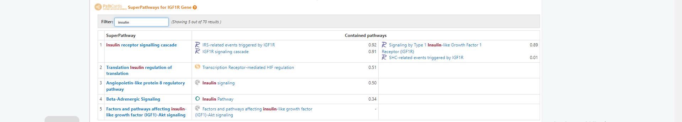
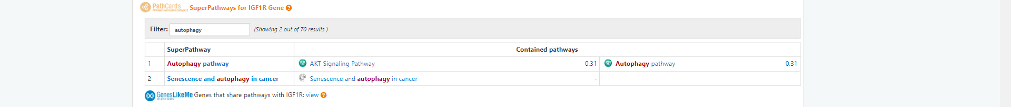

HSPA1B
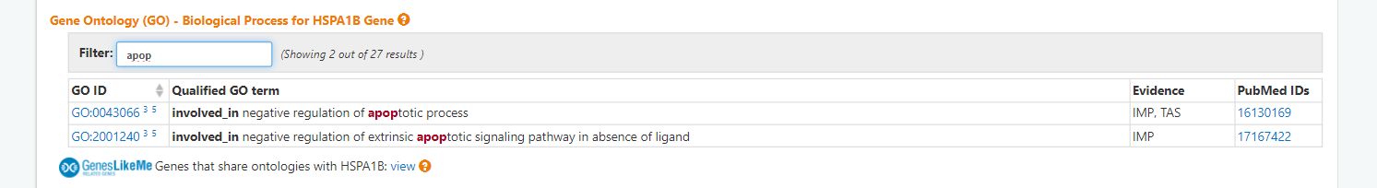
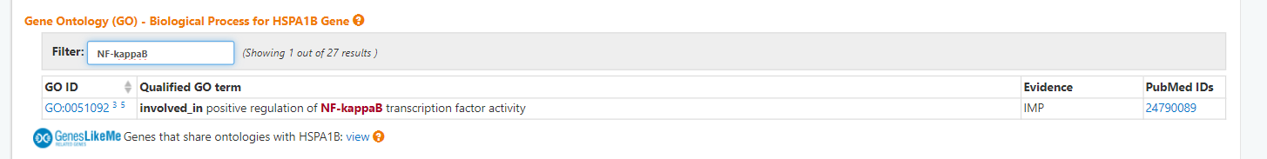
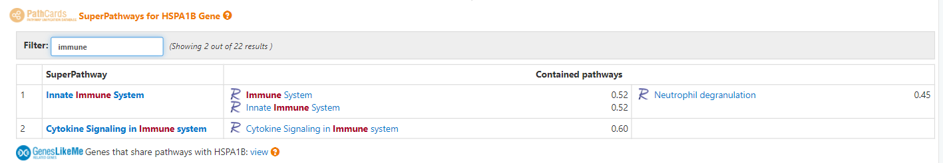
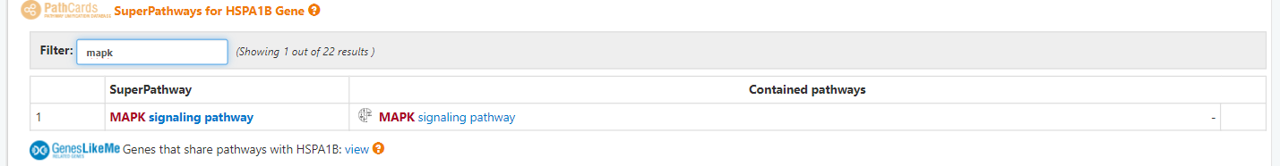
RB1CC1
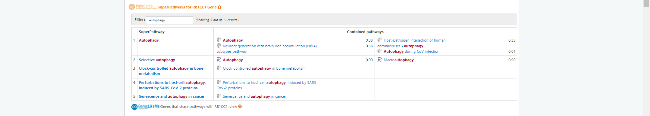
RET
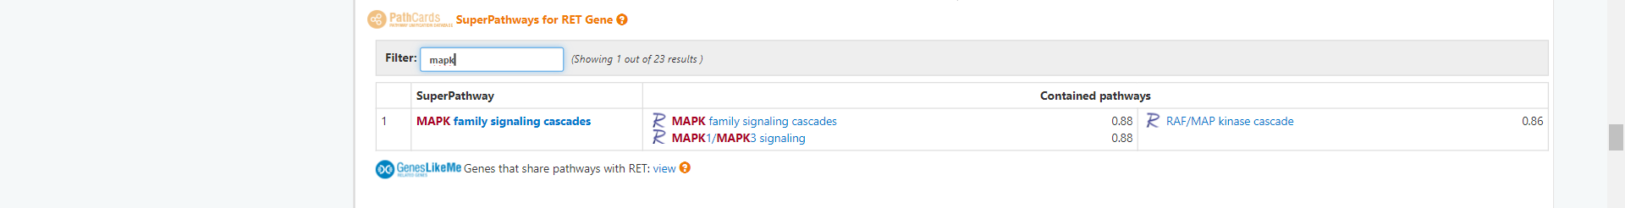
NFKB1
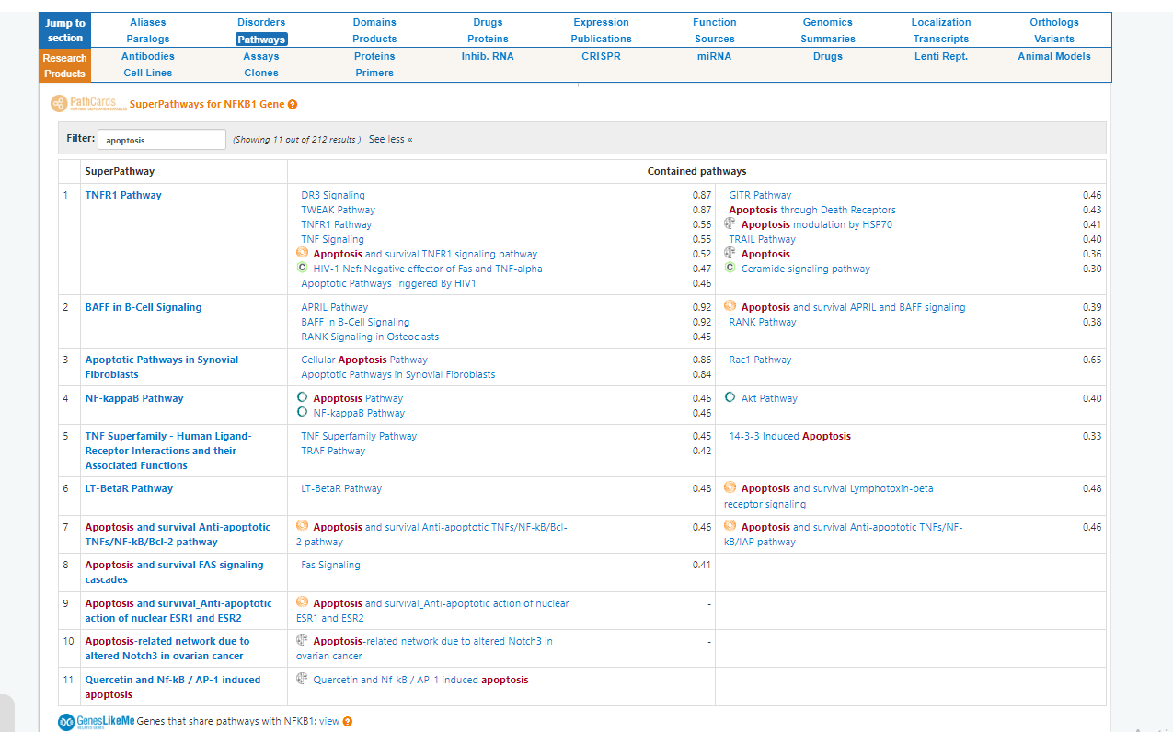
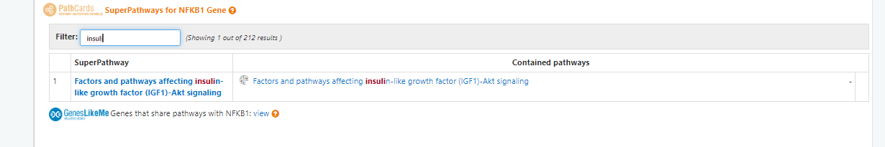
MTOR
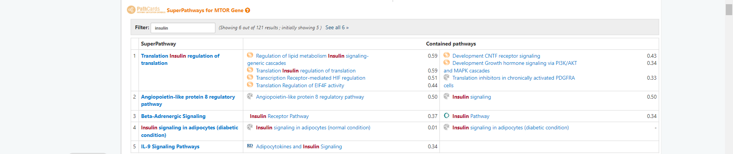
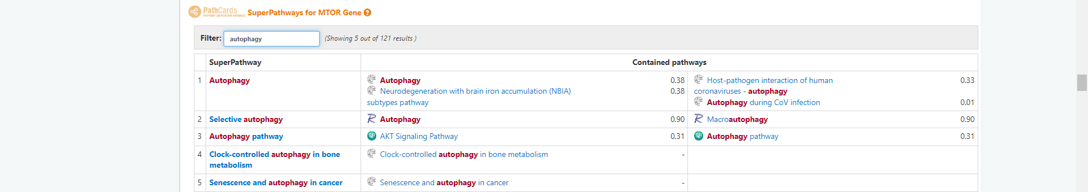
DDX58
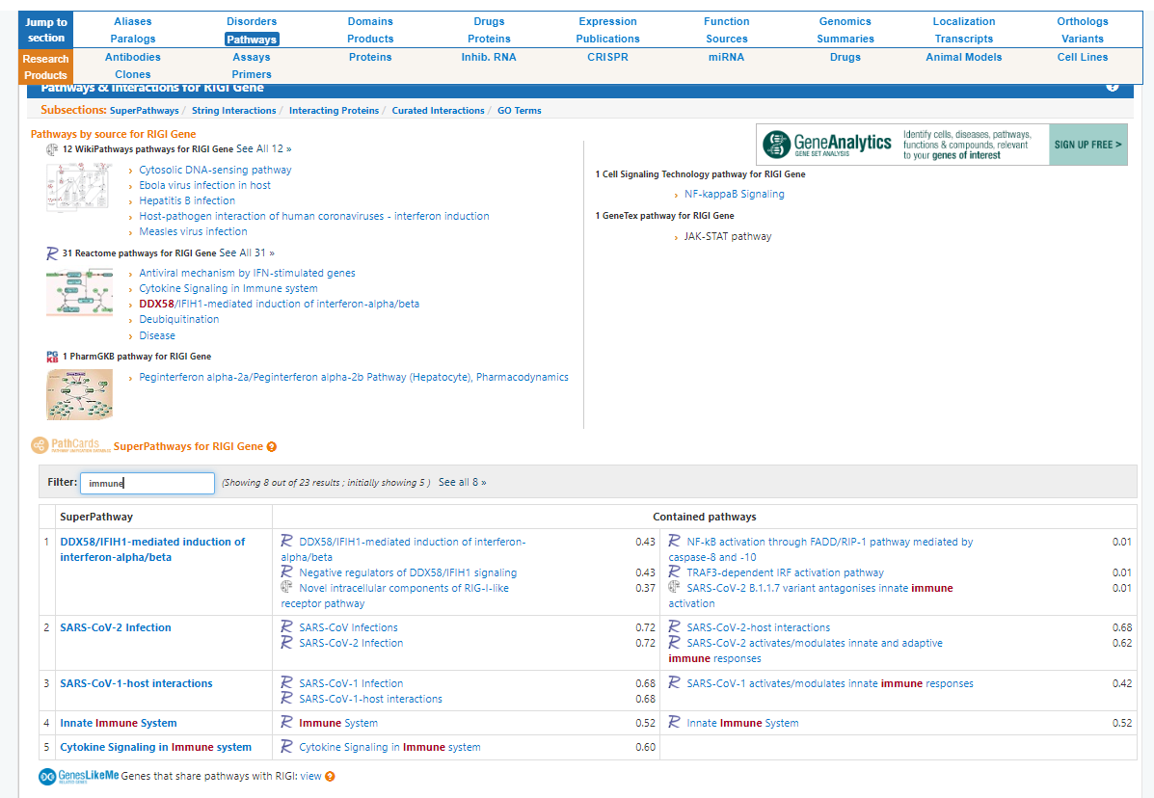

Figure S2. Protein-Protein Interaction analysis of the retrieved mRNAs:
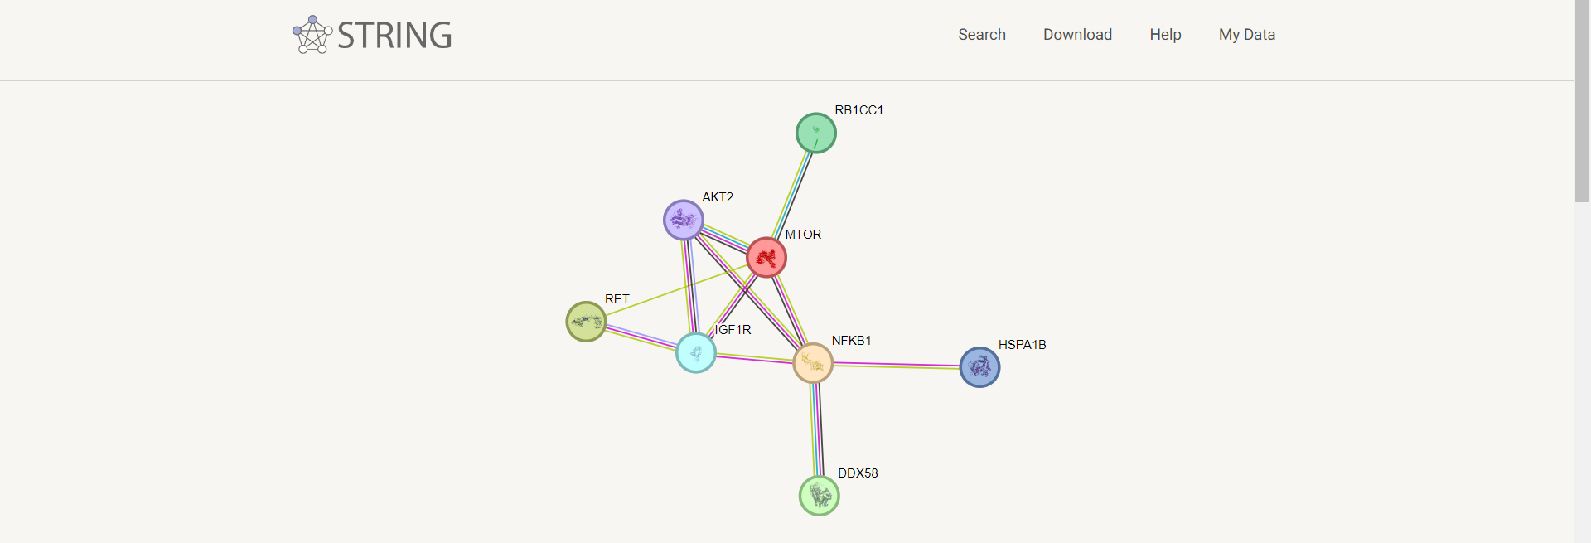
Figure S3. Validation of the interaction between the selected mRNAs and the retrieved miRNAs from the mirWalk (http://mirwalk.umm.uni-heidelberg.de/).
hsa-miR-15b
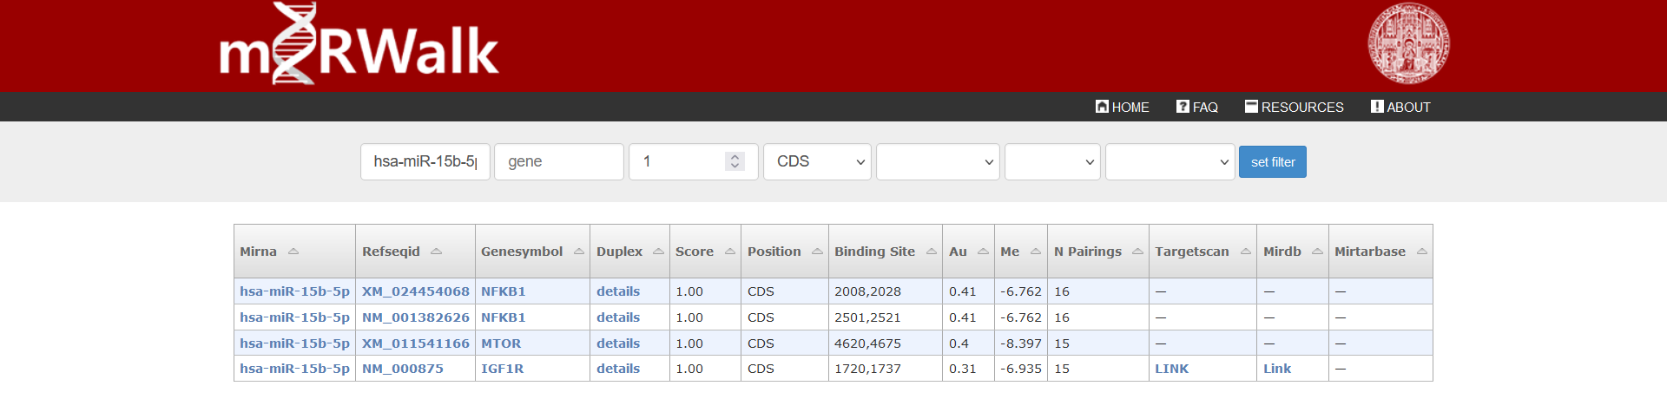

hsa-miR-3163
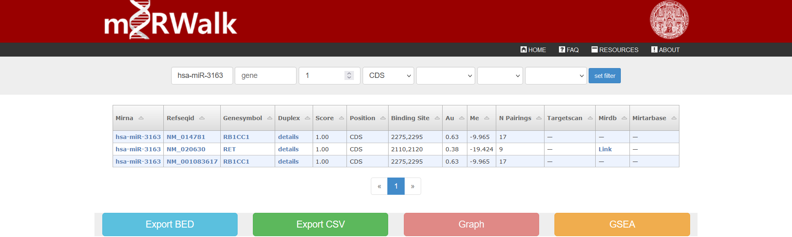
hsa-miR-611
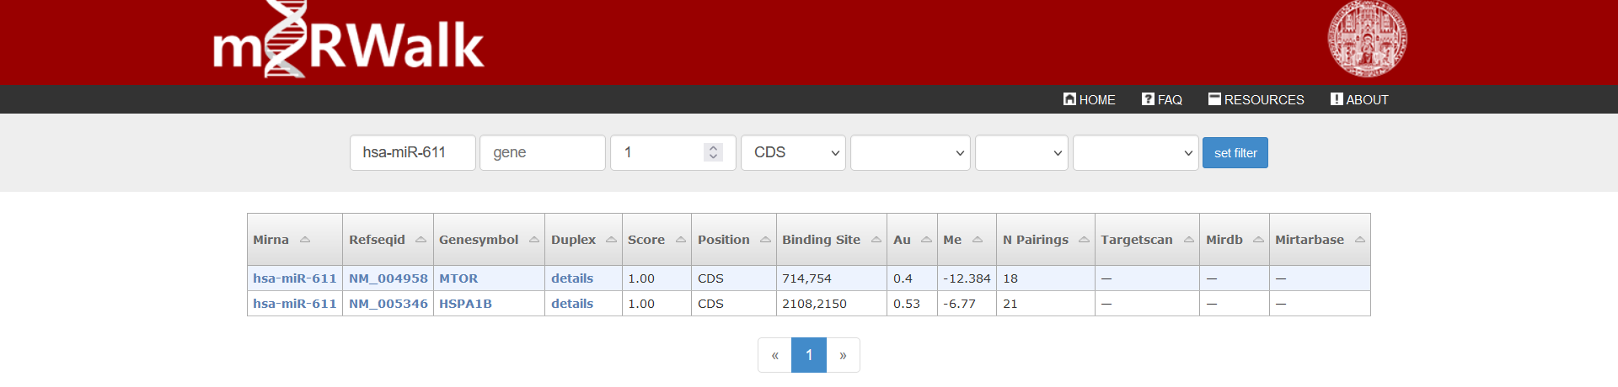
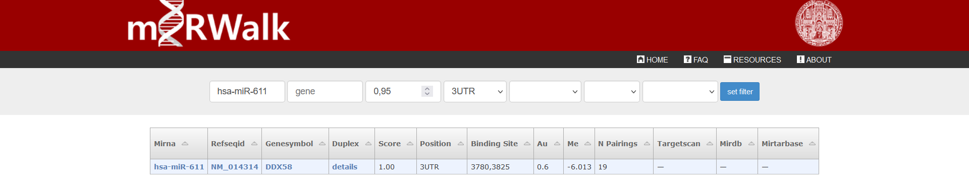
hsa-miR-30a
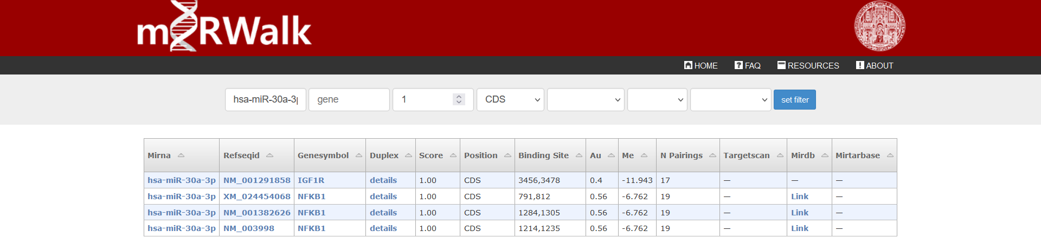
hsa-miR-342
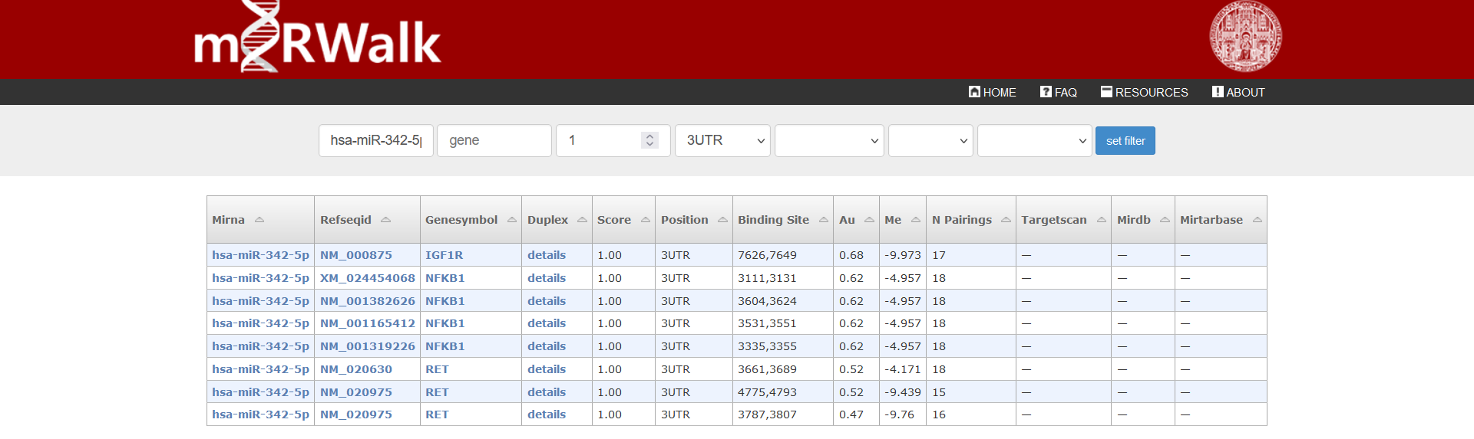
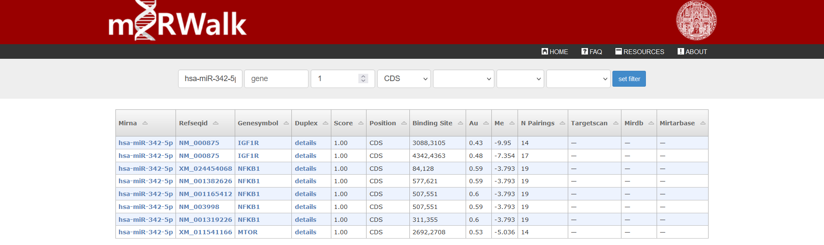
hsa-miR-636
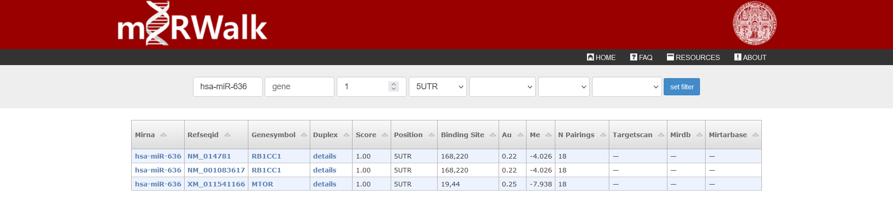

Table 2s: Epigenetic regulators of retrieved genes.
 | NFKB1 | MTOR | IGF1R | RET | RB1CC1 | HSPA1B | DDX58
miR-15b-5p | √ | √ | √
miR-342-5p | √ | √ | √ | √
miR-636 |  | √ |  |  | √
miR-611 |  | √ |  |  |  | √ | √

